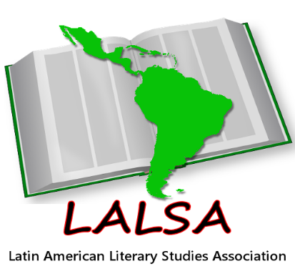
Latin American Literary Studies Association
2021 Conference
11 – 12 November 2021
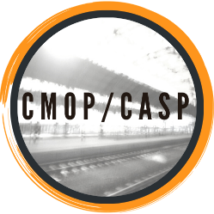
Aberystwyth University

In collaboration with

the Centre for the Movement of People /

Y Ganolfan Astudio Symudedd Pobl

CONFERENCE PROGRAMME

Thursday, 11 November

15:00 – 15:30 Welcome from LALSA and Aberystwyth University

15:30 – 17:00 Session 1 – Reconfiguring Human Space(s)

- ‘El deseo poderoso de tocar’: Touch and (Im)personal Spaces in Cuentos de Eva Luna
Mel Boland, NUI Galway, Ireland
- Un ejemplo de eco-noir: la fractura ecológica en El mal de la taiga de Cristina Rivera Garza
Rafael Andúgar Sousa, University of California, Santa Barbara, USA
- Faithful Witnessing in Samanta Schweblin’s Distancia de rescate (2014)
Ricki O’Rawe, Queens University Belfast, UK

17:15 – 18:45 Keynote:
Whose World Culture? Mexican Reflections from Utopia to Planerarity
Ignacio Sánchez Prado, Washington University in Saint Louis, USA

19:00 – 21:00 Online social event

Friday, 12 November

10:00 – 11:30 Session 2 - Reconfiguring Text Space(s)

- El cuaderno de Blas Coll: The Curious Case of the Ever-expanding Notebook
Nicholas Roberts, Durham University, UK
- Espacio, identidad y decolonialidad en ‘Borderlands La Frontera: The New Mestiza’ de Gloria Anzaldúa
Fernando Limeres Novoa, O Itsmo CLACSO, Spain
- Take My Word for It: Appropriation of State Discourse by the Public Narratives Of Disasters
Victoria Carpenter, University of Bedfordshire, UK

11:30 – 12:00 Tea/coffee

12:00 – 13:00 Session 3 - Reconfiguring Literary Space(s)

- Contemporary Brazilian Literature, Literary Awards and Translation: Transnational Movements
Cimara Valim de Melo, IFRS, Brazil
- Translating P’urhépecha Literature: (Re)configuring Mexico’s Multilingual Literature
Tania P. Hernández-Hernández, El Colegio de México, Mexico

13:00 – 14:00 Lunch

14:00 – 15:30 Session 4 - Reconfiguring Violent Space(s)

- La casa del dolor ajeno: México y Perú en tiempos violentos
Allen Juan Zegarra Acevedo, University of Florida, USA
- Situating Memory(ies) in Al sur de la Alameda: diario de una toma
Céire Broderick, University College Cork, Ireland
- The Affective Feminine and Las Islas Malvinas: (Re)Configuring Nation Space
Jennifer Wood, Aberystwyth University, UK

15:30 – 15:45 Tea/coffee

15:45 – 17:15 Keynote:
Patagonia and Wales: ‘Where the Welsh Are’ (Title tbc)
Lucy Taylor, Aberystwyth University (UK)

