|  |  |
| --- | --- |
|  | **Entrance Examination**  **May 2021** |
| **PHYSICS**  Time allowed: 1.5 hours (90 minutes)  This examination paper consists of two sections, A and B. Section B is composed of seven independent questions. Try to attempt **ALL** the questions from Section A and **AT LEAST SIX** questions from Section B. (If you answer all the seven questions in Section B, the best six will contribute to your overall mark.)  Remember to show how you work out your solutions.  Please clearly indicate each question number ahead of your working out and answers, and highlight your final numerical answers (including units) by, for example, underlining or framing them.  Marks will be awarded for correct approaches, thoughts, ideas, or methods, even if the final answer is incorrect or missing. No negative marks will be awarded for inaccurate or faulty arguments or incorrect answers.  The following lists of fundamental constants and formulae should be more than sufficient to answer all questions. However, standard booklets of fundamental constants and/or formulae, provided by your school, may be used in addition.  Any calculators are allowed to be used. | |

**Fundamental Constants**

Electron charge $e=1.60×10^{-19} C$

Electron mass $m_{e}=9.11×10^{-31} kg$

Gravitational constant $G=6.67×{10}^{-11} m^{3} kg^{-1} s^{-2}$

Plank’s constant $h=6.63×10^{-34} m^{2} kg s^{-1}$

Speed of light $c=3.00×10^{8} m s^{-1}$

Gas constant $R=8.31 J K^{-1} mol^{-1}$

**Further Useful Constants**

Gravitational acceleration $g=9.8 m s^{-2}$

Mass of an alpha particle $m_{α}=6.64×{10}^{-27} kg$

Boltzmann constant $k_{B}=1.38×{10}^{-23} J K^{-1}$

Astronomical unit $1 AU=1.5×{10}^{11} m$

Ångström $1 Å={10}^{-10} m$

Electronvolt $1 eV=1.6×{10}^{-19} J$

Avogadro number $N_{A}=6.22×{10}^{23} {mol}^{-1}$

Temperature conversion $T_{K}-T_{℃}=273.15$

**Useful Formulas**

$$PV=Nk_{B}T PV=nRT$$

$$n=\frac{N}{N_{A}} M=\frac{m}{n} ΔU=cmΔT$$

$$v≡\frac{dx}{dt} a≡\frac{dv}{dt} ω=\frac{2π}{T}$$

$$s=s_{0}+ut+\frac{1}{2}{at}^{2} v=u+at a_{n}=\frac{v^{2}}{r}$$

$$y=u_{y}t-\frac{1}{2}gt^{2} x=u_{x}t$$

$$E_{kin}=\frac{1}{2}mv^{2}=\frac{p^{2}}{2m} E_{pot}=-\frac{GMm}{r} E_{pot}=mgh$$

$$F_{e}=k\frac{qQ}{r^{2}} F_{g}=\frac{GMm}{r^{2}}$$

$$E=hf c=λf λ_{0}=2L λ_{B}=\frac{h}{p} N=N_{0} 2^{- \frac{t}{τ}}$$

$$F=PA E=mc^{2} g=\frac{GM}{r^{2}} ρ=\frac{m}{V} A=πr^{2}$$

$$V=IR q=CV E_{J}=Vq q=It q=Ne$$

$$P=IV=I^{2}R=\frac{V^{2}}{R} \sum{I{}_{i}}=0 \sum{V{}_{i}}=0 c=\frac{c_{vacuum}}{n}$$

$$\frac{1}{f}=\frac{1}{o}+\frac{1}{i} M=\frac{i}{o} n_{1}\sin{ α_{1}}=n_{2}\sin{α_{2}}$$

**SECTION A**

Experimental Data Analysis of the Expansion of a Spring to Measure Gravitational Acceleration

The force needed to expand a certain helical spring by up to about 0.2 m is proportional to the expansion of the spring. The constant ratio, spring constant $k$, between the exerted force and the resulting expansion is measured to be: $k\left(≡\frac{F}{ΔL}\right)=35 N m^{-1}$

The spring, hanging from a stand, can be loaded by different masses, $m$. The resulting expansion of the spring due to six different masses is summarized in the following table:



The uncertainty of measuring the length of the spring is: $e_{L}=±1 mm$

The length of the unloaded ($m=0$) spring is measured to be: $L_{0}=220 mm$

a)

Calculate the expansion, $ΔL≡L-L_{0}$, of the spring for each of the six masses. [2]

b)

Plot the expansion, $ΔL$, against mass, $m$, indicating also, by error bars, the uncertainty of the measured lengths. [4]

c)

Assuming that the plot verifies that the expansion of the spring, $ΔL$, is proportional to the force exerted on the spring (which, in this experiment, is the weight $F=mg$), draw a line of minimum gradient and a line of maximum gradient. [2]

d)

Work out values for the minimum and maximum gradients, and determine the mean gradient and its absolute and percentage uncertainties. [6]

e)

Using the formula $mg=kΔL$, derive a value for the gravitational acceleration, $g$, from the gradient read from the graph. [2]

f)

Estimate an absolute uncertainty on the derived value for $g$. [2]

g)

Comment the result on whether the derived value for $g$ is realistic. [2]

**SECTION B**

**1**

What wavelength range, $Δλ≡λ_{max}-λ_{min}$ is covered by sound waves between the frequencies of musical notes $F_{3}$ and $F_{4}$?

(The frequencies of the two notes are $f_{3}=174.61 Hz$ and $f_{4}=349.23 Hz$.

Sound waves travel in air at a speed of $v=340 m s^{-1}$.)

[5]

**2**

A car is travelling at $v_{1}=90 km h^{-1}$ on a flat (horizontal) road when its driver slows down to $v_{2}=30 km h^{-1}$. Assuming that the total mass of the car is $m=2000 kg$, how much kinetic energy does the car lose during the braking? What is happening possibly to the lost energy?

[5]

**3**

If the volume of hydrogen gas, originally at a temperature of $10 ℃$, in a sealed container is increased by 15 % and the volume of the gas is decreased by 15 %, what will be the final gas temperature?

[5]

**4**

A radioactive material of mass $m_{1}=21 g$ has a half-life of $T=9 days.$ In how many days will the mass of the material be reduced to $m_{2}=12 g$?

[5]

**5**

Four lamps, A, B, C, and D, each of resistance $R=3 Ω$, are connected in the circuit shown below. The battery has an emf of 9 V. Calculate the net power, $P≡P_{A}+P_{B}+P_{C}+P_{D}$, of the four lamps. The internal resistance of the battery can be ignored.

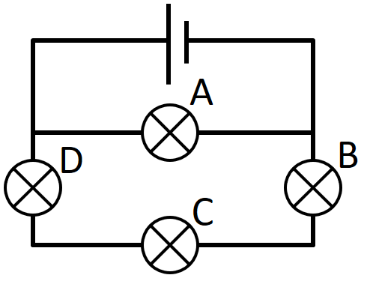

[5]

**6**

A cannon ball is shot from ground level with an initial speed of $v=80 m s^{-1}$ and at an initial angle of $α=45°$, measured to the horizontal direction. What will be the distance between the cannon and the cannon ball at $t=7 s$?

[5]

**7**

We want to create an $h_{i}=36 mm$ tall real image of an $h_{o}=12 mm$ tall object at $d=0.6 m$ distance from the object by using an optical lense. A thin lense of what optical focus, $f$, should we use and how far from the object should it be placed?

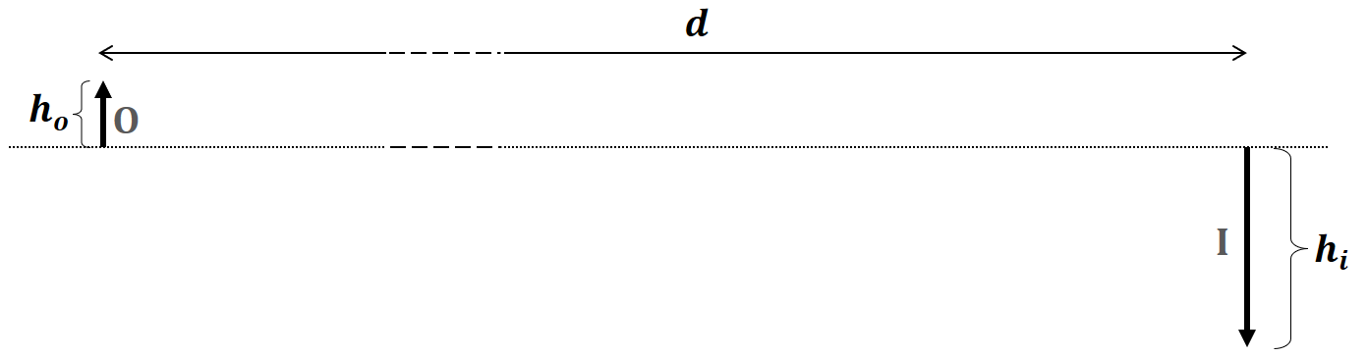

[5]