# **Managing Access to SharePoint Sites and Sharing Documents in SharePoint**

SharePoint sites are widely used for the purpose of storing and sharing information, which can often include personal and/or sensitive data. As a result, it is crucial that all information within SharePoint sites is suitably protected, and is only available to users who have a legitimate need for access.

The following guidance provides information on how to manage access to SharePoint sites and the recommended method of sharing documents in SharePoint.

## **SharePoint Site Access**

SharePoint site owners are able to manage the access permissions for their respective sites. It is strongly recommended that site owners utilise the three default permission groups which are created for each new site:

* ‘Name of Site’ **Owners** - Users belonging to this permission group will have **full control** permission levels, which will allow them to change the content and settings on the site.
* ‘Name of Site’ **Members** - Users belonging to this permission group will have **contribute** permission levels, which will allow them to view the site and change the content on the site, but not make changes to the site itself.
* ‘Name of Site’ **Visitors** – Users belonging to this permission group will have **read** permission levels, which will allow them to view the site but not make changes to the site or to its content.

Site owners are advised to avoid allocating permissions on an individual basis. To ensure consistency across sites, utilising the default permission groups will ensure that permission levels are standardised and the risk of permitting inadvertent access to particular sites and/or files is reduced.

To add user(s) to one of the permission groups:

* Click on the **Settings** cog in the top right corner, and select **Site settings** from the options presented:

* Select the **Site permissions** option under **Users and Permissions**:

* Select the permission group that you wish to add the user(s) to e.g. ‘Name of Site’ Members.
* Click the **New** option and select **Add Users** from the dropdown:

* Enter the email addresses of the user(s) when prompted, before clicking Share. Please ensure that you use the correct details, particularly where there are a number of different users with similar names and/or email addresses. You will also have the option to send an email invitation to any new users added.

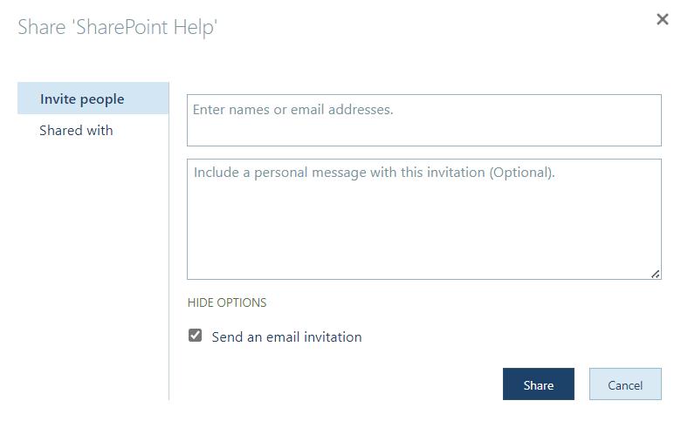

* User(s) added will then appear in the list of users belonging to that particular permission group.

Further information relating to sharing a SharePoint site with other users is available at [How do I share a SharePoint site with other users?](https://faqs.aber.ac.uk/index.php?id=1239)

## **Sharing Documents and Folders**

The default setting for all SharePoint sites should be that only site owners are able to share documents and folders with others. To ensure that the setting is active for sites which you manage:

* Click on the **Settings** cog in the top right corner, and select **Site settings** from the options presented:

* Select the **Site permissions** option under **Users and Permissions**:

* In the **Permissions** tab, select the **Access Request Settings** option:

* Ensure that both the **Allow members to share the site and individual files and folders** and **Allow members to invite others to the site members group** checkboxes are ***unchecked***.

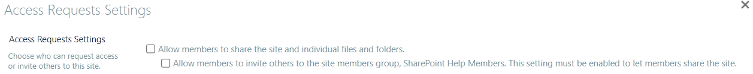

The folders and files stored on each SharePoint site would usually be accessible to any users with access permissions for the site (unless particular document libraries have been created with unique permissions). However, there may be occasions when specific documents, files or folders will need to be shared with users who do not otherwise have access to the SharePoint site.

In order to share a particular file or folder:

* Click on the **Share this item with other people** button next to the file or folder:

* You will then have the option to share with specific people or to make the file or folder available to any Aberystwyth University users who have access to the copy link.

### **Share with specific people**

This option allows you to send an email invitation to specified users or groups, and makes keeping track and maintaining lists of those with access easier.

Users can enter the names, email addresses or groups requiring access where prompted. When entering user details, please ensure that you use the correct details, particularly where there are a number of different users with similar names and/or email addresses. The level of access to be permitted can also be amended by clicking the dropdown and selecting from three possible options:

* **Can edit** – Make any changes
* **Can view** – Can’t make changes
* **Can’t download** – Can view, but not download

You will also have the ability to add a personalised message before clicking **Send** in order to update the permissions.

### **Make available to any Aberystwyth University users**

The other option is to make the file or folder available to anyone who has access to a share link. Colleagues should note that any share links created can be shared more widely, beyond the originally intended recipients, therefore this option may not be suitable if access to the content should be restricted.

To create a share link:

* Click on the **cog symbol** next to the **Copy link** button

* Select the desired option for your access requirements from the options presented:
  + **People in Aberystwyth University** – this will give anyone with an Aberystwyth University login the ability to access the file or folder if they have the link (whether they receive it directly from you or it has been forwarded from someone else);
  + **Only people with existing access** – this does not change any permissions and it doesn’t result in a link which can be shared more widely. This option would be used, for example, to send a link to someone who already has access;
  + **People you choose** – this option only gives access to people you specify, although other people may already have access (e.g. via the site). Only people who have been provided access will be able to use the link (even if the link is shared more widely).

* Select the level of access to be permitted by clicking the dropdown under **More settings** and selecting from three possible options:
  + **Can edit** – Make any changes
  + **Can view** – Can’t make changes
  + **Can’t download** – Can view, but not download

* Click **Apply** to confirm your permission settings.
* Select **Copy link** in order to generate the link to be shared with your intended recipients.

* Share the link with your intended recipients.

## **Further Information**

Users, and particularly administrators of SharePoint sites within their areas of work are strongly advised to complete the [SharePoint Administrator Training](https://www.aber.ac.uk/en/is/it-services/web/sharepoint/training/) materials, which provides guidance on how to set up a site, add elements such as libraries and lists, setting site permissions, and customising the site.

[SharePoint User Training](https://www.aber.ac.uk/en/is/it-services/web/sharepoint/training/) is also available, intended for SharePoint users. The materials provide guidance on how to access SharePoint and use site elements such document libraries, calendars and task lists.

Colleagues requiring further support or guidance in respect of SharePoint are asked to [contact Information Services](https://www.aber.ac.uk/en/is/help/contactus/) with details of their enquiry.