6. Approving Content (Moderators Only)
- From the Content menu on the top left of the page, select ‘Approve Content’
- The Approve Content page appears.
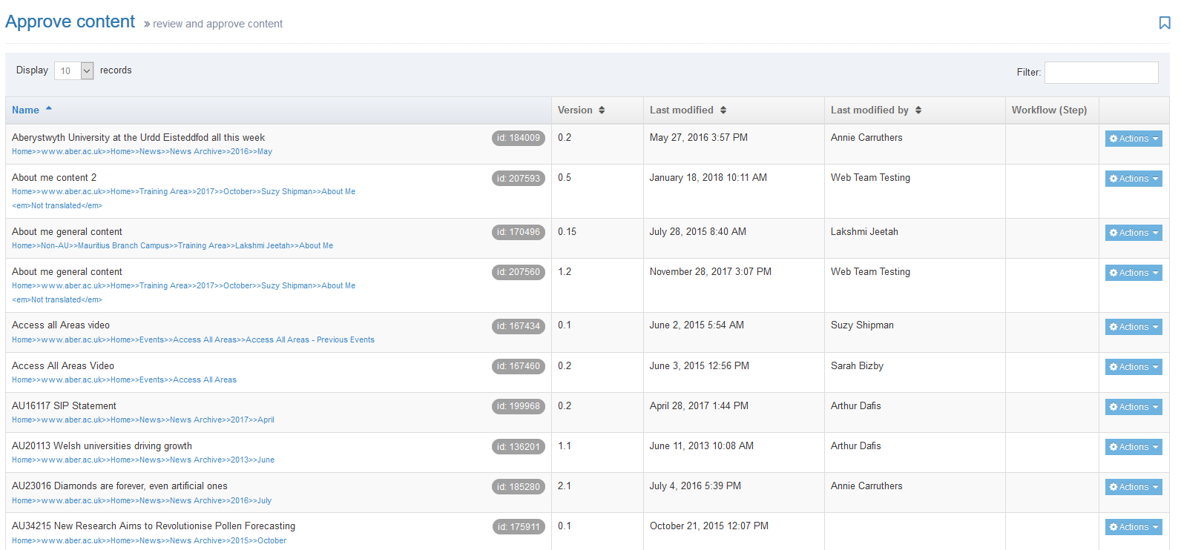
- If you are looking for a particular piece of content, you can order the list by name, by the date it was last modified, or by the person it was last modified by. Click on the column names to use them to order the items.

- If you have not already previewed the content to check it:
  - Click on the Actions button to the right of the item and select Preview.
Note: this preview might give you a distorted view of the page if there is more than just this one piece of content in it. If in doubt, use the section preview instead to check the page.
- You can check what has changed in the piece of content by looking at the history:
  - Click on the Actions button to the right of the item and select History
  - The Content history will be displayed:
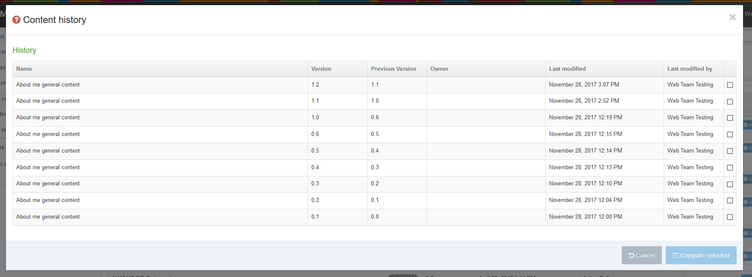
  - Tick the boxes in the right-hand column for the 2 versions you wish to compare and click the 'Compare selected' button.
  - The 'Compare versions' screen will appear, showing you what changes have been made. The HTML is displayed, rather than the actual appearance of the content.
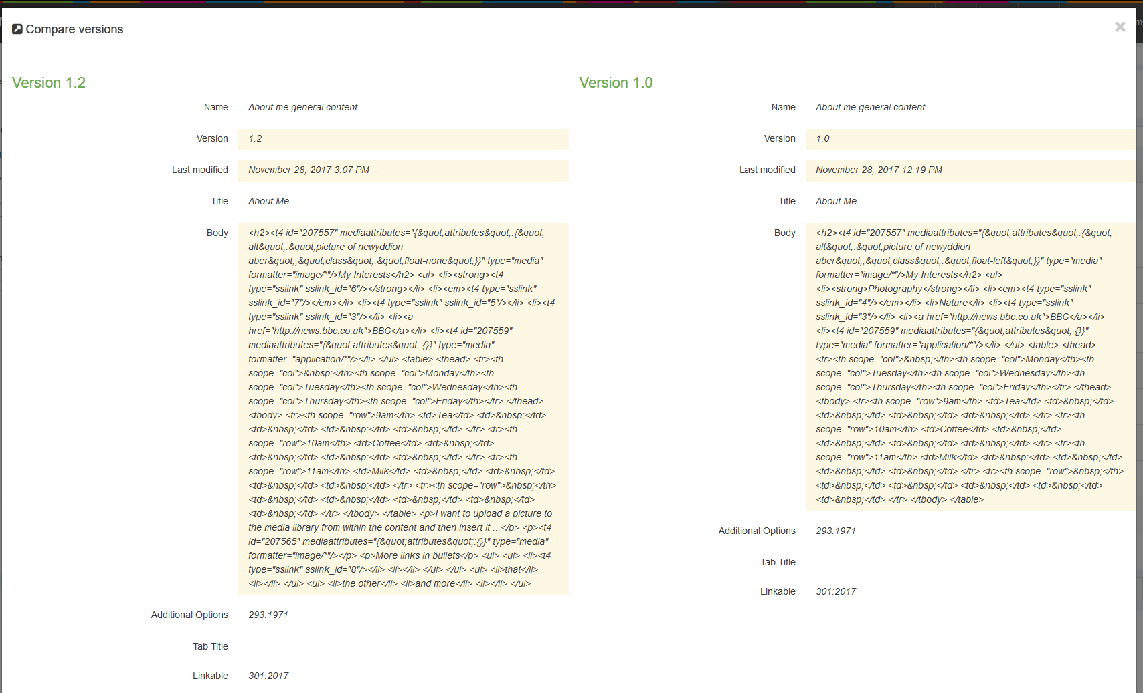
  - If you wish to approve or reject the content based on the comparison, click on either the Reject or Approve buttons at the bottom of the screen. Otherwise click the Cancel button or the X in the top right corner to return to the Approve content screen.
- When you are ready to approve the content, click on the Actions button to the right of the item and select Approve
- The Approve content screen will appear where you can add a comment if required, and click the final Approve button to complete the process:
- A success message will be displayed at the bottom of the screen, and the content will be removed from the approval list:

