31. Creating a Feature Tile Grid
31. Creating a Feature Tile Grid 1
Introduction 2
Example Feature Tile Grids 3
Creating a Feature Tile Grid 5
Add content where you want the feature tile grid to appear 5
Create a new section to store the tiles 6
Add the tiles 8
Feature Tile 9
Feature Tile (external link) 10
Feature Tile (quote) 11
To Finish 12

Introduction
Feature tile grids can be used to display several items in yellow and grey boxes.
There are three different types of tiles that can be displayed in the grid:
- Feature Tile - Heading with optional further details, linking to a section in the CMS.
- Feature Tile (external link) - Heading with optional further details, linking to an external page.
- Feature Tile (quote) - Quote, Source and Year, mainly used for quotes from alumni donors
You can combine Feature Tile and Feature Tile (external link) items, but don’t attempt to combine Feature Tile (quote) items with any other sort of tile.
The feature tiles rearrange themselves for mobile screen resolutions or if a user has their browser in a smaller window.
Feature tile grids can only be created by Moderators because a new section must be created, but if you already have one in your site, it can be edited by both Contributors and Moderators.

Example Feature Tile Grids
Simple Feature Tile Grid:
Feature Tile Grid with brief details:

Feature Tile Grid with larger details and reduced heading size:
Feature Tile Grid with quotes:
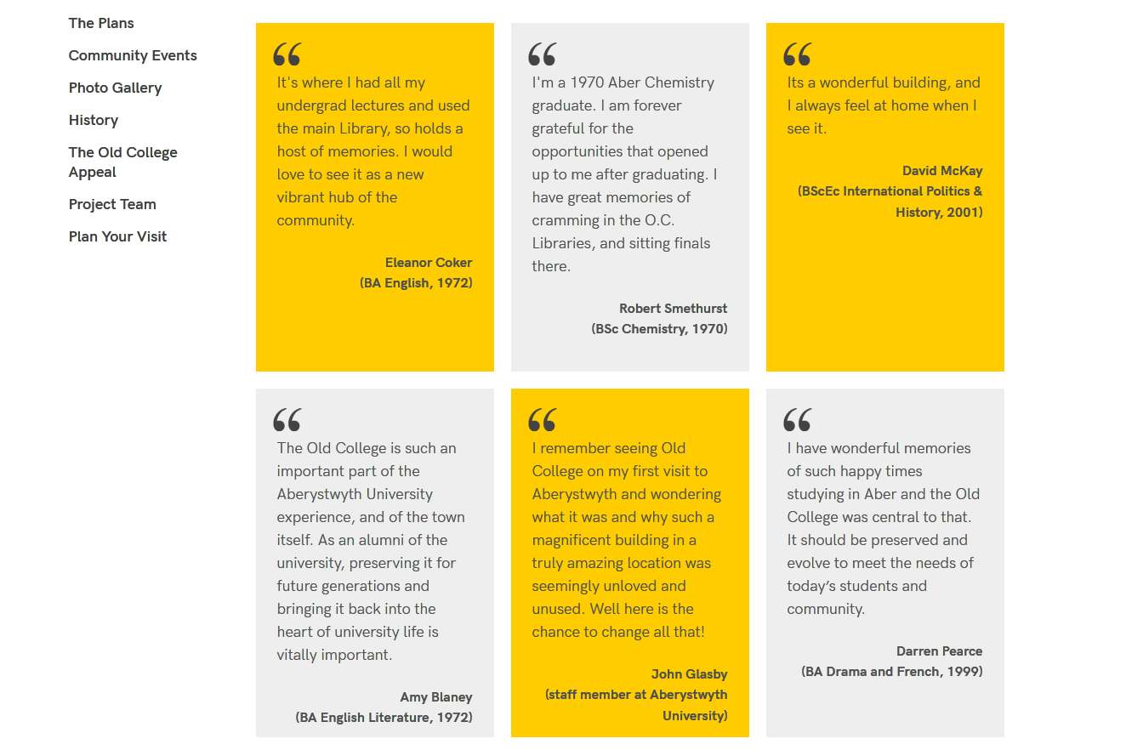

Creating a Feature Tile Grid

Add content where you want the feature tile grid to appear
- Open the section in the CMS where you want the feature tile grid to appear.
- Click on the Content tab.
- Click Add content and choose 'Display Feature Tiles'.
Note: If you don’t see this content template in the list, you’ll need to contact Information Services to ask them to enable the necessary templates for feature tile grids.
- The 'Display Feature Tiles' template is displayed:
- Give the piece of content a name.
- Click Save changes to save the content.
- If required, you may need to order the content in your section so that your feature tile grid appears in the correct point in the page. See Information Sheet 8 for further information on reordering content.

Create a new section to store the tiles
- Return to the Site Structure and find the section where you want the feature tile grid to appear.
- Click on the Actions button to the right of the section you have chosen, and the Actions menu will appear. Choose 'Create Section'.
- The General Section Details page will appear:
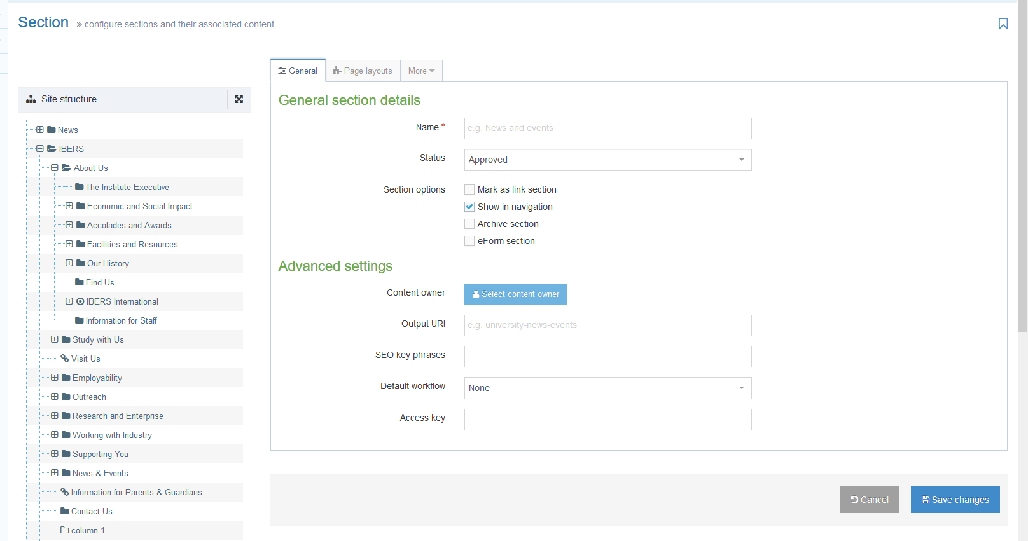
- Type features as the name of the section. It is important to use the correct wording, or the image menu will not work.
- Un-tick the “Show in navigation” tick box so that this section will not show up in the left menu.
- Click Save changes at the bottom of the screen.
- You will be returned to the Site Structure.

Add the tiles
- Click on the plus sign to expand your section so you can see your new features section.
- Click on the features section.
- Click on the Content tab.
- Click Add content and choose 'Feature Tile', ‘Feature Tile (external link)’ or ‘Feature Tile (quote)’, depending on what type of tile you are adding.
Note: If you don’t see these content templates in the list, you’ll need to contact Information Services to ask them to enable the necessary templates for feature tile grids.
- The chosen template will be displayed.

Feature Tile
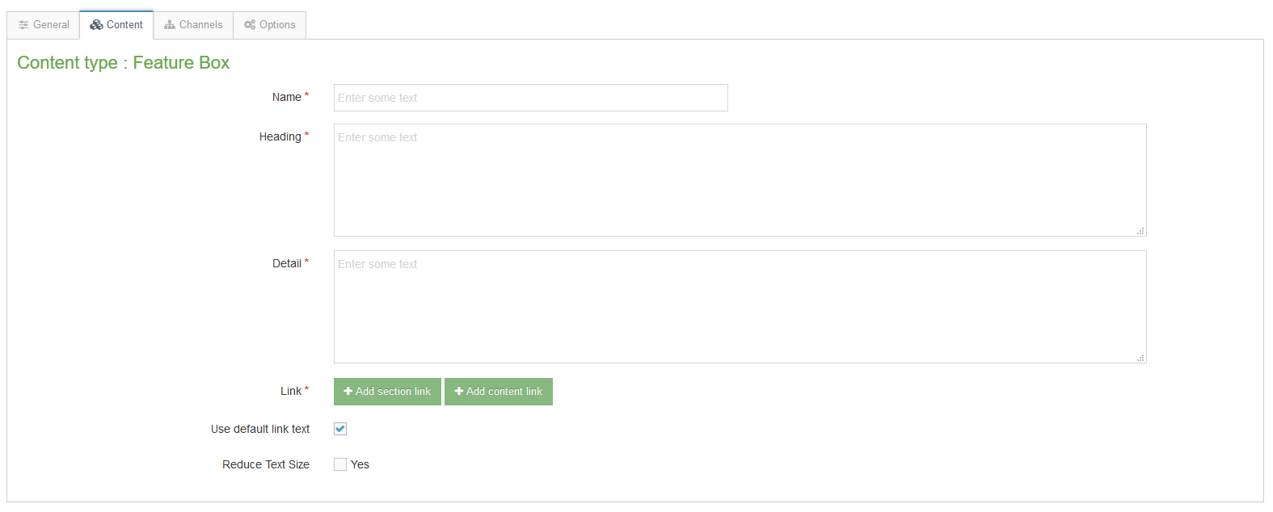
- Give the item a name. You may wish to use the same text as will appear to the user, so you can see which item is which in the content list.
- Type the headline text in the 'Heading' box.
- Type the brief further details in the 'Detail' box (optional).
- Click the 'Add section link' button to choose the section you wish to link to.
- When you have chosen the section, it will be displayed beneath the Add section link button.
- If your Heading is long you can tick the 'Reduce Text Size' tick box to make the font size smaller.
- Click Save changes to finish.

Feature Tile (external link)
- Give the item a name. You may wish to use the same text as will appear to the user, so you can see which item is which in the content list.
- Type the headline text in the 'Heading' box.
- Type the brief further details in the 'Detail' box (optional)
- Type or paste the external link address in the Link box.
- If your Heading is long you can tick the 'Reduce Text Size' tick box to make the font size smaller.
- Click Save changes to finish.

Feature Tile (quote)
- Give the item a name. You may wish to use the same text as will appear to the user, so you can see which item is which in the content list.
- Type the quote in the ‘Quote’ box.
- Type the name of the person giving the quote in the ‘Source’ box
- Add the year and the person studied here and their course in the ‘Year’ box e.g. ‘English, 1972’. You can also use this box to say a person was is/was a member of staff e.g. ‘staff member, 2007’.
- Click Save changes to finish.

To Finish
- Repeat as above for each feature tile you want to add
- When you have finished adding your feature tile items, return to the Site Structure.
- Click on the Actions button for the section where the image menu will appear (not the features section). Choose 'Preview section'.
- Check that the feature tile grid appears as you would like it to:
- Remember that you will need to approve the content that you have created so that the new feature tile grid will be displayed on the live webpage.

