3.3. Reusing Existing Content

Mirroring Content
There may be occasions where you would like to use the same piece of content in several pages – e.g. the contact details may be the same for every page within a section. You can create an identical, linked ‘mirror’ version of the piece of content and place it in a new section. All mirrored versions are updated whenever any one of them is updated.
- From the Site Structure, browse to the section (let’s call it Section A) where the piece of content you want to reuse is located. Click on the name of the section to open it for editing.
- The ‘General section details' page appears. Click on the ‘Content’ tab.
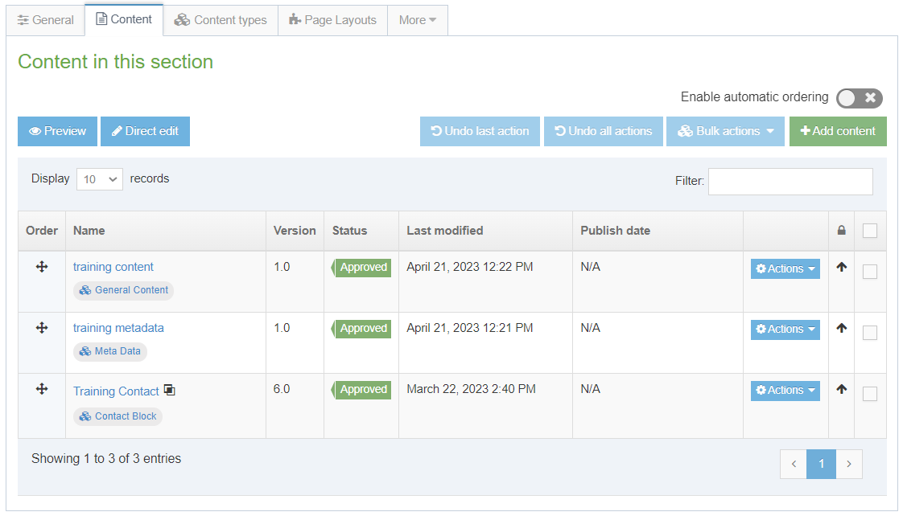
- You will now see the content currently in this section (A). Find the piece of content that you wish to reuse and click on the Actions button to the right of it. Select ‘Mirror’.
- The ‘Mirror Content' screen will appear, where you can choose the section you want to mirror the content into:
- Choose the section (let’s call it Section B) where you want the mirrored content to be placed, by clicking on the section name.
- The ‘Content in this section' page for the original section (A) will reappear, with a message at the bottom of the screen to tell you the mirroring has been successful.
- If you wish to reuse more pieces of content from this section (A), repeat the process.
- To check the mirrored content, browse to the section (B) where you placed the mirrored content and click on its name. You can return to the main Site Structure to do this or use the Site Structure bar on the left of the screen.
- The ‘General section details' page appears. Click on the ‘Content’ tab.
- You should now see the mirrored content appearing in the list of pieces of content, with a symbol next to it which shows it is mirrored:
Note: If you want to mirror multiple pieces of content at the same time, tick the boxes to the right of the items, then click the 'Bulk actions' button and choose 'Bulk mirror' from the menu.

Duplicating Content
If you are creating several similar pages, you may wish to copy some content from one section to another prior to modifying it. To do this, use the procedure above, choosing ‘Duplicate’ instead of ‘Mirror’ from the Actions menu. Then you can browse to the newly copied content and edit it as required.

