29. Adding a Page Intro

Introduction
It is possible to add a large image (or video) at the top of your page, with a headline and introductory text beneath.
Example page with large image:
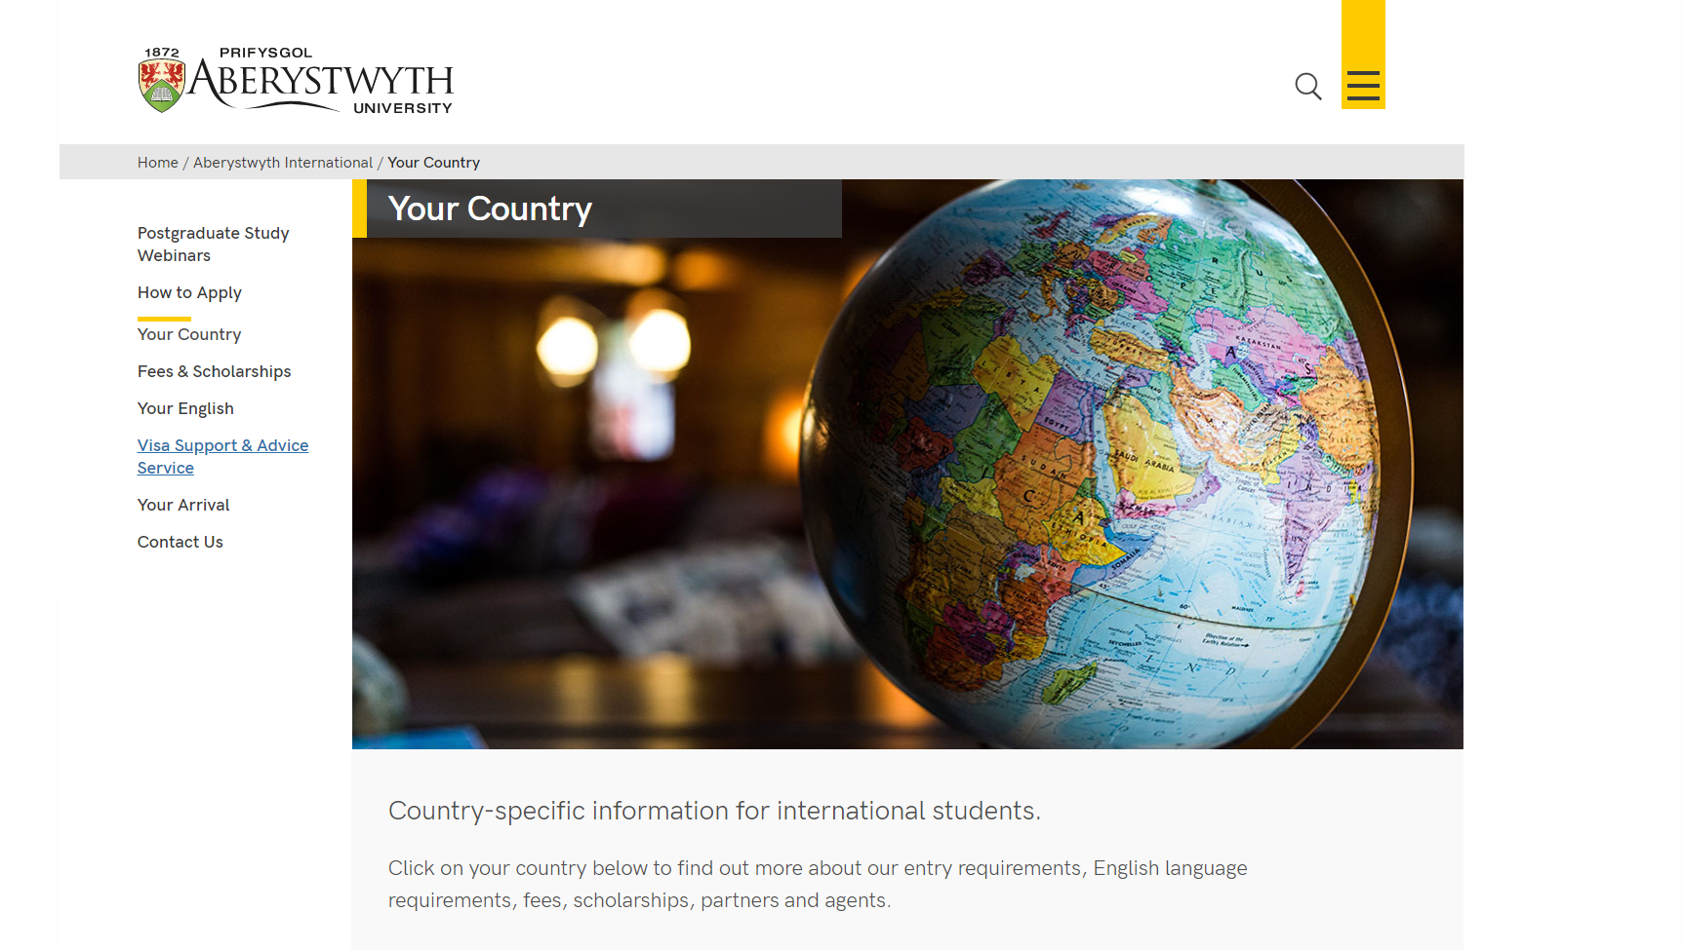
Example page with video:
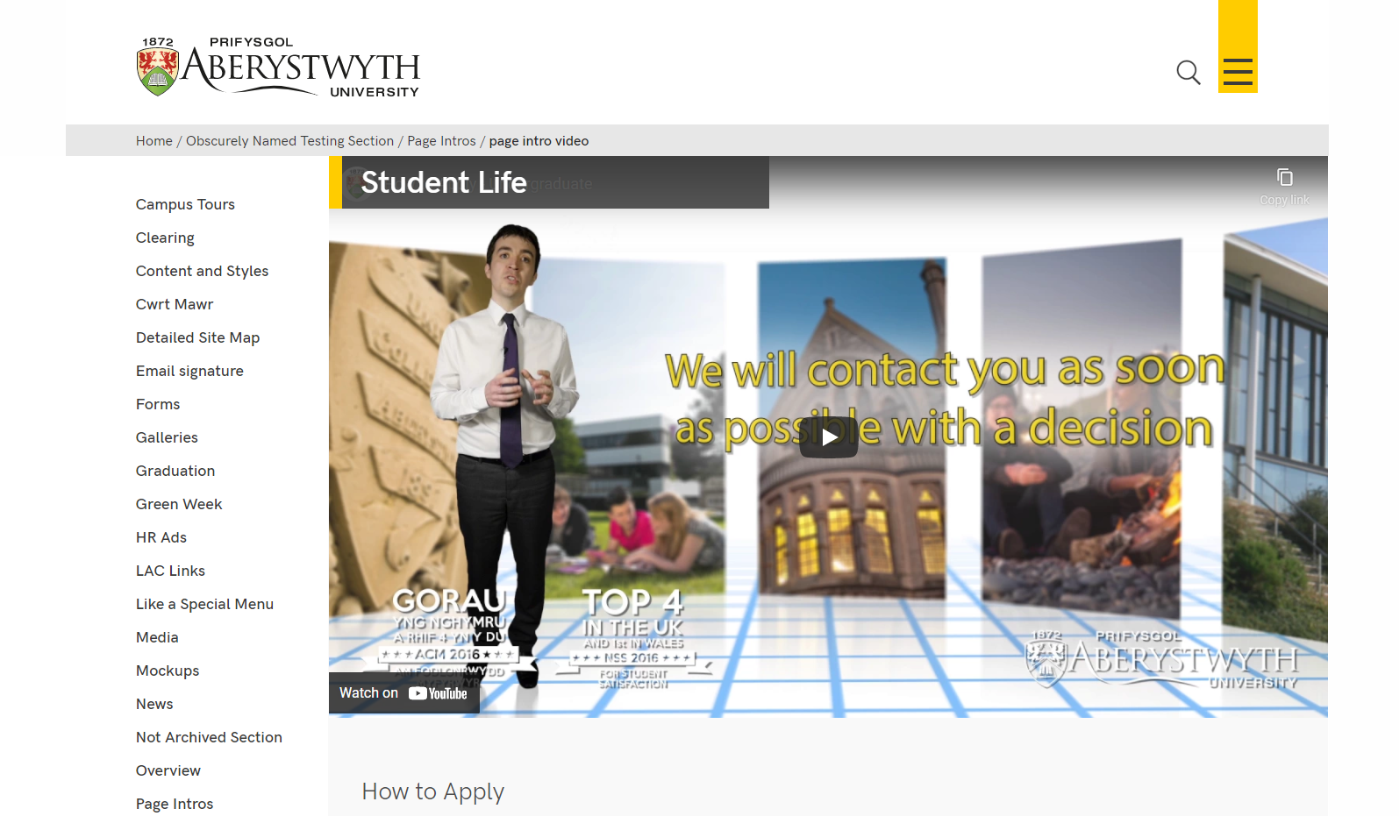

Preparation
You will need to have your image or video ready before you start.
If you get your image from the AU Photolibrary (http://photolibrary.aber.ac.uk/) you can choose the 'University Web - normal hero' option, and then crop the image to include the most important/interesting part of the photo. Otherwise you will need to use a photo editing tool (such as Photoshop or GIMP) to crop the image to the correct size (1140 x 585px).
Your image is likely to be large (in terms of file size) so you should reduce its size by using the 'Save for web' tool in Photoshop (or similar) to compress it to a smaller size (under 200kB).
More details on preparing images for use on the web can be found in Information Sheet 30.
For video, the video should have been uploaded to YouTube. When your video is ready, visit the YouTube page for your video. This link will be included in the email you receive when the video is ready.

Creating the Content
- Open the section in the CMS where you want the large image or video, and introductory text to appear.
- Click on the Content tab.
- Click Add content and choose 'Page Intro - Image or Video'
Note: If you don’t see this content template in the list, you’ll need to contact Information Services to ask them to enable the 'Page Intro - Image or Video' template.
- The 'Page Intro - Image or Video' template is displayed:
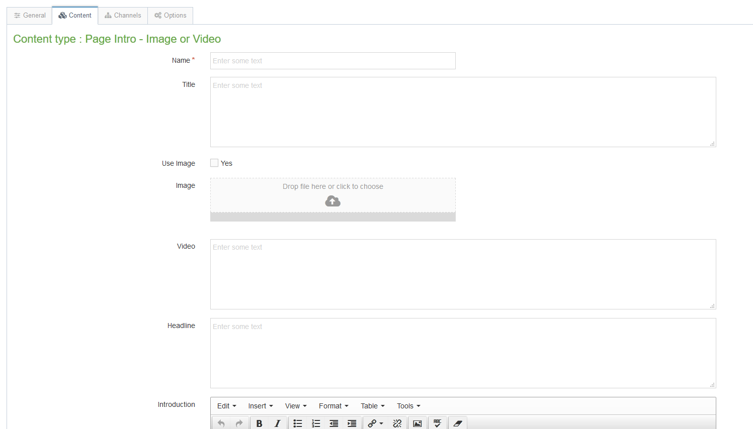
- Give the piece of content a name.
- Type the main heading for the page in the Title box

To add a large image:
- Tick the Image tick box.
- Click on the Image box and find the image you want to use from your computer (you should have already created a 1140 x 585px image and compressed it).

To add a video:
- View your video on YouTube and copy the last part of the web address. The web address will look like this: https://www.youtube.com/watch?v=AR9vEg7IrEk – you just need the code at the end, after “?v=” – in this case it would be AR9vEg7IrEk.
- Paste this code into the Video box.

To add the Headline and Introductory text:
- Type the text you wish to appear on the left in italics (under the image) in the Headline box.
- Type the text you wish to appear on the right (not in italics) in the Introduction box.
- Click Add to save the content.
- If required, you may need to order the content in your section so that your Page Intro appears at the top of the page. See Information Sheet 8 for further information on reordering content.

Additional Options for Advanced Users
It is possible to have a combined image and video (you click on the play button to show the video), and to have the headline and introduction text full width (rather than being on the left and right) as below:
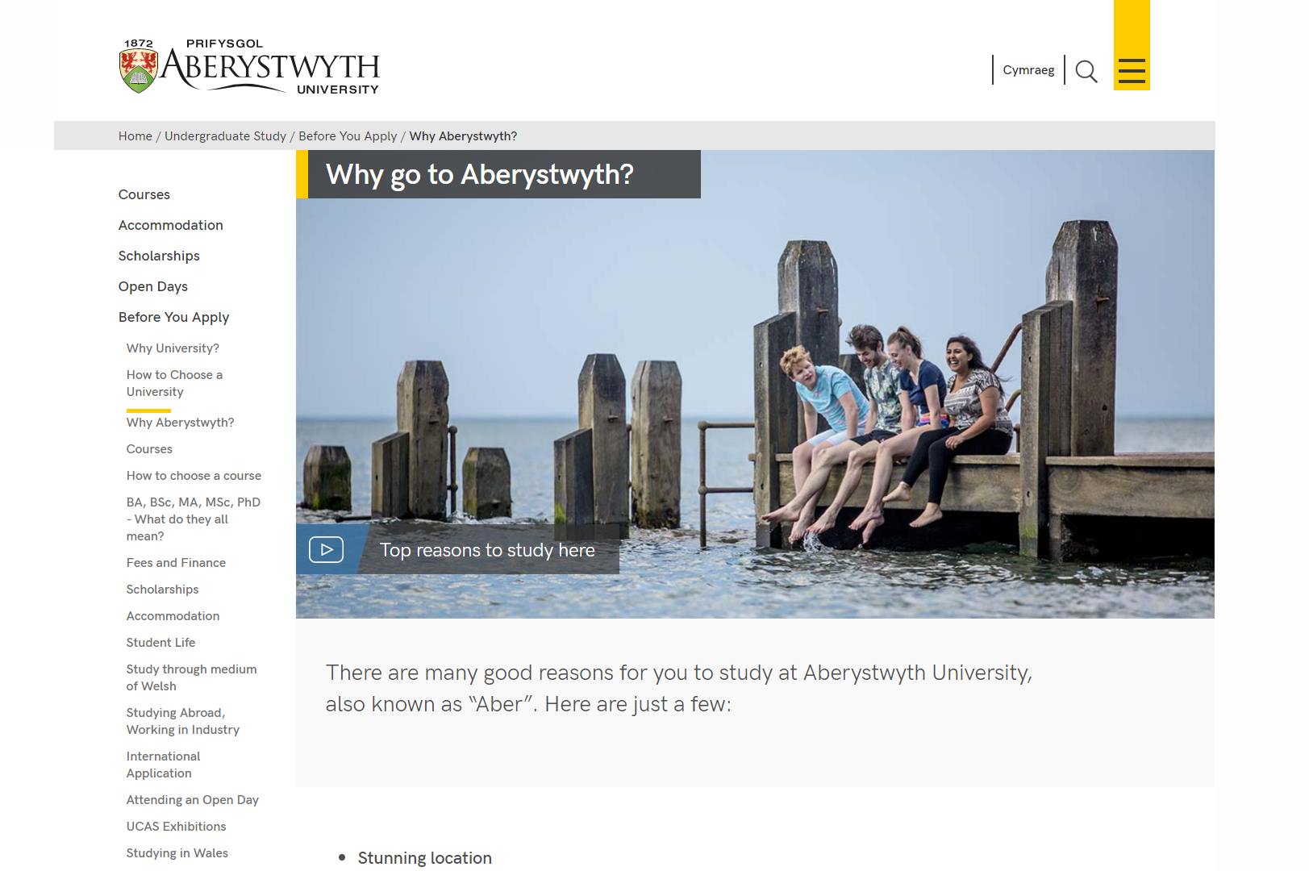
At the bottom of the Page Intro - Image or Video template are the additional options to allow this.
- Full Width Text: tick the box for 'Full Width Text' and choose to have wide introduction text.
- Combined Image and Video: Do not fill in any details of the image or video at the top of the template. Instead, scroll to the bottom instead and fill in the following fields:
  - Use Combined Image and Video: tick the box
  - Combined Image: choose your image, which should have been created in the same way as above.
  - Combined Video: paste in the video code, which should have been found in the same way as above.
  - Combined Video Title: type in the text that the user will see overlaid on the image, so that they know what the video is about.

