28. Creating Highlighted Text Blocks

Introduction
It is possible to highlight an area of text in your page by adding a box around it to make it stand out more. There are two different types of highlighting that you can use
- Box Container
- Notification (standard or centred)
The application of each of these styles is very similar. However, it can involve working in the HTML view, so is only suitable for confident/experienced CMS users.
If you need help creating highlighted text blocks, please contact us by email on is@aber.ac.uk or by phone on 2400.

Box Container
This creates a box outline around the content. The box will have a yellow border.
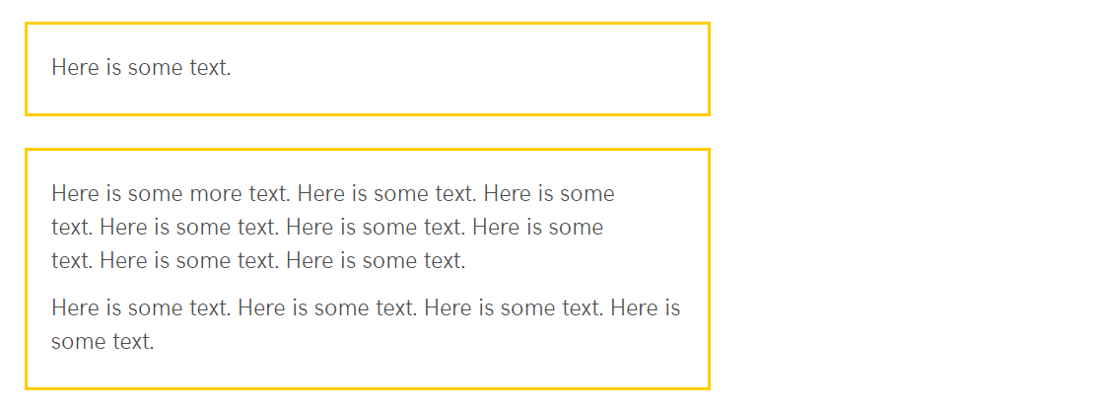

Notification
This creates a box around the content with a light grey background.

Standard
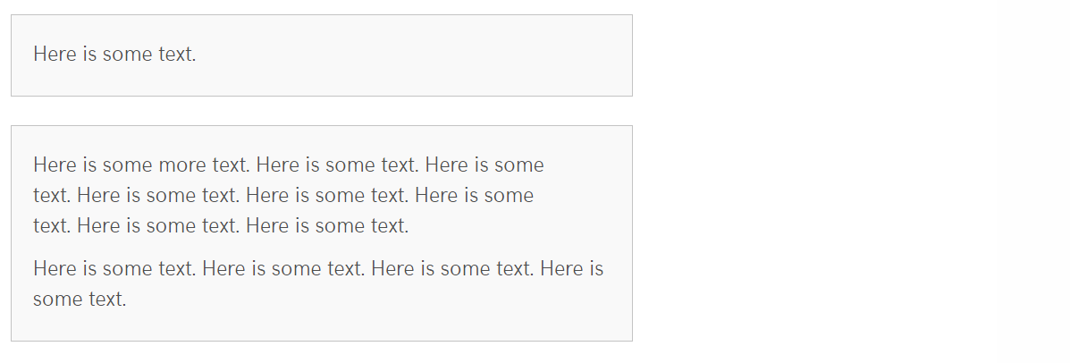

Centred
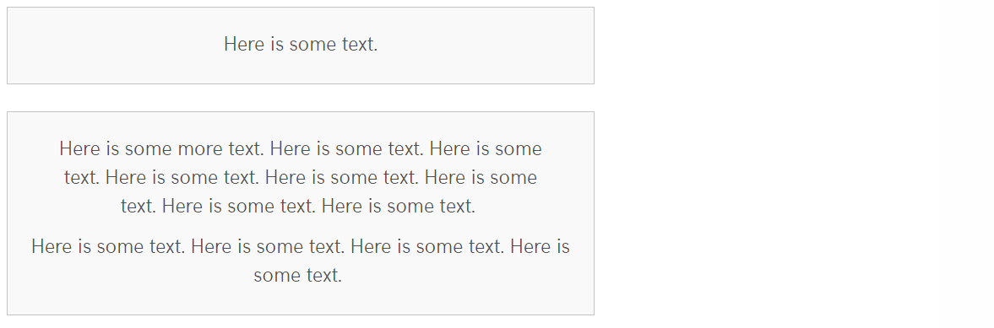

Creating Your Highlighted Area

Highlighting a Single Paragraph
- Open or create the piece of content where you wish to add the highlighted text.
- Find or add the text you wish to highlight.
- Click on the paragraph you wish to highlight in the editor window
- Look at the bottom of the editor window where you should see 'p'
- Click on the p, so the whole paragraph is selected.

- Click on the 'Format' menu, then put your mouse over 'Formats' then ‘Custom Formats’ so a further sub-menu appears:
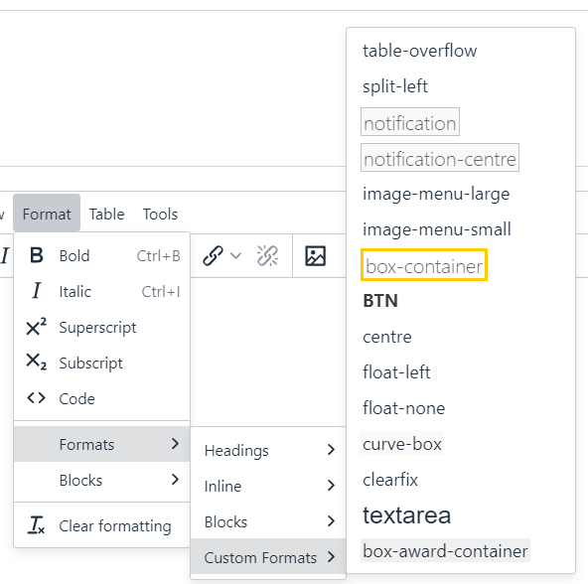
- Choose one of the following from the second menu:
  - For a Box Container, choose 'box-container'
  - For a standard Notification box, choose 'notification'
  - For a centred Notification box, choose 'notification-centre'
- Your text should now be displayed in in the appropriate type of box in the editor window.
- When you have finished adding your box, click Save changes to finish.
- Preview the section from the site structure to make sure the box is displayed as expected.

Highlighting Multiple Paragraphs
- Open or create the piece of content where you wish to add the highlighted text.
- Find or add the text you wish to highlight.
- Open the Source code editor by clicking on the Tools menu and choosing Source code:
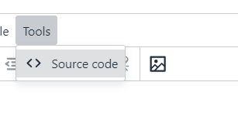
- The Source code editor appears:
- Look for the text you want to highlight. If your page has lots of content, you may need to look carefully through the HTML view to find your text.

- Make a new line before and after the text that should be highlighted, making sure to keep any opening and closing tags with the text that they surround. A tag is some text between "pointy brackets" (<>). It may be paragraph tags <p> and </p>, or it could be heading tags like <h2> and </h2>.
For example:
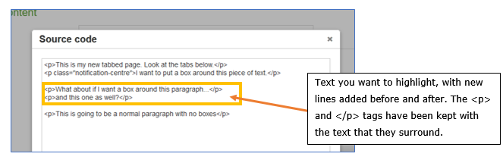
- In the new line before the chosen text type one of the following:
  - For a Box Container, type <div class="box-container">
  - For a standard Notification box, type <div class="notification">
  - For a centred Notification box, type <div class="notification-centre">
- In the new line after the text type </div>
- Your HTML should now look something like this:
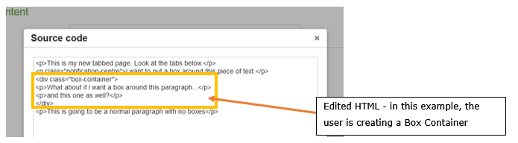
- Click the Save button at the bottom right of the Source code editor to save your changes.
- Your text should now be displayed in in the appropriate type of box in the editor window.
- When you have finished adding your box, click Save changes to finish.
- Preview the section from the site structure to make sure the box is displayed as expected.

