2.3. Previewing Sections
Sections can be previewed so that you can check how your page looks and functions. You should always preview your page before approving content.

Previewing a Section
- From the Site Structure view, find the section that you wish to preview.
- Click on the Actions button to the right of the section you have chosen, and the Actions menu will appear. Choose 'Preview section'.
- The preview of the page will open in a new window (or tab).
- If the preview doesn’t appear:
  - In Firefox:
    - check at the top of your browser window for a message saying “Firefox prevented this site from opening a popup window”.
    - Click on the Options button on the right and options will appear:
    - Click on “Allow popups for cms.aber.ac.uk”, and your preview should open.
    - This only happens the first time you preview from your PC
  - In Chrome:
    - check at the end of the browser address bar for a “Pop-up Blocked” symbol.
    - Click on the symbol and options will appear:
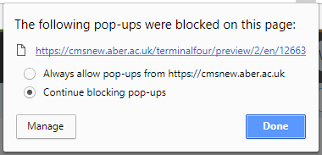
    - Select “Always allow pop-ups from cms.aber.ac.uk” and click Done. Refresh your page and try the preview again.
    - This only happens the first time you preview from your PC
- Check that the preview looks as you would expect.
- Click on the links to make sure that they go where you expect them to
- If you find there are things you need to change, you can leave this preview window/tab open so you can come back to it after making changes.
- After making any necessary changes, click on the 'Save changes' button to save the content before refreshing the preview window/tab so that you will be able to see the changes there. You can refresh the page by clicking on the refresh button which is usually on the left or right of the browser address bar. Alternatively pressing the F5 key on your keyboard will refresh the page.
- When you are happy with the preview of the section, you can proceed to approving the content. Please see Information Sheet 6 for more information on the Approval process.

