2.1. Creating a Link Section (Moderators Only)
Link sections can be used to add an item to your department’s navigation that is not actually within your department. Instead of being a section to which you add content to create a page, this section will merely direct to user to the web page of your choice.
For example, many of the links in the menu on the university's About Us page (below) are link sections which take the user out of The University section.
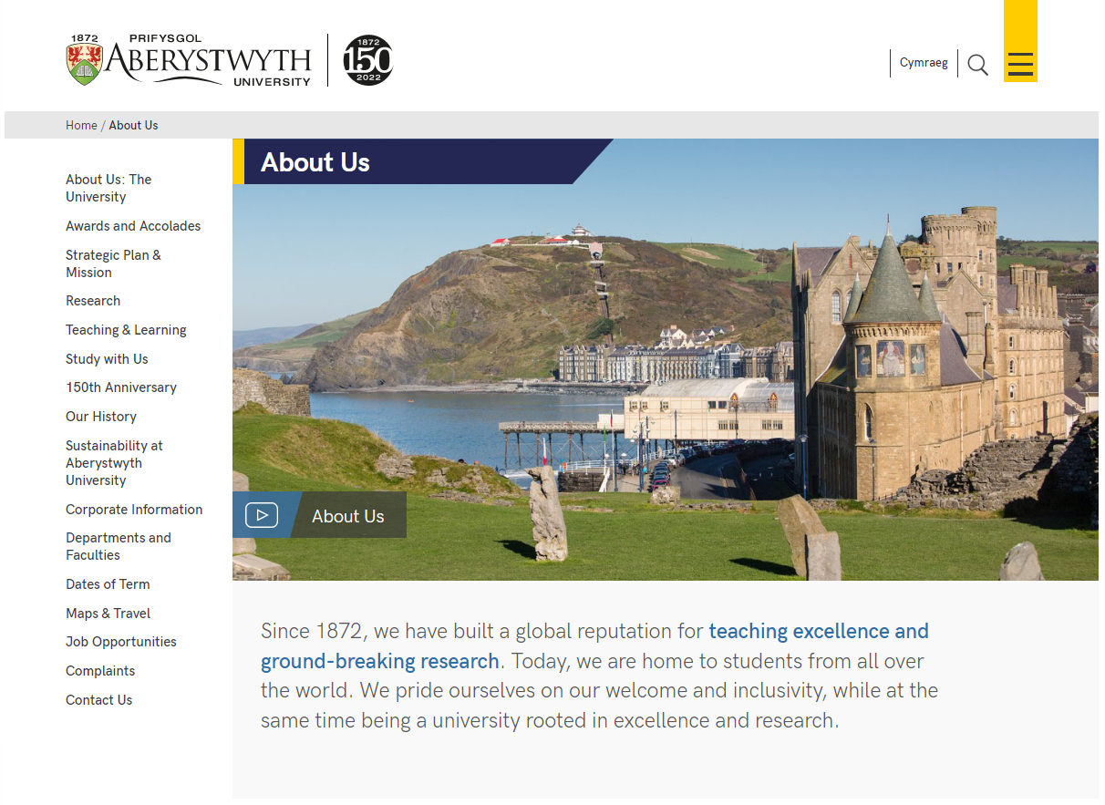
There are 2 types of link section – one is linking to a section within the CMS (in your department/area or elsewhere); the other is linking to a site outside of the CMS (this could be an AU site that is not in the CMS, or an external site)

Link Section – within the CMS
- From the Site Structure view, find the section where you wish to work.
- Click on the Actions button to the right of the section you have chosen, and the Actions menu will appear. Choose 'Create section'.
- The General Section Details page will appear:
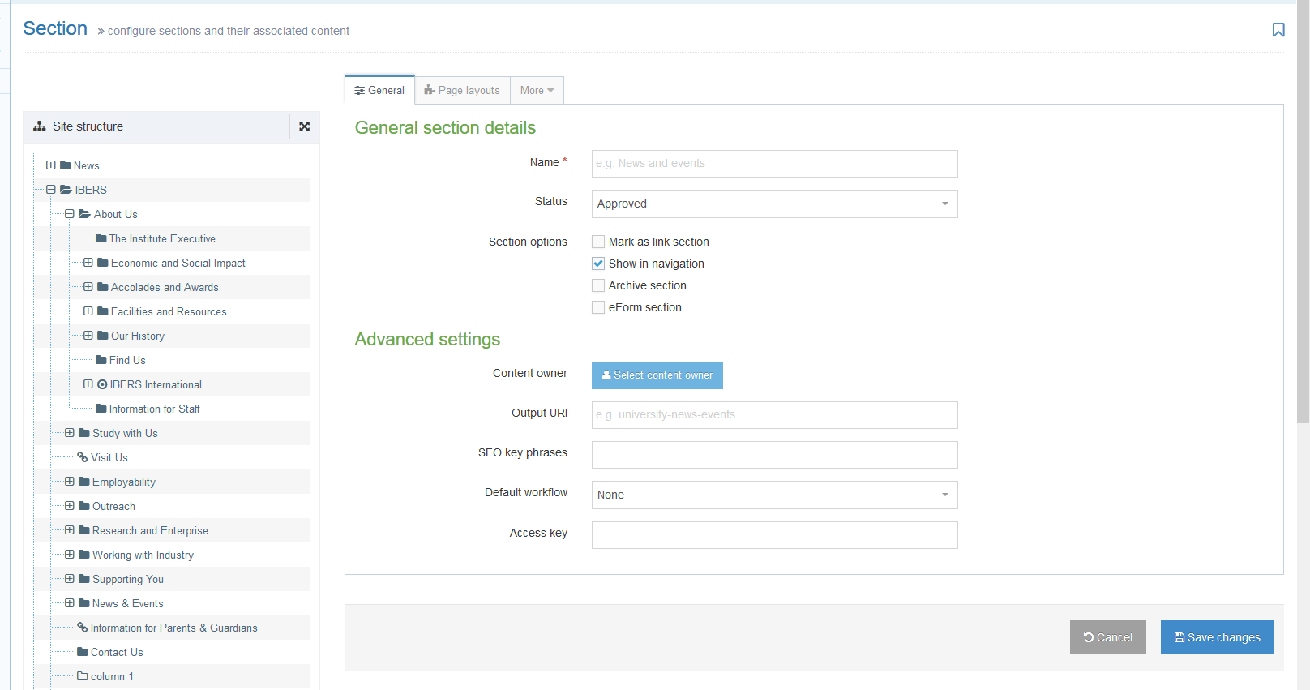
- Insert a name for the section. This name will appear in the left menu of your site.
- Tick the ‘Mark as link section’ box. Many of the options will now disappear.
- Click on the Details tab.
- In the Link type line, select ‘Section’.
- Click on the 'Select Section' button which has now appeared.
- The 'Select section' window will pop up. Click on the section you wish to link to.
- The section you chose will now be displayed in the Details tab.
- Click on the 'Save changes' button to finish.
- You will be returned to the site structure page, where you will see the section link icon next to the section name:

Creating the Welsh Version of your link section
- Click on the 'Site language' icon (globe) at the top of the screen and select Cymraeg. The Welsh version of the site structure page appears.
- Find the link section you just added. It will be called ‘Not translated’ as the Welsh title has not been set but you should see the internal section link icon next to it. Click on the words ‘Not translated’ to open the section for modifying.
Note: If there are lots of new sections which haven’t had their Welsh title set, it can be hard to find the right one that you need to work on – move or hover your mouse over the words ‘Not translated’ and a small box containing the English title of the page will appear.
- The Welsh version of the 'General section details' screen will appear.
- Add the name of the section – this should be the Welsh equivalent of the English Name.
- Click on the Details tab.
- In the Link type line, select ‘Section’.
- Click on the 'Select section' button which has now appeared.
- The 'Select section' window will pop up. Click on the section you wish to link to.
- The section you chose will now be displayed in the Details tab.
- Click on the 'Save changes' button to finish.
- You will be returned to the site structure page, where you will see the section link icon next to the section name:

Link Section – outside of the CMS
- From the Site Structure view, find the section where you wish to work.
- Click on the Actions button to the right of the section you have chosen, and the Actions menu will appear. Choose 'Create section'.
- The General Section Details page will appear.
- Insert a name for the section. This name will appear in the left menu of your site.
- Tick the ‘Mark as link section’ box.
- Click on the Details tab.
- In the Link type line, select ‘External URL’.
- Type or paste the URL to link to in the ‘Link URL’ box.
- Click the 'Save Changes' button to finish.
- You will be returned to the site structure page, where you will see external section link icon next to the section name:

Creating the Welsh Version of your link section
- Click on the 'Site language' icon (globe) at the top of the screen and select Cymraeg. The Welsh version of the site structure page appears.
- Find the link section you just added. It will be called ‘Not translated’ as the Welsh title has not been set but you should see the internal section link icon next to it. Click on the words ‘Not translated’ to open the section for modifying.
Note: If there are lots of new sections which haven’t had their Welsh title set, it can be hard to find the right one that you need to work on – move or hover your mouse over the words ‘Not translated’ and a small box containing the English title of the page will appear.
- The Welsh version of the 'General section details' screen will appear.
- Add the name of the section – this should be the Welsh equivalent of the English Name.
- Click on the Details tab.
- In the Link type line, select ‘External URL’.
- Type or paste the URL to link to in the ‘Link URL’ box.
- Click the 'Save Changes' button to finish.
- You will be returned to the site structure page, where you will see external section link icon next to the section name:

