13. Creating Tabbed or Accordion Pages
Tabbed pages and Accordion pages are used to allow multiple pieces of information to be available on the same page. They allow the user to swap between the tabs (or accordions) without moving off the main page.
Tabs:
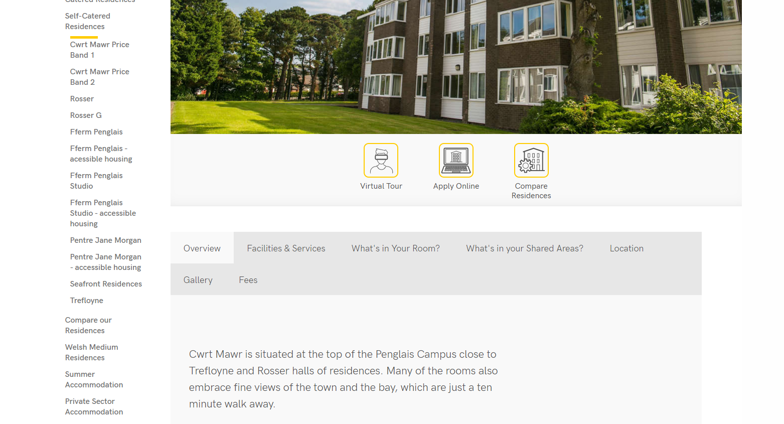
Accordions:
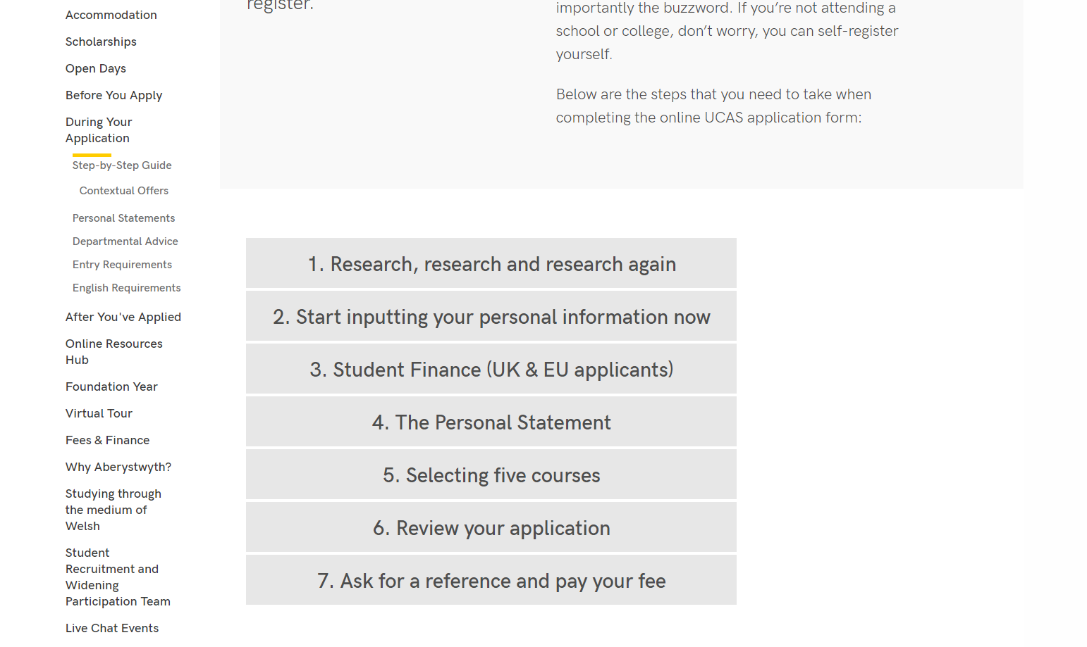

Creating a Tabbed or Accordion Page

Create Section
- Create a new section to become your tabbed or accordion page. Name it and give it an appropriate Output URI as usual.

Add Title and Introductory Text
- Open your newly created section and click on the Content tab.
- Click the Add content button and choose the content template named “General Content”.
- The General Content editor will open:
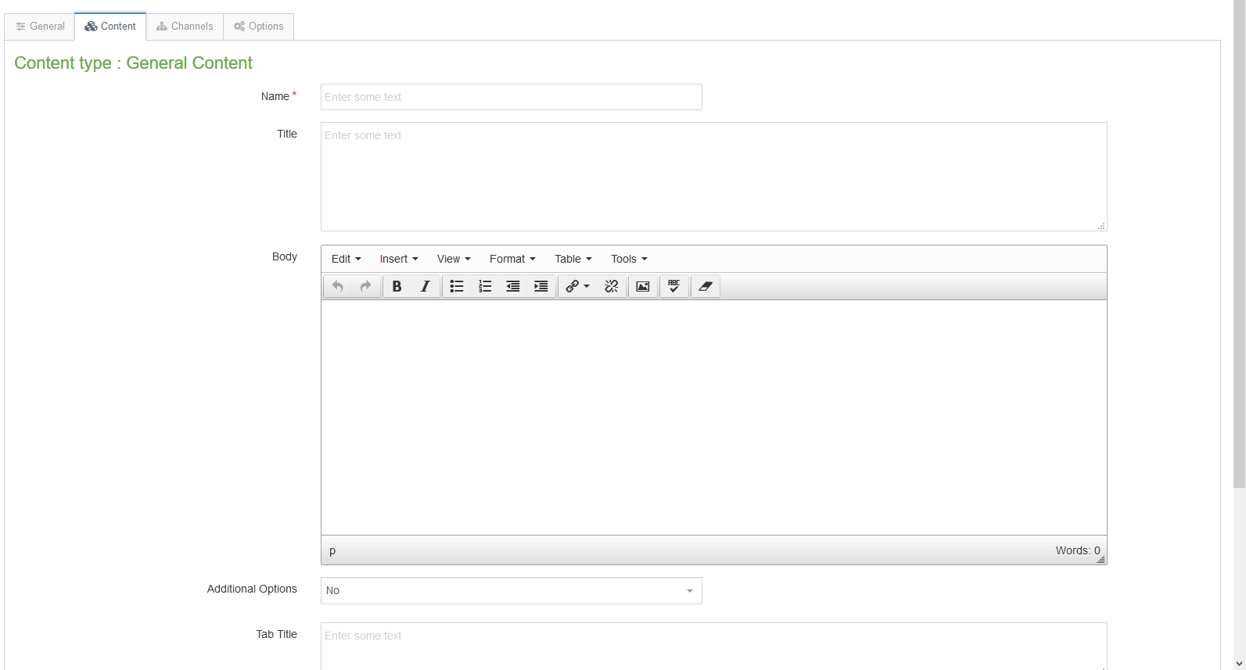
- Insert a name for your new content in the Name box. This isn’t seen by people using the web site, but it is important that you choose something that will make sense to other CMS users.
- Enter the title of the page in the “Title” box.
- Enter the Introductory text in the “Body” box. This text will remain on the page all the time regardless of which tab the user is viewing below it.
- When you have finished adding content click on the Save changes button.
- You will be returned to the Content tab, where you can see your newly added content listed.

Creating the Tabs or Accordions
- Now you will need to add the tabs/accordions that you wish to appear on the page. Until you do this, your page will look like an ordinary text page
- Click the Create content button and choose the content template named “General Content” again.
- Insert a name for your new content in the Name box. This isn’t seen by people using the web site, but it is important that you choose something that will make sense to other CMS users.
- Don’t fill in the Title box– leave it blank.
- Enter the content for the tab in the Body box.
- Scroll down so that you can see the Additional Options drop-down menu and the Tab Title box at the bottom of the template:
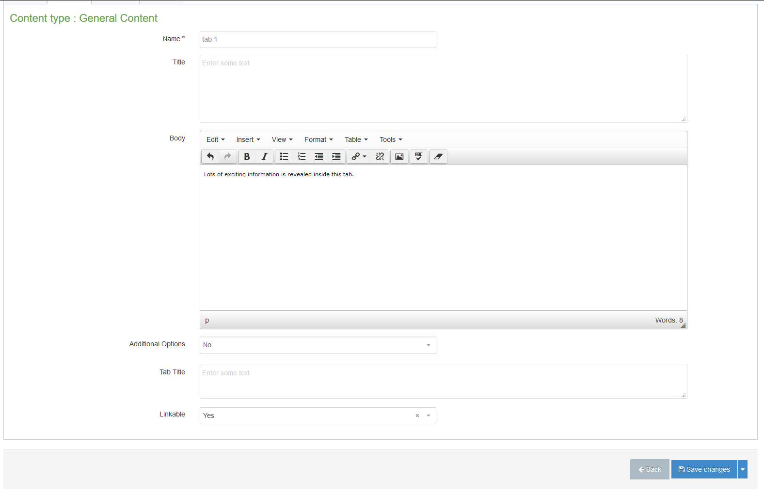
- Choose ‘Yes’ in the Additional Options drop-down menu
- You should now see the additional options of ‘Accordion’ or ‘Tabbed’ – pick the one you want to use.
- Type the title of the tab in the Tab Title box.
- If you would like the ability to link directly to a specific tab or accordion with the page, set the Linkable drop-down menu to Yes.
- When you have finished, click on the Save changes button.
- Repeat the process from points 11 to 20 above until you have finished adding all your tabs/accordions. Ensure that all headings have been set to the correct level, in accordance with Digital Accessibility Guidance for Staff.

Finishing Off
- Preview your section to make sure that the tabs are appearing as you expect
- Approve all the content and wait for the next publish to go through

