# 10. Working with Departmental News

Departmental News pages that are using the News system need to be treated a little differently from normal pages, and there are extra steps you will need to take to ensure they appear correctly

The News system allows you to have one news store which is used in several ways. The 3 latest news articles are listed on the Department homepage and the 10 latest articles are listed within the dedicated News & Events section. Clicking on a news headline takes the user to the full news article.

News appears at the bottom of the department homepage:

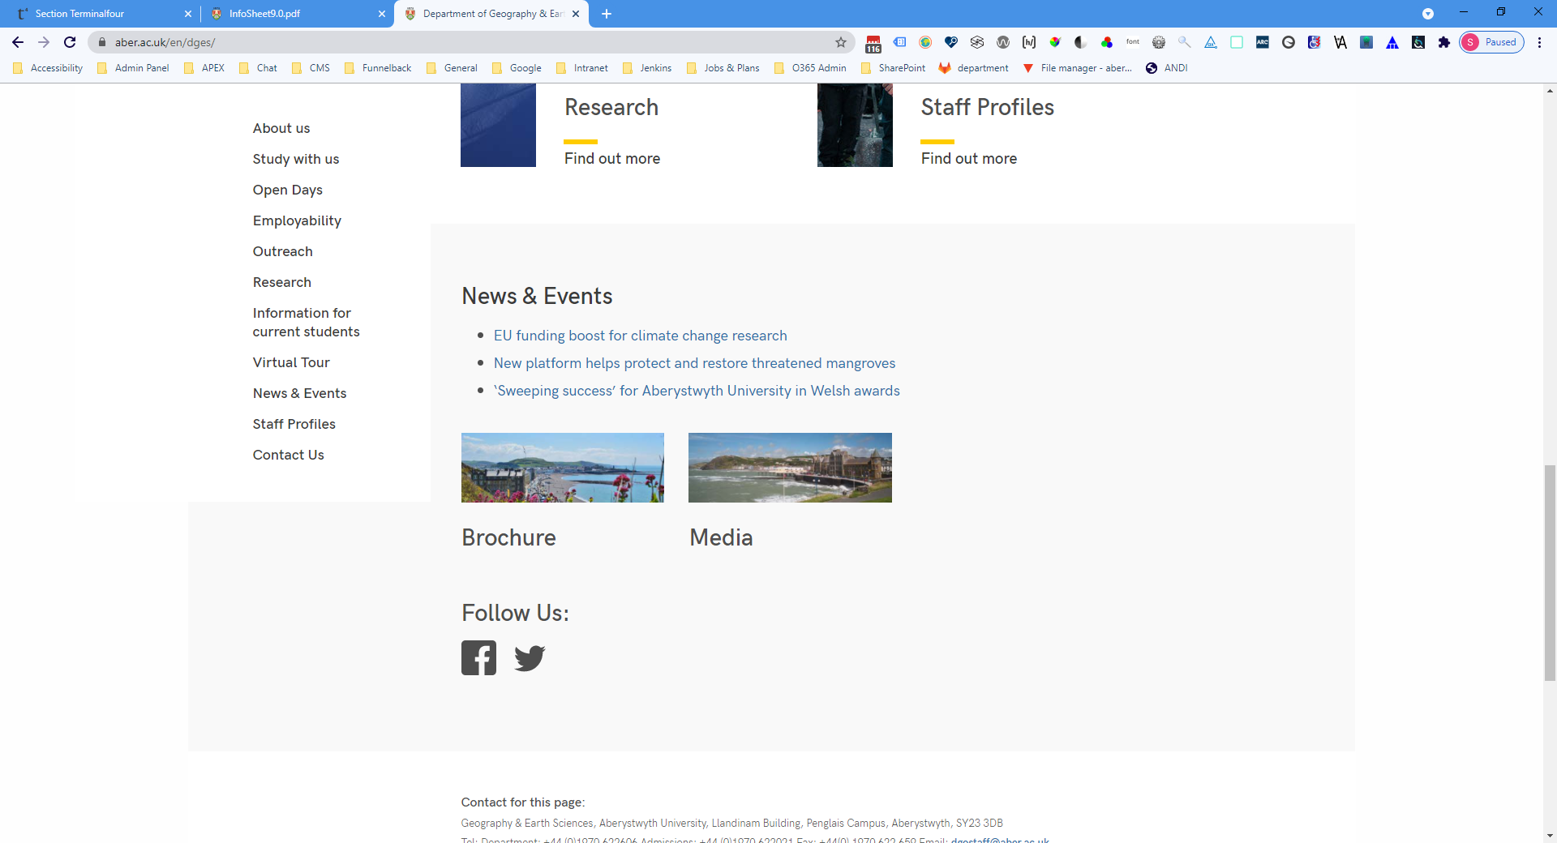

The News & Events page includes images and abstract for the main stories:

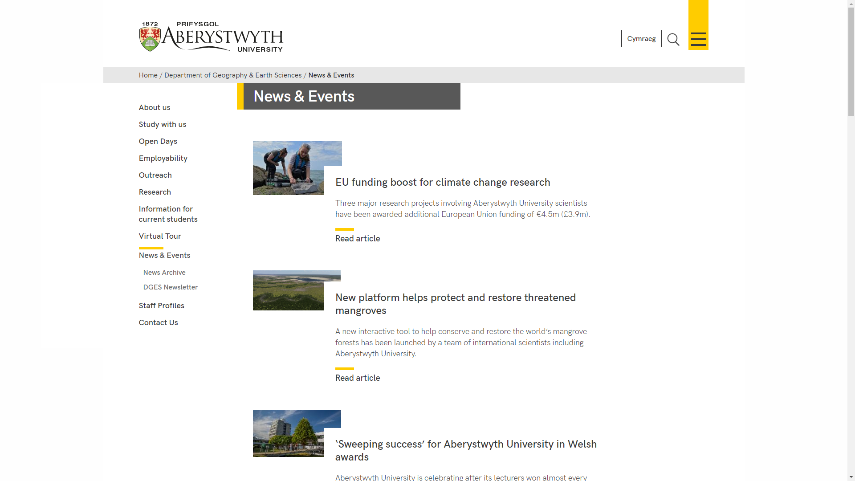

A link to a News Archive section will also be displayed at the bottom of the News & Events section.

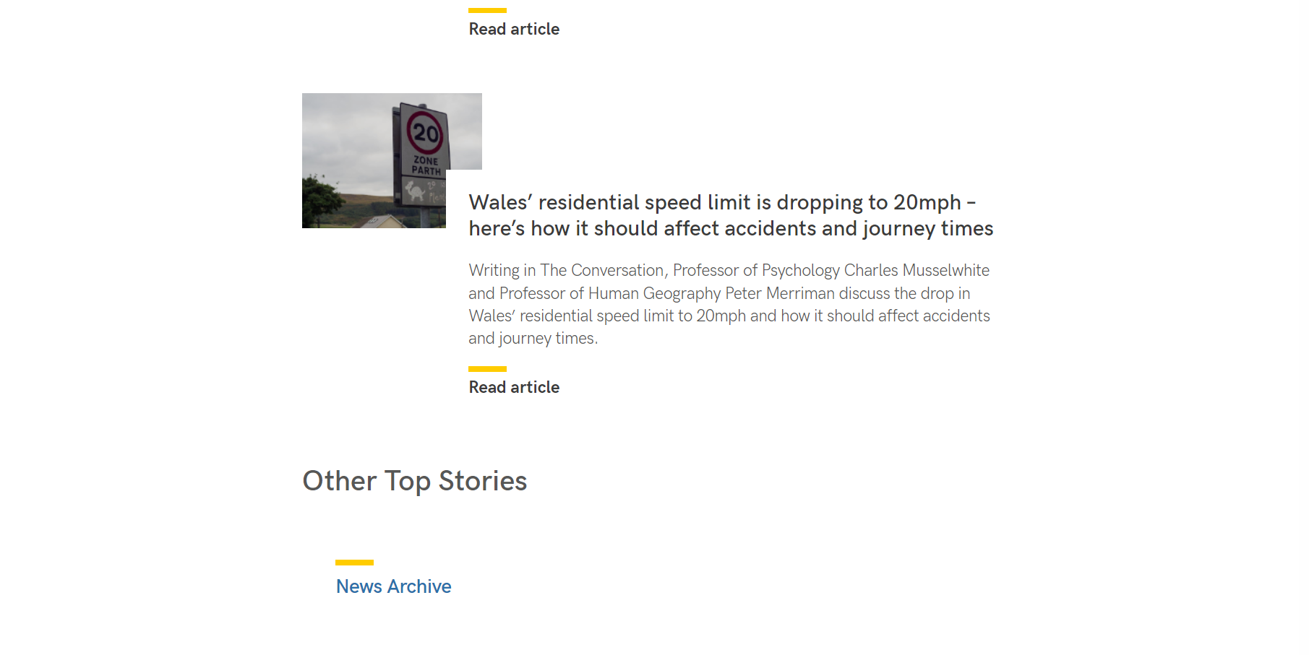

The News Archive section will also include images and abstracts from archive news stories:

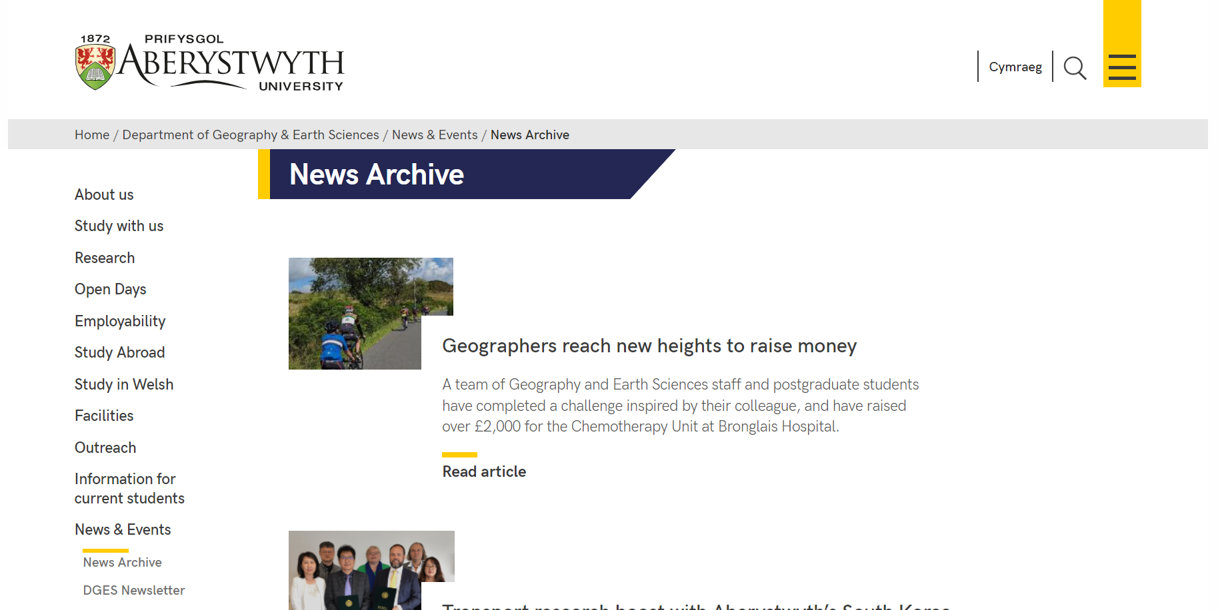

Standard display for news articles.

Top:

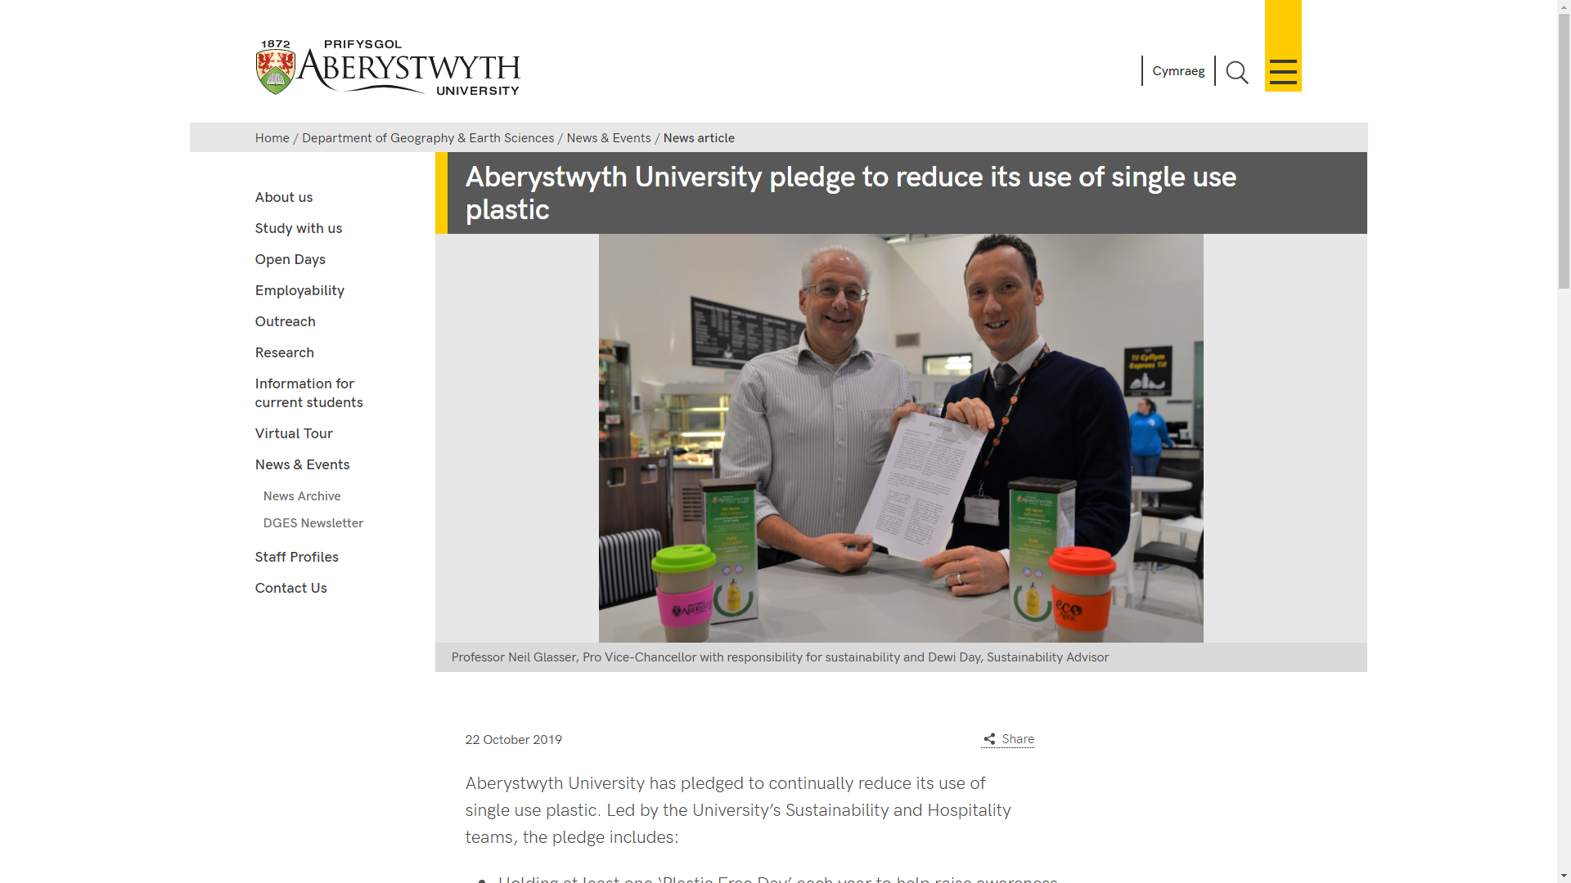

Bottom:

## Screenshot of the bottom of a news article page

## Mirrored News Content

The University’s Communications and Publications and Public Affairs Team will mirror news content published on the University News webpages (<https://www.aber.ac.uk/en/news/>) so that stories also appear on the Departmental News pages of the relevant areas.

These will be identified by the following symbol:

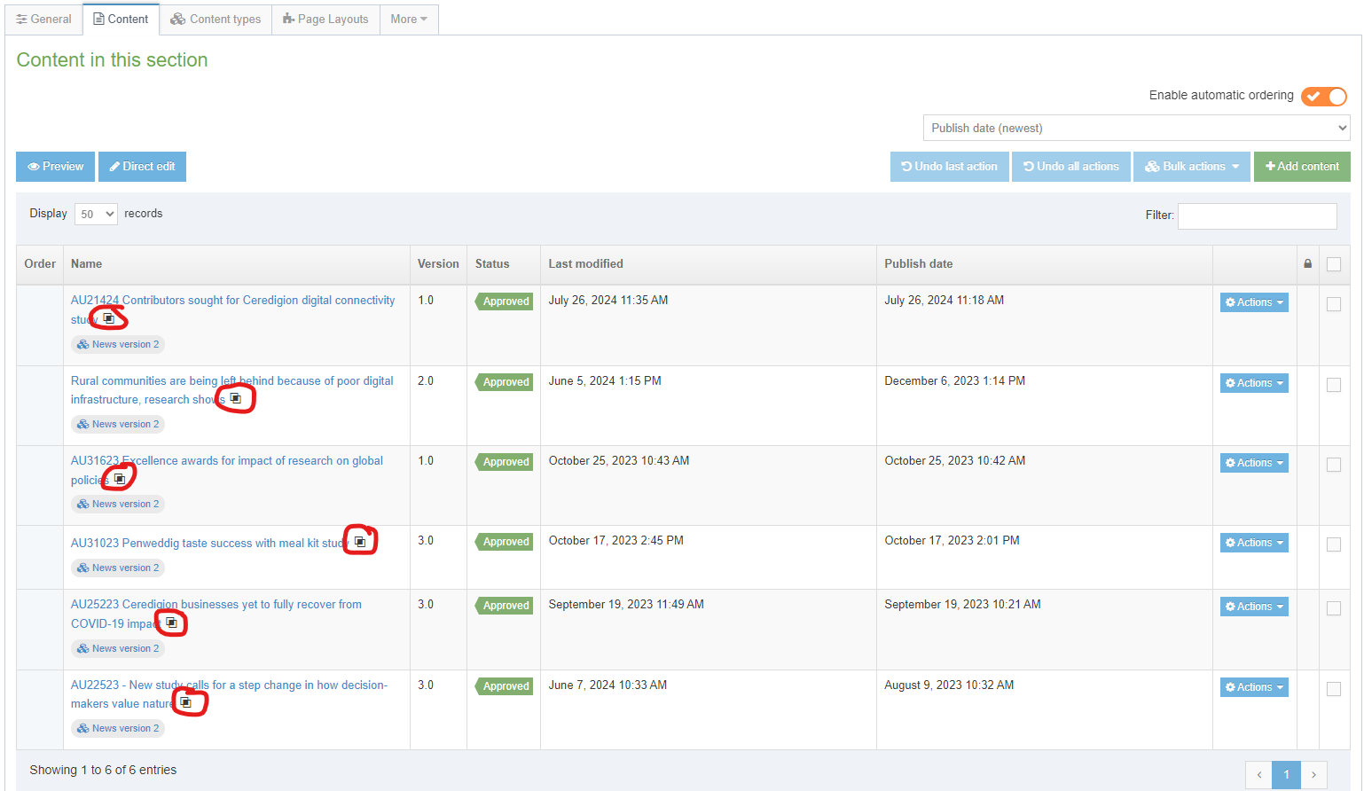

Hovering your cursor on the symbol will provide details of the other sections in which the content has been mirrored:

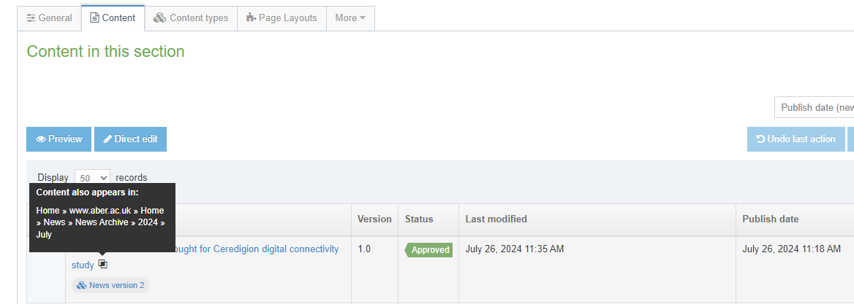

Colleagues are asked to refrain from making changes to mirrored news articles as any changes made will be replicated elsewhere, and to liaise with the Communications and Public Affairs Team if any changes are required to these news articles.

## Creating a News Article

News articles are usually stored in either a section called 'Latest News' (to appear on the ‘News & Events’ page), or ‘Other Stories’ (to appear on the ‘News Archive’ page). These sections will be located within a section called 'News & Events', or something similar.

For most departments this will be one of the top-level sections in your site and appears in the left-hand menu throughout your site.

1. To create a new News Article, find your ‘News and Events’ section in the CMS and expand it to see the sections inside. Open the ‘Latest News’ section by clicking on it.
2. Click on the Content tab and you will see any existing news items listed
3. Click on the Add Content button
4. All departments will now be utilising the more recent news style, therefore please choose the 'News version 2' template. Although other templates are broadly similar with some minor differences, ‘News version 2’ is considered the most appropriate to ensure consistency across all news pages.
5. The template will appear
   1. The more recent 'News version 2' template:

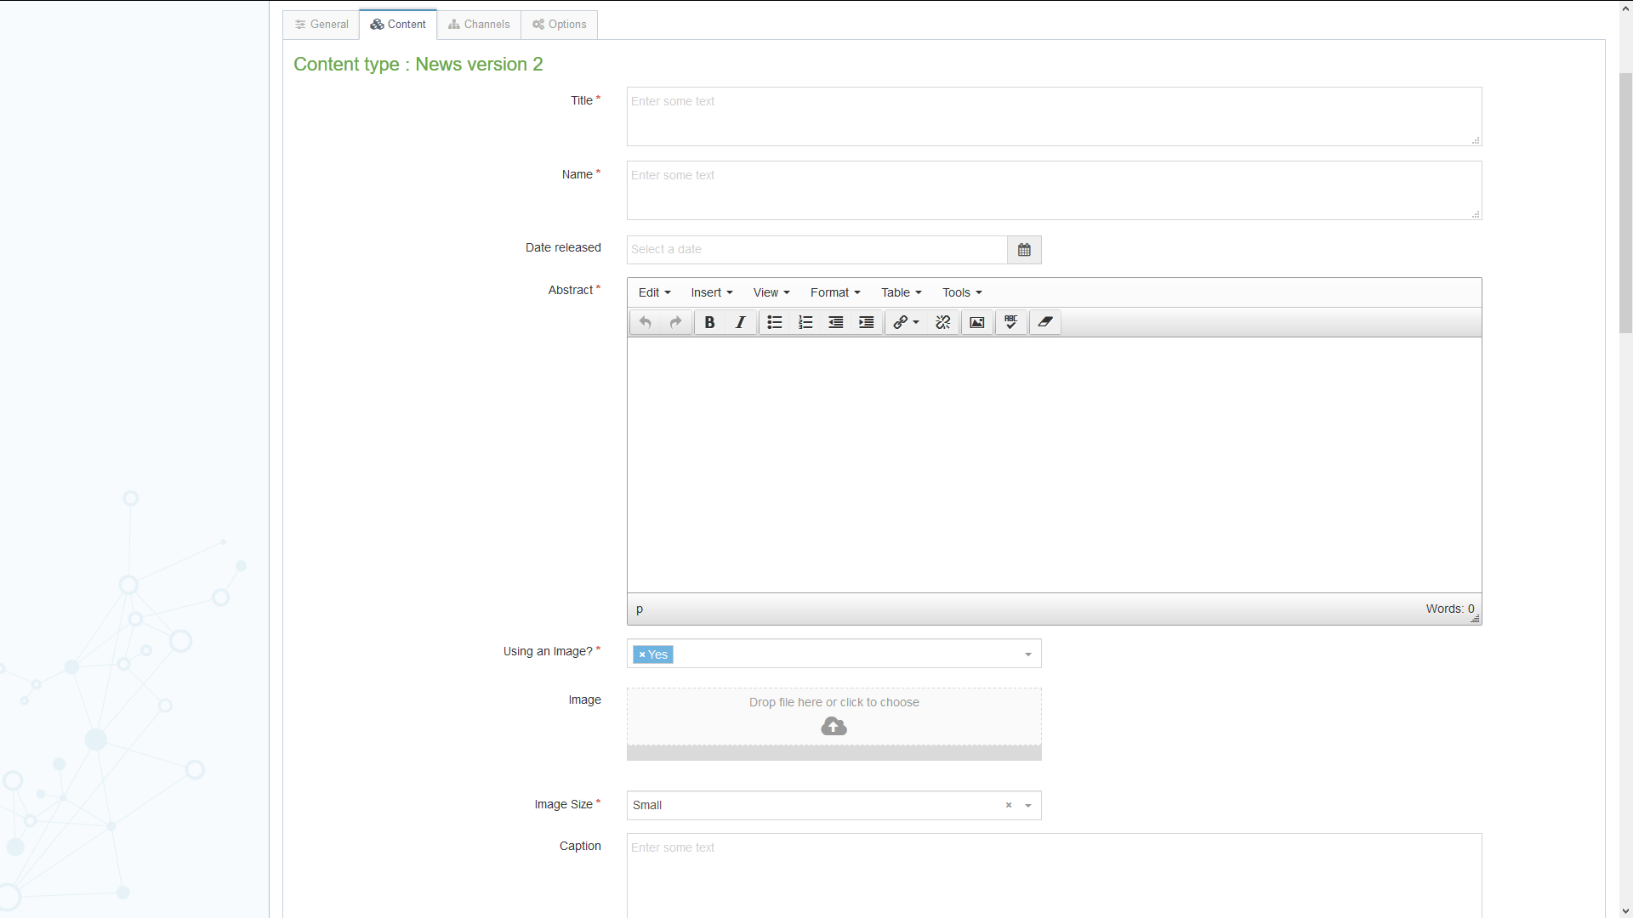

1. Fill in as many fields as you have information for – some are essential, and others are optional:
   1. **Title** (*essential*) – this is the main headline of the news item.
   2. **Name** (*essential*) – this is the name of the piece of content and doesn’t show up for people viewing the web page – it’s just for you and your colleagues to know what this piece of content is.
   3. **Date released** – this is filled in for you automatically with the current date and time – if the news article is to be released on a future date rather than immediately, change this date. It will appear under the headline when the news article is viewed. *Changing this date will* ***not*** *affect when the news article shows up on the web site – this is done by another mechanism – see point 7 for more information*.
   4. **Abstract** (*essential*) – this is a brief summary of what the news article contains – it will appear on the main News section.
   5. **Use an image?** (*essential)* - this needs to be set as Yes if you wish to use an image in your news article, otherwise your image will not be displayed. If you are not using an image, set it to No.
   6. **Image** (*recommended)* – this is where you can upload an image to go with the news article. Click on the box to choose an image from your computer or drag an image onto the box to select it. You can use an image up to 1140 x 500 px.
   7. **Image Size** (*essential*) - this is where you specify what size image you have chosen to use above. 200px = smaller, 400px = small, 800px=big.
   8. **Caption** – this is the caption to go with the image – it will become the alternative text for the image and will also show beneath the image when the full article is viewed.
   9. **Full text** (*essential*) – this is the main text of the news article.
   10. **YouTube Video Code –** this is where you can embed a YouTube video within the news article if you want to. You will just need to enter the last part of the YouTube video address Just the last part e.g. just "kktMqrMioY0" from https://www.youtube.com/watch?v=kktMqrMioY0
   11. **Full text part 2** – this is where you can continue the main text of the news article if you would like the YouTube video to be positioned in the middle of the story rather than at the end of the story.
   12. **Links** – this is where you can place any links related to the article – these will be placed at the bottom part of the article. You should use a bulleted list for the links, and they should be text links – i.e. don’t just type in the URL of web site.
   13. **Contacts** – this is a list of any specific contacts for this news article – you will already have your general contact block appearing on the left under the menu, so you will only need to use the contacts if they are different or more specific. The contacts appear on the bottom of the page when the article is viewed.
   14. **News code** – this is used if you have a coding system for your news articles and want to record that.
   15. **Add to AU Homepage?** - this is only used for the university's central news pages. It marks the news article to be displayed on the university homepage.
2. The news item will not yet show up anywhere on your site even on preview in the CMS as the release date needs to be set. As mentioned previously the ‘Date released’ field in the news template is only used to *display* a date on the page – to set the date at which the news shows up on the page, we need to use the options tab:
   1. Click on the Options tab – you’ll now see the 'Content embargo and expiry information' page.
   2. Enter the date and time when the news article should be released in the Publish Date boxes.
   3. If required, enter the expiry and review dates and select an archive section.
3. Click on the 'Save changes' button to finish. You will be returned to the list of content in the News article section.
4. If you now preview the News section of your site, you should see your new News Article appearing at the top of the list (unless you set the publish date in the past, before other article’s publish dates)

## Reorganising / Archiving Your News

When adding new items, you will find that older items will get dropped off the list shown on the ‘News and Events’ page as it only shows the 10 most recent items. If you want items to still show up on the news pages, you can move them to a different CMS section so they will appear on the ‘News Archive’ page.

1. Open the ‘Latest News’ section for editing and click on the Content tab
2. Find the news item which has dropped off the list (they should be automatically ordered by publish date) and choose Move from the Actions menu (accessed from the Actions button to the right of the news item)
3. The 'Move content' screen will be displayed – click on the ’Other Stories’ section which should be inside the ‘News and Events’ section (along with the ‘Latest News’ section)
4. You will be returned to the list of content in the ‘Latest News’ section with a success message at the bottom. You will see that the news item you moved is no longer in this list
5. If you now preview the News section of your site, you should see the moved news article appearing on the ’News Archive’ page.