CMS Training: Contributor
  - 15 May 2023

Exercises
For each exercise there is a basic part and an advanced part. Basic parts should be completed by everyone attending the course. Advanced parts are optional and can be completed if you finish the basic parts. You might also consider working through the advanced parts in your own time after the training session.
Contents
CMS Training: Contributor 1
Exercises 1
Exercise 1 – Preparation 3
A. Find your Media Library category 3
B. Find an Image 5
C. Upload your Image 6
D. Create a Variant of your image 7
E. Prepare a PDF file (Advanced) 10
Exercise 2 – Adding the main text of the page 11
A. Add General Content 11
B. Insert a Table 14
C. Insert Links 16
D. Insert Image 20
E. Insert PDF file 22
F. Add Related Links to your page (Advanced) 23
Exercise 3 – Adding Contact Details & Meta Data 24
A. Add Contact Details 25
B. Add Meta Data 27
C. Add extra text to your page by Mirroring & reorder the text in the page (Advanced) 29
Exercise 4 – Welsh 30
A. Create a Welsh version of your general content 30
B. Create Welsh versions of your other content (Advanced) 32

Exercise 1 – Preparation
Basic (A-D): Prepare for your new page by uploading a photo to the Media Library and creating a variant.
Advanced (E): Find and upload a PDF file to the Media Library.

Find your Media Library category
- Open the CMS by opening a browser and typing cms.aber.ac.uk into the address bar. Log in using your usual username and password.
- Click on the Content menu on the left of the screen and select Media Library.
- Expand the 'Categorised' category on the left of the Media library by clicking on the plus sign next to it so that you can see the Training category within it.
- Expand the Training category.

- Scroll down to find the appropriate year and month, then find the sub-category with your name on it and expand it.
- Click on the Images sub-category.

Find an Image
- Open a new tab in your browser (shortcut is ctrl+t).
- Type this address: www.aber.ac.uk/cmstraining.
- Right click on the image you would like to use and choose ‘Save Image As’
- Save the image on the PC you are using (e.g. on the desktop) so that you can find it in a moment.
- Close the tab and return to your T4 tab.

Upload your Image
- Click on the Add Media button at the top right of the page.
- The General Media Information screen opens:
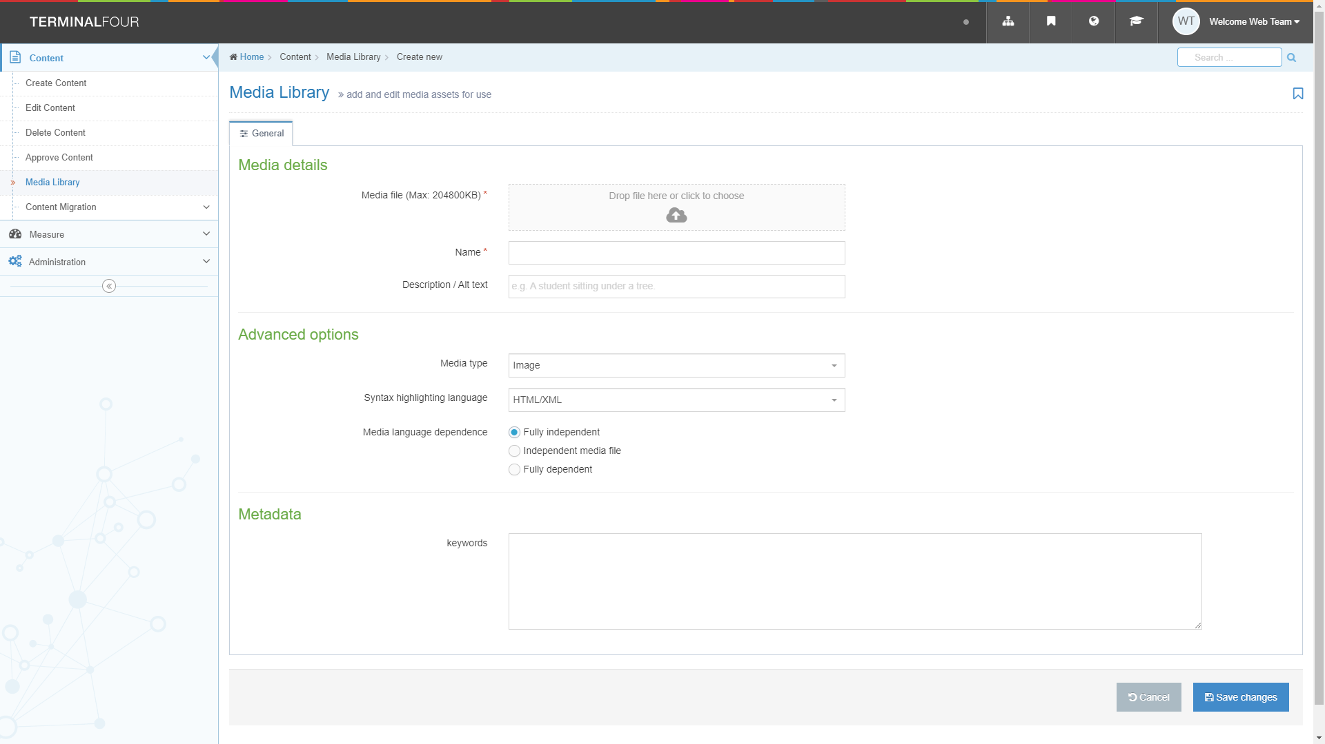
- Click on the grey box next to ‘Media file’ and find the image that you downloaded. Click on the Open button.
- Leave the Media type set to ‘Image’.
- Type a name for the image in the Name box – this could be the image’s filename.
- Click the ‘Save changes’ button to finish.

Create a Variant of your image
- Click on the ‘Actions’ button to the right of your image and choose ‘Variants’ from the menu that appears:
- The ‘Media variants’ screen appears:
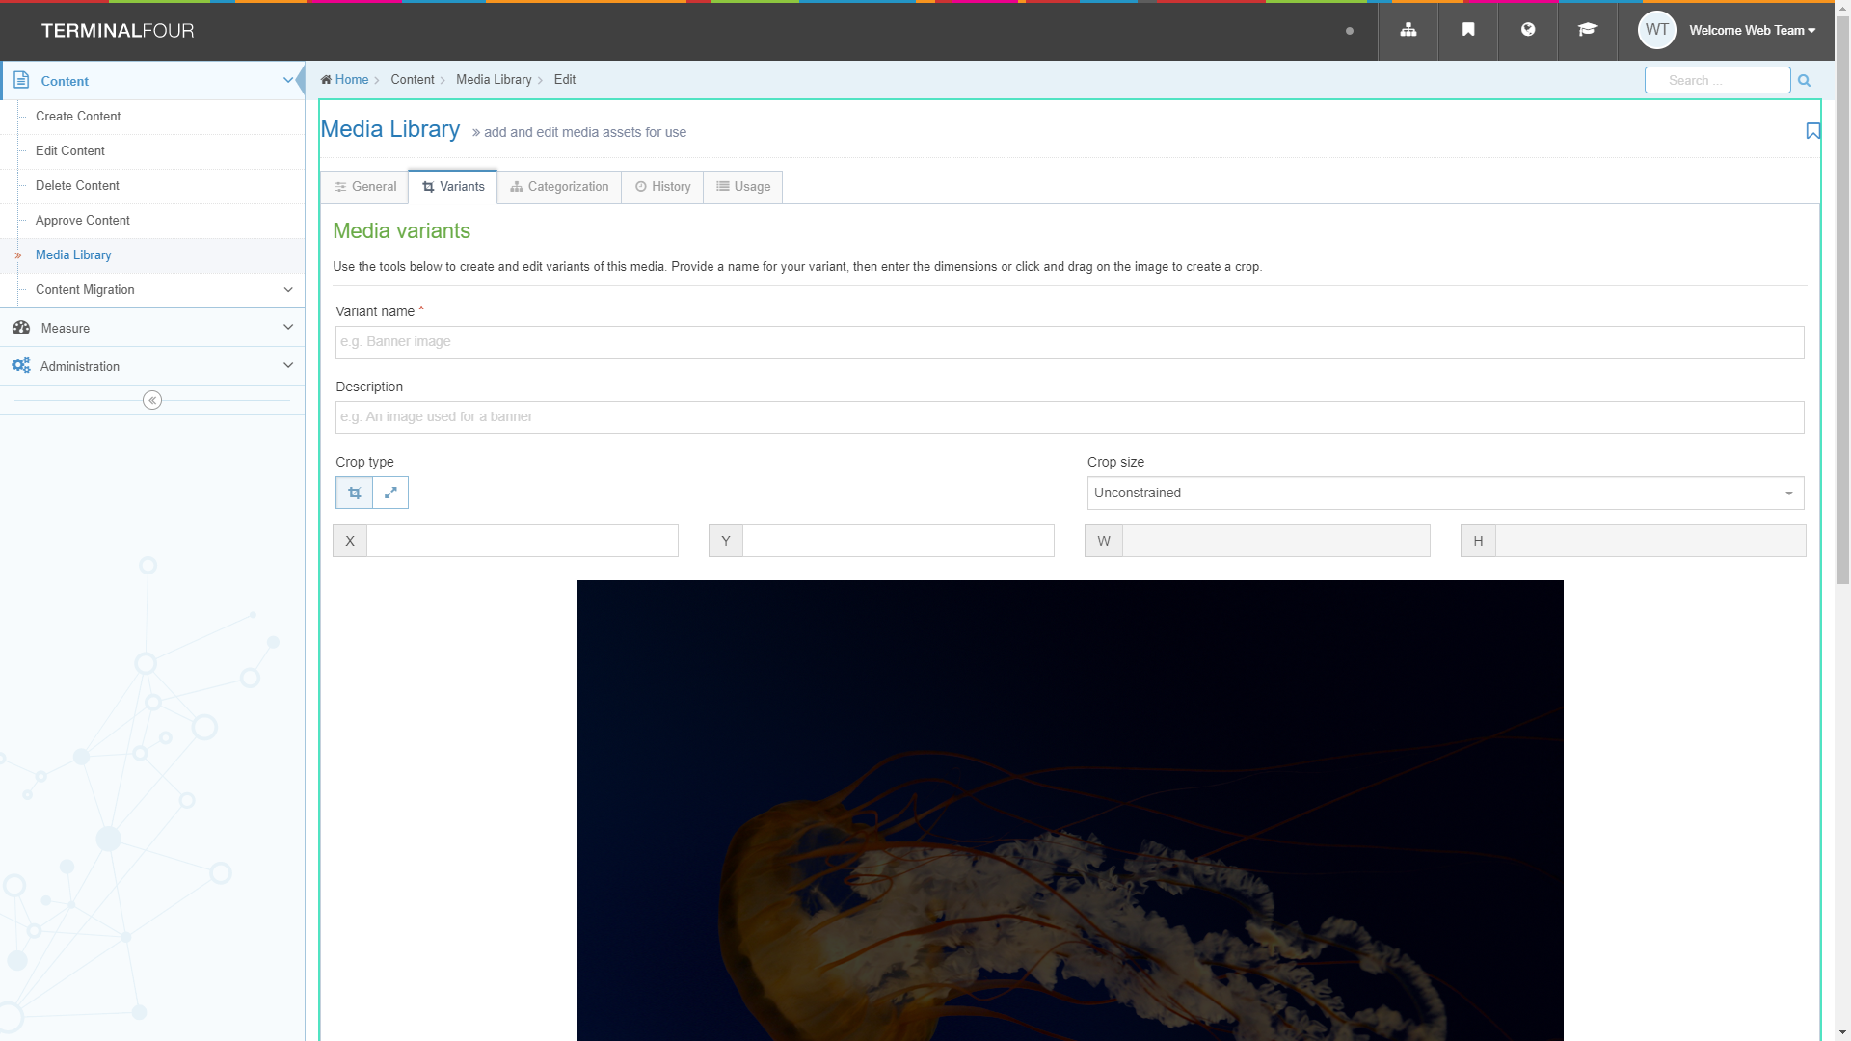

- Click on the Resize button to switch to Resize mode:
- Create a variant of the image that is a sensible size for a web page by checking that the ‘Maintain aspect ratio’ box is ticked, and then typing 300 in the W box. As you type the height (H box) will change automatically to keep the image in proportion.
- Click into the ‘Variant name’ box and name your new variant (e.g. Tulips-300).
- Scroll down beneath the image and click the ‘Save variant’ button.

- Your new variant should appear at the bottom of the screen in the ‘Existing variants’ area:
- Scroll up and click ‘Media Library’ in the Content menu on the left of the screen to return to the Media Library.

Useful Tips:
You could create more than one variant of an image to be used in different locations. You can also crop an image to only use part of it.

Prepare a PDF file (Advanced)
Find a PDF or Word file on your PC that you wish to use in your page and make a note of where it is located. If you don’t have one, visit a website to find one and save it to your PC.
Based on the principles in the steps above, upload your PDF into your category of the Media Library. Note: When uploading a PDF, it is important to include a Description – this will be used as the link text for the PDF when you insert it into your page.

Exercise 2 – Adding the main text of the page
Basic (A-E): Add a piece of General Content to your section; do basic formatting, add a table, links, an image and a link to a PDF or Word file.
Advanced (F): Add Related Links to your page.

Add General Content
- Return to the Site Structure by clicking on Site Structure symbol in the menu at the top right of the screen:
- Expand the section with your name on it by clicking on the plus sign to the left of it.
- Click on your About Me section.
- Click on the Content tab.
- Click on ‘Add Content’ on the top right of the page 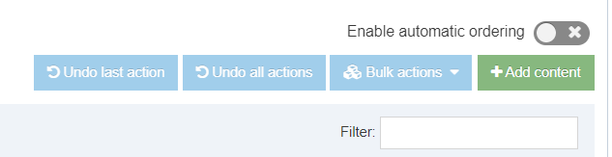
- Click on the template named ‘General Content’ – the General Content template appears.
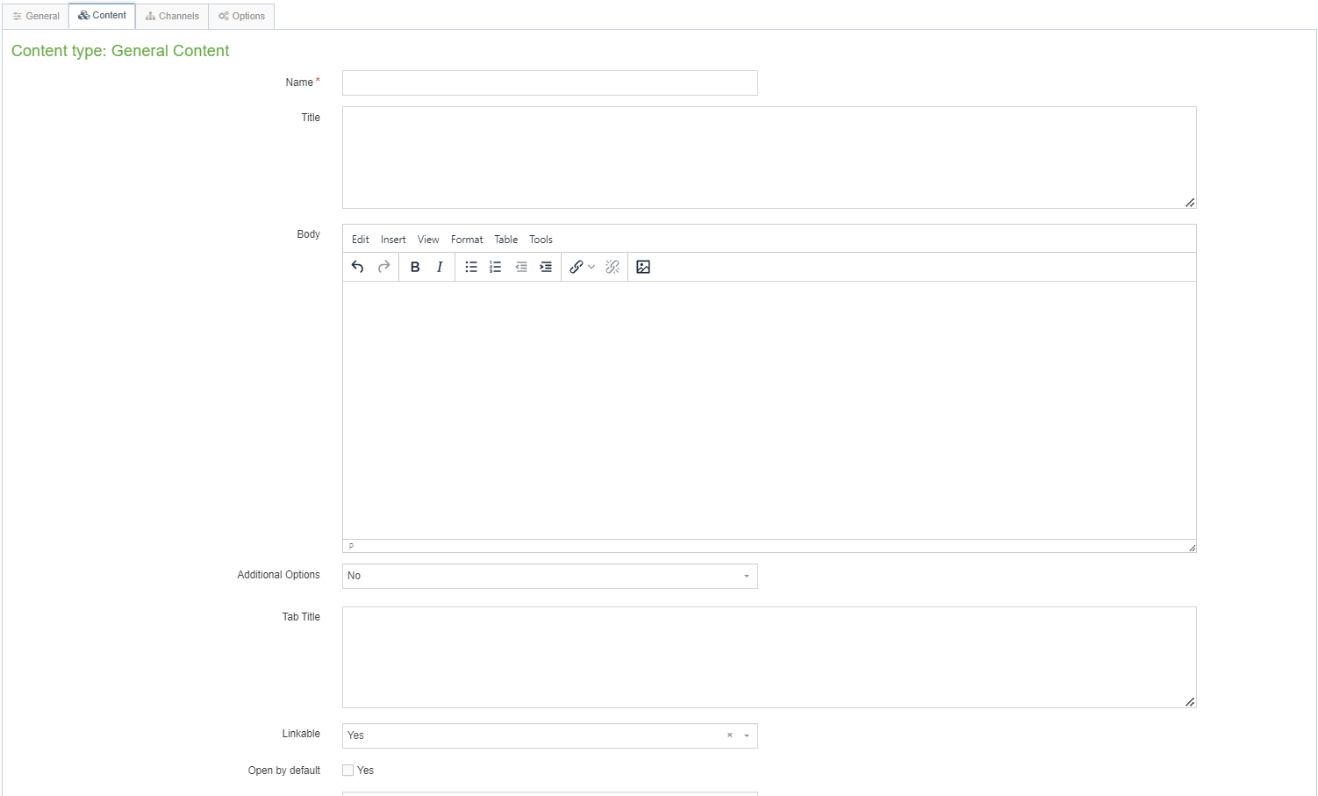
- Type a name for this piece of content in the Name box (e.g. About Me General Content).
- Type the main heading of the page into the Title box (e.g. About Me).
- Type some text into the Body box.
- Create a Heading 2, a bulleted list, and some bold and italic text:
  - Heading 2: Type the text for your heading, then select it and click on the Format menu. Put your mouse over Formats, then in the 2nd menu put your mouse over Formats, then Headings, and choose Heading 2
  - Bulleted List: Click on the bullet list button, and start typing your list.
  - Bold: Select the text and click on the B button.
  - Italic: Select the text and click on the I button.
- Click ‘Save changes’ to save your work.

- Preview your page:
- Return to the Site Structure by clicking on the Site Structure symbol at the top of the screen.
- Click on the ‘Actions’ button to the right of your About Me section and choose ‘Preview section’ from the menu that appears.
- The preview of the page will open in a new tab – leave the tab open when you’ve finished looking at the preview so that you can reuse it later as you continue working on the page.

Useful Tips:
If the preview doesn’t appear, check at the top of your browser for any messages blocking popups.

Insert a Table
- Return to your newly added content by clicking on the section name, clicking on the Content tab, then clicking on the piece of content.
- Create a blank line where you wish your table to be created and place your cursor in the line.
- Click on the Table menu, choose either 'Insert table with column headings' or 'Insert table with column and row headings' (as required) and select the number of cells you need by moving your mouse across the grid:
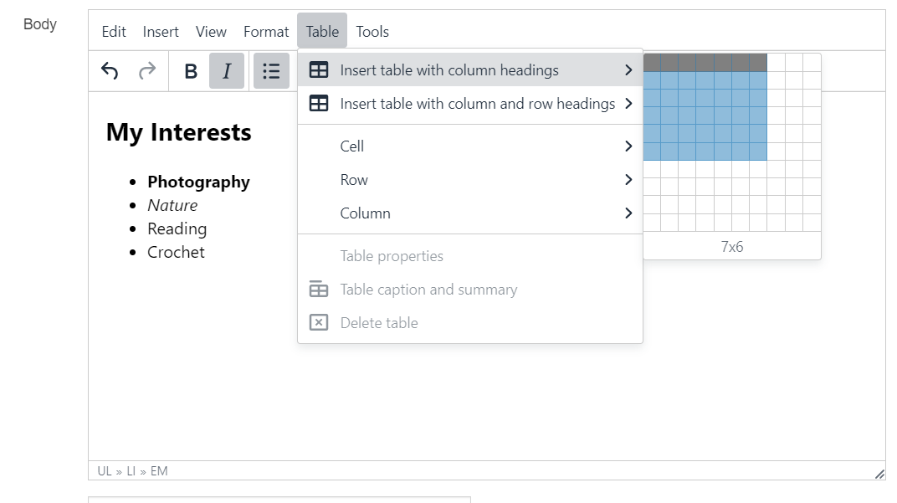
- The table will appear in the editor window. The headers will be pre-filled with text so you can see them clearly:
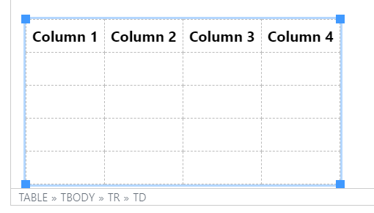
- Click into the table and replace the default headings with your own text.
- Click in each cell of the rest of the table and enter the data.
- Add an extra row to the table by placing your mouse in the last row, clicking the Table menu and choosing Row > Insert row after (alternatively you can right click in the last row and choose Row > Insert row after).
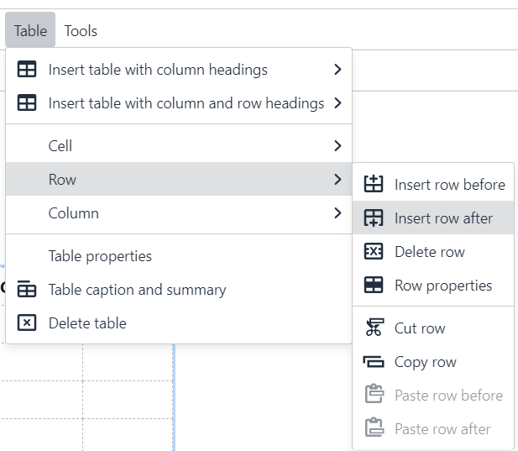
- Click 'Save changes' to save your work.
- Return to your preview tab from the end of part A and click refresh () or press the F5 key – view your new table in your page.

Useful Tips:
When you create a table it will look very small at first – it will stretch as you start to type in it. Don’t be tempted to make it wider by dragging out the edges.
All tables should have a header row or a header row and a header column.

Insert Links
- Return to your content by clicking on it.
- Type some text to be used as the link text for your internal link (i.e. a link to an Aberystwyth University page that is held in the CMS).
- Select the text, click on the Insert/Edit Link icon and choose ‘Insert section link’
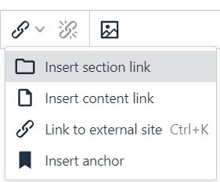
- The 'Select section' pop-up appears:
- Expand the www.aber.ac.uk folder, and then expand the Home folder within it.
- Pick a section of the website to link to and click on the section’s name.
- Your internal link has now been created.
- Type some text to be used as the link text for your external link (i.e. a link to an external web site, or an Aberystwyth University page that is not yet held in the CMS).
- Select the text, click on the Insert/Edit Link icon and choose ‘Link to external site’
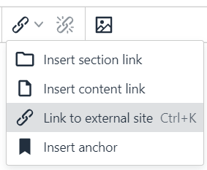
- Type (or paste) the web address of a web page or web site that is not in the University’s CMS (e.g. http://www.bbc.co.uk/) into the ‘Url’ box.
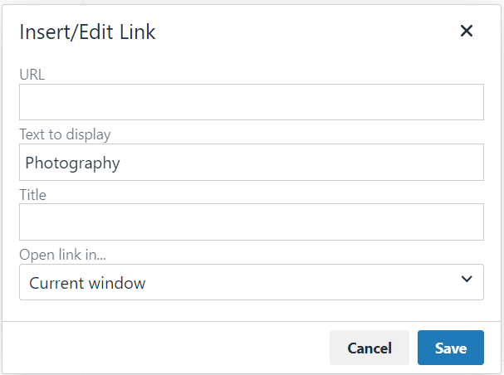
- Click Save to save.
- Your external link has now been created.
- Click 'Save changes' in the main content editor window to save your work.
- Return to your preview tab from the end of part A and refresh the page – view your new links in your page.

Useful Tips:
Link text should be 'friendly' - this means it should be self-explanatory and the user should know where the link is taking them, even if they could only see the link text, and none of the text around it.
When choosing a section to link to in an internal link, be careful not to click on the name of the section while browsing through the site structure – only click on the + signs to expand sections and look inside them.
For external links make sure to include the http:// or https:// part of the web address. The CMS may try to help you if your web address begins with www, and add the http:// for you, but not all web addresses begin this way so you shouldn't rely on the CMS to fix up your link.

Insert Image
- Return to your content by clicking on it.
- Place your mouse cursor in the line on your page where you want your image to be.
- Click the Insert file link or image button
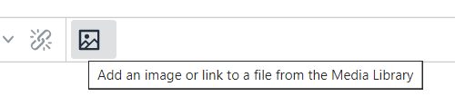
- Find your images sub-category in the Training area and click on it.
- Click on the name of the photo you uploaded earlier.
- Pick the variant you created earlier by clicking on its name.
- The image will now appear in your content editor window.
- Double click on the image and the 'Set media attributes' window will pop up.
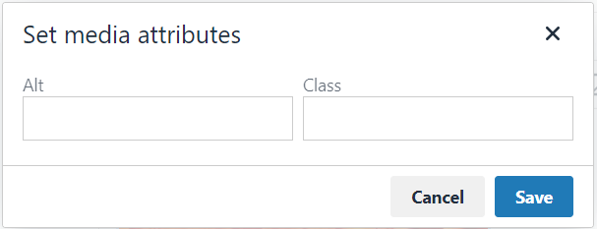
- Type a brief description of the image in the alt box.
- If required, you may choose how you would like to position your image. To position it on the left with the text flowing round it, type float-left in the class box. If you want your image to be in line with the text, type float-none in the class box. To centre the image, type centre in the class box.
- Click Save to save your changes.
- Click 'Save changes' in the main content editor window to save your work.
- Return to your preview tab from the end of part A and refresh the page – view your new image in your page.
Useful Tips:
The default position of images is on the right of the page with text flowing round it. If you are happy with this there is no need to type anything in the class box.
When you make changes to the class box in the image’s media attributes, you will not be able to see any difference to the image in the editor. You can only see the effect of these changes when previewing your page.
Alt text is very important and should always be added for every image. It allows users who can’t see the image (for whatever reason) to still get a feel for how the page looks.

Insert PDF file
- Return to your content by clicking on it.
- Place your mouse in the position where you would like to insert your link to a PDF file.
- Click on the Insert file link or image button.
- Find the PDF sub-category within the main Training category, and click on it.
Note: If you created your own PDF category in Exercise 1E, you should find and click on this category
- Check that the PDF you want to use has Alt/Description text under its name.
- Insert the PDF by clicking on its name.
- You will now see the description text appearing in your content, linking to the PDF.
- Click 'Save changes' in the main content editor window to save your work.
- Return to your preview tab from the end of part A and refresh the page – view your new PDF link in your page.

Useful Tips:
You can only insert a PDF file if it has text in the description box – the CMS uses this text as the link text for this PDF.
Remember that the best place for content is in a web page – only use PDFs where necessary (e.g. for long text, or items that the user will need to print out and fill in).

Add Related Links to your page (Advanced)
Now you have learnt the basic skills of creating and editing content, you can create and edit other types of content.
Use the principles learned in Exercise 2A to create a piece of Related Links content.
Note: when creating your Related Links, you should use a bulleted list in the Links box so that the links you choose are styled correctly. Links are created in the same way as in Exercise 2C.

Exercise 3 – Adding Contact Details & Meta Data
Basic (A-B): Add Contact Details and Meta Data to your page by Duplicating and Mirroring existing pieces of content into your new section.
Advanced (C): Add extra text to your page by Mirroring & reorder the text in the page

Duplicating content creates a copy that can then be amended. You can use it to create a page with a similar layout, or to add metadata which is similar across various pages.
Mirroring content creates an identical linked copy of the content. You can use it to display the same content in different places without the risk of the content falling out of sync. When any of the mirrored items are edited, the changes will appear everywhere the content is mirrored. Mirroring is commonly used for things like contact blocks that are the same across many pages.

Add Contact Details
- In the "mini site structure" (to the left of the content list), click on your main section (the section named after you – e.g. Suzy Shipman).
- Click on the Content tab to view the content in this section.
- Click on the Actions button to the right of the piece of content called “Training Contact” and select 'Mirror' from the menu that appears.
- The “Mirror content” pop-up will appear: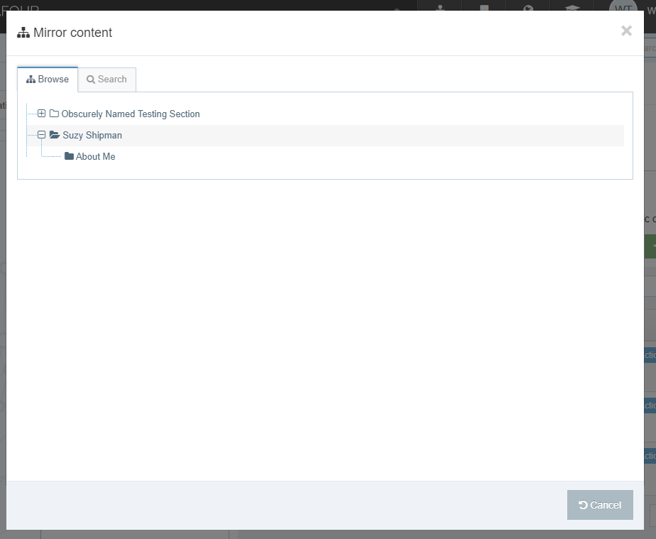
- Click on your About Me section.
- The content has now been mirrored.

Useful Tips:
After you have chosen the section you wish to place your mirrored content into, you will be returned to the section that you were mirroring from.
As the contact details are mirrored, any edits made will also be made in all the other mirrored versions of this content. The symbol in the content listing () reminds you that this content is mirrored – be careful when you see this on other content so that you don’t accidentally edit content that appears in other pages.

Add Meta Data
- Click on the Actions button to the right of the piece of content called “training metadata” and select Duplicate from the menu that appears.
- The “Duplicate content” pop-up will appear:
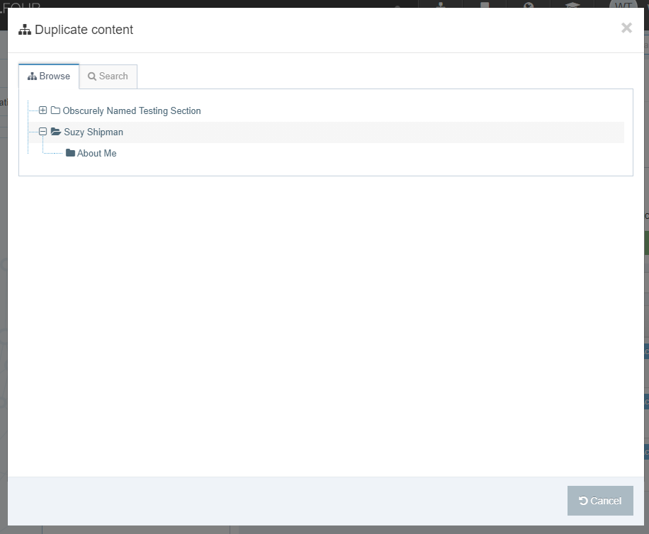
- Click on your About Me section.
- The content has now been duplicated.
- In the "mini site structure" (to the left of the content list), click on your About Me section.
- Click on the Content tab.
- You should now be able to see the training contact and training metadata listed.
- Click on the training metadata to modify it.
- Edit the Meta Authors box with your own name.
- Edit the description to make it specific to your page in the Meta Description box.
- Edit the keywords to make them specific to your page in the Meta Keywords box.
- Click 'Save Changes' to save your work.

Useful Tips:
After you have chosen the section you wish to place your duplicated content into, you will be returned to the section that you were duplicating from.
Metadata is not seen on the page but is hidden behind the scenes – it’s used by Search Engines.

Add extra text to your page by Mirroring & reorder the text in the page (Advanced)
Using a similar process to that detailed in 3A 1-4, mirror the “training content” from your main section into your About Me section. Now change the order of the content in your About Me section so that this one (training content) will appear first on the page - look at the list of content and click and drag items by clicking on the move icon in the Order column on the left. Position training content at the top above the other content. Check your preview to see how the text on the page has moved.

Exercise 4 – Welsh
Basic (A): Create a Welsh version of your General Content
Advanced (B): Create Welsh versions of your other content

Create a Welsh version of your general content
- Return to the Site Structure by clicking on the Site Structure symbol in the menu at the top right of the screen.
- Click on the language change button (top of the page) and select Cymraeg.
- Click on the Amdanaf I section.
- Click on the Content tab.
- Click on the content marked as 'Not translated'.
- Give the content a name, a Welsh title and some Welsh text in the body.
- Click on 'Save changes' to finish.

Useful Tips:
If your page has a lot of formatting, you can swap language while you have the content open, so that you can copy the English Body and paste it into your Welsh version. This should only be done when you have the Welsh text ready.
It’s important to remember that when editing the Welsh version of a piece of content for real there should never be English text in it – for this training session it’s acceptable to have something like “Welsh text here” but never do this on real pages.
If you move your mouse over the words Not translated in the list of content you will see what the content is called in English. This is particularly useful if there is more than one piece of content marked as Not translated.

Create Welsh versions of your other content (Advanced)
Using a similar process to that detailed in 4A, modify all of your pieces of content so that they have Welsh versions. If you completed all the advanced exercises you should have 2 additional pieces of content marked as Not translated – these will be your Meta Data and Related Links.

Training Evaluation Form:
https://www.aber.ac.uk/en/is/it-services/web/training-evaluation/

