Remote Desktop Connection Settings for Teams
- Start Remote Desktop
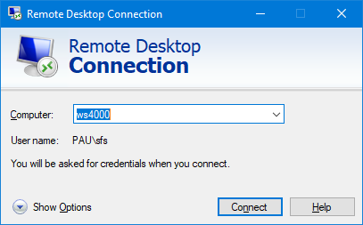
- Click on the Show Options button in the bottom left corner.
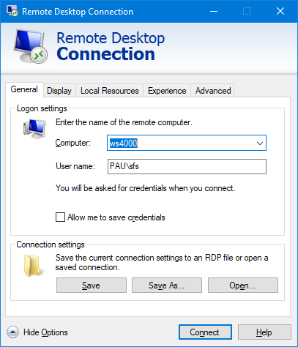
- Click on the Local Resources tab.
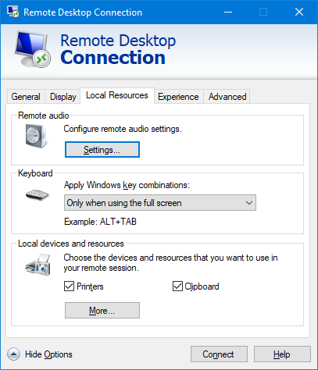
- Click the Settings button under Remote Audio.
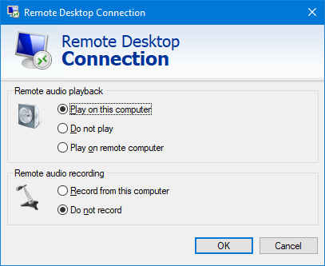
- Click on ‘Record from this computer’ to select it.
- Click OK to continue.
- At the bottom of the Local Resources tab, click on the ‘More’ button.
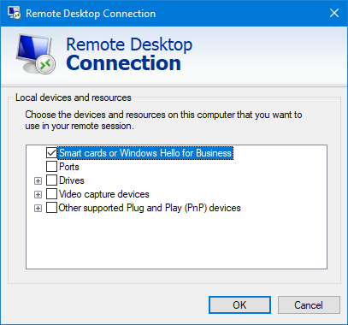
- Tick the box for ‘Video capture devices’.
- Click OK to continue.
- At the bottom of the tab, click on the Connect button to connect to your remote PC using these new settings.
- If you are asked ‘Do you trust this remote connection?’ check that the ‘Remote computer’ name is correct and click Connect to continue.

Note:
If Teams is already running on your work PC, close it fully and then restart it so that it will be able to use your local devices. Closing the window doesn’t close it fully, you’ll need to right click on the Teams icon in the system tray (bottom right corner of your desktop) and choose Quit from the menu. Restart Teams in your usual way.

