Initial Teacher Education Black, Asian and Minority Ethnic Recruitment Plan
The Initial Teacher Education Black Asian and Minority Ethnic Recruitment Plan sets out the actions that we have identified as being deliverable in the short term to increase the representation of applicants and students of BAME backgrounds on the PGCE course of the Aberystwyth Partnership. This is the first stage as part of a longer-term strategy to ensure that the diversity of the teaching workforce within the partnership more closely reflects the school pupil population of the partnership and of Wales as a whole.

BAME Recruitment Plan
Date  July 2022 | 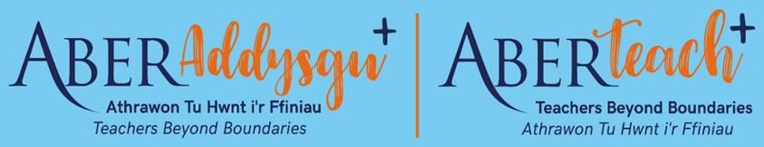
Areas to develop | Actions | Schedule | Progress – Oct 2022
Advertising, marketing, recruitment in addition to usual marketing activities. | Ensure BAME students represented in all  advertising and marketing materials at a  realistic level. | October 2022 | BAME students are currently represented in all  advertising and marketing materials and as  publicity is constantly renewed and  developed this needs to be continuously  reviewed.
 | Include students of BAME backgrounds in  our student profiles on the PGCE website. | November 2022 | Recent former students are being contacted with  a view to developing student profiles that  represent the diversity of our students ensuring  that BAME teachers are represented.
 | Work with Diversity and Inclusion Officer to target undergraduates of BAME backgrounds. | October 2022 | Part of some ongoing work focussing on  recruitment to the course with plans to engage  with students and ensure that the messaging  around teaching for BAME students is positive  and welcoming and is reflected in practice.
 | Direct emails to undergraduate second  and third year students of BAME  backgrounds in October/November to  encourage applications to the PGCE course. | November 2022
 | Emails to all appropriate subject graduates  in June to encourage applications. | June 2023
 | Ensure all rejected applications (prior to  interview) are reviewed by a second tutor  to ensure that diversity of qualification  and experience is noted. | August 2022 | In place. All applications for the PGCE course,  are given a second opinion to ensure that the  decision is appropriate.
 | Where possible include a school-based  mentor teacher of BAME background or  other qualified interviewer of BAME  background. | September 2022 | Aim to recruit BAME teachers from partner  schools to join interview panels and support in  recruitment fairs, Open Days, PGCE events etc
In-course extra support | Emphasise support for learning/improving  Welsh language through tutoring on the  PGCE course, mentoring support in schools  and access to free on-line courses. | September 2022 | Continue to emphasise this aspect of the course,  which was recognised in recent EWC monitoring,  to all potential applicants.
 | Where appropriate in terms of individual  student’s ITE, place BAME students in  schools with greater population diversity  to more reflect the school’s diversity. | October 2022 | Continue to consider school population diversity  as one of the factors when deciding on the most  appropriate placement schools for students.
 | Commit to support students of BAME  background throughout their university  and school placements from an anti racist  point of view. | September 2022 | Ensure all students are aware of wider support  available from placement schools and Aberystwyth  University.
 | Ensure applicants with VISA requirements  have support from the university. | September 2022 | Actively direct applicants to the university’s  Services if appropriate.
Following graduation extra support | Encourage and support BAME PGCE student  teachers in gaining teaching employment  within the partnership/ Wales. | January 2023
General | Seek opinions of current/new BAME students  to review marketing, recruitment processes. | October 2022 | Survey being prepared to seek views of current  BAME students on the application process,  induction and first weeks of the PGCE course.
Awdur/ Author | Daryl Phillips, Sheree Jonas
Dyddiad / Date | 25/07/22 updated 27/10/22

