Fibonacci Sequence

Can you guess what honeybees, a pinecone, the Pyramid of Giza and Parthenon have in common with a number 1.618? We can look for the answer in the work of an Italian mathematician, Leonardo Fibonacci, who discovered a pattern called the Fibonacci sequence. It's a series of numbers that start with 0 and 1, and each number after is found by adding the two previous numbers (0, 1, 1, 2, 3, 5, 8, 13, 21, 34, 55...). The sequence just keeps going on and on.

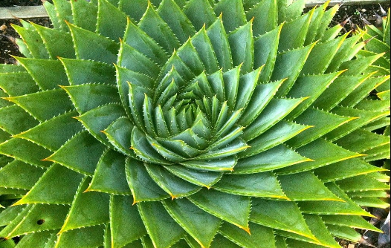
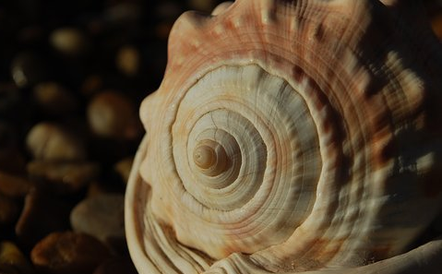
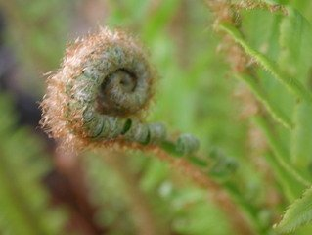
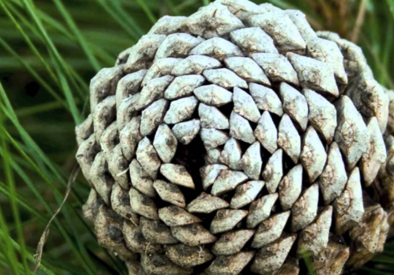
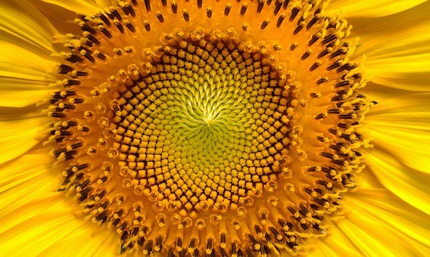
What is interesting, is that these numbers can be easily found in nature. For example, if you count the number of spirals going clockwise and anticlockwise in a pinecone you will notice that these numbers are Fibonacci numbers. The same rule applies to many other plants, like in the arrangement of seeds in sunflowers or scales of pineapples. In many plants, numbers of branches after each branch division also fit into the Fibonacci sequence.

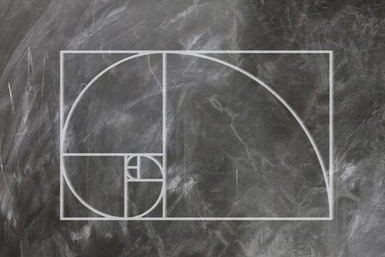

The sequence is often visualised in a graph which you can easily draw yourself. If you draw squares with side lengths equal to the Fibonacci numbers, and you draw the line going through corners of each square you will get The Golden Spiral. The Golden Spiral is a logarithmic spiral, which means it grows bigger as it goes out from the centre. Logarithmic spirals are very common in nature.

The golden ratio exists when a line is divided into two parts and the length of the longer part (a) divided by a smaller part (b) is equal to the sum of (a)+(b) divided by (a). This ratio can be also found when dividing a Fibonacci number by a number previous in the sequence (the bigger the numbers, the closer the approximation). This ratio is denoted by the Greek letter ϕ (phi) and is approximately equal to 1.618.

The golden ratio inspired architects and artists throughout the history and can be found even in the Pyramid of Giza or Parthenon.

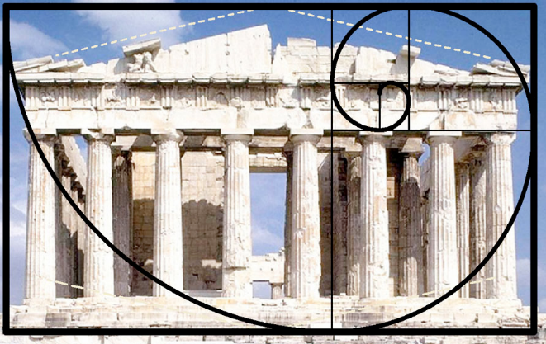
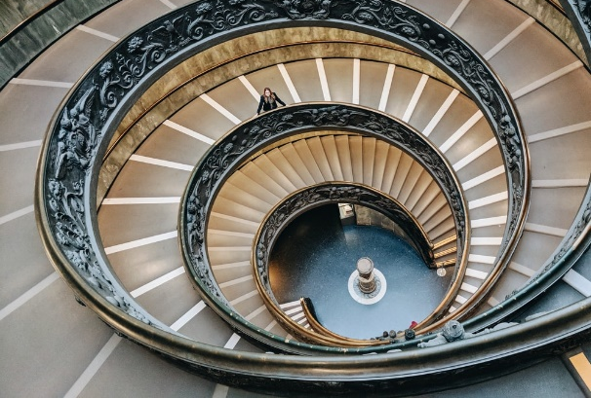

The golden ratio occurs also in honeybees’ colonies. If you divide the number of female bees by the number of male bees, you will get 1.618 – the golden ratio.

The golden angle is another mathematical phenomenon found in nature. The angle, equal approximately to 137.5 is created by sectioning the circle according to the golden ratio. This angle is very important in plants, because they use it develop new leaves. This way, the plant minimizes the overlap of leaves so they can soak up as much sunlight as possible. This pattern is found in many plants, not only in leaf development but also in florets and seeds. Golden ratio and angle allow for the most efficient distribution of seeds and leaves as it minimizes a space between each element.

