Visiting Virtual Worlds: Activity
Dr Helen Miles, Computer Science
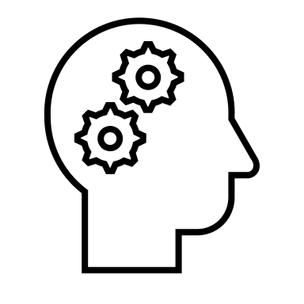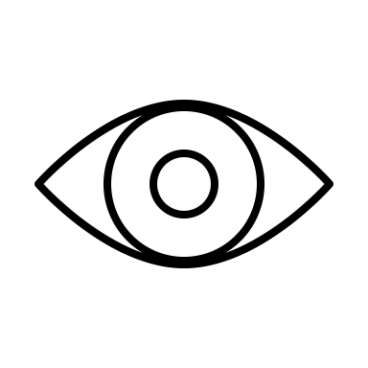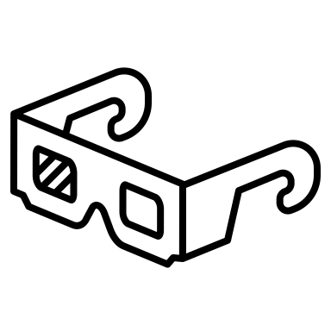
In the video you saw some of the ways our eyes can work out distances, they were all ‘monocular’ methods, meaning they are done only using one eye. With two eyes working together we have another method: ‘Binocular Disparity’, which means that you can use the small distance between your eyes to help you work out distances.
Here’s a short activity to see how this works:
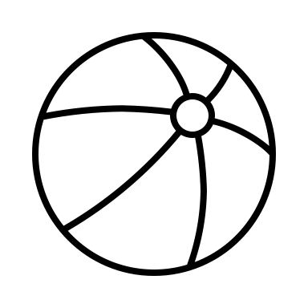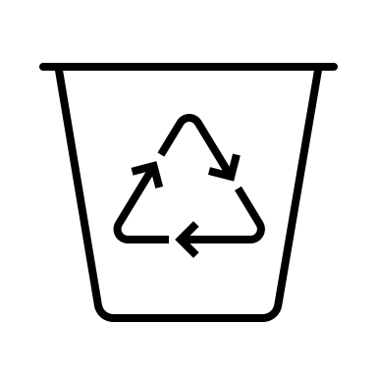 |  | Step 1: Find a small ball and a bucket and go somewhere you have plenty of space to safely throw the ball.
1m |  | Step 2: Place the bucket on the floor and stand about a metre away from it
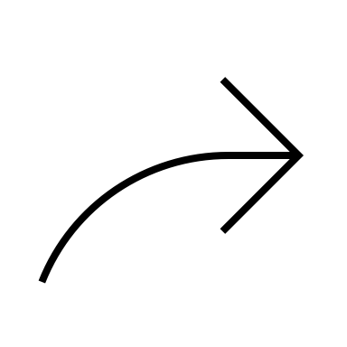 |  | Step 3: With both eyes open, throw the ball into the bucket – it shouldn’t be too difficult to do.
 |  | Step 4: Now step backwards or sideways a couple of steps and close one eye, then try throwing the ball again.
 |  | Step 5: Move a few steps again and switch eyes, then try throwing the ball again. Was it easier with one eye than the other?
 | What happens if you close both eyes, or cover them so you can’t see? Do you think you could still get the ball into the bucket?
 | Ask someone to move the bucket – can you say out loud how far away it is? You might find this difficult to do, that's because it uses a different part of your brain.

