Build a boat and make it go in a straight line

Robot boats use motors to move a rudder at the back which makes the boat turn in the water. If the boat is going in the wrong direction the computer will tell the motor to move the rudder to make the boat go the right way. Using the motor takes energy from the batteries, to use as little battery power as possible we want the boat to sail in a straight line without moving the rudder much.

In this experiment you’ll make a simple sailing boat and add different things to it to make it go in a straight line.

Things you will need

- A plastic drinks bottle, preferably a 500ml one but you could use a bigger one if that’s all you have.
- Sellotape
- string
- a straw or bamboo skewer
- a piece of tissue paper. Ordinary paper will do if you don’t have tissue paper.
- some scissors with a sharp end or a sharp knife
- a freezer with enough space to lay the bottle flat
- somewhere to float the boat, a sink, bathtub or pond will work.

Making the hull

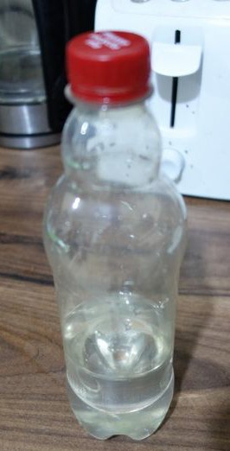
Fill the bottle about 2/5ths full, so if its a 500ml bottle put in 200ml of water.

Lay the bottle flat in a freezer, leave it for a few hours until all the water has frozen. By having it frozen it will stop the water moving around and keep the boat upright.

Installing the mast

Make a small hole about ¾ of the way along the top side of the bottle with some scissors or a knife. This needs to be wide enough to fit the straw in. Be careful not to split the bottle. Insert the straw into the hole you just made.
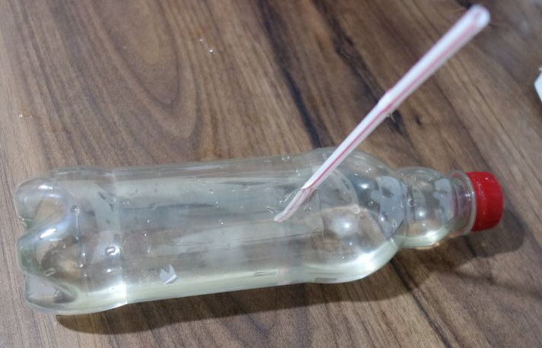
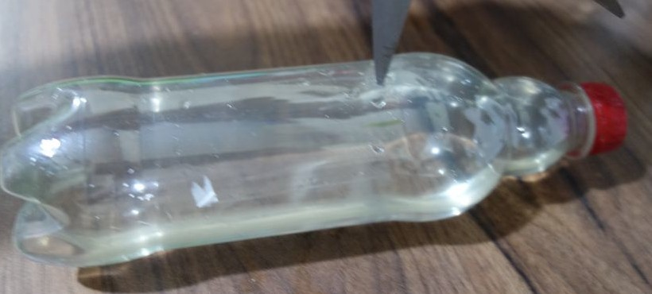

Making the sail

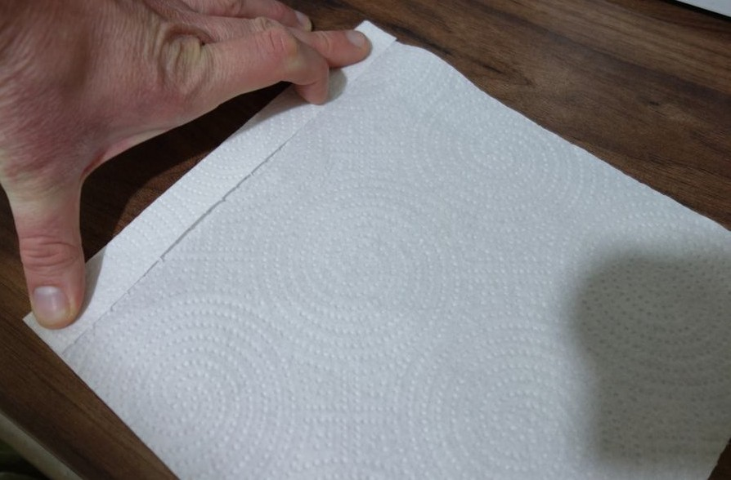
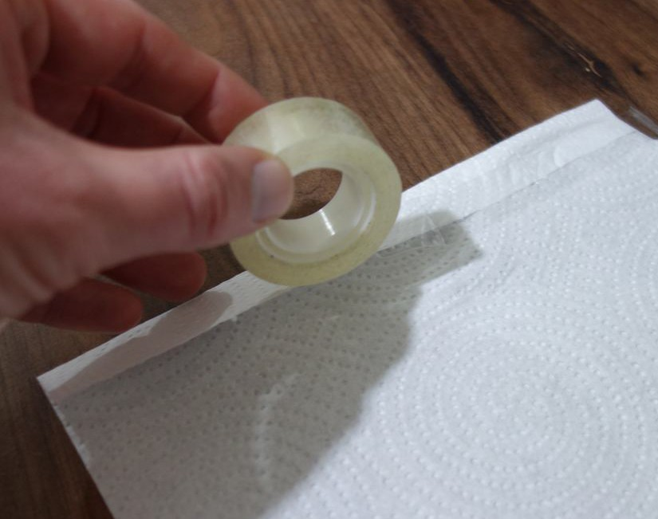
Take the piece of tissue paper and fold about 1 to 2 centimetres along the end of it. Tape down this fold with Sellotape.
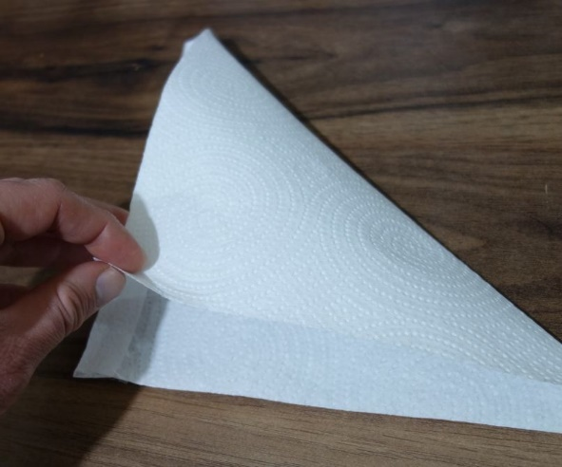
Fold the tissue in half diagonally to make a sail shape and tape it down along the same side as your fold.

Put the straw into the hole made by the fold. Only about 3/4s of the straw needs to be inside the sail, if the sail is longer than this then cut the bottom off. Insert the straw into the hole you made in the bottle.

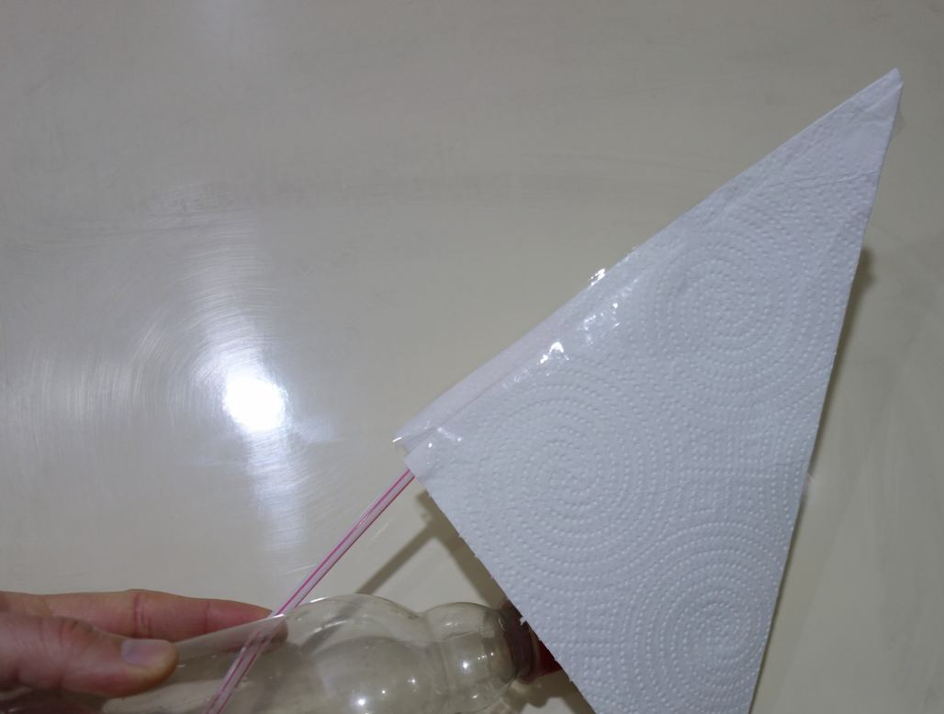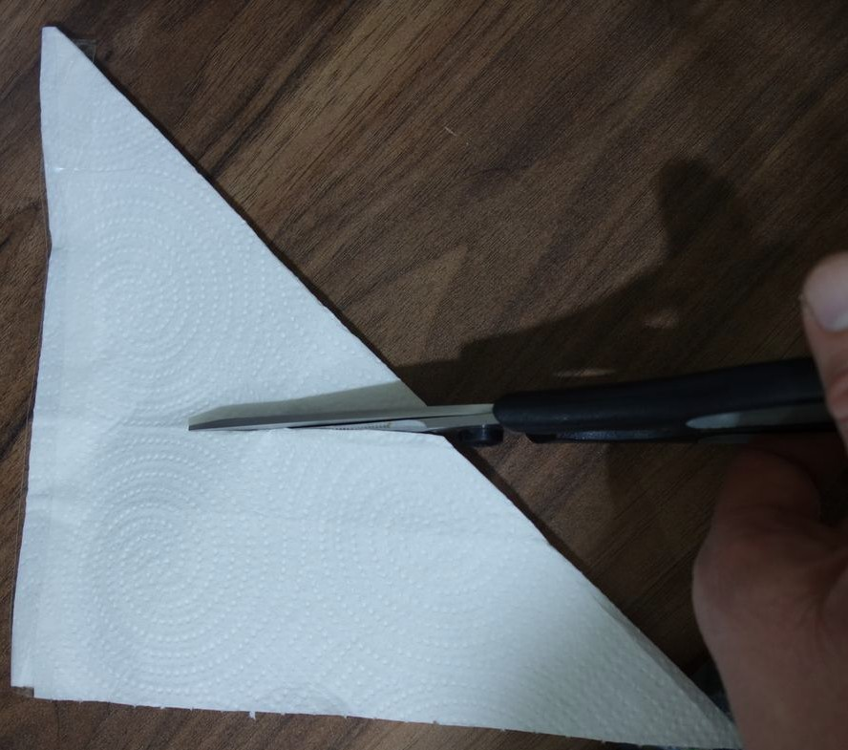

Attaching the sail

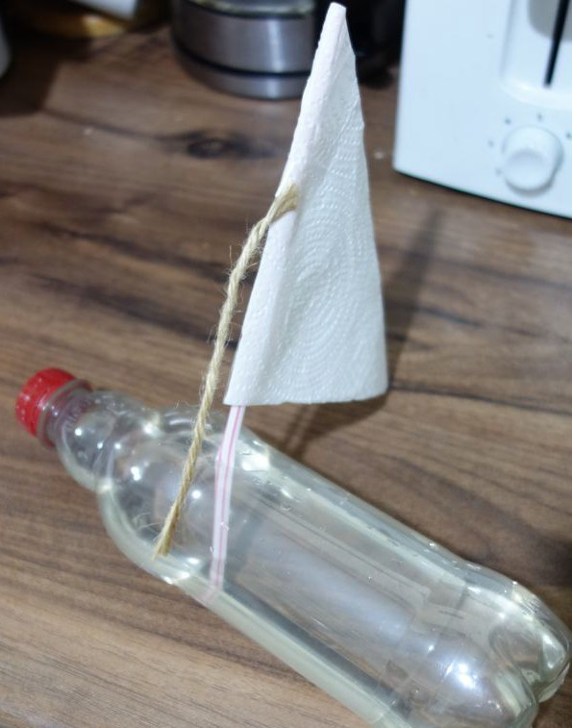
Cut a piece of string about 7 centimetres long and tape it halfway up the sail along the fold the straw goes into. Attach the other side to the side of the bottle just about the level of the ice. This will help stop the straw bending.

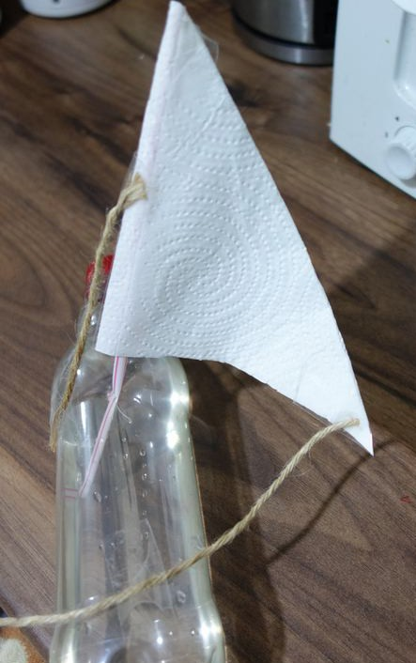
Cut another piece of string about 10 centimetres long and attach it to the bottom corner of the sail. Attach the other end to the back of the bottle (when the bottle is laid down). This string will keep the sail out the side of the boat.

Sailing the boat

Put the boat into a sink or bath filled with water. Blow from behind and watch it go along. Does it go in a straight line?

Are there any other problems with it?

Making it go in a straight(er) line

Try some of the following:

Make a second mast and sail and place it about ¼ of the way along the bottle. Put the sail on the opposite side to the front one. Now the wind will catch the boat on both sides and is less likely to turn it. Before doing this you might have found the boat would lean towards the sail, possibly dipping the sail in the water. With one sail on each side it should be more balanced.

Create a fin from cardboard and attach it to the bottom of the boat underneath the ice. Cover it in Sellotape to make it waterproof.

Create a rudder and attach it to the back of the boat. Cover the underwater parts in Sellotape to make them waterproof.

Does your boat sail any straighter now?

Can you think of any other improvements you could make?

