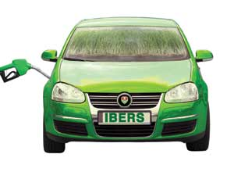
Activity sheet
You have a new job working for a bus company. Your boss has asked you to do an experiment to see if you can make fuel for the buses out of grass. You’ve heard that we can run buses on alcohol, so now all you need to do is figure out how to make it. She has sent you to BEACON with a trailer full of cut grass.
(1) The first thing you need to do is to get as much liquid out of the grass as possible. Which bit of equipment will you use?
- Centrifuge
- Rotary evaporator
- Screw press

(2) Congratulations! You now have a big tank full of bright green grass juice. The next thing you need to do is to use special microbes that eat the sugar in grass and make alcohol. Which bit of equipment will you use?
- Centrifuge
- Fermenter
- Screw press

(3) Well done, you now have a liquid that smells a bit like beer, so there is definitely alcohol in it. But when you look in the tank, you can see there’s a lot of solid bits in it that look like they might block up the engine of a bus. What bit of equipment might you use to remove the solid bits?
- Fermenter
- Centrifuge
- Rotary evaporator

(4) It looks like you have successfully got rid of all the big bits out of the alcohol fuel. But there might still be some really small bits that will damage the engine and you’re worried about the bus breaking down. What bit of equipment might you use next to get rid of the really small bits?
- Membrane filter
- Spray dryer
- Biomass dryer

Well done! You now have something that you can take back to the bus company and put in a bus.
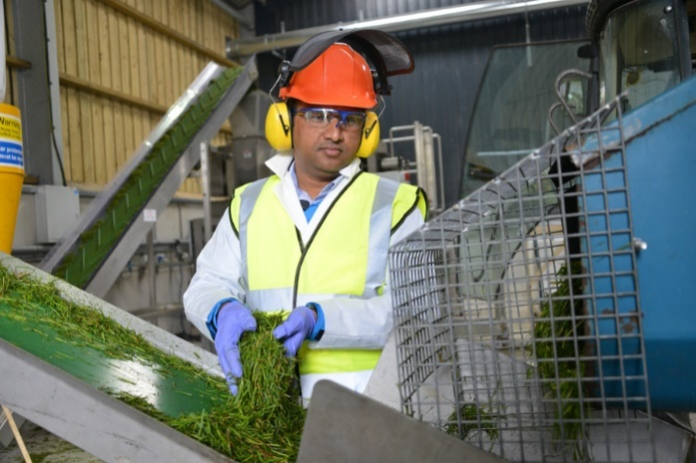
- The fermenter will then be used – This will allow special microbes to eat the sugars in the grass in turn creating alcohol.
- Putting grass into the conveyor belt before it goes into the screw press.
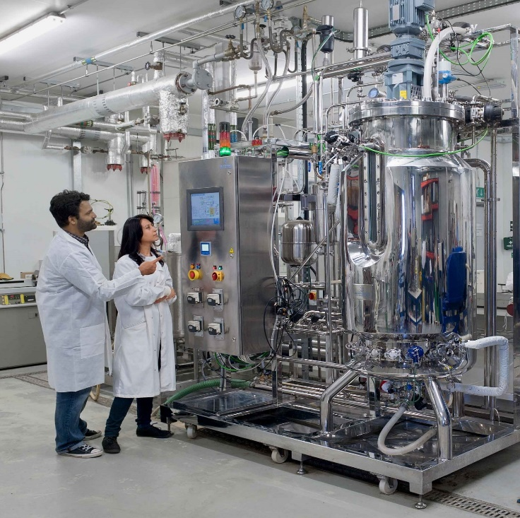
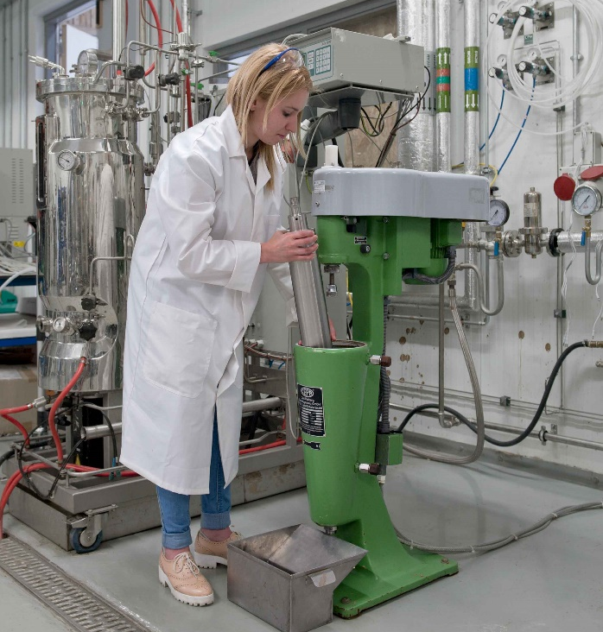

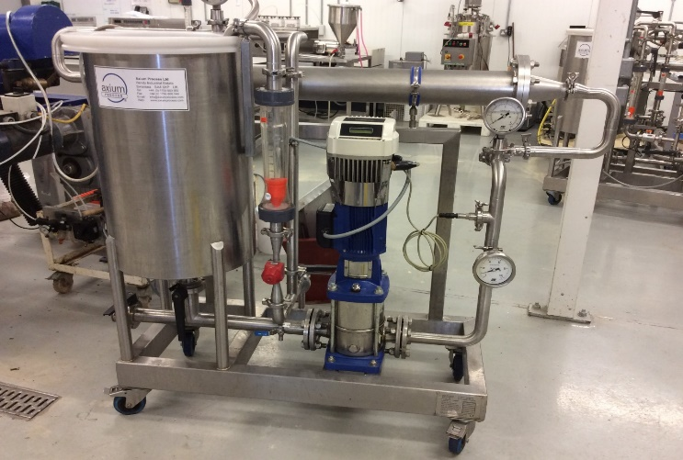
- The centrifuge can then be used to clear up any unwanted solid bits.
- The membrane filter will then work to get rid of the smaller bits which could damage the engine.

Answers
(1) Screw press - C
(2) Fermenter - B
(3) Centrifuge - B
(4) Membrane filter - A

