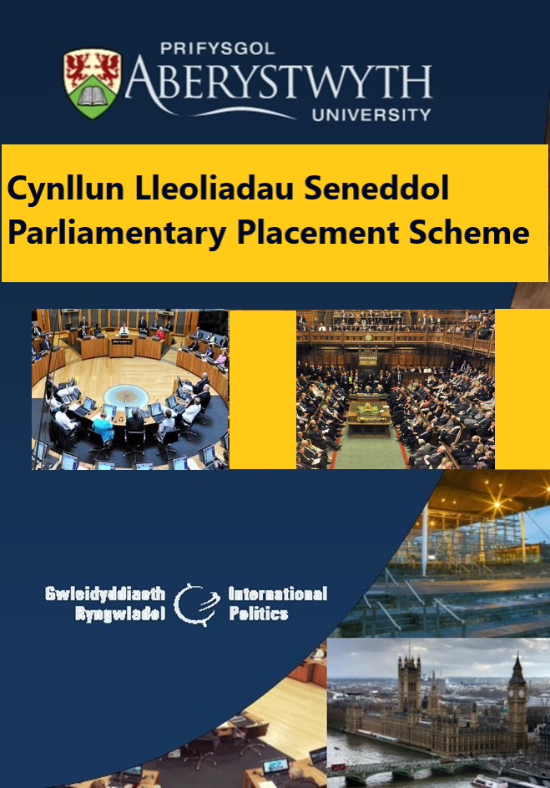
‘At the bottom of all the tributes paid to democracy is the little man, walking into the little booth, with a little pencil, making a little cross on a little bit of paper - no amount of rhetoric or voluminous discussion can possibly diminish the overwhelming importance of the point’ Winston S. Churchill | 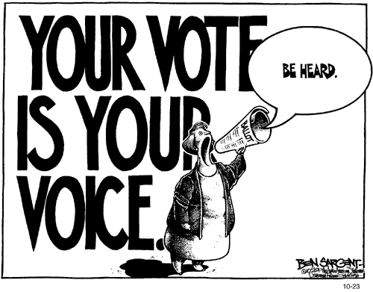
Croeso

Croeso cynnes i chi gyd i’r Cynllun Lleoliadau Seneddol ar gyfer y flwyddyn academaidd 2023-4. Mae’r ddogfen hon yn gyfle i chi ddarllen am rai o brofiadau myfyrwyr fu ar y cynllun yn Nhŷ’r Cyffredin a Senedd Cymru yn ddiweddar. Rwy'n gobeithio y byddwch chi i gyd yn gweld y broses yn un werthfawr a diddorol. Cofiwch fy mod yma i'ch helpu a'ch arwain drwy'r broses wrth i ni anfon ein myfyrwyr i fyd gwleidyddiaeth go iawn gyda balchder. Pob lwc i chi gyd.

Hwyl
Gerry

Welcome

A warm welcome to you all for the Parliamentary Placement Scheme for the academic year 2023-4. This document will allow you to share some of the recent student experiences of this scheme in the House of Commons in London and in the Senedd in Cardiff. I do hope that you all find the process invigorating and enriching. Please remember that I am here to help and guide you through the process as we proudly send our students out into the world of real politics. The best of luck to you all.

Best wishes
Gerry
*Diolch i Seren Fach am ei chyngor
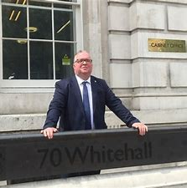 | - Dr R. Gerald Hughes  - Tiwtor Chyflogadwyedd/ Employability Tutor  - https://www.aber.ac.uk/en/interpol/staff-profiles/listing/profile/rbh/  - E-bost/ E-mail: rbh@aber.ac.uk

Diolchiadau
Rydym yn hynod o ddiolchgar i Aelodau Seneddol, Aelodau Senedd Cymru a'u swyddfeydd a gyfrannodd at y Cynllun eleni, ac a sicrhaodd fod y myfyrwyr yn cael cyfleoedd mor werthfawr yn ystod eu lleoliad.

Mae myfyrwyr ar y Cynllun yn gallu gwneud cais am fwrsariaeth i gyfrannu tuag at y costau yn gysylltiedig â'r lleoliad. Ar gyfer 2017, 2018, 2018, 2019, 2020, 2021, 2022, a 2023, ariannwyd y bwrsariaethau gan Alumni y Brifysgol. Rydym yn hynod o ddiolchgar i'r Alumni am gefnogi'r cynllun hwn ac i'r Swyddfa Datblygu a Chysylltiadau Alumni am hwyluso hyn.

Thanks
We are extremely grateful to the Members of Parliament, Members of the Senedd and their offices who contributed to the scheme this year and ensured that the students had such valuable opportunities during their placement.

Students on the scheme can apply for bursaries to contribute towards their expenses during the placement. In 2017, 2018, 2019, 2020, 2021, 2022, and 2023, the bursaries were funded by Alumni contributions. We are extremely grateful to our Alumni for supporting this scheme and to the Development and Alumni Relations Office for facilitating this.

Cynlluniau Seneddol
Beth yw'r rhain?
Dyma gyfle i fyfyrwyr gael profiadau ymarferol o fywyd gwleidyddol, yn rhoi cymorth i gynrychiolwyr gwleidyddol yn Nhŷ'r Cyffredin neu Senedd Cymru. Bydd myfyrwyr yn gweithio yn swyddfa Aelod Seneddol neu Aelod o Senedd Cymru am 4-6 wythnos yn ystod gwyliau'r haf (wedi'r arholiadau a chyn gwyliau haf yr Aelodau). Fel arfer, mae'r gwaith yn cynnwys ysgrifennu datganiadau i'r wasg, gwaith ymchwil a delio â materion etholaethol. Gall hefyd gynnwys mynychu digwyddiadau (rhai yn nodedig iawn!), neu fod yn rhan o ymgyrch etholiadol.

Pwy all fod yn rhan o'r cynllun hwn?
Mae'r Cynllun yn agored i fyfyrwyr ail flwyddyn yn unig. Lleoedd cyfyngedig sydd ar gael felly tynnir rhestr fer a threfnir cyfweliadau er mwyn dewis myfyrwyr ar gyfer y Cynllun. Rydym yn dewis myfyrwyr sydd wedi dangos eu bod yn frwdfrydig ynglŷn ag astudio Gwleidyddiaeth Ryngwladol, rhai sy'n gallu gweithio'n galed a diwyd o dan bwysau, a chanddynt sgiliau rhyngbersonol da ac yn gallu addasu'n gyflym i amgylchedd gwahanol.

Y Cynllun Lleoliadau Seneddol
Pwrpas y llyfryn hwn yw rhoi gofod i nifer o fyfyrwyr a fu’n rhan o’r Cynllun Lleoliadau Seneddol dros yr ychydig flynyddoedd diwethaf i rannu rhai o’u profiadau gyda chi. Mae proffiliau’r myfyrwyr yn dangos eu brwdfrydedd am y cynllun, yr ehangder profiadau a gynigiwyd, a’r budd a gafwyd o’r profiadau ar y Cynllun Lleoliadau Seneddol. Rydym yn falch iawn o’u cyflwyno i chi, gyda dymuniadau gorau wrth i chi ymgeisio.

Parliamentary Placement Schemes
What are they?
Students get hands-on experience of political life, assisting political representatives in the House of Commons or the National Assembly for Wales. Students work in the office of a serving Member of Parliament or Welsh Senedd Member for between 4 and 6 weeks during the summer (after exams and before parliamentary recess). The work typically includes writing press releases, research work and dealing with constituency matters, but also includes attending events (sometimes prestigious!) and in the past students have even been on the pre-election campaign trail.

Who can participate?
The scheme is open to second year students only, the placements take place at the end of year two. As places are limited, students are shortlisted and attend an interview to be selected for the scheme. We select students who have proven that they are enthusiastic and passionate about studying politics or international politics, can work hard and diligently under pressure, who have good interpersonal skills and who are capable of adapting quickly to working in this very different environment.

The Parliamentary Placement Scheme
The purpose of this booklet is to allow a number of students who have participated in the Parliamentary Placement Scheme over the last few years to share some of their experiences with you. The student profiles illustrate the enthusiasm of the students towards their placements, the breadth of experiences that were the provided, and how each student has benefitted from their experience on the Parliamentary Placement Scheme. As such we commend them to you and wish you well in your application.

Student: Jameson Torry

Placement: Craig Williams MP, Montgomeryshire
During the summer of 2023, I spent eight weeks working for Craig Williams MP, both in Westminster and in my home constituency of Montgomeryshire. The primary aspects I assisted with was Mr. Williams’ role as Parliamentary Private Secretary to the Prime Minister, Rishi Sunak MP. I attended multiple events within parliament and my constituency, including networking events, constituent meetings and local show campaigns.

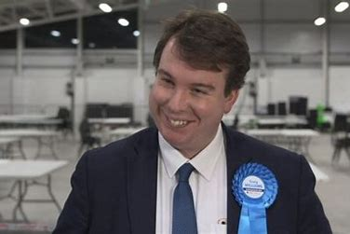

Within Mr. Williams’ team, my responsibilities were varied, I was tasked with managing Mr. Williams caseload involving constituency enquiries where I would have to research queries in detail and respond promptly, informatively and with compassion. Many of these enquiries involved personal circumstances that had to be treated with the upmost sensitivity, I frequently engaged with other Government departments like the Home Office, for advice and solutions to complicated cases.

Other responsibilities were more centred around Mr. Williams role as PPS, this involved creating datasets and spreadsheets to assist Mr. Williams in the efficient running of day-to-day business. This involved widescale research on a multitude of different topics and ensuring MP’s that were stakeholders in particular areas were incorporated effectively. I further assisted Mr. Williams in office admin, diary organisation and other administrative related areas.

Whilst working in Westminster and in my home constituency, I developed skills in networking, research tasks and communication; skills that would be vital in any future role, whether it be in your studies, future employment aspirations and especially in future political involvement.

The placement enabled me to understand domestic politics at a greater level. What we see on our TV screens is a very small portion on what is a constantly working very large machine. Any student that engages with this placement will become far more in tune with what our political system is, which will further assist you in future studies and perhaps a career in politics. The placement is undoubtedly the best thing I have done with my degree.

My advice to any prospective student is to embrace the experience and get as involved as you can. This placement is what you make it. Take every opportunity to network with colleagues in Parliament or the Senedd, people are very accommodating, most likely recent graduates and understand your position. Ask questions wherever you can, seek out opportunity!

Student: Cai Phillips

Placement: Dylan ap Iorwerth AS, Ynys Môn

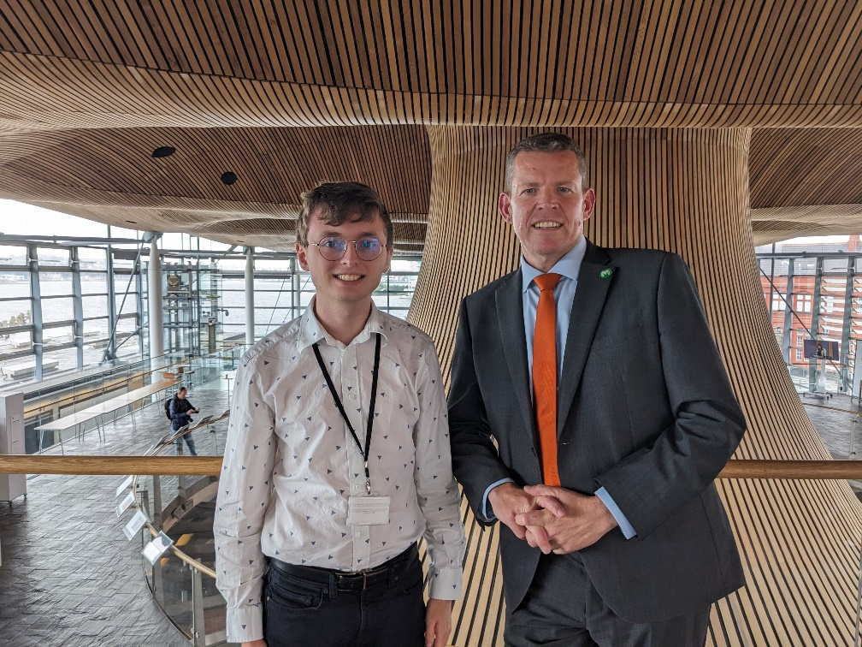

Cefais tair wythnos arbennig yn gweithio yn y Senedd ym mae Caerdydd i arweinydd Plaid Cymru, Rhun ap Iorwerth, ac aelod o'r Senedd dros Ynys Môn. Roedd yn brofiad diddorol iawn ac yn llawn cyfleoedd i gyfrannu i wleidyddiaeth.

Gweithiais gyda thîm glòs yn swyddfa Plaid Cymru yn y Senedd trwy gydol y cyfnod ac roedd yn fewnwelediad llawn gwybodaeth i sut mae gwrthblaid yn sicrhau bod nhw'n craffu ar y llywodraeth drwy'r wahanol ffurf, ond hefyd ar gynrychioli a chefnogi etholwyr.

Roedd swyddi bob diwrnod yn wahanol er enghraifft cefais gyfle yn wythnos un i weithio ar bapur briffio i Rhun ap Iorwerth ar gyfer digwyddiad yn ymwneud gyda gwrthwynebiad i beilonau yn Sir Gaerfyrddin. Wedyn diwrnod arall cefais gyfle i helpu llunio cwestiwn i'r Trefnydd a chafwyd ei ofyn ar lawr y Senedd yn ymwneud gyda gwasanaethau bysiau.

Cefais hefyd cyfle i weithio ar ddarn o waith ymchwil swmpus ar strategaeth newydd i gyfryngau cymdeithasol Rhun ap Iorwerth gan gymryd esiamplau o arfer da ar draws y byd. Roedd hyn yn galluogi fi i ddefnyddio fy sgiliau cyfryngau.

Yn ogystal fe wnes i ddylunio poster ar gyfer digwyddiad hydrogen Cymru a gafodd ei ddefnyddio fel cyhoeddusrwydd. A hefyd fe wnes i greu clipiau fideo o areithiau Rhun ap Iorwerth i roi i fyny ar y cyfryngau cymdeithasol.

Y peth gorau oedd bod Rhun ap Iorwerth hefyd yn arweinydd ac felly roedd yn galluogi fi i gael y profiadau ychwanegol hynny a hefyd teimlo'r prysurdeb y Blaid yn ganolog. Roedd hyn yn cynnwys cwrdd â Mick Lynch (arweinydd Undeb RMT), mynd i ddigwyddiad gan amryw elusennau a sefydliadau oedd eisiau tynnu sylw'r gwleidyddion ar fater penodol a hefyd helpu trefnu digwyddiad hydrogen oedd yn cael ei noddi gan Rhun ap Iorwerth. Roedd bod yn y swyddfa yn gyfle hefyd i rwydweithio gyda phawb.

Yn bendant roedd yn tair wythnos i gofio ar amser oedd yn destun craffu ychwanegol i'r Senedd yn ymwneud gyda newid cyflymder isafswm a chyhoeddi cynllun newid i'r nifer o aelodau'r Senedd. Amser diddorol iawn i Wleidyddiaeth Cymru. Byddai'n argymell unrhyw un i dderbyn y cyfle hwn gyda breichiau yn agored, mae wir yn agor drysau ac yn agor eich meddwl ar sut mae pethau'n gweithredu.

Student: Joseph Moore
Placement: Jayne Bryant MS, Labour, Newport West, Senedd Cymru

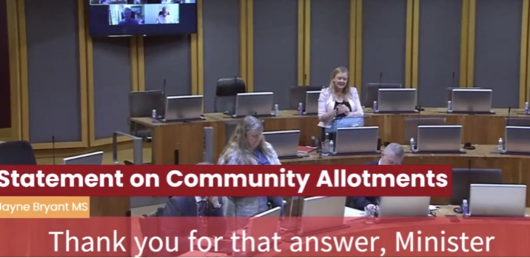

During my placement in the summer of 2022, I worked for Jayne Bryant MS, representing Newport West in the Senedd for Labour. We also worked closely with her Senedd colleagues their respective teams. The main events I helped organise at the Senedd include, a reception for the European Association for Quality Assurance in Higher Education and a reception for delegates from the Basque region of Spain, who were in Wales to remember refugees who came to Newport during the Spanish Civil War. In addition to these events, I had the pleasure of attending Cross-Part Groups which discussed topics like hospital construction, education reform, supporting disabled communities, and reform to diabetes legislation.

My responsibilities when at the Senedd included research, giving briefings to Jayne about events and meetings and attending meetings and events in Jayne’s absence and making notes. I was also responsible for helping Jayne prepare questions to the First Minister, and then accessing the recordings of these questions and posting them on her Twitter. Finally, I was also responsible for responding to constituents, union representatives, businesses, and charities.

The highlights of my two months at the Senedd were visiting Jayne’s constituency in Newport and working on Constituency matters, attending social events in Cardiff with other members of the Labour Group, Drafting a press release about safe spaces, and helping a local charity to acquire government support to continue operating.

As well as the great experience, the placement allowed me to develop my oral and written communication, my personal confidence, and taught me how to use excel, Canva and clipchamp. I'd definitely recommend the parliamentary placement scheme, the working environment was very welcoming and you have to chance to make contacts that would be useful if you were ever considering a career in politics.

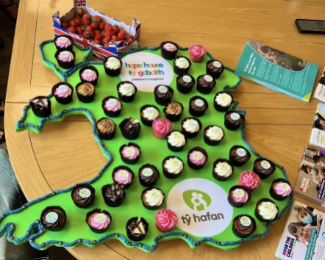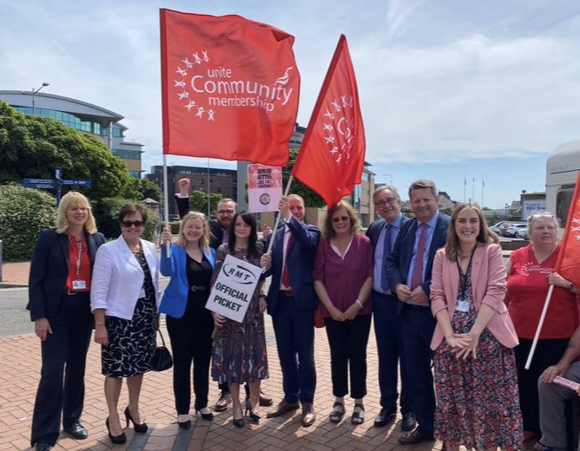
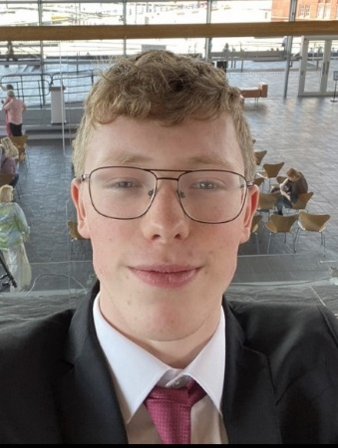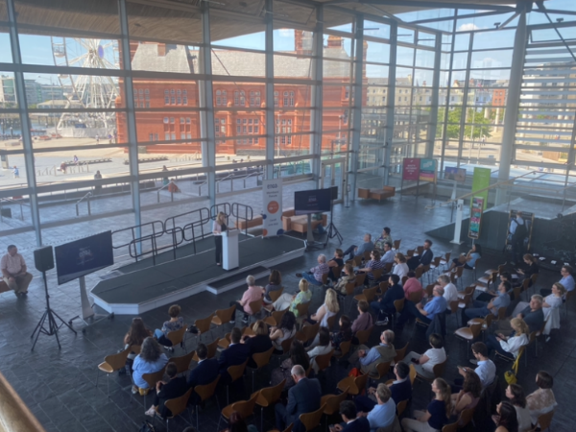
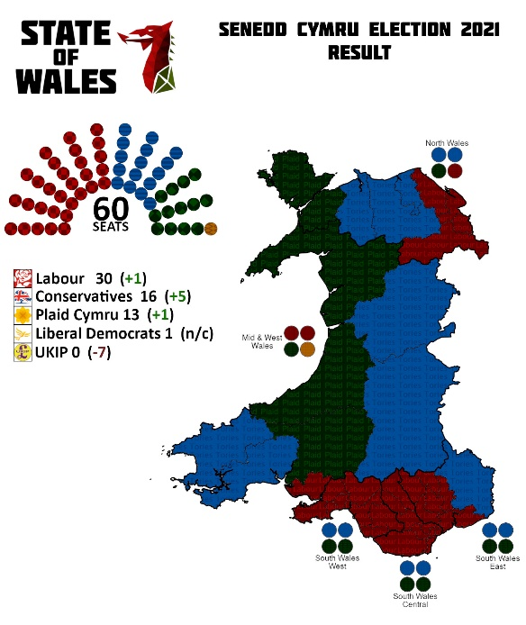
Student: Joe Palmer
Placement: Sarah Jones MP for Croydon Central, Westminster

During my placement in the summer of 2022, I was part of the team for Sarah Jones MP representing the Croydon Central constituency. I worked with both her constituency team, and her team in Westminster. The main events I assisted with as part of her team were a constituency fundraiser evening, and an Energy Tax Rebate advice session, as part of a wider campaign on the Cost-of-Living Crisis. I also was able to attend events in Westminster and elsewhere in the constituency such as a celebration of Police Community Support Officers as part of the member’s Shadow Home Office remit.

Within the team, my responsibilities included managing my own caseload of constituent casework – which included assessing, researching, and resolving constituent queries or referring to outside agencies as appropriate. My responsibilities also consisted of attending meetings and taking notes, writing briefings, and drafting questions for relevant ministers in Parliament.

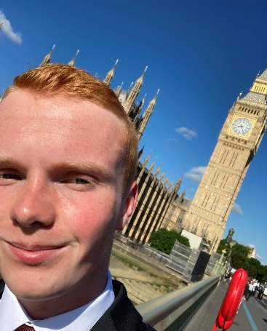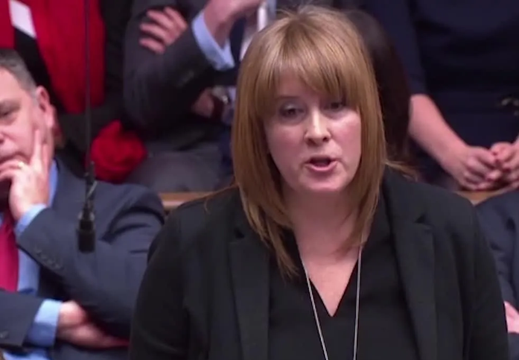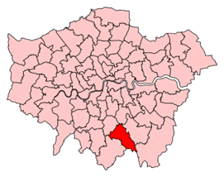
Location of the Croydon
Central Constituency

Whilst working in both the constituency and Westminster, I have developed a skill-set that will be vital in either the workforce or further study, such as prioritising multiple workloads, research, and public facing communication skills.

I believe that the placement in Westminster is one of the best things I have done with my degree. It has given me experience of politics in practice and has allowed me to make some real difference in a short time.

My advice to potential candidates would be this … embrace it! Get to know the people in the office and be ready to learn lots and use your initiative to help the office when needed. Your skills and knowledge that you have learnt in Aber going into the placement may help the office greatly! This may give you the grounding and experience for a bright future career.

Student: Aled Lloyd
Placement: Rhun ap Iorwerth AS, Plaid Cymru (Ynys Môn), Senedd
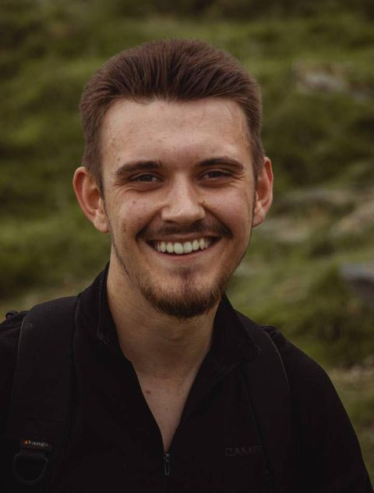 | 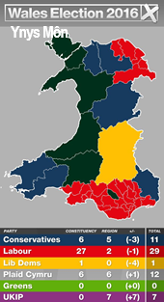

Fy mhrofiad
Roedd fy mhrofiad yn gweithio efo Rhun ap Iorwerth a’i swyddfa yn anhygoel. Wnaeth y cyfnod helpu fi weld sut mae Aelod o’r Senedd efo’r gallu i graffu'r Llywodraeth ar yr un llaw, ac ar y llaw arall gynrychioli ei etholaeth leol ar lawer o achosion amrywiol. Cymerwyd y cyfle yn ystod y cyfnod i ymchwilio i bolisïau gwahanol mewn llawer o ddyfnder a wnaeth yn y pendraw gyfrannu at helpu pobl leol Sir Fôn. Roedd hi’n wych cael cyswllt efo Aelod mor gadarn a pharchus yn y Senedd. Fe wnes i gael amser bythgofiadwy a fe wna i awgrymu i unrhyw un gymryd y cyfle.

My experience
In short, working with Rhun ap Iorwerth and his office was amazing. It helped me see how a Parliament member is able to scrutinise the government while representing a local constituency on a whole host of issues. I had the opportunity to research many different policies in great depth that would lead on to helping constituents in Anglesey. It was great to have contact with such an upstanding member of the Senedd. I had a blast doing it and would recommend it to anyone.

My placement
I began my work experience for Rhun’s office at the 10 June 2020 and ended my time working for his office at the 30 July 2020. I would usually work two days a week being Thursday and Friday. The main reason being for this of course were the restrictions that Covid-19 put on my ability and the ability of Rhun’s office to work in an office environment. The work took place online via emails and MS Teams.

I would have a weekly meeting on a Thursday morning and occasionally Fridays. I would not have much contact with Rhun himself, however work very closely with his office staff. A great reason impacting this was the environment of working during the Covid lockdown. Rhun himself apologized for the lack of contact he was able to have with myself. A great portion of the work in undertook over the period was research based. These could be really minor tasks to things that would take up and afternoon and some things that were more long term. I would be asked to research a whole host of different things that would go on to shape Rhun’s policy ideas and scrutiny of the Government. Almost all of these things were Covid-19 related in one way or another. I also undertook some tasks with research teams in the Senedd itself. Here are some examples of this and other tasks I did for Rhun and his office.

- Researching into the impact of lockdown on young people’s mental health
- Researching into how/what the UK had done to fund Zoo’s during the first lockdown this was so Rhun could write to First Minister Mark Drakeford to push for funding for Zoos and Aquariums that were on Anglesey.
- Researching how the Netherlands distributed online counselling. This was for the Senedd Research office as the welsh government wanted to see how the Dutch distributed online counselling as they were one of the first to have a system like that in place therefore were years ahead of the curve. Covid-19 saw the rest of the world try and catch up to put some sort of framework of online counselling in place.
- I assisted Rhun in preparing for meetings with Young Farmers.
- Anglesey was the last county in wales to have supply teachers on furlough pay. There was a big debate between the council and the schools. The council did not want to take the money back from the schools as the schools didn’t see why they needed to pay supply teachers as they weren’t working. The council being a Plaid Cymru one did not want to damage its reputation among schools further. This left supply teachers in June not being paid since March. This left Rhun in a pickle as 10 supply teachers wrote into Rhun giving their side and perspective. My job was to go through all the emails and write down what their experiences were and what exactly they wanted. This was able to give Rhun the context and argument to put forward to the council to make a case for the supply teachers.
- I drafted a letter to the Welsh Health Minister Vaughn Gething MS (an Aberystwyth graduate) about an elderly woman who was not able to get a take at home kit for the reason that she did not have an email address. A constituent therefore felt left in the dark.
- I wrote a number of responses to enquiries on social issues such as white privilege. In the aftermath of the summer’s BLM protests constituents wrote in raising concerns about racism in wales. I wrote a response to a constituent noting what the party’s stance had been and also what they had raised in debates previously.

Student: Sam Hall
Placement: Mike Wood MP, Conservative (Dudley South), House of Commons

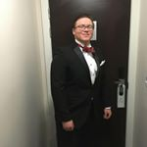 | 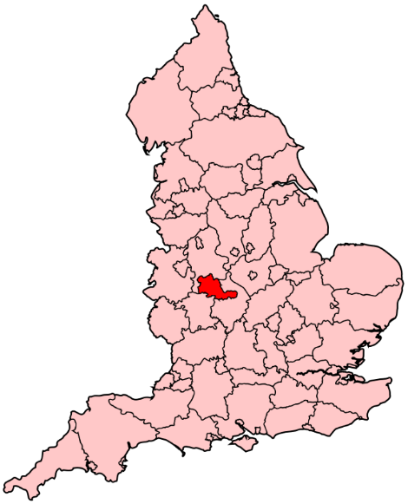  Location of the Dudley South Constituency
Although I secured a placement, because of COVID-19 I only had one week in Parliament. Nonetheless, it was easily the best week of the summer. Prior to that, I’d completed a few newsletter-type pieces, working remotely, for Mike in his role as a Parliamentary Private Secretary (PPS) to the Home Office. Parliament is a wonderful place to work. A mixture of a modern office and a museum, it is a lovely place to get lost - which is fortunate because I successfully managed to do so every lunchtime, not helped by the one-way systems put in place by COVID-19.
I caught glimpses of the Speaker, lots of MPs (even chatting to a few!), stuck my head into Boris’s office, and was even successfully snuck into the chamber’s press galley whilst a debate on extending furlough was ongoing, by a very understanding doorkeeper- even though official tours were not allowed to take place. Each day was a mixture of typing up speaking notes for Mike (depending on what the day’s business was and when he would be called) - so that’s he’d have something to prompt him, as well as more typical intern tasks like making coffee. I also used skills that I’ve developed over the course of my degree; mainly taking a complex issue and picking out the key information and arguments and presenting them.
As I was only there for a week and tours were not officially allowed, myself and Mike’s assistant (Dan) often took the long way round when out and about on tasks – such as filling up water bottles etc. I found Mike very approachable - it probably helped that we had an office dog, courtesy of Dan (Bella, a therapy dog).
Food-wise, there are a number of options all across the estate, all of which do varied, quality and reasonably priced food. You could of course bring a packed lunch in, but when in Rome…! Next to listening to a live debate in person (rather than just BBC Parliament - which is always on in the office), taking lunch on the terrace by the Thames was excellent.
Overall, my only complaint would be that I did not get to do more in-person work. It was such a unique experience, and I would definitely consider something similar after graduation.
Student: Phaedra Karaoli
Placement: Ben Lake MP, Plaid Cymru (Ceredigion), House of Commons

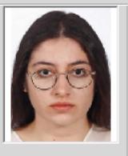  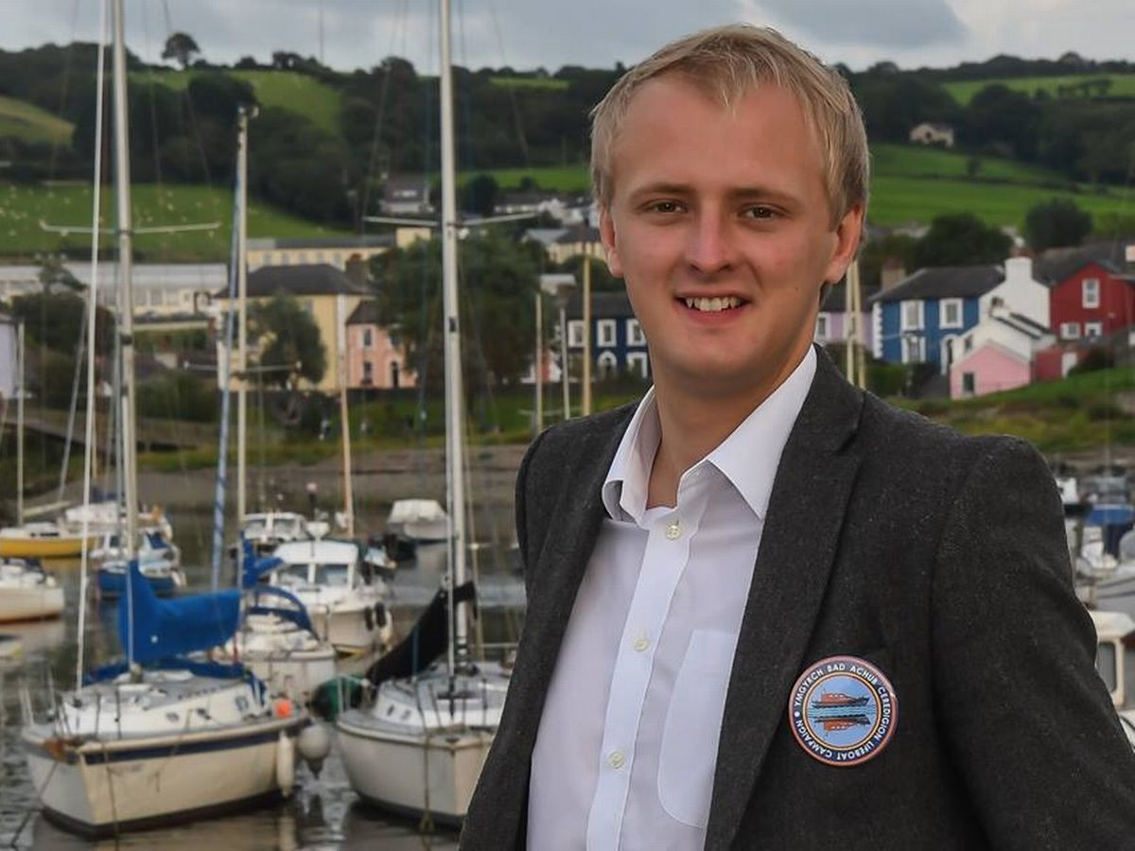 | 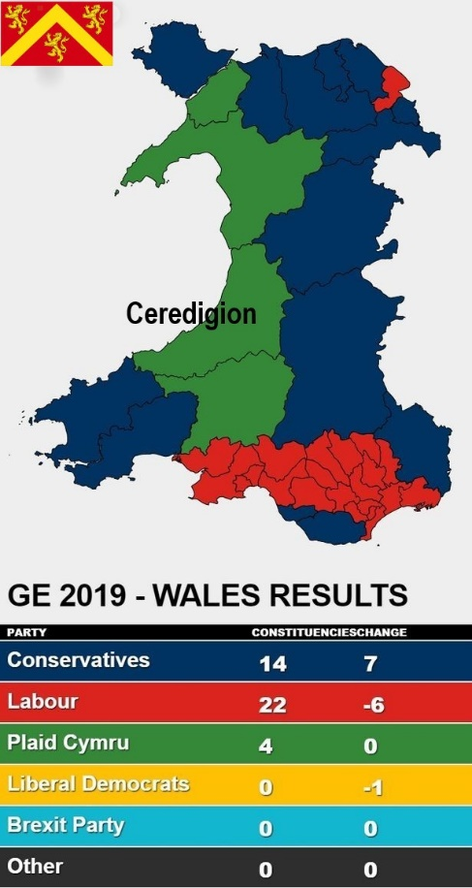

I was placed with Ben Lake, MP for Ceredigion, though I actually worked for all four Plaid Cymru MPs. As such, I was assigned a variety of different tasks that depended on each MP’s agenda. My experience in the constituency and the parliamentary office made me realise the multi-dimensional nature of MPs role as both representative of their constituency and their party, and the flexibility it requires to keep the balance right.

Initially, I worked for one week in Ben Lake’s constituency office in Lampeter, where my tasks were mostly focused on constituent’s casework, including responding to campaign emails, drafting correspondence, and also attending the weekly surgery drop-in session. I particularly enjoyed working for the constituency of Ceredigion, as it is where I live, and it made me acknowledge and understand the issues of the area and the concerns of my fellow constituents. These varied from personal issues to concerns over governmental plans and initiatives regarding climate change, foreign and domestic policy issues and of course Brexit!

Thereafter, I worked for four weeks alongside Plaid Cymru’s Westminster team, where I conducted research, summarized reports and drafted briefings for various issues concerning the interests of the MPs. I also had the opportunity to get directly and personally involved by attending meetings and events on behalf of or along with the MPs, including participating in a round-table and joining Liz Saville-Roberts’ meeting with the Minister for Welfare Delivery at the Ministry of Works and Pensions.

My placement took place during a transitional period for the British Government, with May’s stepping-down; the appointment of Boris Johnson as Prime Minister; and the confrontation over Brexit at its peak. One of the most memorable moments was attending Theresa May’s final PMQs and the media coverage events surrounding Boris Johnson’s election.

Apart from the experience in parliament the placement offered me a good insight into working life in London. Initially, it seemed a bit daunting, but I soon got the flow. London itself is an exciting city and there is always something different to do, so try to make most of your time there!

The placement gave me the opportunity to improve my interpersonal skills, work in a high-pressure environment and get out of my comfort zone, and I would advise everyone to give it a go!

Student: Helena Lane
Placement: Mike Wood MP, Conservative (Dudley South), House of Commons

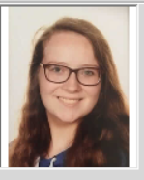 | 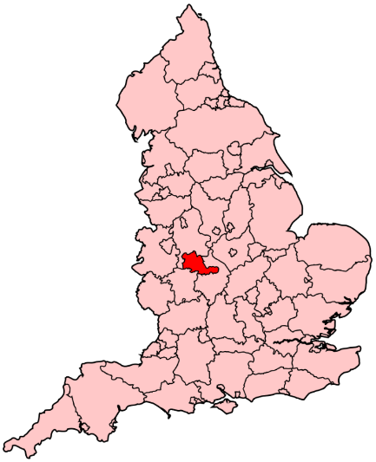  Location of the Dudley South Constituency | 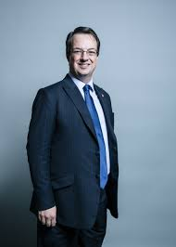

I worked with Mike Wood, a Conservative MP, in July 2019. I returned from studying abroad less than a week before starting in Parliament, so I had no idea what to expect. I met Dan, the senior parliamentary research assistant to Mike Wood outside Westminster Tube Station. Dan was brilliant – he was so welcoming, especially to what can seem to be a quite intimidating work environment. Dan has worked in Parliament for over five years, so I learnt an insane amount about the building, its history and the people who work there in a very short space of time!

My role was quite varied, but I highly recommend learning the ins and outs of Microsoft Office – especially Outlook and Excel. On my first day, I was tasked with receiving and organising mail – both physical and electronic – which seemed pretty easy! That afternoon I was invited to watch the England Women’s World Cup Football Final – a very surreal experience but a good networking opportunity! I really enjoyed the variety of tasks – I sent emails and phoned the offices of other MPs on behalf of the office, used HTML to code aspects of the MP’s website to make it more accessible to constituents, and even gave tours to visiting constituents!

There were elements I disliked – such as the commute! I lived reasonably close to London, so I thought that it would be relatively reasonable. However, don’t trust the trains! There are also significant numbers of protests, so leave enough time to deal with them. In Parliament itself, there are also more than 1,000 rooms and three miles of corridor, so it is very easy to get lost! However, all corridors eventually lead to Central Lobby, so get a Fitbit and prepare to walk a very long way! And prepare for stairs. So many stairs!

Overall, however, I had a brilliant time, and learnt a lot about the ins and outs of the Houses of Parliament. I am seriously considering applying to a position within Parliament after I graduate – it is an incredibly interesting place to work!

Student: Amarpreet Gill
Placement: Chuka Umunna MP, Labour (Streatham), House of Commons

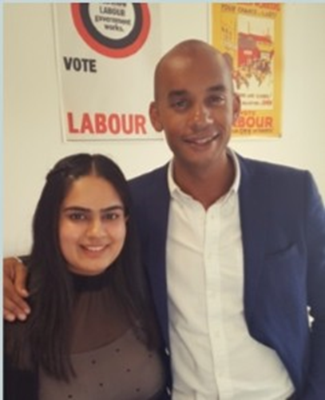 | 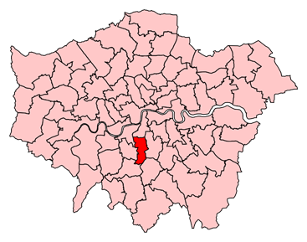  The Streatham constituency in London
For my Parliamentary Placement I was lucky enough to work for my favourite MP - Chuka Umunna, in both his parliament and constituency offices in London. I worked closely with all members of Chuka's team, including his main parliamentary assistants, media manager, and case workers.

The placement took place during the parliamentary summer recess period and the offices were very busy with a lot of preparation for the upcoming Labour Party Conference. There was a lot of tension around the Murdoch proposal to buy all of Sky TV, where the Culture Secretary delayed her decision. Many constituents were emailing in their concerns with regard this issue, and I prepared responses - making sure that the Labour Party and Chuka's point of view were concise and came across effectively.

The main tasks that I carried out mainly concerned constituency issues: I learned how MP’s case workers carry out constituency work. I had to deal with many personal issues that constituents were facing, nee ding urgent help at times. I also had to deal with constituents concerns in relation to government plans and proposals, where some started petitions, asking for Chuka's support. Through dealing with these issues, I learned a lot about how the casework database system worked, therefore developing my IT skills. I also briefed Chuka on his visits in his constituency and got to know constituent when, for instance, visiting local businesses.

he best part of my placement was getting to know Chuka personally, being able to talk to him and ask him questions about his opinions. He has always been somewhat of a political idol for me, as my political beliefs are very much similar to his. Consequently, being able to work for his office and get to know him was an honour. Every part of my placement was amazing, from getting used to commuting around central London to learning about the office' s work, it was a fantastic experience all round.

As I have said, I developed IT skills from completing a lot of database work. As part of my dealing with constituency issues, I learned how the case workers' online system worked, I also developed my people skills, learning how to liaise with others effectively. This placement was absolutely amazing for my career development and to get a taster of the working world of real politics. I believe it has really prepared me for a future job as I would like to work directly in politics. Overall, it has given me a valuable insight, and has prepared me for a working life in London.

My advice would be to really get to know the people you will be working for on placement, to not hold back (do, for instance, ask a lot of questions relating to your placement), and to make contacts for your future job prospects. It is natural to be nervous when first arriving, but once I settled in, I got an amazing buzz from being part of such a fast-moving environment.

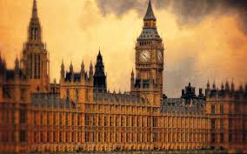
Student: Carys Major
Placement: Mike Wood MP, Conservative (Dudley South), House of Commons

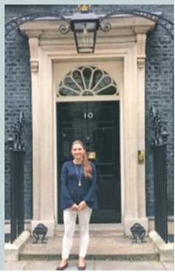 | 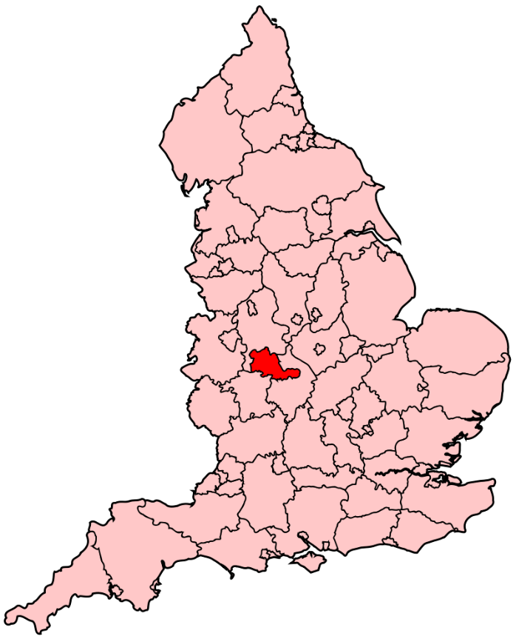  Location of the Dudley South Constituency
I spent approximately three months with Mike Wood, MP for Dudley South, and his researcher Dan Horrocks. The main event in UK politics during my time on placement was Brexit. Other notable events included the Queen's Speech and the State Opening of Parliament and the state visit of King Felipe IV and Queen Letizia of Spain. This was an opportunity for me to experience the workings of a state visit and how they are conducted. Towards the end of my placement, the office was also preparing for Party Conference.

During my time in Parliament, I undertook a range of tasks. Whilst in the office, this included casework, which involved dealing with local issues, answering emails or phone calls to constituents in order to assist them with any queries they had, replying to any other emails and responding to correspondence. As well as replying to emails and helping out with other admin, I also made phone calls and answered calls that came through to the office. I attended many events including charity events, receptions, and meetings alongside Mike and Da n.

Some memorable events including being able to sit in the House of Commons chamber during Prime Minister’s Question Time, and the Queen's Speech/ State Opening of Parliament. We also attended an event in the Speaker's House, and I had the opportunity to sit in the House of Lords during a debate. Other receptions that I was lucky enough to a attend included the release of the new £10 note, an event in the Taiwanese Embassy, and as Mike is the Chairman of the All-Party Parliamentary Beer Group, I was fortunate enough to attend many receptions and events hosted by the Beer Group alongside Mike and Dan!

I also visited the constituency twice throughout my placement, attending an apprentice ship fair and a jobs fair, both hosted by Mike. Whilst visiting the constituency, I had the opportunity to meet the staff that worked in the constituency office, and I was also able to see not only what an MP's role is within Parliament, but in their local constituency as well.

Having the opportunity to undertake my placement at the heart of British politics, walking around and working every day was a highlight for me, especially at such an interesting time in UK politics. Other memorable highlights included being in Parliament during the Queen's Speech and the opening of Parliament and being able to visit Downing Street: events I will never forget. Overall, having the opportunity to get an insight right into the centre of British politics was the greatest highlight.

During my placement, I was given the opportunity to develop and improve a number of skills. The skills that I developed most were my decision making, organisation, and research skills. For example, being able to manage emails and phone calls coming through to the office at all times, making sure you wrote down important information. If any research needed to be undertaken, I learned how to get the most effective research done in a short amount of time. Having the opportunity to work in and observe how an MP’s office works in a professional environment was also a valuable experience.

Networking and meeting people occurred frequently during my placement. I met new people at events, so inter-personal skills and being able to talk and converse with people formed a huge part of my placement. As mentioned above, I have benefited and learned so much from my placement - and have developed a number of skills and made contacts with many people. I have been able to learn so much more about how British politics works, by being at the heart of the Government every day.

I would recommend this opportunity; it has been so eye-opening and an extremely invaluable experience. It is not an experience to miss out on!

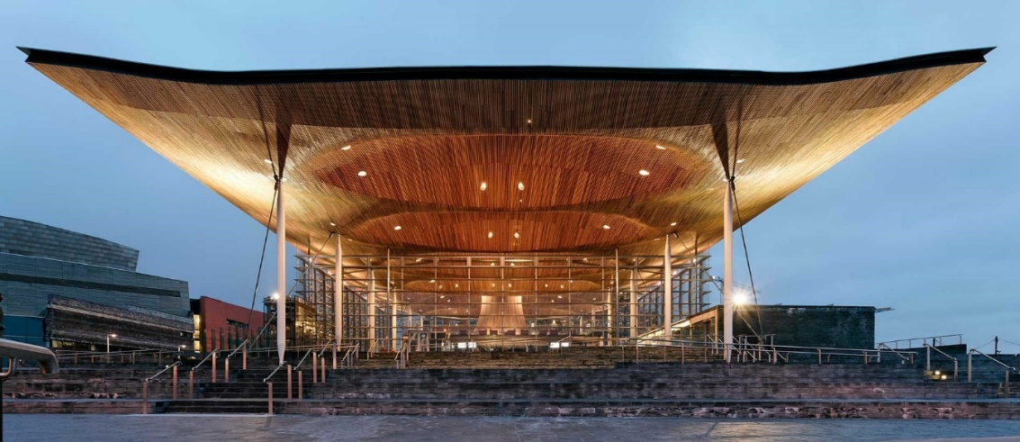

Student: Glenn Pritchard
Placement: Chuka Umunna MP, Labour (Streatham), House of Commons

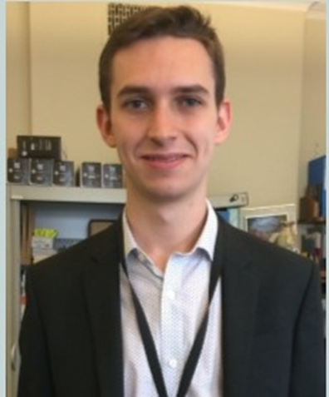 | The Streatham constituency in London

If last year's Aberystwyth cohort to Westminster and Cardiff Bay were faced with the EU Referendum vote, then this year's individuals was most certainly focused on the ambivalence of what sort of Brexit resolution we would see - as Labour Party opinion remained split and the Conservative party came out from the sudden June 2017 snap election with far less support than it expected. For five weeks, I worked in the office of Chuka Umunna MP for Streatham and split my work between the Commons and the constituency.

In the parliamentary office in Westminster, enjoying the variety of different tasks undertaken by each office. I began my placement at the end of June, just after Chuka had been re-elected with his largest ever majority. Working alongside a strong team of six (including two Aber Interpol alumni), I initially began work on summarising reports, providing research and drafting responses to the many hundreds of emails and letters the office receives regarding campaigns and constituent's case work. I also began to answer specific emails and letters from constituents and non-constituents interested in Chuka's views on Brexit which were a cornerstone of his campaign in the general election and very much a focus in his day-to-day parliamentary activities.

I attended a number of very busy weekly surgery drop-in sessions where constituents came to consult Chuka's team for advice on specific issues and seek representation. Being a London constituency issues largely concerned immigration and housing which were particularly interesting to me as I have always lived in a rural area and rarely see or experience issues like these. For me, this put into perspective the real scope and depth of the housing crisis in London. While not the glamorous politics that most people perceive as the norm, organising the surgery sessions and listening to and trying to help people was truly the highlight of my experience. I learned from this the important lesson of moving beyond my comfort zone and getting involved in new experiences which has made me more confident in myself.

Living and working in London for the best part of a month was initially daunting but the city grew on me fast. I took the opportunity of the weekends to make the most of my time in London by doing some more ‘touristy’ things. In particular, the Imperial War Museum in Lambeth was an interesting visit.

All in all, I had a fantastic, rounded and engaging experience of what the unseen bureaucracy behind an MP really does, how it functions and why it matters so much. However, far more than a narrow and focused experience, my placement has given me a greater understanding of political processes both locally and nationally; allowed me to develop and broaden my skills through a whole host of experiences; meet some brilliant people; gain a greater sense of direction for careers after graduation and, most importantly, I've grown as a person.

Student: Sophie Royle
Placement: Liz Saville-Roberts MP, Plaid Cymru (Dwyfor Meirionnydd), House of Commons

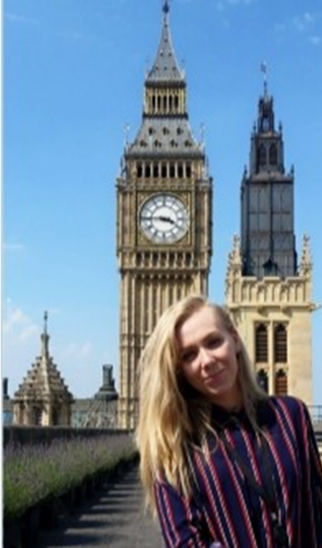 | 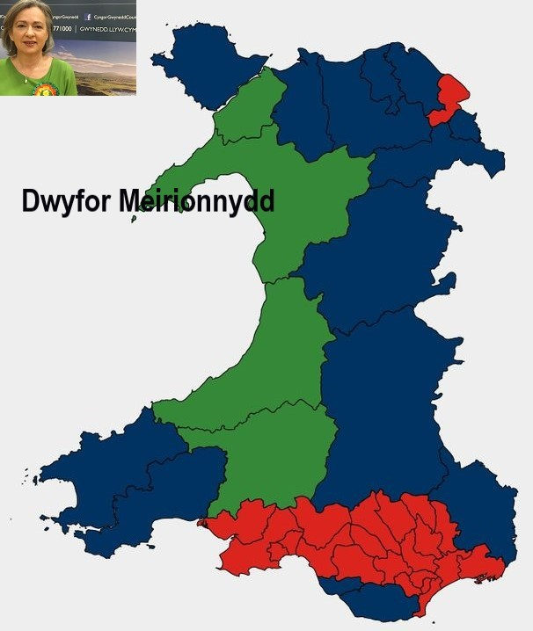
I was placed with Liz Saville-Roberts MP, the leader of Plaid Cymru at Westminster (although, in fact, I worked for all four Plaid Cymru MPs, including Ceredigion's newly elected MP, Ben Lake). My placement started in the first week of the new Parliamentary term after the snap general election, which itself was an important time. However, the biggest event I experienced was the unveiling of the European Union Withdrawal Bill, which threw the House of Commons into a state of flux.

On my first day I was thrown into the deep end to write a research brief on the RNLl’s status in Ceredigion. My tasks thereafter included attending meetings on behalf of the MPs, researching numerous topics for the policy advisors, writing an open letter to be used by leader of Plaid Cymru, Leanne Wood, and writing press releases for BBC and Russia Today. All matters regarding the nuclear safe guarding agency EURATOM were given to me, and I particularly enjoyed writing a 6 minute-long speech for Liz Saville-Roberts on the consequences of UK withdrawal from EURATOM for a major debate in Westminster Hall, which was also broadcast live on BBC Parliament.

I attended the first Prime Minister's Question Time of the new parliamentary term, numerous All Party Parliamentary Group meetings on subjects including EURATOM, several West minster Hall and Chamber debates, Ben Lake MP's maiden speech in the chamber, a one-on-one tiffin with a peer in the House of Lords Tea Room, and Plaid Cymru's summer recess night out.

One of my most memorable moments happened on my second day when I literally walked into Theresa May as we both headed to PMQs. Her armed security guard told me to wait at the door and let her proceed in front of me, so I did, and then he shuffled me into her small entourage before following behind us. I had to walk through Westminster pretending that I belonged with her and her three advisors and try not to look as confuse d as I was feeling.

I had to work to tight deadlines, so I certainly learned more about time management. I also learned a lot about British politics, which is something I was lacking due to my knowledge and experience focusing primarily on Russian politics. I was able to improve some skills that I had already began to obtain, including skills useful for journalism, such as research and formal writing.

The placement opened up numerous windows of opportunity. Networking during my placement has provided me with several useful contacts which I will be able to use after I graduate to further my career progress. This placement and the tasks which I undertook are very credible additions to my CV. During my placement I was offered paid employment as an intern for Ben Lake MP, and the money has contributed to funding further study after I graduate from Aberystwyth.

My advice to hopeful applicants would be to apply and try going out of your comfort zone with regard to who you want to be placed with. I am not a member of, nor allied to any specific party, so I left it to the coordinators of the placement to allocate me to whomever they pleased. I was slightly hesitant when I learn t I had been placed with Plaid Cymru - I imagined I'd walk into an office of independence-plotting MPs singing patriotic Welsh anthems all day - I couldn’t have been more wrong, and I had arguably the best experience available. So, I advise all hopeful applicants to consider being placed with in a different party to broaden your political knowledge and get a fresh perspective of UK politics from the inside.

Student: Sam Shenton
Placement: Dan Jarvis MP, Labour (Barnsley Central), House of Commons
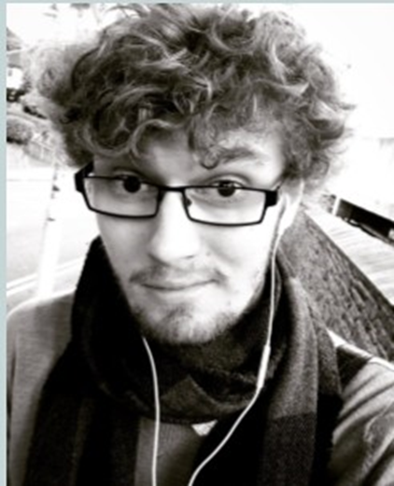 | 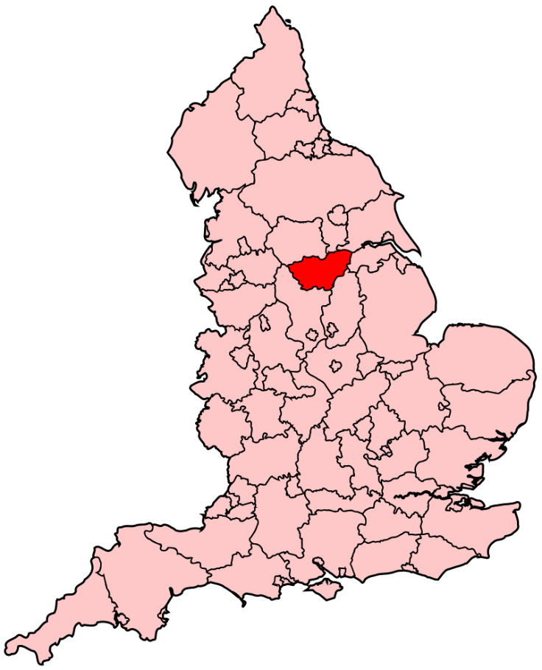  Barnsley Central constituency
During my placement I worked for Labour MP Dan Jarvis, who represents Ba rnsley Central. Some of the main events we focussed on during my placement were, of course, Brexit, as well as the aftermath of the Queen's Speech. Dan also stepped up his campaign to change the organ donation system in England to one of deemed consent, or opt-out, and I was involved in that.

With the campaign to change the system of organ donation, I was involved in showing a family involved in this campaign (relations of Max Johnson) around parliament and arranging their tickets to Prime Minister's Questions. Dan had a question scheduled on the issue to First Secretary of State Damian Green, standing in for Theresa May, which linked to Max's heart condition and the policy of organ donation. Other than that, I was also involved in writing responses to constituents and others, corresponding with the Barnsley office, collecting and sorting mail, and the joys of answering the phone.

I attended the Yorkshire Farmer' s Forum in Parliament, which was fun and nice to hear familiar accents talking about Yorkshire produce. Showing the family of Max Johnson around was certainly the highlight and also hit quite close to home because of my family's history with a similar heart condition.

My placement result in an improvement in written communication skills, particularly my letter writing. And, frankly, the experience reduced my shyness as I had to speak to a variety of new people as part of my placement. It was good to be plunged into talking to people I hadn’t met before and network with them. The Yorkshire Farmer' s Union event was a particularly notable example here - I didn’t' t realise I knew so much about sugar beet production!

I really benefited from the placement. London is, first and foremost, a fantastic place to experience for longer than a short break. The halls of the Palace of Westminster are also striking if nothing else. The skills I have developed including inter-personal skills are also of considerable benefit.

My advice would be to make sure that you communicate with those you are placed with if any personal circumstances arise, enjoy working with them, and let them know if there are problems. I would advise you to go into the placement with an open mind - don' t fix your expectations in any particular way. Just take each task as it come s, but at the same time, ask if there is anything you can specifically do, that you are good at or want to improve. Also, budget well: London is expensive!

Student: Richard Watt
Placement: Stephen Crabb MP, Conservative (Preseli Pembrokeshire)
House of Commons
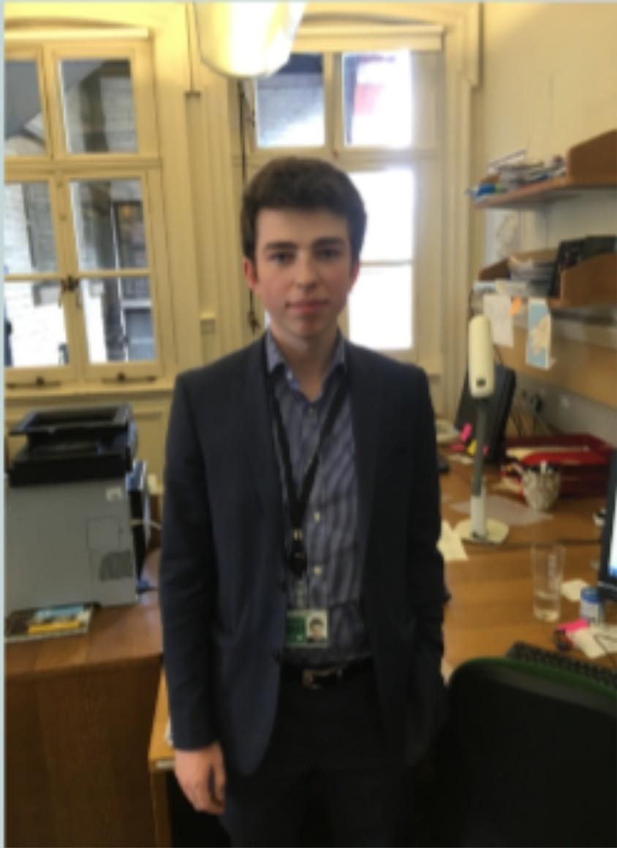 | 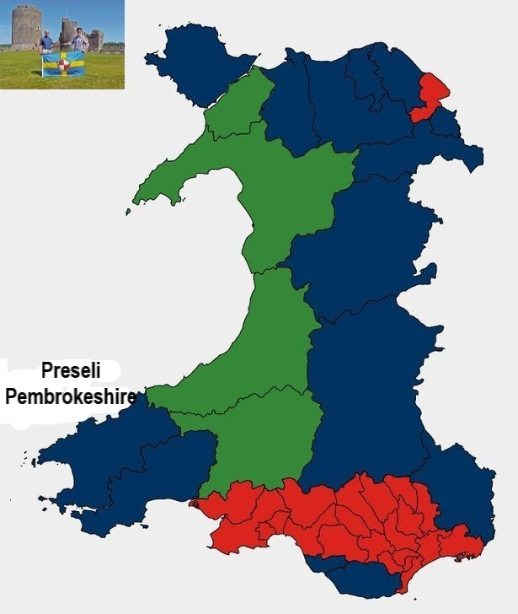

Looking back over last year's reports, I thought I would have been in for a comparatively boring 6 weeks on my placement. There was no referendum fast approaching and everything seemed to be set for a strong Conservative presence in Westminster. This, however, was to be far from the case. I started my placement four days after the snap General Election of 2017 - when the Conservative Party survived a major scare from Jeremy Corbyn's Labour Party.

I began working in the office of the Conservative MP Stephen Crabb, the member for Preseli Pembrokeshire. Every day I would commute to Portcullis House and must go through guest security (something that finally changes when you get a security pass!). Beginning my placement was rather daunting, I had never met Stephen or any of his staff, so I knew little of what to expect. I was, however, in capable hands, being helped by everyone I met. I worked alongside Stephen’s Parliamentary assistant, carrying out tasks such as managing his diary, replying to constituency e-mails, summarising reports, arranging and attending meetings within all areas of Stephen's interests (from the Qatari Ambassador to a meeting with the Irish Finance Minister to discuss issues pertaining to Brexit and the potential effects on trade between Ireland and Preseli Pembrokeshire).

While I was working for Stephen, I managed to attend the Queen's Speech debate, and also a number of Prime Minister’s Questions, watching how the politicians actually debate and talk about the running of the country. Having a constituency so far away in South West Wales, Stephen travelled and visited his constituents weekly, leaving myself and my colleague to get on with the tasks that MPs need completing, with the work never stopping. I quickly learned that in the political circles of Westminster, you need to be able to talk with confidence and intelligence to be heard. Our ideas used by Stephen in interviews and debates if they were thoughtful enough.

During my experience, I developed my role in supporting Stephen in West minster. It was a truly an eye-opening experience as I saw Stephen a number of times every day and I had the experience of being treated as a full-time member of staff. I learned what it really takes to work in such a demanding ever-changing environment. Having not really had an over burning passion for domestic politics, being thrown in with such an unusual situation, I have gained invaluable experience for both my life in general and for my thoughts about the political system we live in.

Overall, I had a wonderful experience and would highly recommend it to any Interpol student, whet her or not interested in domestic politics or not, it is just too good of an opportunity to miss, what have you got to lose!!

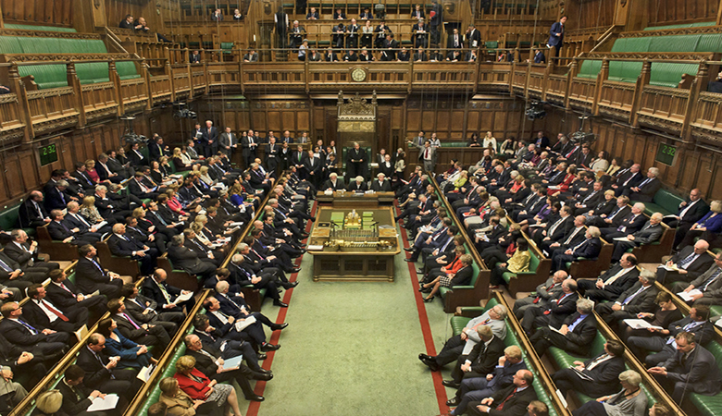

Student: Sam Wiblin-Rowlands
Placement: Ann Jones AM, Labour (Vale of Clwyd), National Assembly for Wales

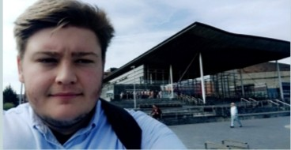 | 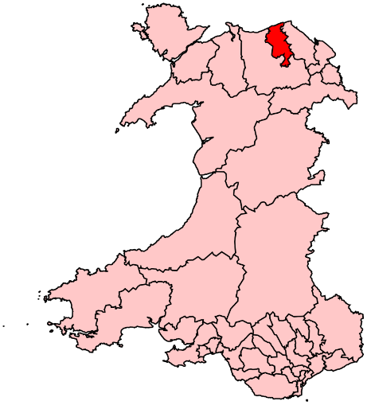  Vale of Clwyd constituency
During my placement I worked for Ann Jones AM, as well as the parliamentary Labour group office. The main events while working at the Assembly was the Grenfell disaster, and the affect that had on the politics behind social housing; and the Queen’s Speech, and the ramifications that had for Wales, especially with regards to the Barnett Formula. During my placement I had responsibility for several roles. The main area I focussed on was data analysis, producing briefs on every Welsh constituency using data from local council reports and the National Survey for Wales. When FMQ' s and plenary was in session, I would be responsible for creating video clips of AMs talking in the Siambr and uploading it to their social media accounts. The biggest highlight of my placement was being able to see how party politics worked behind the scenes and working with the Labour party whips to ensure that AMs followed the party line.

While working at the Assembly, I developed and improved several skills that will be useful in a large variety of workplaces. These included my research capabilities and my familiarity with software such as Microsoft Excel (for producing and analysing spreadsheets). My oral communication skills also developed – an essential skill in any working space involving politics.

I really benefited from my time in the Assembly. I made great contacts in the Labour office, an essential experience if you are considering a career in politics. The placement demonstrated to me just where a politics degree can take you. My advice to future applicants would be to use the CV services provided by the Careers Service! It was very useful to have constructive feedback on my CV and how to improve it. Also, if you are selected to go on a placement, try to not be too nervous on your first day and be sociable with other people in the office. You will be working with them for 8 hours a day for the next 4 to 6 weeks. If you are unsure of something, or if you are about to make a mistake, it is always better to ask for help.

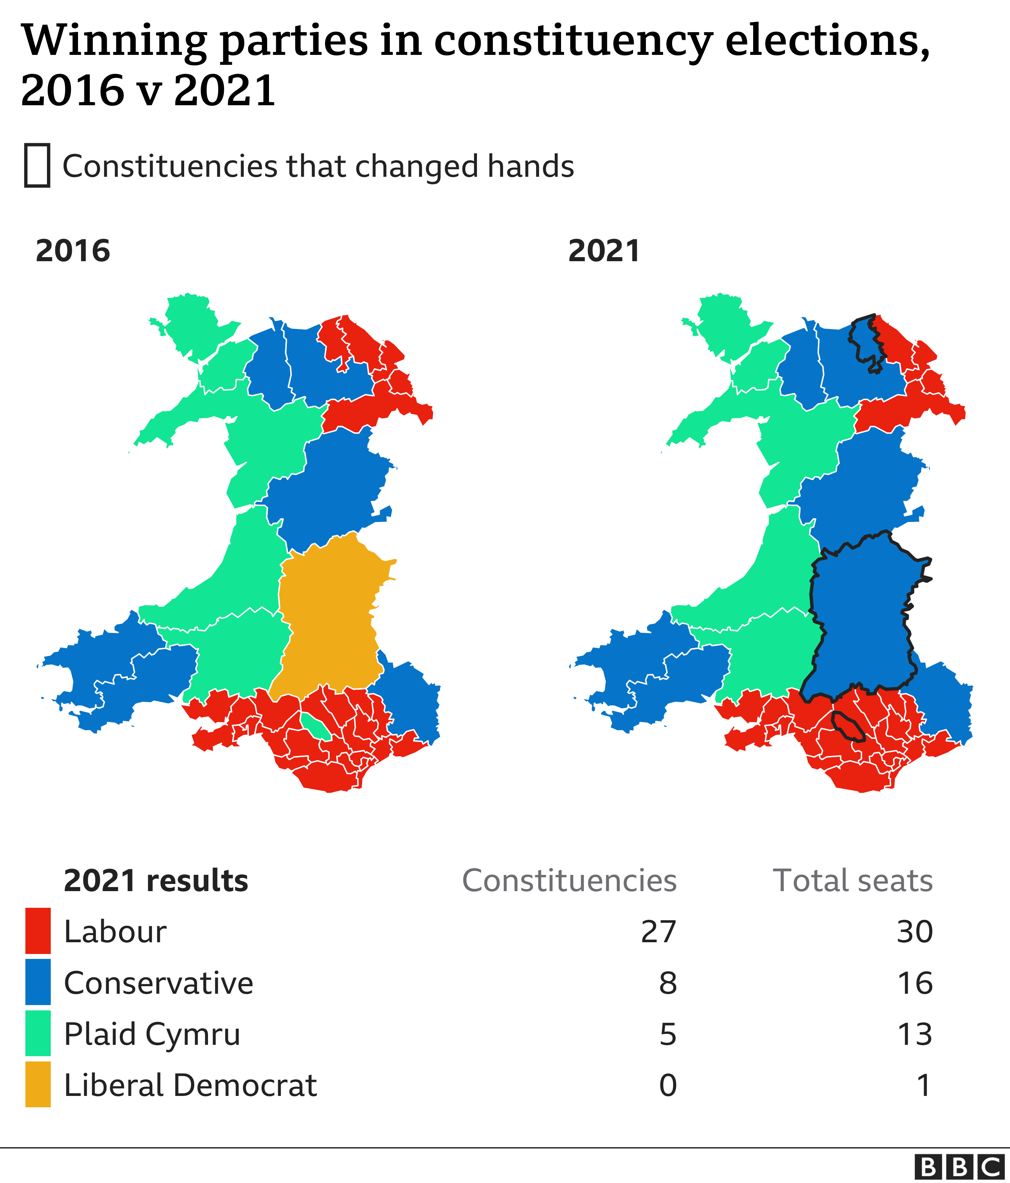
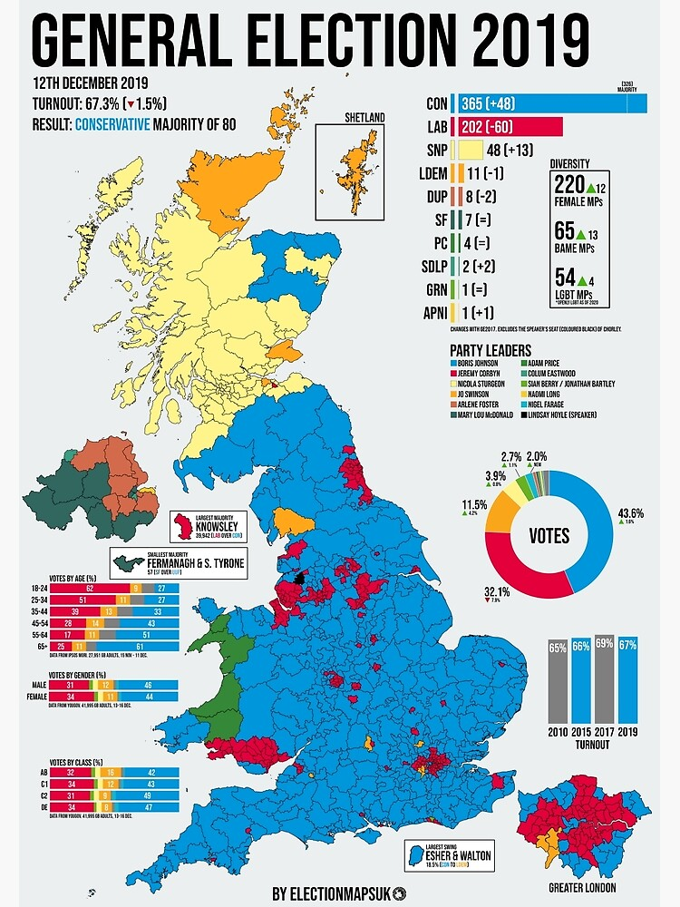

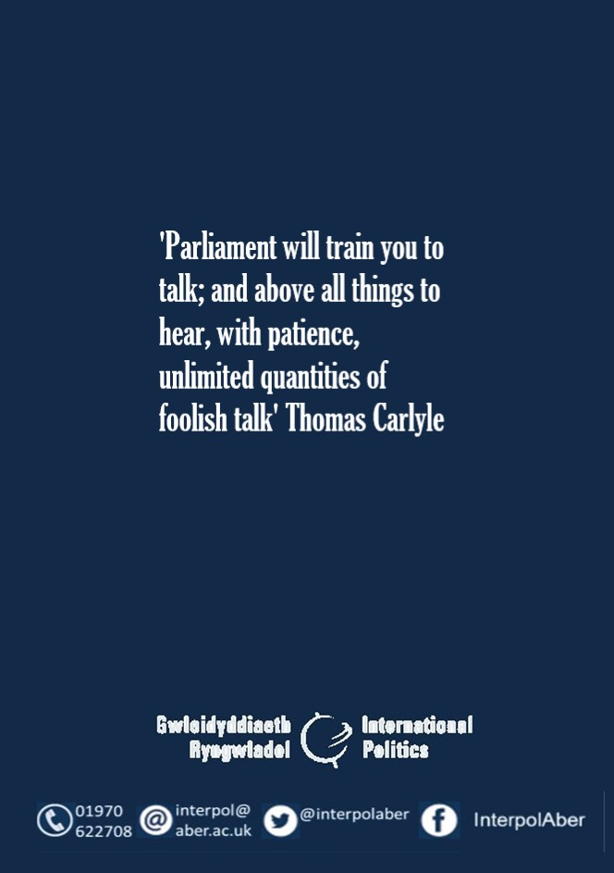

https://www.rhunapiorwerth.cymru/
National Federation of Young Farmers' Clubs, http://www.nfyfc.org.uk/
Other activity trackers are available.
Chuka Umunna resigned from the Labour Party in February 2019. He was then a founder member of the so-called Independent Group (later Change UK). He subsequently left Change UK and, after a short time as an independent, he joined the Liberal Democrats. He failed to be re-elected in the 2019 general election.
Imperial War Museum, https://www.iwm.org.uk/
European Atomic Energy Community, https://ec.europa.eu/energy/topics/nuclear-energy_en
The Barnett Formula is a mechanism used by the Treasury in the United Kingdom to automatically adjust the amounts of public expenditure allocated to Northern Ireland, Scotland and Wales to reflect changes in spending levels allocated to public services in the constituent parts of the UK. The formula applies to a large proportion of the budgets of the devolved governments.

