Panopto Lecture Capture Software Guide

*Learning and Teaching Enhancement Unit (*[*elearning@aber.ac.uk*](mailto:elearning@aber.ac.uk)*)*

*September 2024*

Panopto is the University’s Lecture Capture Software. For further information on its use, please consult the Aberystwyth University’s [Lecture Capture Policy.](https://www.aber.ac.uk/en/is/regulations/lecture-capture-policy/)

This guidance is split into six sections:

## Getting Started

## Make a Recording

## Link Recording to Blackboard

## View and Edit Recording

## Copy and Share Recording

## Editing Captions

## Panopto Shortcut IconGetting Started

* Log into a PC in a teaching room and wait until Panopto opens automatically or click on the Panopto icon on the desktop.
* 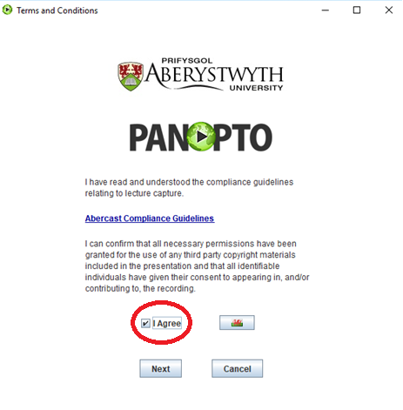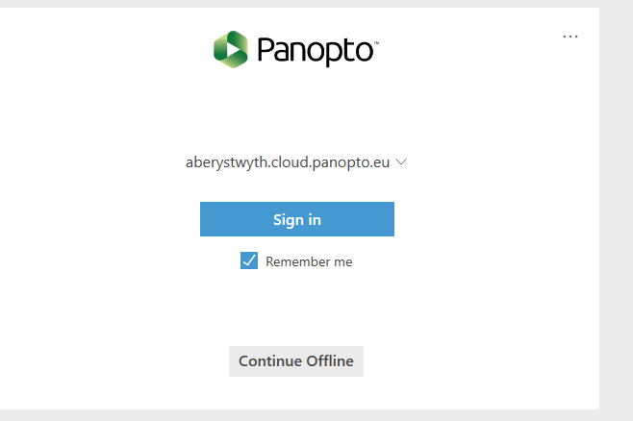When you see the 'Panopto Compliance Guidelines' tick **I Agree** and click **Next**.
* **Untick** the **Remember me** on the log in screen as you are using a shared machine and proceed to sign in using your AU username and password.
* A browser window will open prompting you to enter your Aberystwyth University username and password.
* You will then be taken into Panopto to start recording.

## Make a Recording

Naming and Folder location

* The first step is to choose the correct location to save your recording. Click on the drop-down arrow on the top right and either:
  + choose the module folder and remember to select the correct academic year for the module in question
  + OR type in the module code / name in the search bar.
* **NOTE:** The default folder location is the folder you last made a recording in.

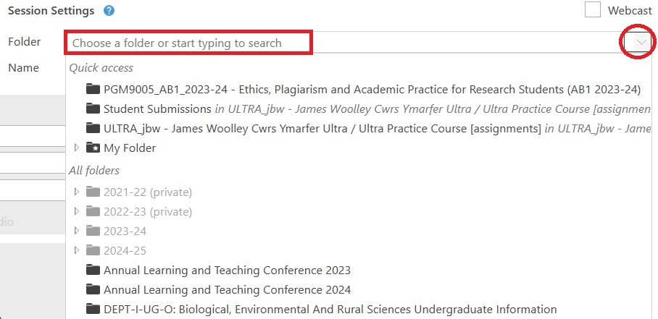

* It is important to give your recording a meaningful name so that you and your students can find the recording easily as the default name is the date and time of the recording.

Session Settings with Name of recording circled

Checking Settings

Before starting a lecture and making a recording check that the settings are correct. In the **Primary Sources** settings on the left-hand side choose:

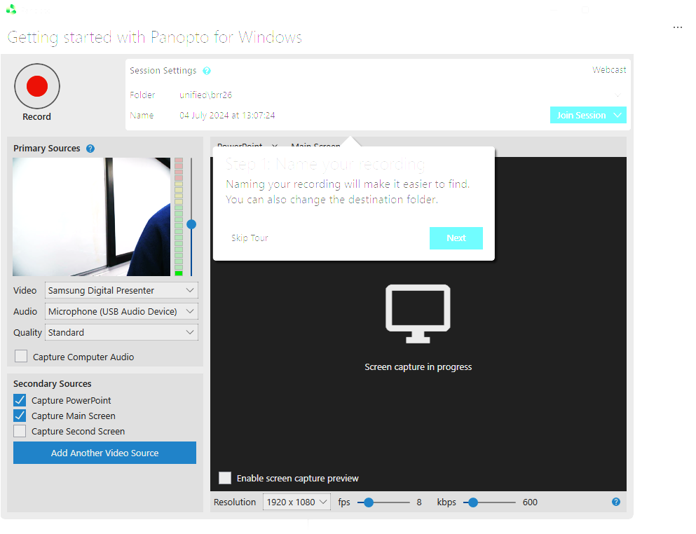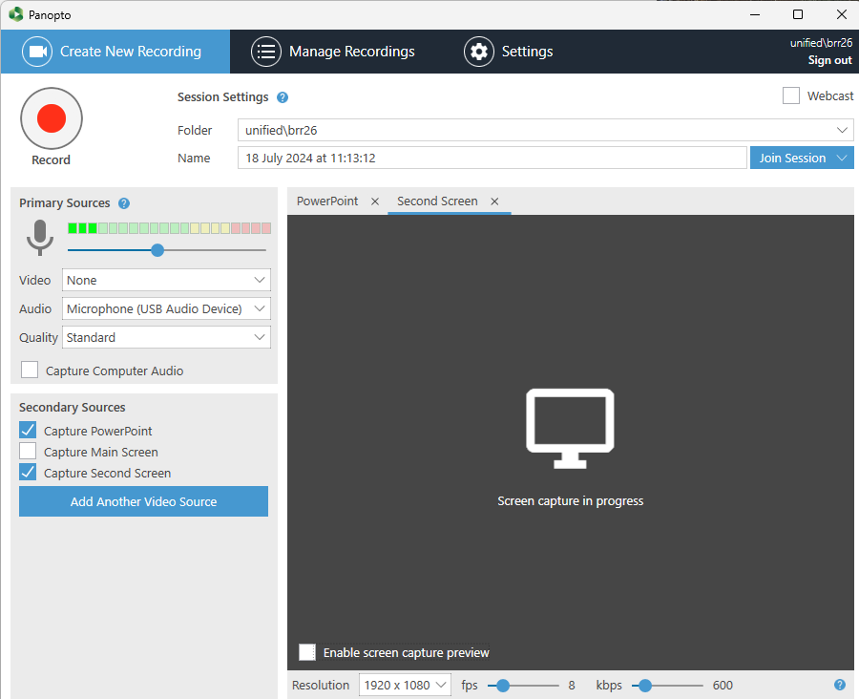

**Video**: Select **None** if you only want to record the presenter's audio and not video. To record video as well as audio select **Samsung Digital Presenter**

**Audio**: Choose **Microphone (USB Audio Device**) to record the audio with a Neck Microphone. To ensure adequate sound levels check there are 2-3 green audio bars highlighted. Move the slider on the right of the audio bars to increase the volume of the recording.

Quality: Choose **Standard**

Check this option '**Capture Computer Audio**' if you want to record any sounds made by your computer whilst recording as well as the audio recorded by the microphone.

**Secondary Sources**

Select the **'Capture PowerPoint**' option if you're only using PowerPoint slides or **'Capture Second Screen**' if you want to show something else on the monitor.

A screenshot of a video recording
When all the settings are correct, click the red record button at the top right (or you can press F8) to start recording. If you have started your PowerPoint presentation through the Panopto recorder there is an option to start recording automatically when you start the presentation.

A screenshot of Pause button
To pause the recording press the 'Pause' button (or F9 on your keyboard). You may need to pause the recording for an informal question and answer session or during a class discussion. Remember to restart the recording at the end of the informal session.

When you've finished your lecture press the 'Stop' button at the top (or F10 on your keyboard) to cease recording.

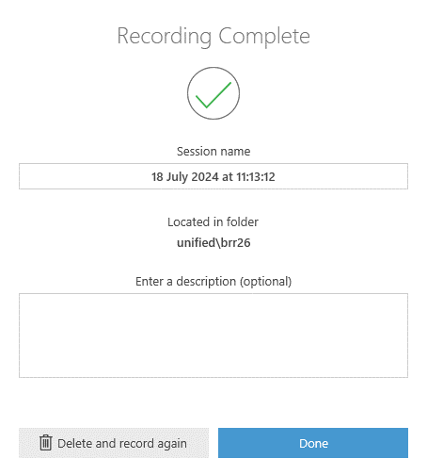

* In the **Recording Complete** dialogue box you can change the title of your recording and enter a description of the video, then click **Done**. (If you are unhappy with the recording, you have the option to **Delete and record again**.) The system will then automatically start uploading the recording to the server. Once this has been completed, you will receive an email notification.
* You can now log out of the computer while the recording uploads.

## Link Recording to Blackboard

In line with the Blackboard RMP (Required Minimum Presence) the link to the Panopto course tool should sit in the 'Module Information' folder. You can also create a link to the Panopto module folder (so that students can see all the recordings in one location).

Single Panopto recordings should be included alongside the relevant learning materials / activities for the module.

### Add a link to a single recording

* To add a link to a single Panopto recording in Blackboard, open the required module in Blackboard
* Open the **Module Information** folder
* Click the purple plus icon **(+)**
* Click **Additional Tools**
* Click **Single Panopto video**

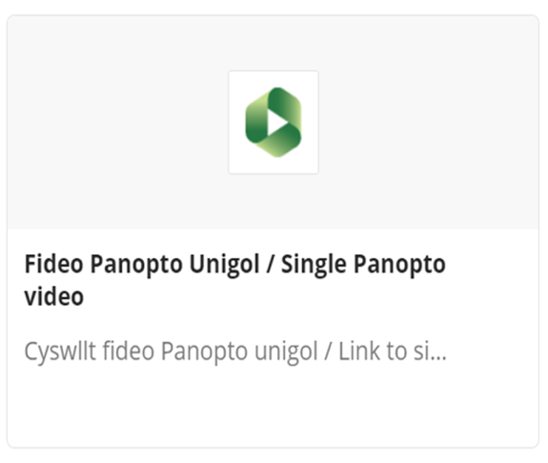

* Select the video by checking the checkbox and click 'Insert'. You will see a confirmation message **Content Items loaded** when the recording has loaded successfully.

### Add a link to all recordings

* Open the **Module Information** folder
* Click the **plus icon (+)**
* Click **Additional Tools**
* Navigate to **All Panopto videos** and click on the **plus icon (+) in a circle** in the bottom right-hand corner.

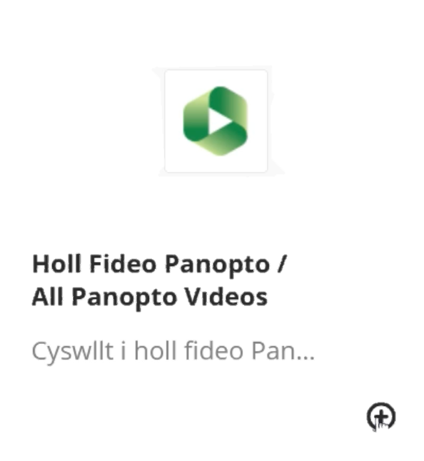



* A link to **All Panopto Videos** for the module will appear in Blackboard. Remember to set make the folder **Visible to participants.**

## View and Edit Recording

### View Recording

To view your recording, log into Panopto at [panopto.aber.ac.uk](https://aberystwyth.cloud.panopto.eu/) and choose the correct folder destination in your video library. Click on the image to open and view the recording.

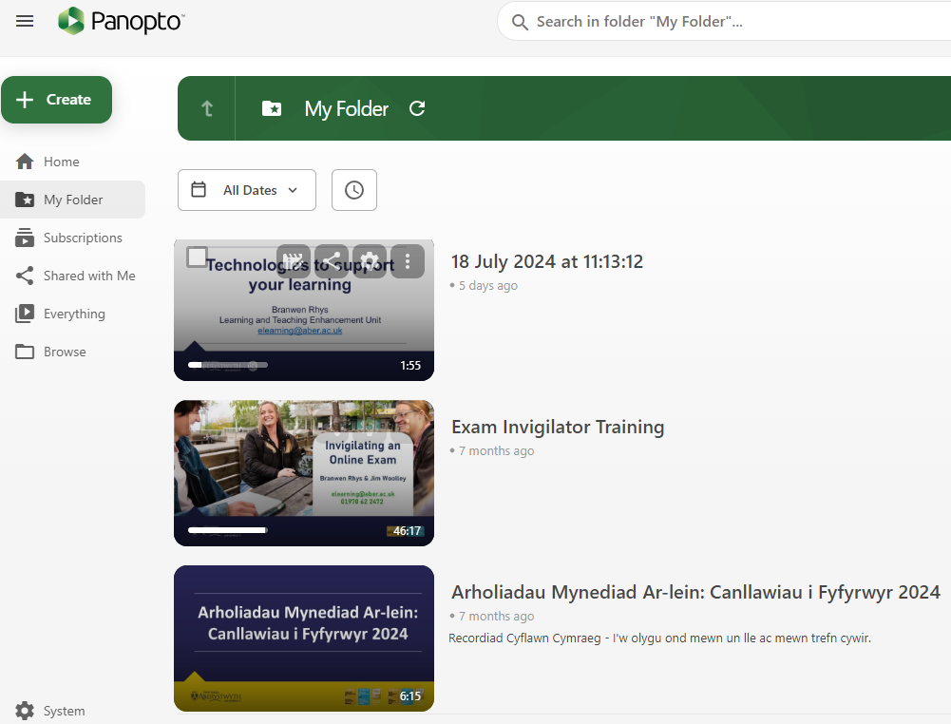

### Edit Recording

* There is no requirement to edit recordings, although you may wish to edit the start and end of lectures in some circumstances. See the [AU Lecture Capture Policy](https://www.aber.ac.uk/en/is/regulations/lecture-capture-policy/), point 4.5 for examples of situations where editing would be required.
* To edit a recording, select the recording in the checkbox and click on the **Edit** icon.

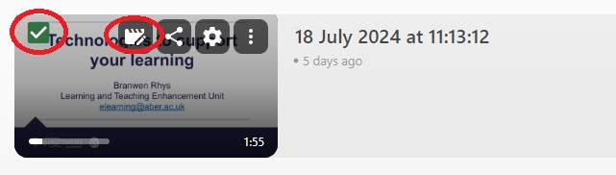

* The video will open in the Panopto editor.
* A timeline will open at the bottom of your recording showing the different streams, Primary and Secondary Streams. Each stream will be on a separate row. When you play the recording in this view, a vertical red bar will move through the timeline. (See below)

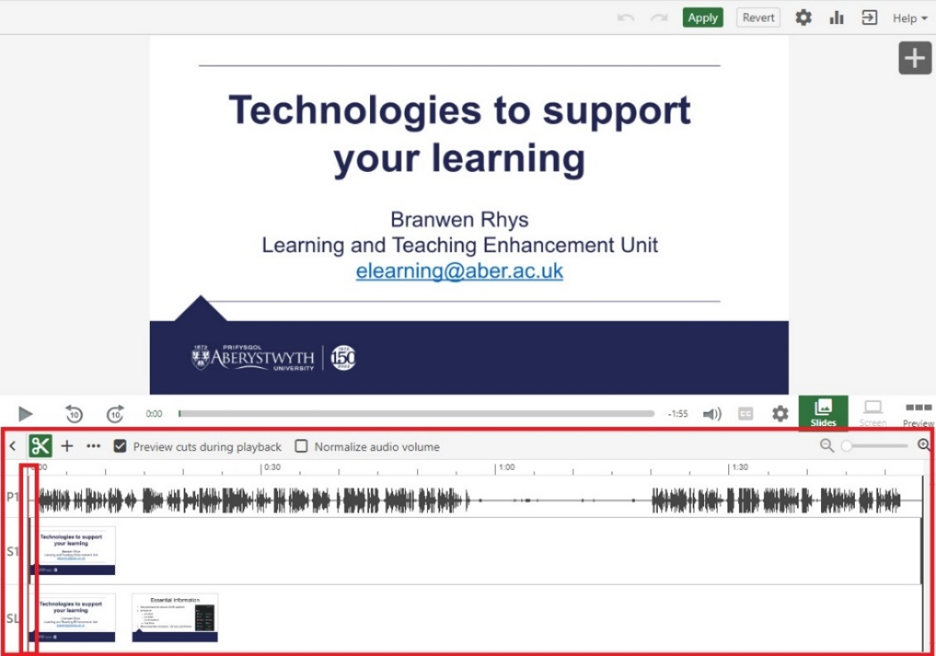

* To edit or trim your recording click on the **cut** or **scissors** icon.



**NOTE:** Before editing an original source video, the user will receive a warning window indicating that the video is referenced by other video(s). For further information on Reference Copies click[*Learn About Video Reference Copies*](https://support.panopto.com/s/article/Learn-About-Video-Reference-Copies)*.*

* Two grey lines will appear, one at the beginning and one at the end of the timeline. To cut a section from the beginning of your recording, play the video and pause it just before you’d like to start. Select the **Scissors** icon and drag the grey line to trim or cut out this section.

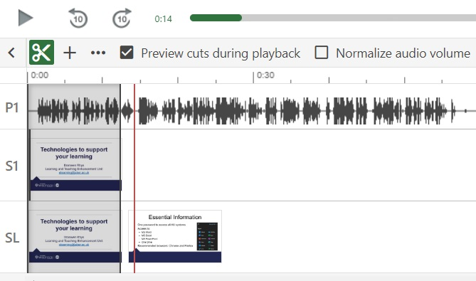

**NOTE:** The grey line will snap into the same position as the red line allowing you to be precise with any cuts.

* Trimmed out sections will always appear in your timeline – but they will not appear during playback after publishing your changes. It is possible to re-insert the cut sections if you need to at a later date. When you have finished cutting the recording click **Apply** on the top right-hand side of the screen.

## Copy and Share a Recording

To copy Panopto videos from previous years, it is recommended to copy them into the current years’ folder of the course. This allows access to all students enrolled on the Blackboard course to view the videos:

* 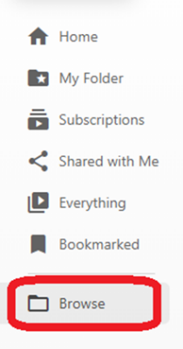**Log in** to Panopto
* Use **Browse** in the left-hand menu to locate the folder **from which you want to copy**. Alternatively use the search bar at the top of the page.
* **Select** the video or videos you would like to copy.

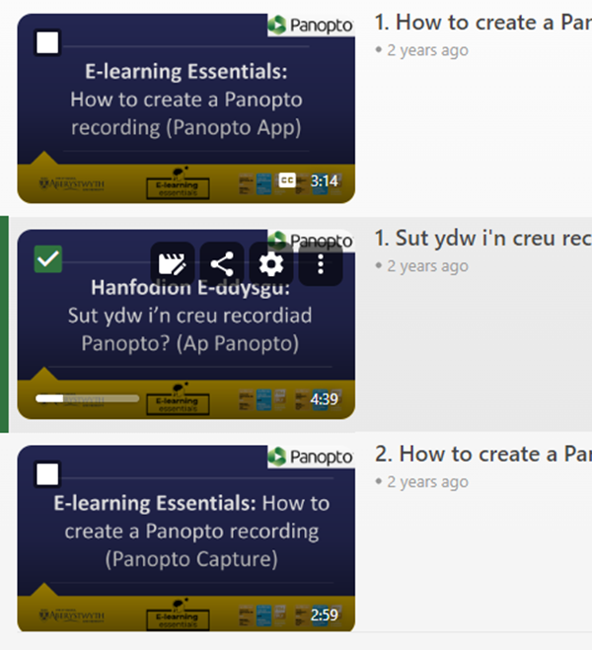

* Press the **Copy** button.

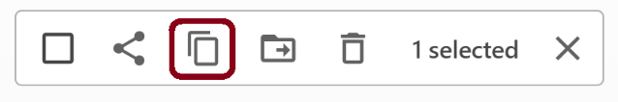

* Locate and select the folder you want to copy the video to in the dropdown menu that appears. Press **Copy**.

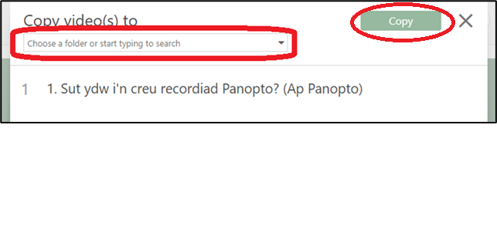

**NOTE:** This process creates a reference copy of the video which takes up minimal additional storage. Video reference copies refer back to an original source video but with a completely clean slate of viewer-contributed metadata, such as quiz results, comments, and notes. When its source video is edited, the reference copy will automatically also reflect the same edits.

### Share a Recording

To manage the sharing permissions on a recording login into Panopto and select:

* **Manage Recordings** (at the centre top of the screen)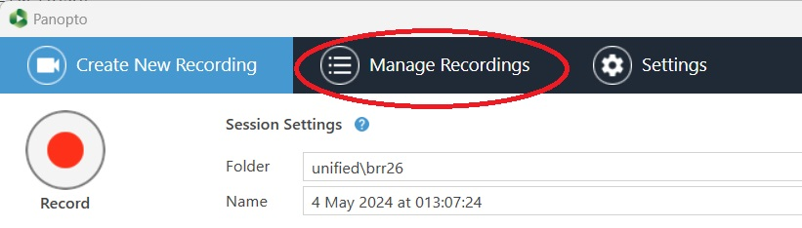
* 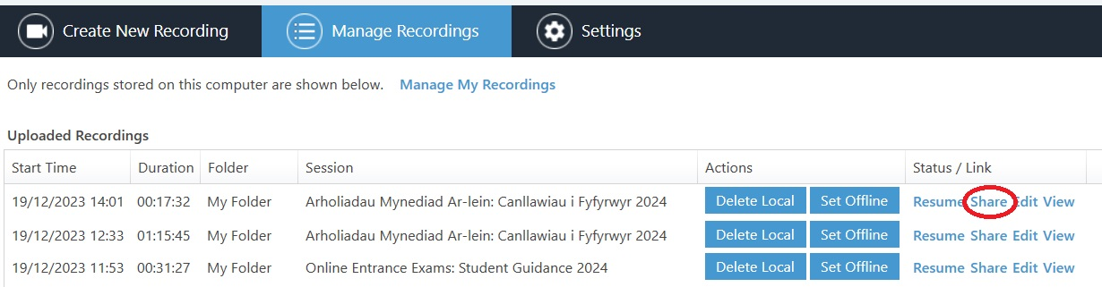**Locate the** required **recording and click Share on the far right-hand side**
* Press **Change** to select the option you wish to use. See [this article on the Panopto Support pages](https://support.panopto.com/s/article/Share-a-Video#hTargetInstance1) for more information.
* Select **Link** and click on the **Copy Link** button to circulate the recording. 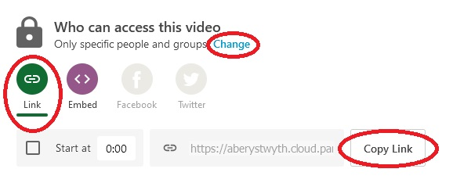

## Editing Captions

Panopto has the capability to add Automatic speech recognitions (ASR) captions to all recordings made in Panopto. **Captions are not 100% accurate** and we would recommend checking the captions carefully before publishing them. To view and edit the captions on your recording,

* Open Panopto and navigate to the recording you would like to see the captions
* Select your required recording and click on the**Edit** icon.



* Select **Captions** from the left-hand navigation menu and you will see the captions for your recording.

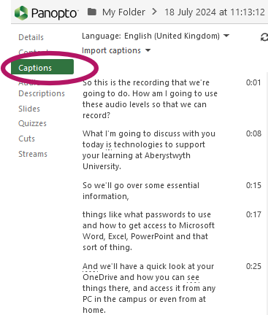

* To edit the captions, simply double-click on the required caption and amend the text as needed.
* A screenshot of the Closed Captions button highlightedTo see the captions on screen when viewing the recording, press the **Closed Captions CC** button.

### Welsh Language Captions

If you wish to use to enable Welsh captioning, you will first need to [change the language of your Panopto folder to **Welsh**](https://faqs.aber.ac.uk/index.php?id=9392)**.**

Next **Import automatic captions** for the required recording.