Using Podcasts in Teaching
Learning and Teaching Enhancement Unit, October 2020
Contact: lteu@aber.ac.uk

Create a podcast using Panopto
Panopto is the University’s Lecture Capture software. In addition to recording lectures, it can also be used to record podcasts.

The only requirement for a recording is an audio feed. Panopto also has some additional functionality when it comes to recording – you are able to edit the recording.

In order to create podcasts you will need to make sure that you have installed Panopto onto your machine: https://faqs.aber.ac.uk/707

Resources for Panopto:

Webpages: https://www.aber.ac.uk/en/is/it-services/elearning/lecture-capture/
FAQs: https://faqs.aber.ac.uk/index.php?search=Panopto
Blogposts: https://wordpress.aber.ac.uk/e-learning/category/panopto/

How do I make a recording using Panopto? | https://faqs.aber.ac.uk/index.php?id=681  If you wish to only record your voice, ensure that you have None selected in the Video source.  Panopto won’t record without an Audio Source so ensure that this is selected.  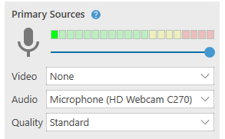
How do I edit a Panopto recording? | Undertaking a podcast in one take can be quite tricky. You are able to edit the recording after you’ve created it.  See further information on how to edit your recording: https://faqs.aber.ac.uk/index.php?id=2289  If you don’t want to work in a live Panopto folder you can use your practice module folder so that you can edit the recording before making it live to your students.  When you are happy, you can move the podcast to the module that you are teaching on: https://faqs.aber.ac.uk/index.php?id=988
How do I add quizzes to a Podcast? | Just as with lecture recordings, you are also able to add quizzes to podcasts to make listening to them active. For further information, see this FAQ: https://faqs.aber.ac.uk/index.php?id=2771  Do, however, think about what you want your students to be doing at the time of listening to the podcasts. Whether or not adding a quiz is appropriate depends on the design of your podcast.
How do I download and share my Panopto recordings? | Once you are happy with your podcasts you are able to download them in .mp4 format so you can share it with others. Further information on how to do this is here: https://support.panopto.com/s/article/How-to-Download-Video-or-Audio-Streams-as-MP4s  You can share it with students via Blackboard by creating an item in your content area and adding the .mp4 file as an attachment.  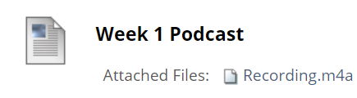
How can I create a Podcast which includes online discussion? | To create a Podcast which includes online discussion, arrange a meeting in MS Teams and record it using Panopto. Make sure you don’t capture the screen nor select any camera, so that only the audio is recorded.

Ten top tips on creating, designing, and releasing podcasts:
- Try and create podcasts regularly and ensure you consistently release them – this might be monthly, every other week, or weekly.
- Ensure your students know how to access the podcasts and recordings. How are you making students aware that their podcasts are ready?
- Think about the learning outcomes of the podcast – what do you want your students to get out of it?
- Have a plan of what you want to say – you might wish to write the podcast out before commencing recording. If you would like your students to feed into the content, such as providing you with questions to answer, then remember to factor this into the timeframe.
- Think about what your student is doing whilst listening to the podcast – are you expecting them to be looking at other material at the same time? Are you expecting them to be able to complete everyday tasks whilst listening to the content? Design the recording accordingly and make sure you communicate this with your students.
- Think about the pace and tone of your podcast. As we’re dealing with audio content, you will have to consider how you are delivering the content.
- Be consistent with structures and also what listeners can expect from the podcast. Make it explicit to your students what the benefit of using it is.
- Storyboard your podcast – structure your material in the correct order.
- How are you measuring the success or impact of the podcast?
- How is the podcast complementing other learning and teaching activities?

Resources on podcasts and learning
Hopkins, J. 2020. ‘Podcasts and Flipped Learning’. Association for Learning Technology. [Online]. Available at: https://altc.alt.ac.uk/blog/2020/01/podcasts-and-flipped-learning/. Last accessed: 11.02.2020.  This blogpost provides an overview of the role that podcasting can have in higher and further education.  The author gives tips on using podcasting for:  - Lecture recordings  - Student-produced podcasts  - Flipped learning, supplementary podcasts and in-class quizzing  Julian Hopkins is a Learning Technologist at the City of Glasgow College. | Things to consider / activities for learning:  - Ask your students to create podcasts to provide fellow students with their own summaries of topics. Use the assessment folder feature of Panopto to ask them to upload their recording. You can then check and share with the rest of the cohort.  - Steer clear on producing lecture content for students – instead build in interactive activities for your students to do. Make reference in the podcasts to any other activities that students have been doing throughout the week – e.g., discussion board posts, email chains, etc.  - Think about how long you want your podcast to be. Research shows that shorter podcasts might be more effective for learners.
Wilson, I. 2019. ‘The Power of the Voice! – supporting learners on placement through podcasting’. Association for Learning Technology. [Online]. Available at: https://altc.alt.ac.uk/blog/2019/07/the-power-of-the-voice-supporting-learners-on-placement-through-podcasting/. Last accessed: 11.02.2020  This blogpost looks specifically at using podcasting for students out on placement so parallels could be drawn with Distance Learning.  Ian Wilson is Senior Lecturer in Education at York St John University.  A recorded podcast of this article is available online. | Ian uses a regular structure to his blogposts for each episode  - What the students should be doing the following week  - Support with their School Based Task  - Answer any of their questions  - A teaching idea  - Some motivational advice  Wilson, 2019  This means that his students were able to know what to expect from the podcast.  In addition to this, by sharing all students’ questions, he was able to provide answers to everyone.  The intention of this podcast series wasn’t to provide lecture material but a support resource for students out on placement. This could be useful for Distance Learners – especially those who are following a more structured Distance Learning programme with timely goals, learning sessions, and activities.
Salmon, G. & P. Edirisingha (eds.). 2008. Podcasting for Learning in Universities. Berkshire: McGraw-Hill Education.  This book is available online via Primo.  Although the publication is dated, Chapter 9, written by Mark J. W. Lee and Belinda Tynan, looks specifically at Podcasts and Distance Learning.  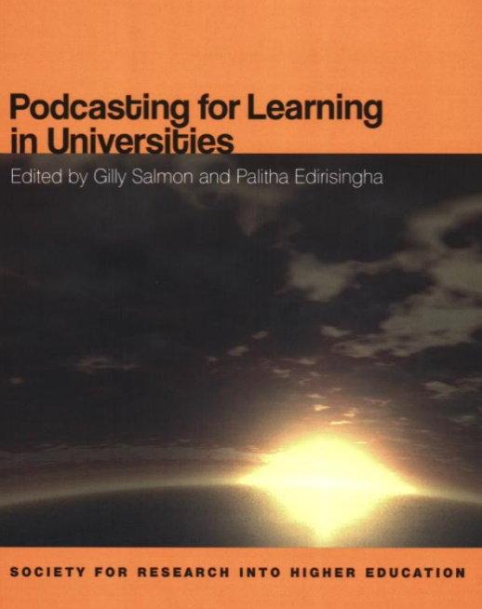 | Mark Lee and Belinda Tynan focus on 2case studies and look at podcasting for Distance Learners:  Case Study 1: Charles Sturt University (Australia) – Pp. 95-98  Lecturers in the School of Information Studies used pre-class podcasts to ‘address preconceptions and anxiety that students bring into the lecture hall’ (2008: 95). Student volunteers created and produced the material.  Case Study 2: University of New England – Pp. 96-100  Lecturers in the Law School sought to create lecture material for those on and off campus. According to the findings, ‘students claimed in anecdotes that podcasts helped them in their learning and reduced isolation they experienced due to studying at a distance’ (2008: 99).  The authors summarise the themes from the case studies (pp. 100-102):  - Increase learner motivation and engagement  - Facilitate and enhance learning outcomes  - Create resources for mobile and lifestyle learning  - Foster a sense of community

