Student Guide to Blackboard Learn Ultra 2023-24
Learning and Teaching Enhancement Unit (elearning@aber.ac.uk)

Contents
What is Blackboard? 2
Getting Started 2
Check your browser compatibility 2
Language preference 2
Ultra Base Navigation Overview 3
Accessing a Course 3
Course Navigation Overview 4
Viewing Panopto lecture recordings 5
Reading List 6
Assignments 6
Blackboard Assignment 6
Blackboard Tests 6
Finding Marks and Feedback 6
Interactive Tools 7
Discussions 7
Journals 7
Collaborative Documents 7
Accessibility 7
Logging out 7
Further Information 8

​
​
​
​

​What is Blackboard?
Blackboard is the University’s Virtual Learning Environment (VLE) - an online site for each course that offers a range of materials to support learning and teaching.

Getting Started
You can access Blackboard any computer, tablet, or mobile device connected to the Internet using a browser such as Google Chrome or Firefox.
Go to https://blackboard.aber.ac.uk
- Login using your Aberystwyth University username and password through the Microsoft Multi-factor Authentication (MFA). It is recommended to use the Microsoft Authenticator App on your phone – a quicker and easier way to login across multiple devices.
If you are using a public service workstation, you can access Blackboard by clicking the desktop icon. You can also access Blackboard from the Information for Students webpage by clicking on Your Sites and Blackboard.
If you cannot login to Blackboard contact Information Services (is@aber.ac.uk).

Check your browser compatibility
When you have logged into Blackboard you can Check your browser to ensure that your browser and operating system are supported. If your browser is unsupported some Blackboard features may not work as expected. Use a supported browser such as Google Chrome and Firefox when doing important tasks such as submitting assignments or taking an assessed quiz.

Language preference
Language preference is automatically taken from your student record. You can change the language interface in Blackboard by going to your profile in Blackboard and changing Language under System Settings.
Click on your name in the lefthand column and then click on the currently selected language to change your preferred language from the dropdown menu: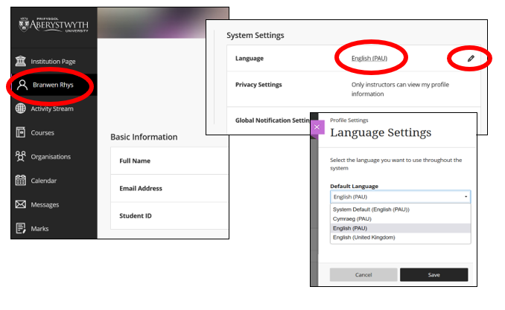
For further information see Blackboard’s Languages FAQ.

Ultra Base Navigation Overview
After logging into Blackboard, you will land on the Courses page. This is where you’ll see all the Courses on which you are enrolled. You will be enrolled on your Courses once you have completed Registration. There is a Blackboard course for every module you are taking. On 1st August each year, your will see your courses for the coming academic year.
Use the menu along the lefthand side to navigate to different functional areas of Blackboard.
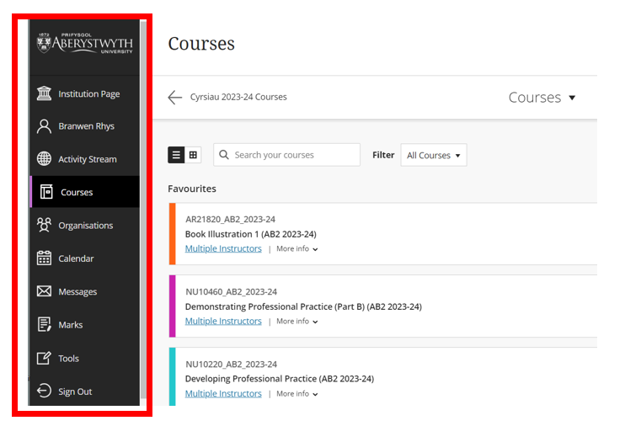
Refer to our How do I get started with Ultra Base Navigation FAQ for further information on how to:
- View your courses (Courses that you are enrolled on as a student)
- View your Organisations
- Manage your Profile
- View your Notifications

Accessing a Course
To access one of your courses in Blackboard click on the course from the course list or grid as seen below:
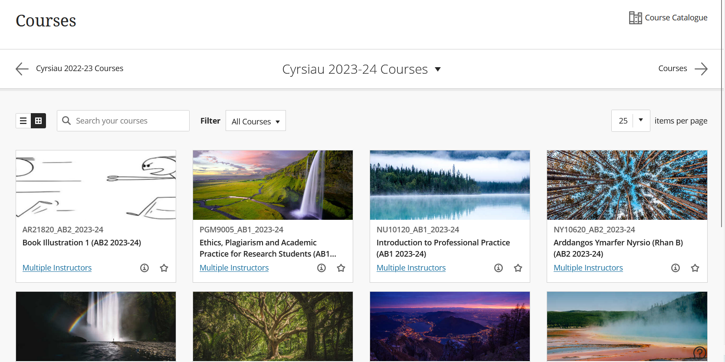
To access previous years’ courses, click on Cyrsiau 2022-23 Courses in the top left-hand corner. Alternatively, you can use the drop down in the middle of the screen (as seen above) to choose your preferred year.
If you cannot see your course listed contact your department.

Course Navigation Overview
Your lecturers are responsible for populating your courses with your learning materials, assessments, and activities. The University has a Required Minimum Presence that outlines what can be expected to be included on the course.
The courses have been created with two folders:
- Module Information: where you can expect to find information about how the course is run.
- Assessment and Feedback: where you can expect to find your assignment briefs and submission points.
Your lecturers will have also created an organised location for learning materials. Here you’ll find your course materials as well as any activities that your lecturer might ask you to do.
When you click on a course it will open in the same browser or tab:
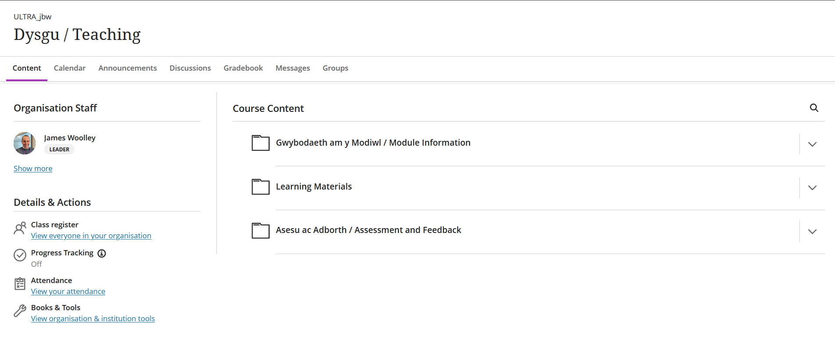
- Content: this is the Course Content landing page.
- Calendar: items like Turnitin and assignment due dates are automatically added to the calendar.
- Announcements: look here for announcements on upcoming tasks, deadlines, or activities;
- Discussions: lists all the discussions in the course.
- Gradebook: contains information on your assignments, exams, progress and grading statistics.
- Messages: Ways to communicate with other members of the course.
- Groups: Your tutor may arrange students into seminar groups, release activities based on group membership or create groups for assessed work; a list of group members is also available here.
Down the lefthand side of the Course Content Page are a list of useful links:
- Course Staff: lists staff who are contributing to the course. You can send a message to the staff member by clicking on the envelope logo next to their name.
- Class Register: lists all people enrolled on the course
- Progress Tracking: This feature allows you to track your own progress through the course (if your lecturer has enabled it). You can see what material you’ve viewed and what tasks are pending.
- Attendance is managed outside of Blackboard, so you can ignore this link
- Books and Tools: this is a quick link to your reading lists and Panopto recordings.
Take a look at Navigating Inside a Course in Blackboard further information.

Viewing Panopto lecture recordings
In line with the Lecture Capture Policy, Panopto is the software used to record lectures. You access your lecture recordings via Blackboard.
You can access all recordings on the course by clicking on the Holl Fideo Panopto / All Panopto Videos link:
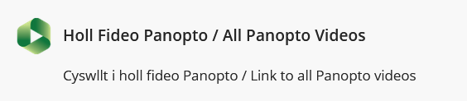
If your lecturer chooses to link to individual recordings, then they will display with the same Panopto icon.

Reading List
You can access your reading list via a link to your course’s reading list on the course. You can click on the link to access your readings:
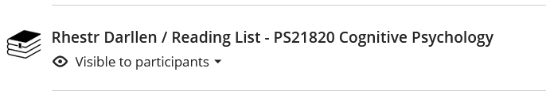

Assignments
In line with the E-submission Policy, all word-processed work is submitted, marked, and feedback released via Blackboard.
Most text-based assignments are submitted using Turnitin. For information on submitting via Turnitin, please see the FAQ How do I submit an assignment in Turnitin?

Blackboard Assignment
For some courses, you may be required to upload assignments through Blackboard Assignment, rather than Turnitin. For information on submitting via Blackboard assignment, please see the FAQ How do I submit a Blackboard Assignment?

Blackboard Tests
You may be assessed using Blackboard tests. These are used for everything from formative style low stakes assessment up to summative online examinations. Blackboard tests are located in your course. For information on how to participate in a Blackboard Test, see the FAQ Blackboard Test taking guidelines (student).

Finding Marks and Feedback
There are two ways to access your grades and feedback in Blackboard:
- The original Turnitin submission link
- The Gradebook in your course (Blackboard Assignment and Test)

Interactive Tools

Discussions
Discussions are interactive tools in Blackboard courses where you can post and respond to lecturers and other students. These might be used for online learning activities as well as for assessment.
Discussions are set up by your lecturers. For information on how to participate in a Discussion see the FAQ How do I use Discussions in Blackboard?

Journals
Journals are reflective tools in Blackboard courses where you can post time-stamped reflections. Journals are private between members of the course team and the student.
Journals are set up by your lecturers. For information on how to participate in a Journal see the FAQ How do I add an entry to my Blackboard Journal?

Collaborative Documents
Collaborative Documents are Word, Excel, or PowerPoint files that you and fellow students can collaborate on in your own time outside of classes.
Collaborative documents are set up by your lecturers. To collaborate on the document, click on the link and select Edit Document. As this links to Microsoft OneDrive, you may be asked to authenticate.

Accessibility
Blackboard Learn Ultra has been designed to be as accessible as possible. It is fully compatible with screen readers and other assistive technologies. For further information on Blackboard and Accessibility see Accessibility in Blackboard Learn.

Logging out
When you have finished using Blackboard, click the Sign Out button.
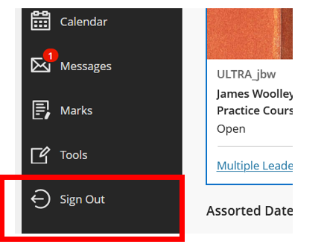

Further Information
- FAQs
- Blackboard Student Help Pages
- Information Services: is@aber.ac.uk / 01970 62 2400

