Allergies and food intolerances

At Aberystwyth University we have put in place procedures to make sure that our customers are informed of all allergens that are in the food that we serve.
There are 14 legally defined allergens, which are:-
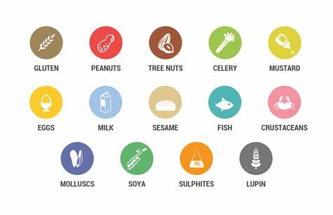
Gluten (Such as barley and Oats), Crustaceans (Prawns, Crab, Lobster), Molluscs (Mussels and Oyster), Tree Nuts (Such as Almonds, Walnuts, Hazelnuts), Eggs, Lupin, Milk, Mustard, Peanuts, Celery, Sesame, Soya, Sulphites, Fish

All these allergens are noted on a daily allergen sheet that is produced at all our outlets for the food that is being served. This will be on display, as well as the following symbols being placed onto our menus to show which of these are contained in the dishes.

All our food handling and production is controlled by our HACCP. These Hazzard Analysis and Critical Control Point procedures cover every part of our food process’. From auditing our suppliers to how we make and serve our food. This is then regularly checked by our independent environmental health consultant. These systems are to ensure we make note of all allergens and to prevent all possibilities of any cross contamination by allergens.

We also are very aware that some people are allergic or have intolerances to foods not listed on the allergen sheet as standard, strawberries and spicy food are two examples. In such cases our standard labelling will not cover these, so we ask that you please let us know any requirements you may have. In the Foodhall and Pantycelyn, all our food is made by our team of chefs. So, we will be able to ensure that we produce food that is safe for you to eat.

All the restaurants and cafes on campus are here to provide for you, our students. So please do talk to us to discuss your needs and requirements. Particularly if you have an intolerance or an allergy that is not part of the 14. Our priority is to help you have the best experience whilst studying in Aberystwyth. Part of which, is to ensure that you can buy food and drinks that comply with any varied and specific diets that our students have, and we would welcome the opportunity to talk to you about this.

Best Wishes

The Hospitality team
Hospitality@aber.ac.uk

