These procedures apply to:
- Every University department that utilises vehicles and trailers.
- Any University member who is required to operate a vehicle and trailer on University business, including the use of their personal vehicles to tow a trailer, combined authorised driver (Grey Fleet).
Introduction:
This document is designed as a guidance for departments with the purpose of ensuring that the University performs its duty of care to University members when their University related business requires the towing/use of trailers and any other towing equipment.
Proper use of trailers can be demanding on drivers and requires several factors to operate in a ‘safe’ manner, including driver licence category entitlement, driver competence, previous experience and a reliable knowledge of the risks, requirements, and restrictions in place on what can/cannot be towed as wells as the processes involved.
A ‘Brief’ explanation of vehicle weighting:
Unladen weight
The unladen weight of any vehicle is the weight of the vehicle when it’s not carrying any passengers, goods, or other items. It includes the body and all parts normally used with the vehicle or trailer when it’s used on a road. It doesn’t include the weight of fuel or batteries in an electric vehicle - unless it’s a mobility scooter or powered wheelchair.
Maximum authorised mass
Maximum authorised mass (MAM) is the weight of a vehicle or trailer including the maximum load that can be carried safely when it’s being used on the road. This is also known as gross vehicle weight (GVW) or permissible maximum weight. It will be listed in the vehicle’s manual and is normally shown on a plate or sticker fitted to the vehicle. The plate or sticker (see below image) may also show a gross train weight (GTW), sometimes referred to as gross combination weight (GCW). This is the total weight of the vehicle plus trailer plus load.
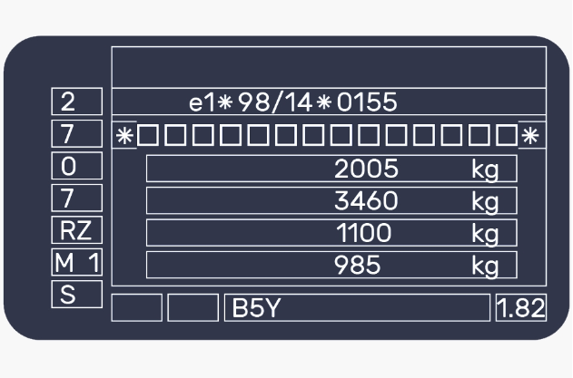
Weight 1 Maximum weight of the vehicle on its own. (GVW or MAM)
Weight 2 Maximum weight of the vehicle and trailer combined. (GTW)
Weight 3 Maximum weight for the front axle of the vehicle.
Weight 4 Maximum weight for the rear axle of the vehicle.
- Trailer with no braking system must not weigh over 750kg and should not weigh more than 50% of the vehicles weight.
- Trailer with braking system, the vehicle and trailer must not weigh over the second weight shown on the vehicle manufacturer’s plates.
Down-plating If a vehicle is unlikely to be used at its potential maximum weight, it may be ‘down-plated’. This means that a lower weight is shown on the plate or sticker attached to the vehicle.

Authorised drivers for towing:
The Travel and Fleet section maintains a database of all drivers permitted to drive fleet vehicles (who may be able to use a vehicle to tow or use trailers). Both authorised (uni fleet only) and combined authorised (uni fleet and personal vehicle).
It is the responsibility of the driver’s line manage to ensure that they forward their respective authorised or combined authorised driver form for processing. Thus enabling the driver to drive and tow a trailer for work purposes on behalf of the University.
Towing based and driving licence requirements:
Identifying what you can and cannot tow can be complicated, the rules on what you can tow and combination for towing are different depending on when you passed your driving test.
Licences issued BEFORE 1st January 1997
You’re usually allowed to drive a vehicle and trailer combination up to 8,250kg maximum authorised mass (MAM). View your driving licence information to check. You’re also allowed to drive a minibus with a trailer over 750kg MAM.
Licences issued AFTER 1st January 1997
If you passed your car driving test from 1 January 1997, you’re allowed to tow trailers up to 3,500kg MAM.
To check if you have the correct licence entitlement to tow a trailer visit.
Towing: licence and age requirements - GOV.UK (www.gov.uk)
Usage and towing:
Towing or using a trailer, can be challenging. Especially, reversing or manoeuvring in tight locations. Drivers should undertake trailer training from a recognised provider if they are unsure, regardless of having the entitlement to tow a trailer on their driving licence. Drivers must notify their line manager if they do not feel confident or competent. Do not tow or use a trailer if unsure.
It is essential that any vehicle used to tow or pull a trailer is fit for purpose, the below must always be considered when towing.
- Is it legal? Check the GVW and GTW before pulling any trailer. Refer to the manufacturer’s handbook.
- Is the vehicle and trailer combination safe and roadworthy? It is the responsibility of the driver to ensure that the checks have been performed prior to undertaking a journey with a trailer. Checking the tyres (conditions and pressure), 7 or 13 pin plug connections, coupling height, mudguards, lights, and brake away cable to name but a few.
- Plan your journey- be mindful of the terrain, braking and stopping performance, as well as responsiveness when starting (particularly steep terrain).
- Trailer and couplings can differ so always follow the manufacturer’s instructions. Make sure you know how to hitch the trailer correctly and connect the emergency brake cable. Ensure that the trailer is level when coupled to the towing vehicle.
- Pay extra care when manoeuvring corners and bends. If the trailer starts to snake or swerve on a journey, slow down gently. It’s a sign that you’re going too fast and/or the trailer is loaded incorrectly. Remember there is a towing speed limit of 60 mph on motorways and 50mph on single carriageways.
- Fit a legal number plate (Registration number and style) to the trailer, it must match the towing vehicle. No handmade numberplates.
All the above should be noted in the risk assessment for towing a trailer, to be read and understood by the driver. If you have not be given one, ask your line manager for a copy of the risk assessment.

Loading:
- Evenly distribute the weight of the load in the trailer and that the nose weight of the trailer is within the manufacture’s recommendations of the towing vehicle.
- Make sure any load is properly secured (secure points on the trailer) and use appropriate lashing and restraints. Ensure that any lashing or ratchet straps are used correct, to avoid coming loose mid journey.
- Never overload a vehicle or trailer. However, tempting it maybe. Spread the load and do 2 journeys instead of 1.
- Cover loose loads with sheeting and ensure it is rated for the load being carried.
- Ensure the jockey wheel, corner steadies/prop stands are fully wound up and properly secured.
When loading a vehicle or trailer, please follow the guidelines provided by Health and Safety to prevent injury or damage to the load. For more information on manual handling, please see the link to the relevant HSE webpage below:
https://www.aber.ac.uk/en/hse/proc-prac/manual-handling/
This page contains a generous assortment of guidelines, tools, and training material to assist staff with properly loading a vehicle or trailer.
Maintaining trailer integrity/functionality:
It is the responsibility of the relevant vehicle custodian within the department to ensure that inspections and servicing are carried out on trailers. Any trailer must be subject to same daily pre-use checks as the towing vehicle. Never drive a vehicle or trailer if it is not safe and/or unroadworthy. Regular and formal inspections, maintenance and servicing must be carried out by a recognised garage or mechanic. Inspections and servicing should be determined by the trailer manufactures’ intervals. However, inspections and servicing may need to be undertaken on a more regularl basis, depending on the age, condition, usage, and the terrain that the trailer is being operated in. All records for the inspections and servicing of trailers must be kept by departmental administrators and forwarded to the Travel and Fleet section as and when requested.
Relevant and useful webpages:
- Driving licence and towing a trailer –
New rules for towing a trailer with a car from 16 December 2021 - GOV.UK (www.gov.uk)
- Requirements for towing trailers in Great Britain-
Requirements for towing trailers in Great Britain (INF30) - GOV.UK (www.gov.uk)
- Towing with a car -
https://www.gov.uk/towing-with-car
- Tow a trailer or caravan with a car: safety checks-
Tow a trailer or caravan with a car: safety checks - GOV.UK (www.gov.uk)
- Securing loads on HGV’s and goods vehicles-
Securing loads on HGVs and goods vehicles - 5. How to load different HGVs, light goods vehicles, small vans and cars - Guidance - GOV.UK (www.gov.uk)
- Load security-
Load security (hse.gov.uk)
- NTTA (National Trailer & Towing Assiation) Guide to safe & legal towing-
NTTA Guide to Safe & Legal Towing

