ABERYSTWYTH UNIVERSITY
TRAVEL POLICY

Date of issue | December 2023
Prepared by | Maria Ferreira
Reviewed by | HS&E Operational Group & Research & Innovation Committee
Approved by | University Executive
Contact email | travelandfleet@aber.ac.uk

Contents Page

- Aberystwyth University Sustainable Travel Policy Statement 1

- Introduction 1

- Responsibilities 3

- Travel Management Company 4

- Recording of Information 4

- Insurance 5

- Risk Assessments 5

- Training for International Travellers 7
- International Travel Documentation 8

- Review and Audit Procedures 8

- Further Information 9

1.0 ABERYSTWYTH UNIVERSITY TRAVEL POLICY STATEMENT

It is the policy of Aberystwyth University, as far as is reasonably practicable, and in accordance with the relevant legislation, statutory requirements, and best practice, to ensure the security, health and safety of employees and students who travel on behalf of the University.

We must ensure that we take our ‘Duty of Care’ seriously and this document gives guidance to all engaged in travel and to those in the University who have a responsibility towards them.

2.0 INTRODUCTION

University staff who have a management responsibility for approving travel must ensure that it is for legitimate business needs. This policy supports delivering the University’s Sustainability Strategy and recognises the University’s responsibility to protect the environment from the impact of its operations and activities and to influence its staff, students, and the wider community to minimise their negative impacts through its actions, teaching and research. Aberystwyth University is committed to net zero carbon by 2030.Ensuring sustainable travel is a part of this commitment.
The challenge of our net zero ambitions cannot be understated. We therefore need to be ambitious and willing to change the way we operate, as well as continually seek opportunities to further reduce our emissions. For example, over the 12 months to July 2023, emissions from flights totalled 416 tonnes (CO_{2e}), which is approximately 3% of our total operational emissions.
Key actions on Travel from the ‘Net Zero 2030’ Strategy include:
- we will reduce total business travel and commuting emissions by at least 54% by 2030.
- we will reduce international travel-related emissions by 30% by 2030.
- we will reduce international air travel by 30% by 2030.
- we will reduce business car mileage by 30% through changes to travel policy.
Against this background, this Travel Policy sets out how all local, national and international travel taken on behalf of the University should take place.
Underlying the Travel Policy is a climate awareness approach of:
• understanding the environmental impacts of travel and using lower-carbon methods of transport where possible (Figure 1)
• minimising the overall number of journeys to reduce carbon emissions
Air travel is not permissible for travel within Great Britain except for the following exceptions:
• For journeys to locations out with mainland Great Britain, including to islands such as Shetland or the Outer Hebrides, as well as to Northern Ireland.
• For disability or other health-related reasons
• Where childcare or other caring responsibilities mean that flights are the only viable option to ensure the wellbeing of travellers and those they care for. In these limited exceptions, approval is required from the travellers Head of Department prior to booking travel.
These procedures are mandatory and should be regarded as standard practice for any travel taken on behalf of the University by staff and students. Where travel is paid for by restricted grant funding, certain principles regarding authorising of travel may not be mandatory.
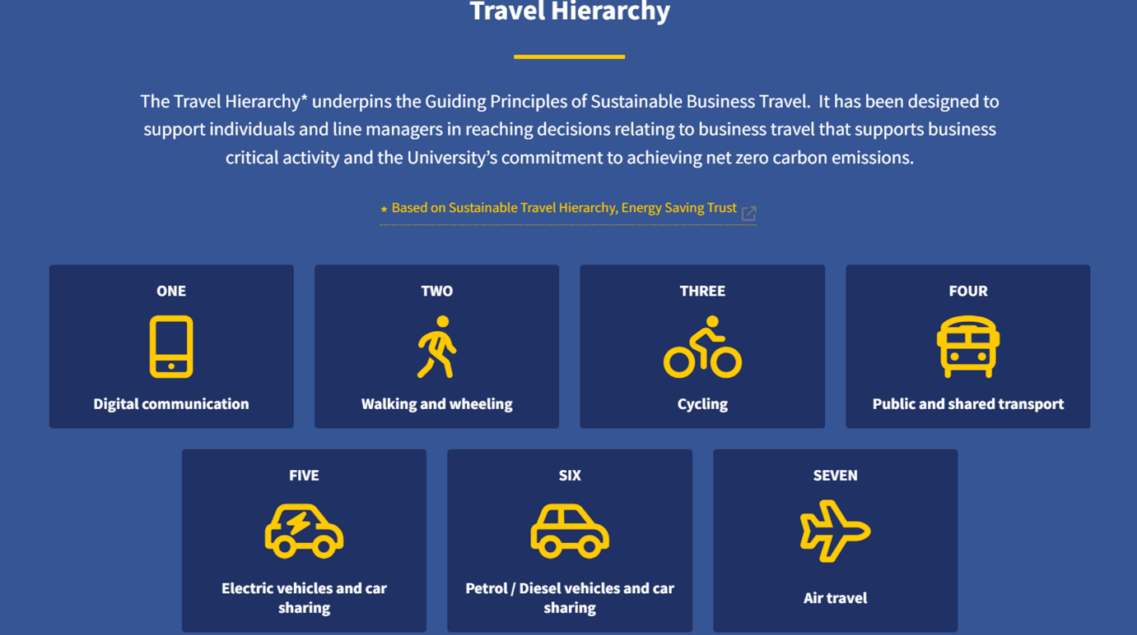
Figure 1

Scope of policy
For the purpose of this policy, standard ‘Business’ is the generic term used for activities associated with, and agreed through, the University, such as lecturing, research work, work placements, visits, fieldwork, business, recruitment, and conference attendance.

As travel is a regular part of the University’s activities it is important that all staff and students undertaking such activities are aware of the risks and are guided to follow the necessary protocol to prevent any ill health, accident, or disruption during their time away. For the avoidance of doubt, this includes those paid under consultancy contracts, invited speakers and those invited for the purpose of academic engagement (for example to attend a doctoral thesis defence). In exceptional circumstances, where travellers are unable to meet the following requirements, requests must be pre-approved by the travellers Head of School or Department.
The Aberystwyth University Travel Policy and supporting documents are designed to highlight the agreed principles, provide information, and guidance to all AU staff and students whilst maintaining the necessary records, as required by the University.

The term ‘domestic’ travel applies to all travel undertaken within the United Kingdom. The term ‘international’ travel applies to all travel outside of the United Kingdom.

Alternatives to travel must be considered prior to booking travel. Examples of alternatives include use of virtual collaboration tools (Teams, Zoom, or equivalent) as well as examining whether colleagues from across the University are attending the event and are able to carry out the same purpose.

Further details are available within the Travel and Expenses Manual which forms part of the Financial Procedures 2023.
3. RESPONSIBILITIES

Vice-Chancellor (VC) and Executive: The Vice-Chancellor, as Chief Executive of the University, has overall responsibility to the University for the promotion, administration, and implementation of the University’s Policies and Policy Standards. The Vice-Chancellor is supported in this day-to-day responsibility by the University Executive, in accordance with the University’s management structure. The Vice-Chancellor and University Executive members require all those with managerial or supervisory responsibilities to exercise sufficient oversight and control to satisfy themselves that due regard is paid to the requirements of the Travel Policy within the areas or for activities under their control or direction. Council gives delegated authority to the Vice-Chancellor for ensuring that a Policy for travel is developed, implemented, monitored, and reviewed.

University Secretary: The University Secretary reports to and shall exercise such functions as are delegated by the VC and has prime responsibility for the efficient and effective functioning of the University and as such is responsible for overall leadership and governance for travel risk management. The Secretary or their nominated deputy will approve, if appropriate, travel to countries where any high (4.0 or above) risk has been identified by Crisis 24; counter- signing the Faculty PVC/HoDs approval.

Director of Finance: The University spends significant sums on travel and associated expenses. The role of the Director of Finance is to provide clear guidance to employees on the procurement of business travel and accommodation and the reimbursement of various benefits. The Director of Finance has the following specific responsibilities:

- To ensure financial approval to travel is given due consideration.
- To obtain maximum value for money from expenditure on travel, subsistence, and hospitality.
- To ensure such expenditure represents the necessary and reasonable costs incurred by or on behalf of university employees who are properly engaged on university business.
- To reimburse employees promptly for expenses incurred on university business.

Director of Student Services: The Director of Student Services will provide specialist advice in relation to student issues in conjunction with international travel. They will also maintain contingency plans for student incidents abroad.

Faculty PVCs(FPVC)/Heads of Departments: Faculty PVCs and Heads of Departments are responsible for planning, implementing, monitoring, and reviewing suitable arrangements in their Faculties or Departments for the effective management of all travel. It is their responsibility to ensure that all their staff members and students who travel for the purpose of University business comply with this Policy. They must have processes in place to identify and understand the risks inherent with a specific travel event and calculate if the benefit to the University outweighs the risks identified. All international travel must be pre-authorised by the travellers HoD, with due consideration given to the ‘travel hierarchy Figure 1) in order to minimise the environmental impact of travel. For international travel, Faculty PVCs and HoDs will approve, if appropriate, travel to countries where any moderate (3.0) risk or higher has been identified by Crisis 24.

Health, Safety and Environment Manager: The Health, Safety & Environment team’s mission is to develop an acceptable risk tolerability level to support inspirational education and research in a healthy, safe and sustainable environment. The Health, Safety and Environment Manager is responsible for providing travel risk management advice in relation to staff and students at Aberystwyth University. They will provide advice to senior staff and travellers, relating to risk identification, control, and mitigation.

Line Managers: Those with line management responsibility are to ensure a suitable and sufficient assessment of the risks has been conducted and is communicated to all travellers. They are specifically required to authorise the travel for staff and students under their care or control from a financial and a duty of care perspective. They must also ensure the travel itinerary and contact details of the traveller(s), and emergency contact numbers, is available. These are to be held securely and readily accessible in an emergency, in a location designated by the Faculty PVC/HoDs.

Staff and Students: It is the responsibility of all staff and students travelling on behalf of the University to comply with this Policy and ensure that the travel risk assessment and activity risk assessments (if applicable) are satisfactorily completed and approved by the appropriate staff member(s) prior to their travel. All staff and students travelling on behalf of the University are required to ensure that the requirements, applicable control measures and guidelines are followed during their period of travel. Regular contact should be maintained through the use of mobile phone or email via a pre-determined contact and/or at pre- arranged times, unless this is not possible due to the remote location of the traveller.

4. TRAVEL MANAGEMENT COMPANY

All travel and accommodation that is funded by the University must normally be booked through the University’s Travel Management Company. This enables us to make efficiencies where possible and assists us in managing and monitoring our travel policy, including our travel related carbon emissions. The exception to this rule includes the permitted exceptions listed below:

- Where staff are attending a conference, and the organiser has prearranged hotel accommodation.
- Where travel has been disrupted and requires emergency overnight accommodation.
- Where travel has been disrupted and they are required to catch an alternative flight to ensure that they attend the meeting/conference on time.
- Where there is civil unrest and instructed evacuation is required.
- For accommodation in Aberystwyth with a preferential rate.
- Any situation, which endangers the health, safety and/or wellbeing of the staff/student.

5. RECORDING OF INFORMATION

In addition to attaining the appropriate approval for the travel to be undertaken, all members of staff must record details of their travel on the Pobl Aber People system. The free text box could be used to record the exact location of the traveller, as well as the itinerary for the duration of the visit. This must be completed before their departure. Guidance on how to do so is available on the Human Resources department website. https://www.aber.ac.uk/en/staff/your-sites/aber-people/

All student travel for placements must be recorded within the Target Connect system. https://careers.aber.ac.uk/. Further advice can be sought from the Director of Student Services or their delegated nominee.

6. INSURANCE

The University arranges travel insurance cover through UMAL. This is managed and co-ordinated by the University’s Travel and Fleet section of the Estates, Facilities and Residences Department.

Travellers must ensure that any service providers are adequately and appropriately insured.

All international travel must be notified to the Travel and Fleet section by emailing travelandfleet@aber.ac.uk at least 5 working days prior to travel by completing the travel risk assessment. This reflects the controls required by the University and ensures that all travellers have considered the risks of travel, obtained the necessary documentation and vaccinations, have followed the correct approval procedure, provided the necessary emergency contact details and are aware of the limitations of the travel cover and of the need to obtain additional personal insurance where necessary.

7. RISK ASSESSMENTS

Travel risk assessments should cover both security threats as well as any health and safety hazards. Further assistance on risk assessment can be found here . If driving as part of your travel plans, more information can be found here.

Domestic Travel

Risk assessments must be undertaken for work activities with identified significant hazards. For some of our travel activities, such as attending lectures at another venue, conferences, recruitment, visits to other public venues such as museums, approval of the travel by the line manager is all that is required.

For other travel activities such as fieldwork or large group trips, where appropriate an activity specific risk assessment identifying controls that have been agreed and approved at a Faculty/Department level should be completed in addition to the line manager approval for travel.

All associated risk assessments and documentation (including full itinerary and emergency contact numbers) that relates to work activity, fieldwork and group trips etc. must be kept by the Faculty /Professional Service Department responsible for the arrangements and be readily accessible in the event of an emergency.

International Travel

All staff and students have access to RiskMonitor Traveller, an online platform, which combines 24/7/365 real-time alerts with country analysis and advice delivered through a single web portal and mobile app. This gives valuable information to travellers to ensure they are well prepared for travel, to mitigate risks and provide timely data in the event of an incident.

Risk analysis is provided by Crisis 24, an internationally renowned company employed by our Insurance Provider, UMAL. Crisis 24 provide a Country overall risk rating as well as a risk-rating breakdown for Security, Environmental, Infrastructural, Political and Medical risks.

Their threat analyses fall into 5 broad categories that requires a different level of action by
individuals or groups travelling on behalf of the University prior to departure:
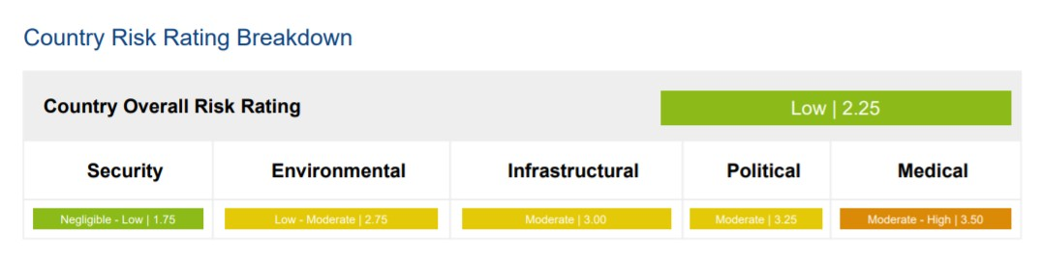

Threat Level | Implication
1 – Negligible | The operating environment is benign and there are only isolated threats to business and/or travel.
2 – Low | The operating environment is permissive, although there are a limited number of threats to business and/or travel that requires basic mitigations.
3 – Moderate | The operating environment is challenging and there are serious threats to business and/or travel that requires some mitigations.
4 – High | The operating environment is hostile and there are significant threats to business, personal safety and/or travel, requiring comprehensive mitigations and planning.
5 – Extreme | The operating environment is characterised by pervasive direct threats to business, personal safety and/or travel, requiring strict risk management procedures.

Prior to any international travel, a travel risk assessment must be conducted. This must consider who is travelling, where they are travelling to, where they are staying, what documents are required for travel and work, the types of illnesses and infections that may be encountered, injuries and emergency provisions and events and/or natural disasters that may occur during travel. This is in order for individuals or line managers to identify the actions required to control those risks, as far as is reasonably practicable.

All line managers and travellers must view the advice provided by Crisis 24 as well as the Foreign, Commonwealth and Development Office (FCDO) travel advice. It is imperative that the assessment is conducted by a competent person and with sufficient time to put the controls/mitigation strategy in place (e.g., effective medical preparation may take up to 8 weeks).

To support this process a template travel risk assessment, taking into consideration the British Standard IS031030 for Travel risk management, has been developed for international travel and the below guidance identifies the various levels of approvals required.

Travel to countries where only negligible or low (below <3.0) risks have been identified by Crisis 24: Crisis 24 and FCDO advice must be followed; significant risks should be assessed and recorded using the travel risk assessment. Line managers to approve.

Travel to countries where a moderate or high (3.0 < risk <4.0) risk has been identified by Crisis 24: Crisis 24 and FCDO advice must be followed. A full written travel risk assessment is to be completed and shared with the HS&E Team. Approval must be obtained from the FPVC/HoPS (or nominated deputy), prior to completing the travel risk assessment. Specialist help and advice is available, if needed, from the Health, Safety and Environment Team.
When considering the travel risk assessment, the FPVC/HoPS must consider the value of the travel to the University’s output and balance the risk or cost of mitigation against the perceived value of the trip. If they believe the risk is too great, then the travel will not be approved.

Travel to countries where a high-extreme (4.0 or above) risk has been identified by Crisis 24: Travel to these countries will not normally be approved. However, if exceptional circumstances apply then the Faculty/Department must request the travel risk assessment be conducted in conjunction with the Health, Safety and Environment Manager and the finalised document must be approved by both the FPVC/HoPS and the University’s Secretary.

Where a student or member of staff wishes to return to their home country where a high-extreme risk has been identified by Crisis 24 then travel may be authorised provided the following criteria have been met:

- The research/work proposed can only be undertaken in that home country/region or it was always the intention of the funding partner/sponsor that the research should be undertaken in that home country/region.
- The research/work does not put the person at a notably greater level of risk when compared to the risks they would be exposed to if returning to live and undertake their usual work in that home country/region.
- The person holds a valid passport/visa for that country.

It must be emphasised that the associated risks for travel are dynamic, and an assessment must be conducted in the planning phase and reviewed prior to departure. Changes to geopolitical situations can happen extremely quickly. Travellers should register with Crisis 24 (https://www.drum-cussac.net/self- registration), using your University e-mail address, and sign up for automated country alerts. It should be noted that the mitigating controls identified in a risk assessment must be implemented by all participants for a risk assessment to be effective.

8. TRAINING FOR INTERNATIONAL TRAVELLERS

Pre-departure training is available through Crisis 24,
https://travelprepare.drum-cussac.net/login/self-registration.php

The first time this site is used - login, then create and account using your University e-mail address.
Day to Day login once registered is: https://travelprepare.drum-cussac.net

All first time AU international travellers are mandated to complete the “International Travel Advice” module to enhance personal safety; it is strongly recommended that this is reviewed on an annual basis, particularly inexperienced travellers or people travelling to countries that have been identified with higher risks.

This module covers issues such as:

- Basic Travel Security Awareness
- Natural Disasters
- Information Security Abroad
- Avoiding Bribery and Corruption when Travelling
- Female Traveller Security
- Kidnap for Ransom

Where the travel risk assessment has identified the need for additional training, this will be provided at the expense of the home department of the responsible person approving the travel. Additional training is likely for all travel to countries with extreme-high risks.

9. INTERNATIONAL TRAVEL DOCUMENTATION

Anyone undertaking international travel on University business are to carry the following documentation:

- Passport, visas, and essential documents.
- Traveller profile information including vaccination record, emergency contacts, next of kin and relevant pre-existing medical conditions.
- Traveller aide memoire of crucial contact details.
- Copy of the University’s Travel Insurance Policy and Travel Insurance Certificate.
- Additional personal insurance for areas not covered by University Policy.
- Copies of any appropriate approved travel risk assessments.

10. REVIEW AND AUDIT PROCEDURES

The Health, Safety and Environment team conduct general and periodic audits to ensure compliance against this Policy Standard and legislation in general.

Faculties/Professional Service Departments must periodically review their own procedures to ensure the requirements of this Policy are implemented, suitable and effective.

In addition, the Travel and Fleet section of the Estates, Facilities and Residences Department in conjunction with the University’s Health, Safety and Environment Operational Group may from time to time review the effectiveness of the University’s policy and procedures for the management of travel on University related business.

This policy will be reviewed every two years, unless there has been a change to legislation, or a global issue that requires a review before that period.

11. FURTHER INFORMATION

UMAL Travel hub - https://umal.co.uk/travel-hub

This will provide you with all aspects of travel advice, and the option to download the GlobalRiskManager app (for travel advice, security information and to receive alerts for any incidents in your destination country).

Crisis 24 - https://www.drum-cussac.net/

The first time this site is used - login, then create and account using your University e-mail address.

Travel advice – type in the country of interest, download pdf.
Travel alerts available in settings (click on your name on the top right corner)

Foreign Commonwealth and Development Office (FCDO) Travel information and advice. This includes general information on the country to assist in the risk assessment process, and also advice on whether the FCDO has warned against travel to your destination country.

https://www.gov.uk/foreign-travel-advice

HS Fit for Travel https://www.fitfortravel.nhs.uk;

TravelHealthPro https://travelhealthpro.org.uk

World Health Organisation http://www.who.int/en/

Travelling with medicine overseas
https://www.nhs.uk/common-healthhttps://www.nhs.uk/common-health-questions/medicines/can-i-take-my-medicine-abroad/questions/medicines/can-i-take-my-medicine-abroad/

Appendix A – International Travel Flowchart

