Academy Forum 3: Designing Authentic Assessments

Lauren Harvey & Jim Woolley, Learning and Teaching Enhancement Unit
UKPSF Mapping: A1, A3, A4, K2, K4, V3

February 2022

What are authentic assessments?

Outlined below are definitions from key articles. All the authors suggest that authentic assessments:

- Assess the skills required of a graduate from the programme
- Reflect real world scenarios that the student may well come across in the future

“authentic assessment aims to integrate what happens in the classroom with employment, replicating the tasks and performance standards typically faced by professionals in the world of work”.

Verónica Villarroel, Susan Bloxham, Daniela Bruna, Carola Bruna & Constanza Herrera-Seda (2018) Authentic assessment: creating a blueprint for course design, Assessment & Evaluation in Higher Education, 43:5, 840-854, DOI: 10.1080/02602938.2017.141239

“an assessment requiring students to use the same competencies, or combinations of knowledge, skills, and attitudes, that they need to apply in the criterion situation in professional life.”
Gulikers, J. T. . et al. (2004) A Five-Dimensional Framework for Authentic Assessment. Educational technology research and development. [Online] 52 (3), 67–86

“Whitelock and Cross (2011) … summarise the common features of an authentic assessment, which include:

- A range of assessment tasks rather than just “traditional” ones
- Collaboration that is similar to that experienced by practitioners or experts in the field
- Problem tasks that are like those encountered by practitioners or experts in the field
- Resources taken specifically from real-world case studies or research
- Simulations of role play or scenarios”

Osborne, R. et al. (2013) Integrating technologies into ‘“authentic”’ assessment design: an affordances approach. Research in learning technology. [Online] 211–18.

JISC in their recent report on The Future of Assessment: Five principles, five targets for 2025 outline Authentic Assessment as one of its key tenets. For JISC there is a direct relationship with technology – they suggest that authentic assessments are ‘designed to prepare students for what they do next, using technology they will use in their careers’.

You can view the full report online, which includes other principles as well, including: accessible assessment, appropriately automated assessment, continuous assessment, and secure assessment.

Looking for inspiration?

If you need some ideas for designing assessments, take a look at Prof Kay Sambell and Prof Sally Brown’s Covid-19 Assessment Collection.
This resource includes authentic assessments from across the sector – plenty of examples here to draw on.

Also, check out Brown and Sambell’s Writing Better Assignments in the post Covid-19 Era for some further tips as to how you might

What are the benefits of Authentic Assessment?

- Interesting and rewarding
- Driver for learning
- Motivating students
- Developing higher order thinking skills
- Developing a wide range of skills
- Opportunities for inclusive practice
- Promote academic integrity
- Link well to real-world challenges

Designing Authentic Assessment

Villarroel et al. (2018), propose four steps to Designing Authentic Assessment:
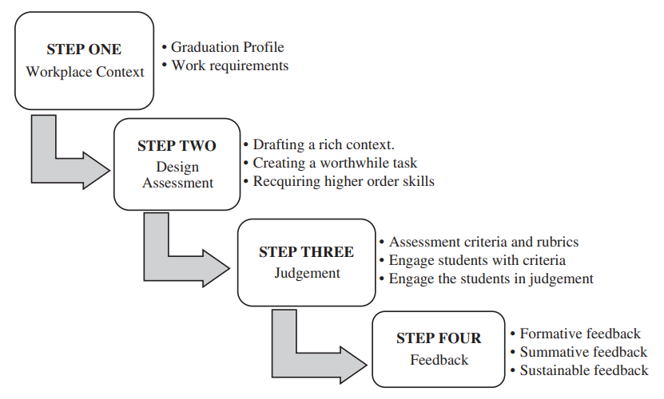
847

Using technology for authentic assessment: which tool should I use?

The following supported tools are available for assessment at Aberystwyth University. Choose the task first before choosing the tool.
- Turnitin – generates similarity report, rich feedback mechanisms
- Blackboard Assignment – multiple files submitted, supports group assessment
- Panopto for Assignment – students create a recording and submit an mp4 file
- Panopto for Assessment – an oral examination or in person presentation is recorded for scrutiny by External Examiner or for the student to examine in the future
- Blogs – students reflect on their learning and present information based on a process. Other students can comment on their blog
- Journals – an individual space for the student and the tutor. Use this type of tool for reflections
- Blackboard tests – a variety of questions presented to students to reflect their knowledge and understanding

An institutional-wide review of authentic assessments.

This case study is an analysis of a review of assessment practices at an Australian University. The case study emphasised the importance for a shared dialogue and understanding of authentic assessment and building links with industry in its design.

Each course team at the institution undertook the following:

- course teams worked together to map the curriculum, including where graduate attributes and professional competencies were being taught and assessed;
- course teams created course learning outcomes that were aligned to the graduate attributes;
- course teams redesigned unit learning outcomes to align to the course learning outcomes;
- course teams developed or revised assessment tasks to measure students’ graduate/professional competencies and disciplinary knowledge;
- course teams reviewed and re-mapped the curriculum to reflect the shifts that were made.

The paper offers a review of this intervention as well as advocating for a wider consultation with industry to establish authentic assessments.

Reference
Hains-Wesson, R. et al. (2020) STEM academic teachers’ experiences of undertaking authentic assessment-led reform: a mixed method approach. Studies in higher education (Dorchester-on-Thames). [Online] 45 (9), 1797–1808.

Help at Aberystwyth University?

Need your students to develop certain digital skills or proficiencies before undertaking an authentic assessment? Check out LinkedIn Learning for lots of content that can help develop students’ skills.
Computer Science, Geography, Psychology, Business, IBERS, Lifelong Learning and the Students Union have their own Academic Champions of Enterprise. You can view a recording on this subject from one of our Learning and Teaching Conferences.

Current practices:

English and Creative Writing: Masters Module
Students need to submit a book proposal and give a pitch to publishers.

Modern Languages
Translation tasks. Consider translation for different audiences.

Computer Science
Applying a concept or idea to a different scenario.

Skills required of graduates

Group 1:
- Building independence – self-regulation
- Doing research outside the class and building up awareness of field
- Building up ability to engage with feedback
- Resilience and independence – see more self-regulation
- Self-reflection
- Not avoid feedback – apply the feedback
- Derive a to-do list based on feedback
- Don’t know how to turn feedback and do it into something next week
- Actionable
- Basic undergraduate skills – that we notice our undergraduates don’t have
- Finding information – start back at the beginning
- Think about the induction skills required
Group 2:
- Presentation skills
- Need for certain technical knowledge
- Need to have knowledge of software cycle in industry
- Need for confidence to enter the industrial workplace as a computer scientist
- Technical knowledge of handling data – qualitative and quantitative data
- Create a structure of an argument and critical analysis – a key skill
- Creative writers: certain technical skills and awareness of publishing cycles
- Literary critics – find evidence, capacity to structure an argument
- Awareness of sector

