Academy Forum 2: How are students using Technology at Aberystwyth University?

Dr Jim Woolley (lteu@aber.ac.uk)

Learning and Teaching Enhancement Unit, October 2022

PSF Mapping: A1, A2, A4, K3, K4, V1, V2
This Academy Forum was based on the JISCs Digital Insights Survey findings for 2021-22. Every year, the Learning and Teaching Enhancement Unit runs the survey for all students to take.
The data from the survey informs:
- Learning Analytics
- Digital Strategy
- Learning and Teaching Strategy
Running the survey means that we can benchmark what we offer against other Higher Education providers. Further information, including a summary of all data, can be found in Student digital experience insights survey 2021/22.
It allows us in LTEU to look at trends and identify areas for improvement and training to offer staff.
The survey and analysis for 2021-22 was run by Lauren Harvey. Joseph Wiggins, a Theatre, Film and Television Studies student assisted with the analysis. You can view Joseph’s summary in this blogpost.
The academy forum began with a Vevox poll asking attendees about the technologies they were using in their teaching, summarised below:
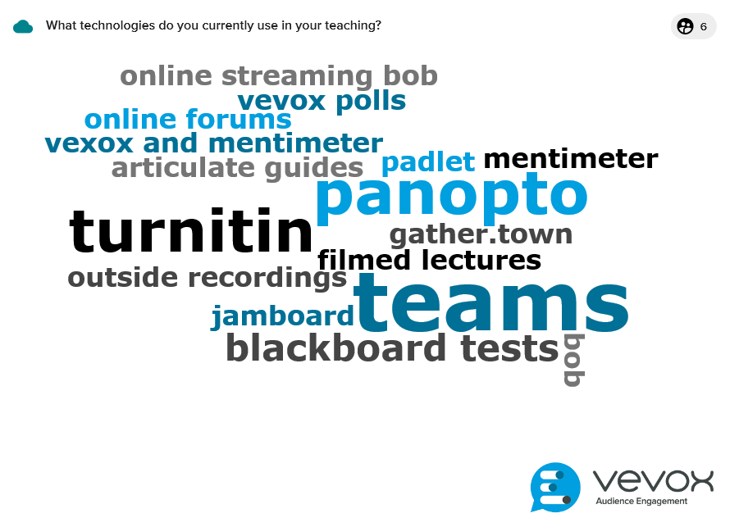

What challenges do you think students currently face in using technology?
- Blackboard isn’t user friendly to people, especially for those who might not have used it before.
- Students using phone or mobile devices to access online activities – mobile devices don’t always render / display correctly.
- Some students might not have access to technology, including mobile devices.
- Over the past couple of years, we could see that students are reluctant to use technology
- Some students might not have the skills to undertake these activities – they might need more support. We also make assumptions that students might know how to use these technologies.
- Use of technology also eats into learner time, so it needs to be well designed and relevant.
- From an educator’s perspective creating meaningful and well-designed learning activities can take more time.
- We need to factor in the extra support required for helping students with engaging with the task.
- Need to ensure that the activities are accessible for all students.
- When we’re using technology to create learning activities, it’s not always clear what the students will see as we’re accessing through an editor interface.
- It can be more difficult to measure student engagement when teaching online.

What currently works well with technology?
- Accessibility – it's a lot easier for students to tailor learning activities to their needs, with additional functionality including colour contrast, size, screen readers, and captions.
- The increase of technology allowed more options for engagement and for students to find what they’re comfortable with and to choose their approach to learning.
- Large lectures can benefit from Vevox and other polling software to help with engaging large groups.
- Outputs from activities can be saved and shared with students afterwards.
- Discussion forums have been useful and it was found that there was more interaction if they were answered anonymously.
- Tests and quizzes in Panopto worked well.

What surprised you about the data from Digital Insights survey?
- The results from the survey might be problematic with neutral or middling responses. The qualitative comments will allow to drill down.
- The survey results show that digital reward for skills was below the benchmark – a discussion was had over how we can reward students.
- Badging and gamification was discussed, as well as skills certificate.
- Creating a quick reference of acquired digital skills will also help with CV writing and job applications
- More focus on how we can make online learning more engaging.

What do you want to change as a result of the findings?
- Consider recognition to help CV building
- Using quizzes more to provide revision materials for students
- Reflect on what technology is being used and what works best for students
- Explore reward mechanisms and gamification
- Mini surveys using online anonymous tools
- Discuss skills and employability, and point students towards digital skills page
- Use quizzes for engagement with Panopto recordings

