Component Marks Transfer Guide
Learning and Teaching Enhancement Unit
elearning@aber.ac.uk
December 2023
Contents
Contents 1
Mapping the Gradebook 1
Mapping Columns to the Astra Component 1
Merged Modules (Parent-Child Modules) 4
Managing Columns in the Gradebook 5
Create a Column 5
Creating a Total Column 5

Mapping the Gradebook
Mapping the columns can be done at any time after your Gradebook columns have been created. For many Blackboard tools, the columns are created automatically (for example when you set up the Turnitin submission point). For other types of assessment, you might need to create your own columns.
If you are working off campus, you will need to have VPN enabled to access MyAdmin.
- To map a module’s marks, go to myadmin.aber.ac.uk
- Click on Grade Transfer
- You will then be taken directly into the Grade Transfer screen in myadmin.aber.ac.uk for that module:
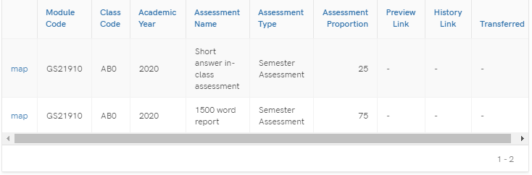

Mapping Columns to the Astra Component
The information displays from AStRA, so if there are any issues or discrepancies, the module record in AStRA needs to be amended. The Assessment Proportion (weighting) for each component will display.
Each component from the Astra module record will be arranged on separate lines.
To begin the transfer process, select:
- Map on the component that you wish to transfer
- A window will open for you to select the Blackboard Grade Centre Column and further details of the Assessment information will be displayed.
- Select the Grade Centre Column that you would like to map by clicking on the dropdown menu. Gradebook Columns will display in the same order that they appear in the Grade Centre. Any hidden columns will display at the bottom of the list and will have (hidden) after their names.
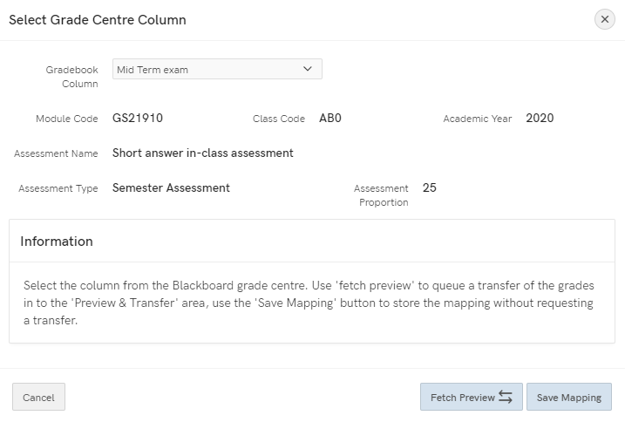
- Note that you can map the same Blackboard Grade Centre column to multiple modules in Astra. However, you can only map 1 Grade Centre Column against each component. Please see guidance on creating Grade Centre Columns further in this document to pull together multiple Grade Centre columns into one column to transfer.
- Fetch Preview to be selected if you want to queue the transfer of grades into the Preview & Transfer area
- Save mapping if you just want to set up the mapping process but transfer at a later date
After clicking Fetch Preview, the option will disappear:
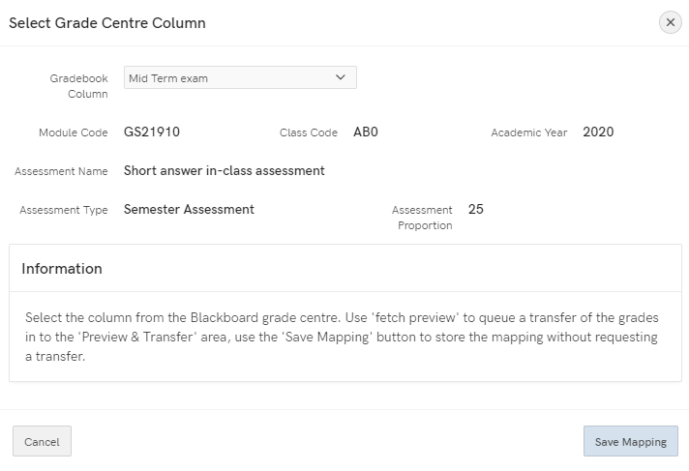
- After 5 minutes, the option to Preview & Transfer will appear
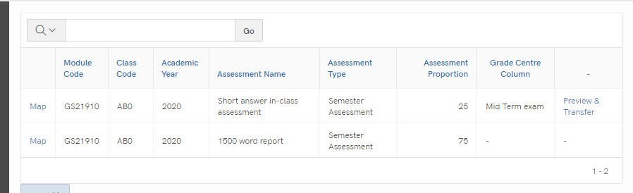

- You can amend the columns against which marks are mapped for any point if you save.
- When you are ready to transfer the marks, click Preview & Transfer. Once you select Preview & Transfer, you’ll be unable to amend the mappings
- In the window that opens, you’ll see the following information:
- The scores for the component will be in the far right hand column – double-check that these scores are correct.
- Anyone with a score of 0 are highlighted as per the below for you to double-check:
- In addition to this, check any marks over 100 or any anomalies
- Note that the marks will be transferred as they are – for example, if there are 120 marks then these will be transferred as they are
- If you are satisfied with the preview, scroll down to the bottom of the page and select Mark for Transfer
- You’ll get a pop up acknowledging that Marks staged for next Transfer
You can then check they have appeared correctly by logging into AStRA and viewing STF080.
To access the STF080 report:
Students > Student Modules > Exams > Assessment Marks per Module
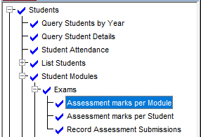

Marks can be altered in AStRA if required. The marks should appear in AStRA quarter past and quarter to every hour.
If you need to transfer additional marks, you can press the Preview & Transfer button again.

Merged Modules (Parent-Child Modules)
If you have parent-child modules:
- Go to myadmin.aber.ac.uk and log in
- Select Grades Transfer tool
- Search for the child module in My Admin
- Select the Column that you would like to map the marks to and follow the process as above

Managing Columns in the Gradebook

Create a Column
Columns need to be created for assignments that are not submitted electronically. Some scenarios include:
- Written exams
- Oral exams
- Artworks / Performance works
- Presentations
To create a Gradebook Column:
- Select the plus icon wherever you want to add an item and select Add Item.
- Add a title. It has a limit of 255 characters.
- If you want the students to see their mark and feedback select Make Visible to Students
- The due date is optional.
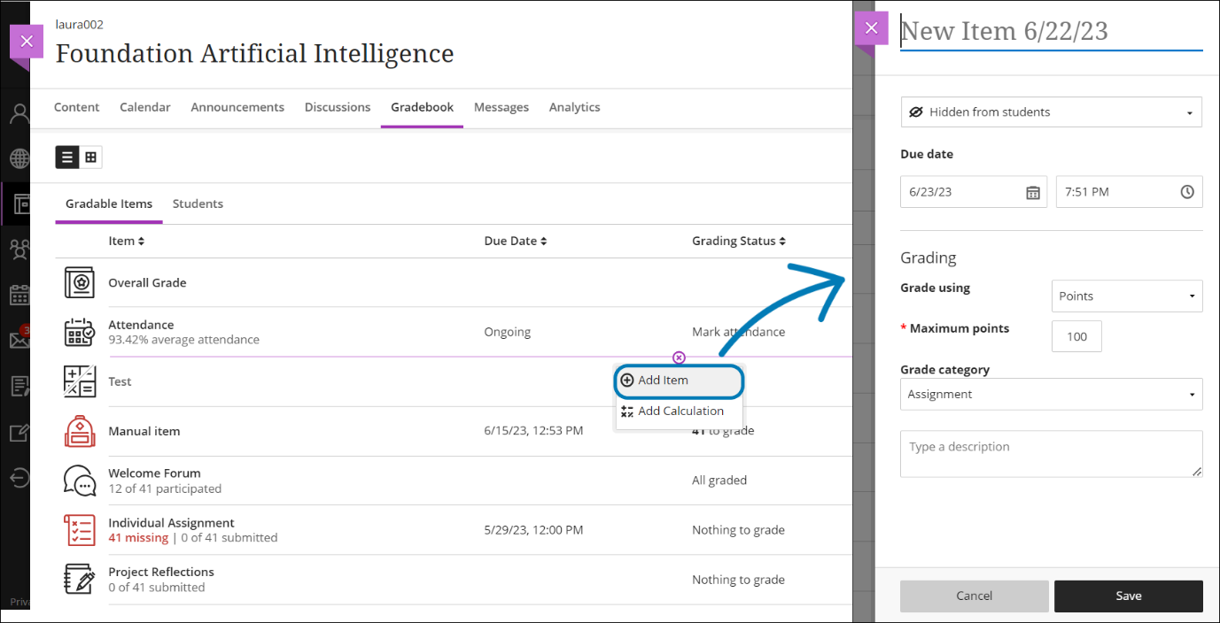

Creating a Total Column
A total column is used for the following scenarios:
- Combining multiple submission points (for example, extension submission points) into one column to transfer
- Where there are multiple assignments in Blackboard that combine to form one component in AStRA

See Blackboard Help for instructions on Calculate Grades.

