Using Vevox for Teaching
Learning and Teaching Enhancement Unit
March 2021
lteu@aber.ac.uk
Using polling software for in-class activities can be a way of improving students’ engagement. This guide provides instructions for using the interactive software Vevox, which includes polling, Q&A and surveys.
Contents
Getting started with Vevox 2
What types of questions are available in Vevox? 4
How do I create activities in Vevox? 5
How do I set up a poll in Vevox? 5
How do I set up a survey in Vevox? 7
How do I set up a Q&A session in Vevox? 9
How do I start and stop my session in Vevox? 11
How do I start a Session in Vevox? 11
How do I stop a session? 11
How do I run polls in Vevox? 12
How do I run surveys in Vevox? 15
How do I integrate Vevox with PowerPoint? 16
How do I integrate Vevox with MS Teams? 21

Getting started with Vevox
Vevox is an interactive software that allows you to conduct polls, Q&A sessions, and surveys that can be set up in advance or live. Aberystwyth University is fully subscribed to Vevox and offers full support to staff who use it.
Open a browser and go to aberystwyth.dashboard.vevox.com. Log in with your Aberystwyth University username and password.
Because Vevox contains a number of interactive elements in one place, you must create a Session before setting up any polls, Q&As, or surveys. This makes sure that all materials relevant to a given Session are in one place.

The first thing you need to do is to create a Session in Vevox. To do this, click on the ‘Create Session’ button. Give your Session a name (for example the module code and day of the seminars you want to use Vevox), then click ‘Create’.
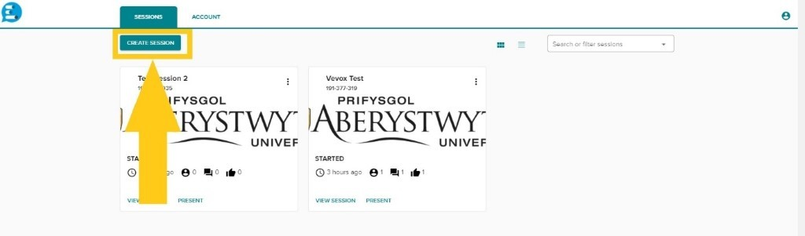

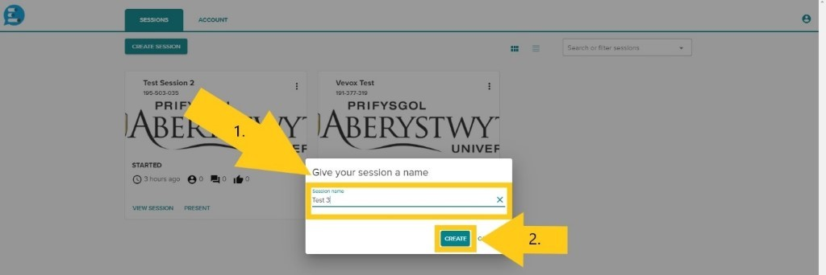
Vevox automatically opens the session and places you in the ‘Polls’ section of your session. You can then navigate to any other part of your Vevox Session through the menu on the left.
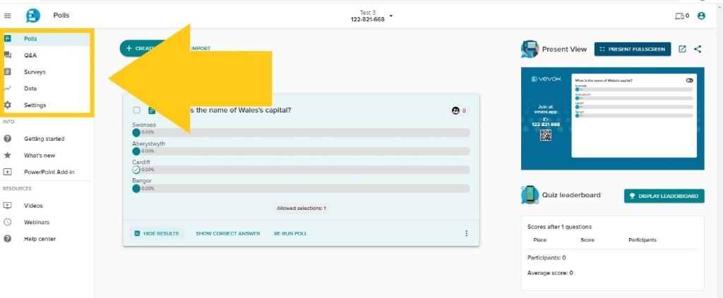
To start a session and enable live polling, Q&A and Surveys, click the small downward arrow next to the Session name and ID. In the dropdown menu, click ‘Start Session’. This can be done at any point before the time you want to use Vevox.
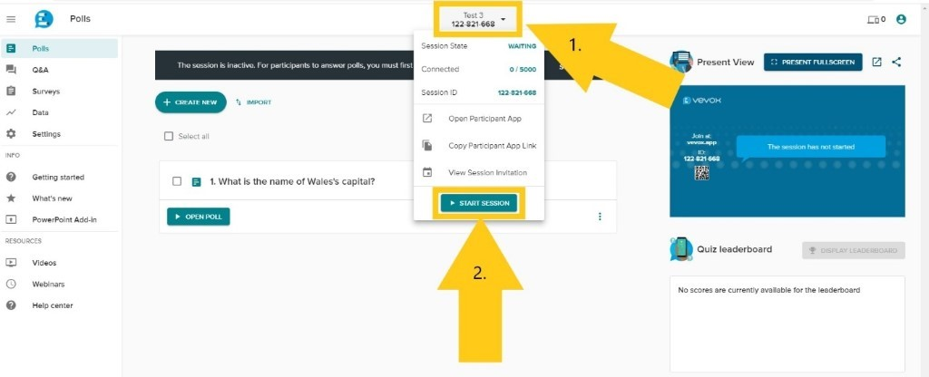
To stop a session, click the same arrow again to bring up the dropdown menu, then select ‘End Session’.
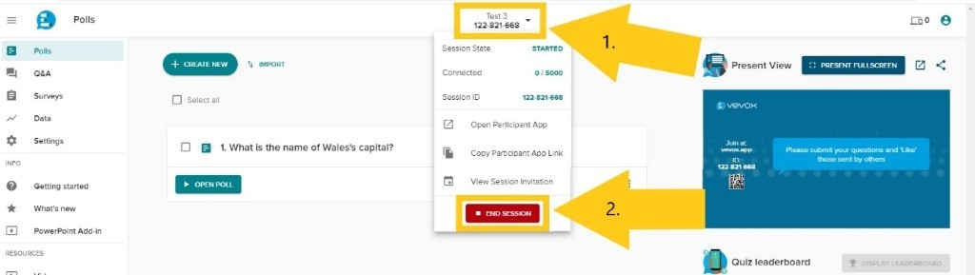

What types of questions are available in Vevox?
Question Type | Description
Multichoice | Gives the audience the option to choose between different answers. A correct answer can be set, or multiple answers permitted. An image can be added to this type of question.
Word Cloud | Audience members can answer a question by submitting words which appear as a “cloud” on the slide. Words that have been submitted the most appear larger.
Text | Allows your audience to write longer comments that appear on the slide in the form of Speech Bubbles, One by One or as a Flowing Grid.
Rating | Allows your audience to rate certain statements i.e. how much they disagree or agree on an issue/statement, using a 1 to 5 star rating system.
Numeric | The numeric poll allows participants to enter any number within a range that you specify.  You also have access to the following additional features with numeric polls:  - Indicate the correct answer if there is one  - Allow answers with up to two decimal places  - Allow for a margin of error for the correct answer
XY Plot | This type of question is for questions where you want to determine the relationship between two data points. Your audience can respond within the parameters that you set up, e.g. a Cost/Benefit comparison.

How do I create activities in Vevox?

How do I set up a poll in Vevox?
The first thing you need to do is to create a Session in Vevox. To do this, click on the ‘Create Session’ button. Give your Session a name (for example the module code and day of the seminars you want to use Vevox), then click ‘Create’.

Vevox automatically opens the session and places you in the ‘Polls’ section of your session.
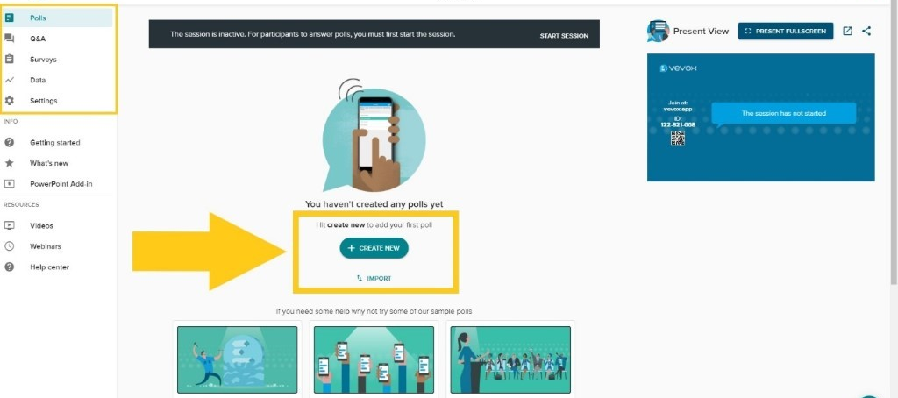
You can now create polls by selecting ‘Create New’ or try out Vevox’s sample polls. You can edit these to your liking. You can then run your poll at any time after starting the Session.
If you want to add a Poll to an existing Session, select the relevant Session in your Dashboard by clicking ‘View Session’. Vevox automatically places you in the ‘Polls’ section of your session and you proceed as explained above.
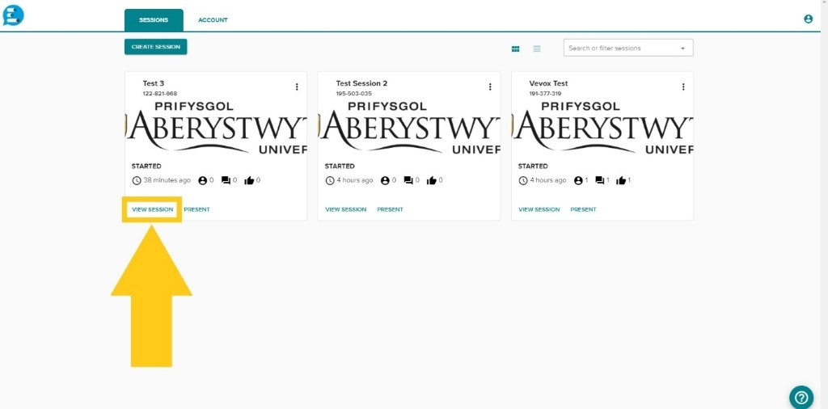

How do I set up a survey in Vevox?
The first thing you need to do is to create a Session in Vevox, as explained above.
When you create a new Session, Vevox automatically opens it and places you in the ‘Polls’ section of your session. In the menu on the left-hand side, click on ‘Surveys’.
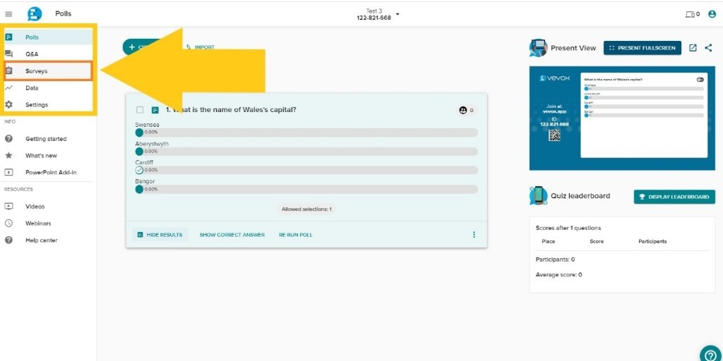You can now create surveys by selecting ‘Create New’ or try out Vevox’s sample surveys. You can edit these to your liking.
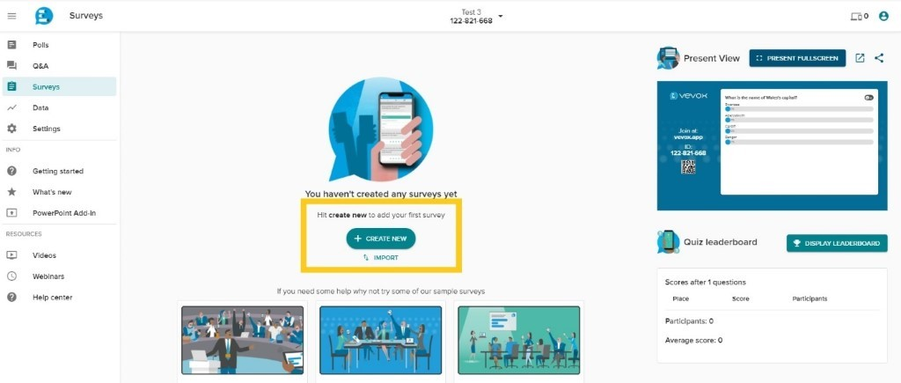
If you want to add a Survey to an existing Session, select the relevant Session in your Dashboard by clicking ‘View Session’. Once in the Session, navigate to Surveys through the menu on the left-hand side (see above).
Respondents can then answer your survey at any point after starting the Session for as long as the Session is active.

How do I set up a Q&A session in Vevox?
As with Polls and Surveys, the first thing you need to do is to create a Session in Vevox, as explained above. Vevox automatically opens any new session and places you in the ‘Polls’ section of your session. In the menu on the left-hand side, click on ‘Q&A’.
You can post a question or announcement on the board. You can also select sample Conversation Starters from the drop-down menu that automatically appears when you click on the announcements text box.
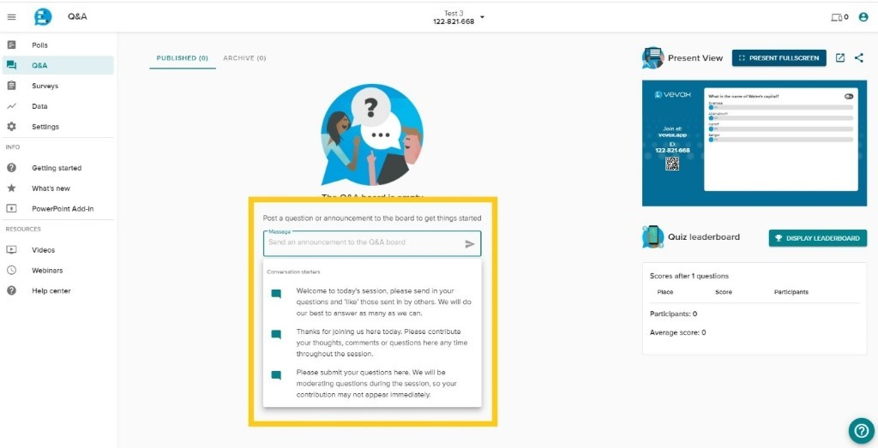
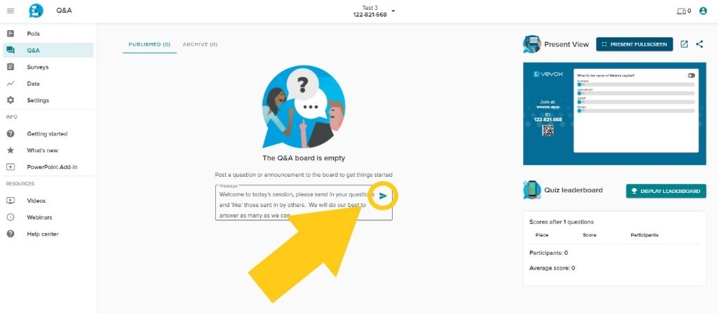 You can make announcements before starting the Session, but your participants will only see them once the Session has started.
You can edit or delete announcements you have made by selecting the three dots (‘More Options’) on the right-hand side of your announcement, and then selecting either ‘Edit’ or ‘Delete’ from the drop-down menu.
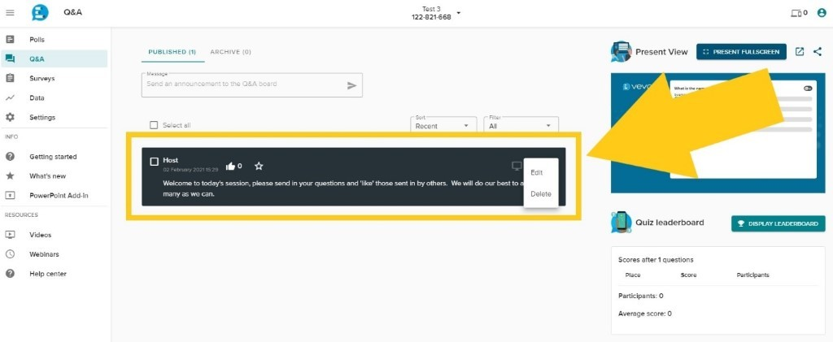
Respondents can ask questions, post comments, and respond to any questions set by you once the Session has started for as long as the Session is active. They can also upvote other people’s comments and questions. Q&As are anonymous. However, you can activate moderation, which lets you review anything posted to the Q&A board before it appears. See our FAQs on how to do that.

How do I start and stop my session in Vevox?

How do I start a Session in Vevox?
Because Vevox contains a number of interactive elements in one place, you must always create a Session before setting up any polls, Q&As, or surveys. This makes sure that all materials relevant to a given Session are in one place.
To start a session and enable live polling, Q&A and Surveys, click the small downward arrow next to the Session name and ID. In the dropdown menu, click ‘Start Session’. You can start a Session at any point before the time you want to use Vevox.

How do I stop a session?
To stop a session, click the same arrow again to bring up the dropdown menu, then select ‘End Session’.

How do I run polls in Vevox?
Online or face to face presenters can create live polls in their Vevox dashboard or using the Vevox PowerPoint add-in.
To create and run a poll from your Vevox dashboard, log in to your Vevox account, create a Session, and create your polls. Make sure you start the session to enable Vevox’s live features, including polling. When you want to run the poll, open Vevox’s ‘Present view’ from your dashboard.
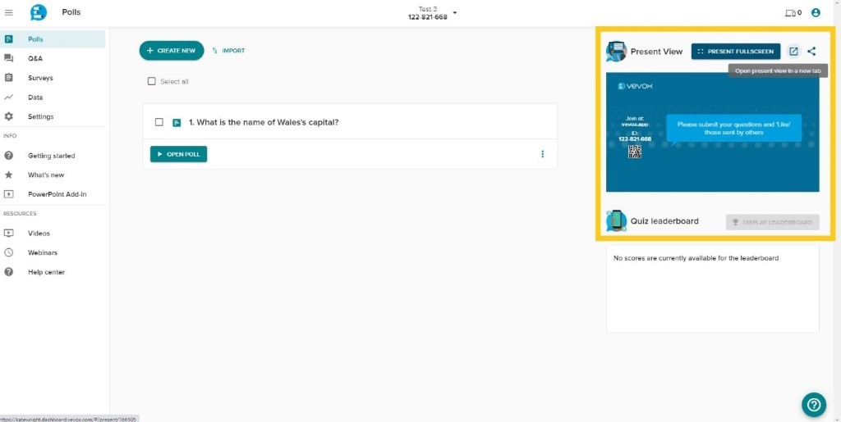
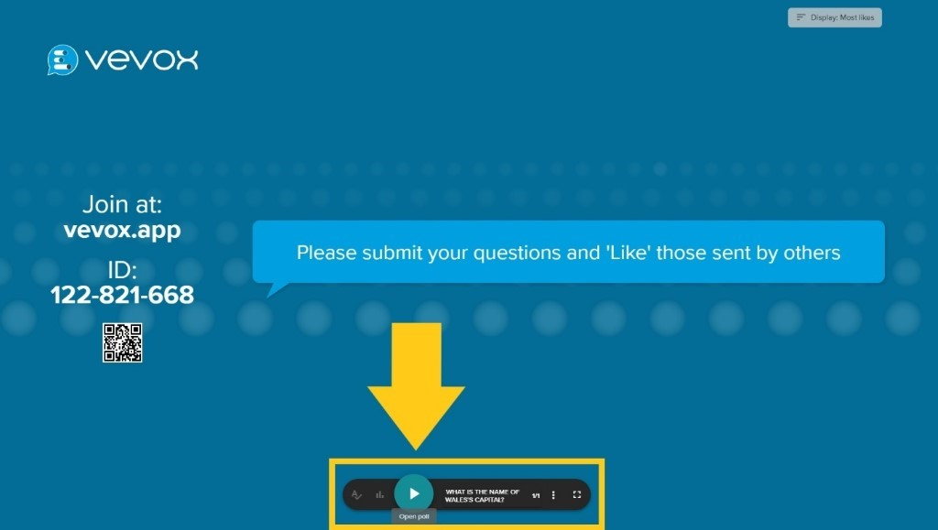Participants are then invited to access a web app (Vevox.app) and enter a 9-digit session ID. Live Polls will then appear instantly on their device for them to respond to and see results. You can close the polls from the control panel at the bottom of the screen.
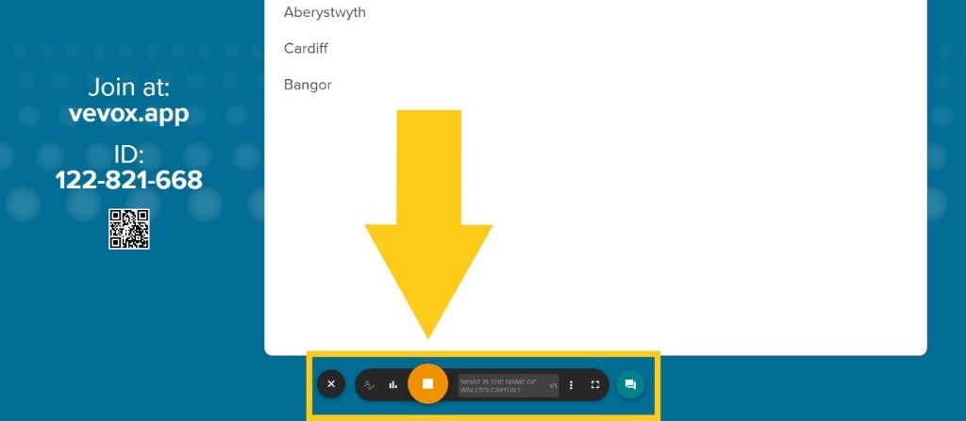You can also open and close polls directly from within the Session. Select the poll you want to open and click ‘Open Poll’. Click ‘Stop Poll’ to close it again.
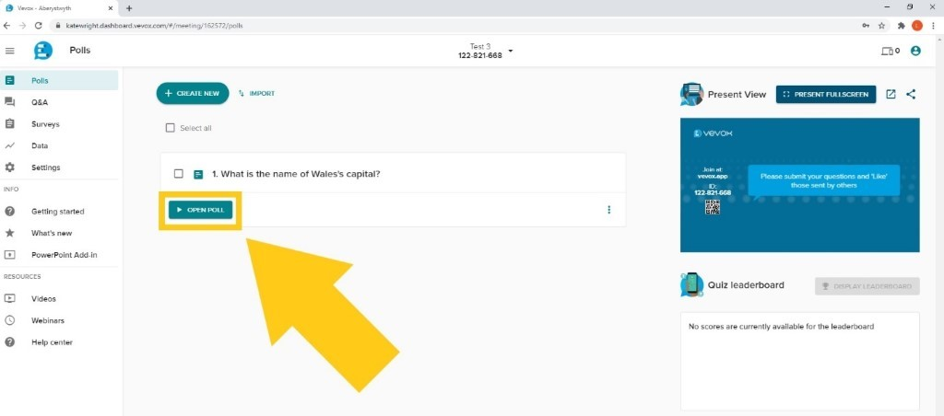
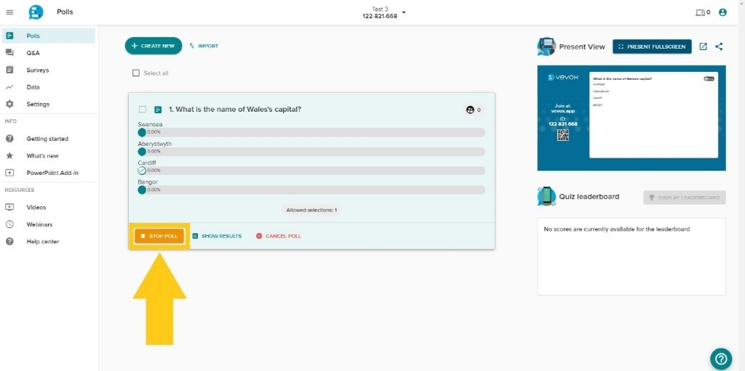
When using the PPT add-in, your polls are embedded in slides. Please see our FAQs on Vevox’s PPT integration for details.
Click as if to move on to the next slide to activate your poll, and again to close it. Results will be displayed upon closing the poll. Please note: you must be connected to a live Vevox Session for the Vevox PPT add-in to work.

How do I run surveys in Vevox?
Log in to your Vevox account, create a Session, navigate to the Survey section through the menu on the left.
Then create your surveys. You can create surveys from scratch or choose from Vevox bank of sample surveys, which you can edit to fit your needs.
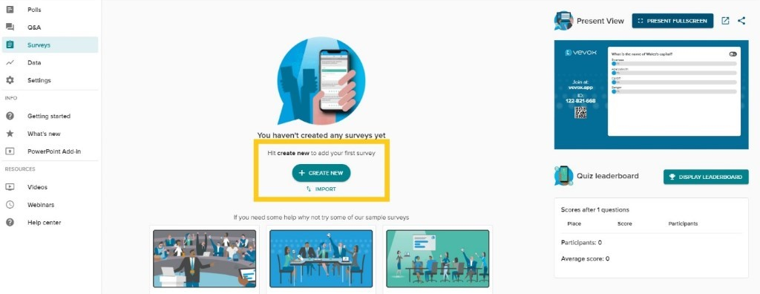
Make sure you start the session to enable Vevox’s live features. Respondents can then answer your survey at any point after starting the Session for as long as the Session is active.

How do I integrate Vevox with PowerPoint?
You can add polls or transform existing slides in polls with the Vevox PowerPoint Add-In. This add-in is only available for Windows.
Download the add in the software centre. The Vevox tab is now available in PowerPoint.
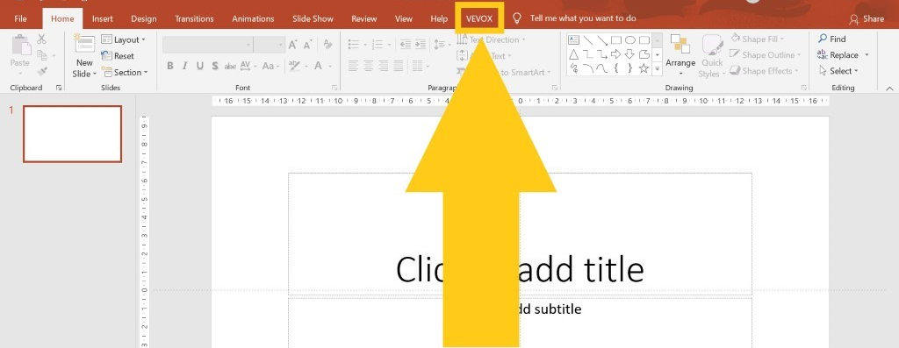Click on the Vevox Tab and click on the Disconnected icon to connect to Vevox.
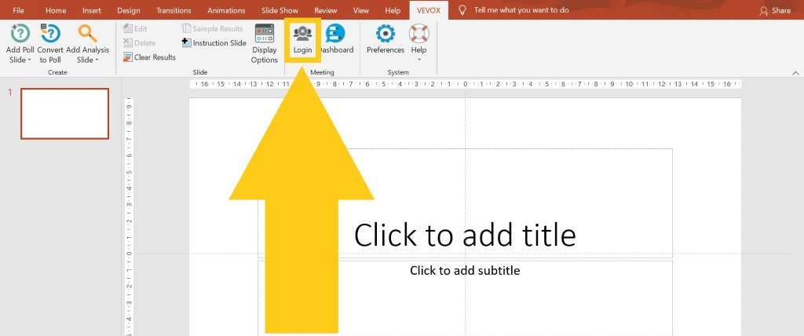
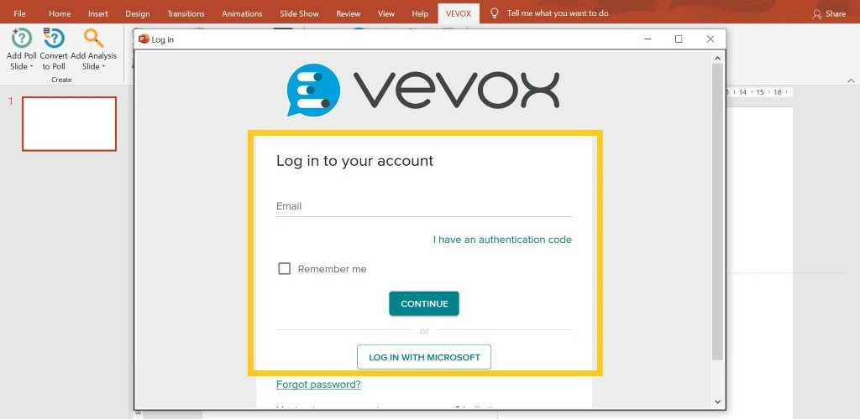Select a Meeting to join (this is another name for Session). The Session must be active to be added.
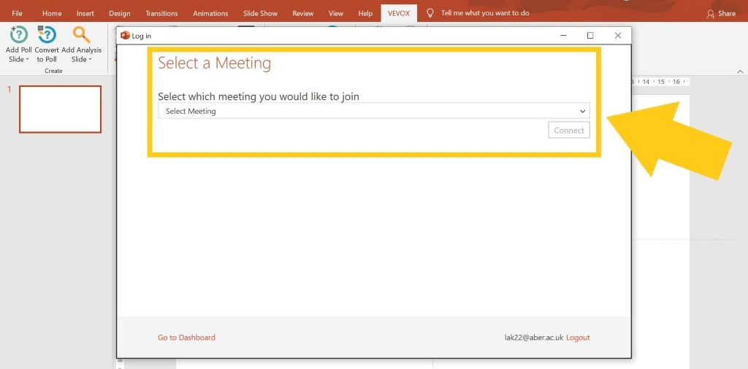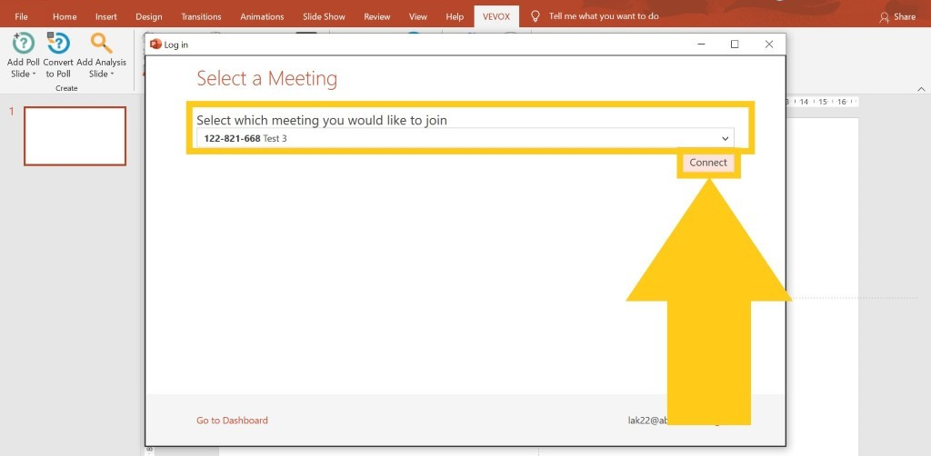You will now be able to see that you are connected to Vevox in PowerPoint (see below).
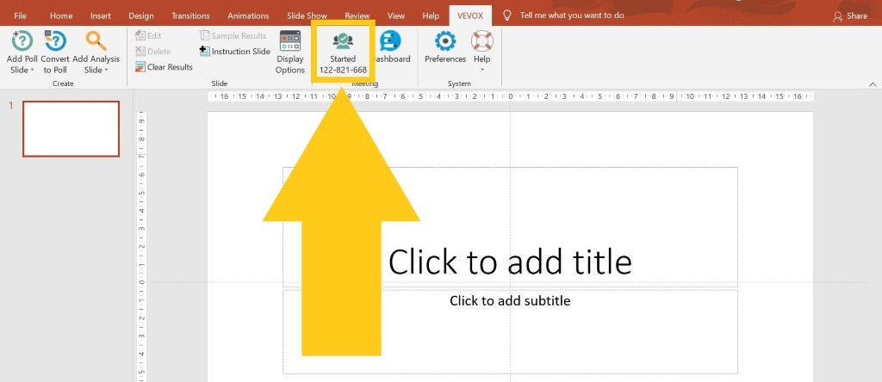You can now add Poll Slides into your PowerPoint from the Vevox tab. You can add Polls on a new slide or an existing slide.
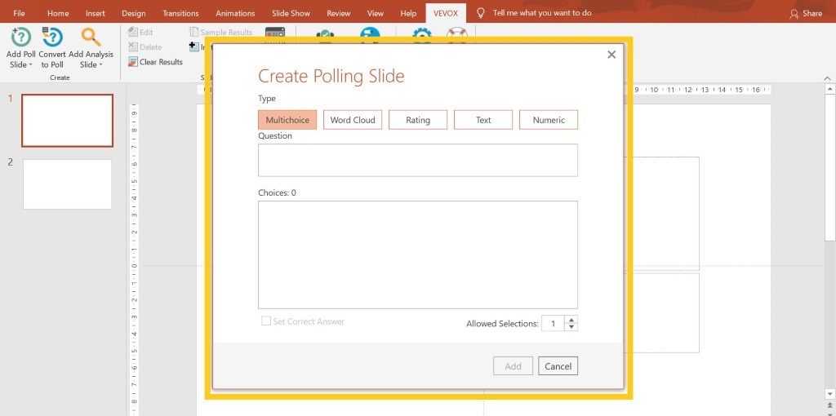You can also convert an existing slide into a Poll by choosing the Convert to Slide option from the Vevox menu in PowerPoint.
When you use this function you can set up, edit, and make changes to your slides & questions working in offline mode. But when presenting your slides (in PowerPoint) you should be online to launch your session and open up the polls to participants. You can also use the Vevox PPT add-in to compare polls from within the same PowerPoint. See our FAQs on how to do that.

How do I integrate Vevox with MS Teams?
To use Vevox’s integration with Teams, you must ensure that the relevant Vevox Session is active. Open the Teams meeting you wish to add Vevox to in your Teams app. Click the plus sign of the meeting’s application bar. This will only appear once you have invited people to the meeting.
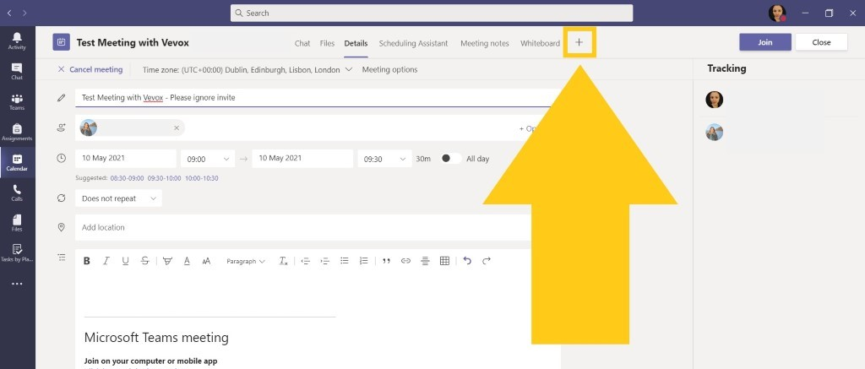Search for Vevox in the grey search bar to the right, then click on the Vevox icon when it appears.
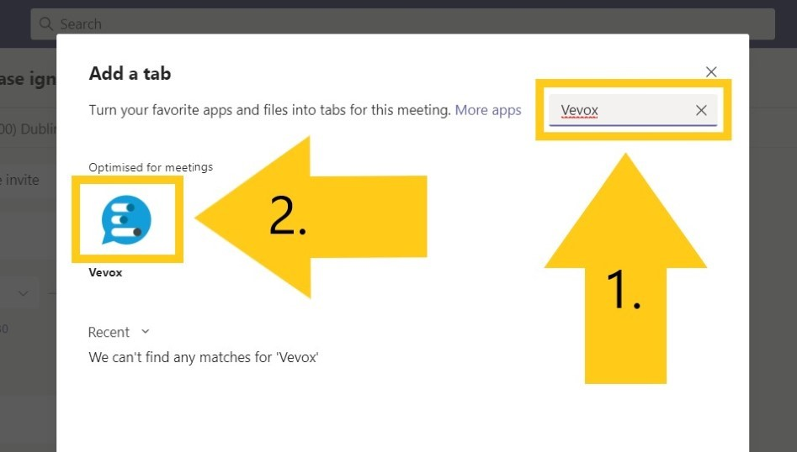
Click ‘Add’.

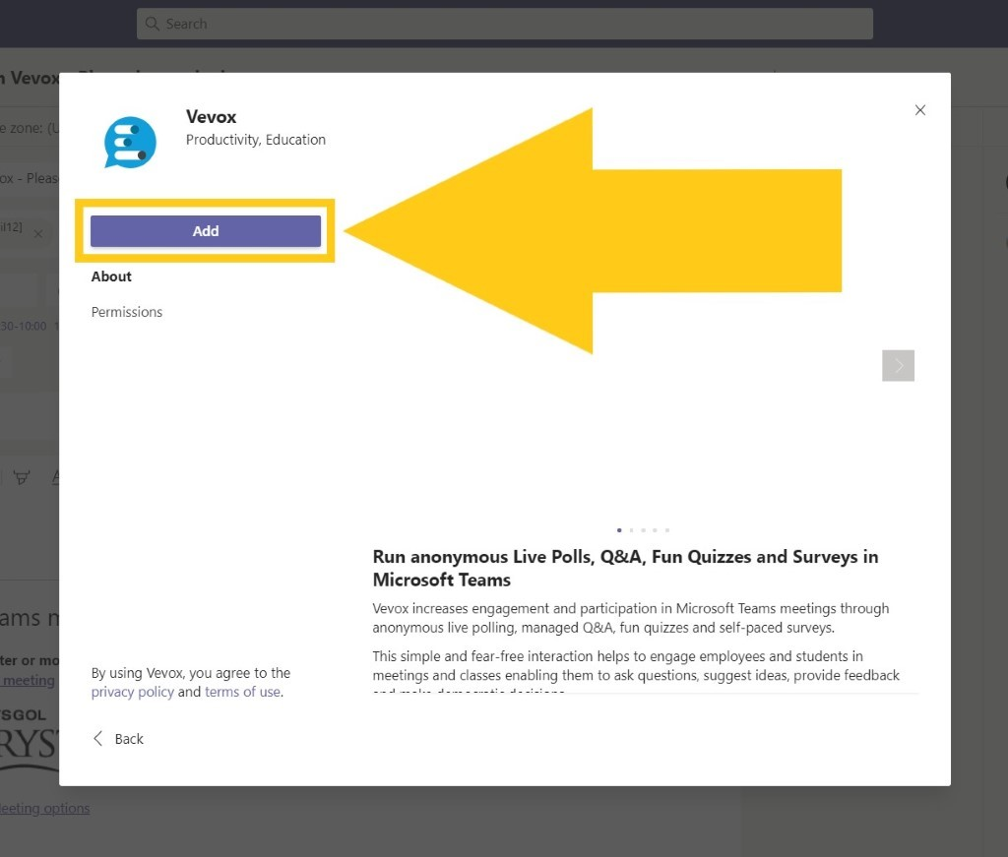
You must now add an active Session by entering the 9-digit Session ID. The Vevox app for Teams will automatically check if your code is valid. If your Session is inactive, the code will not be valid, and you cannot proceed. Once your code has been confirmed as valid, click Save.
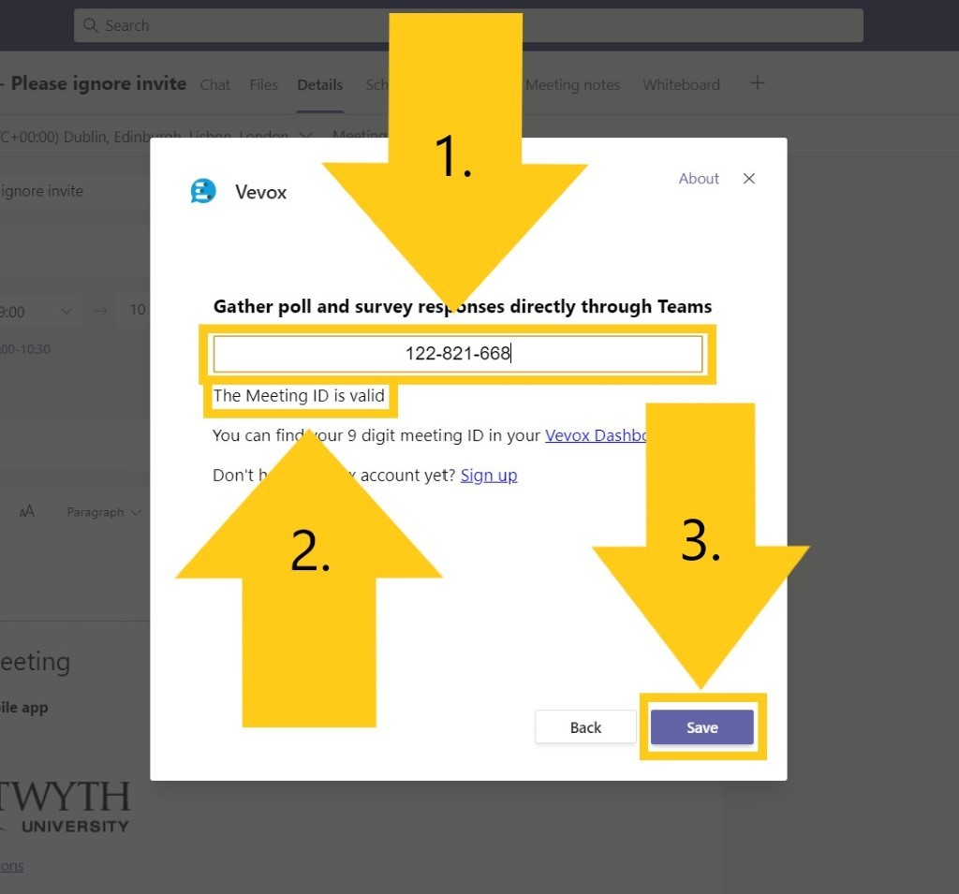 You will then see a preview like the one below to confirm that you have attached a Vevox Session to your Teams meeting.
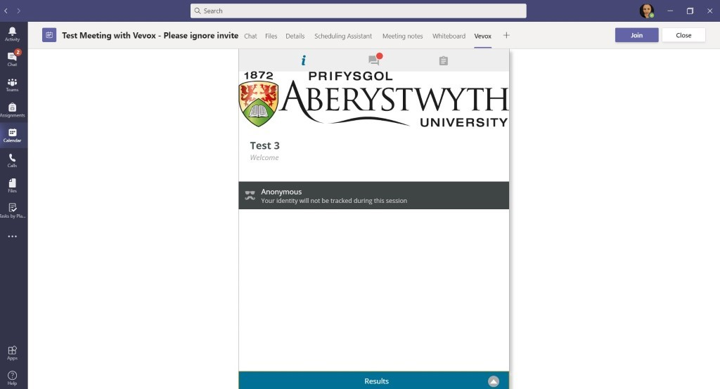
Once you have started the Teams meeting that you attached Vevox to, you will now see the Vevox icon in the menu bar at the top of your call window.
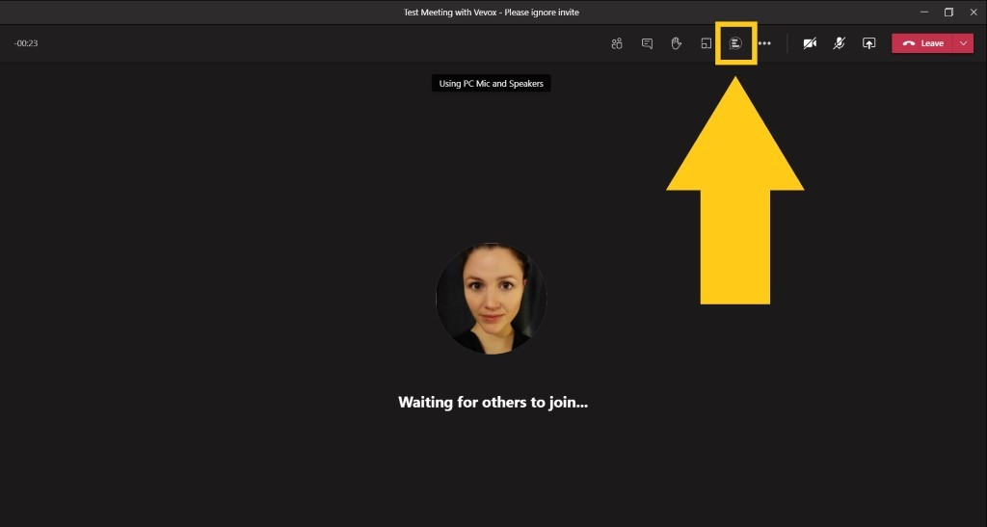
The Vevox window appears just like the Participants List and the Teams Chat when you click on the Vevox icon in the Teams menu bar.
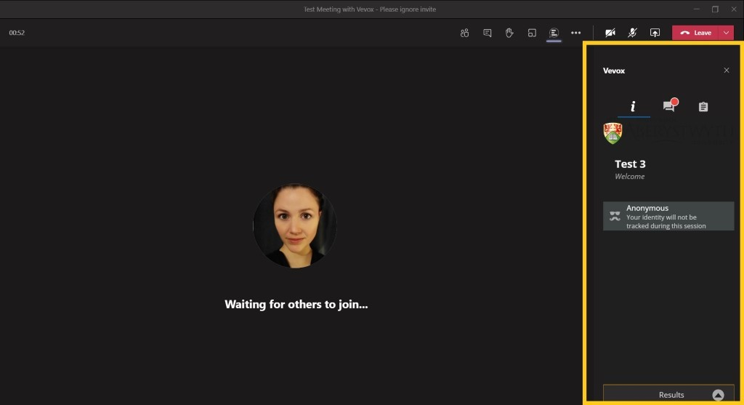
From here, participants can navigate to the Q&A section, and answer any live polls or surveys. Poll results will appear in the poll tab within the Vevox window once you have closed a Poll.

