E-submission Guide
Learning and Teaching Enhancement Unit (lteu@aber.ac.uk)
All word-processed, text-based assignments should be submitted electronically, unless exemption has been approved. All assignment submission points should be in the Assessment and Feedback section on Blackboard.
Aberystwyth University has two different options for electronic submission, Turnitin and Blackboard Assignment. This guide also contains instructions on using Component Marks Transfer workflow.

Turnitin Summary
Turnitin allows students to:
- Submit work electronically
- Download a receipt for their submission
- View their marks and feedback via Blackboard

Turnitin allows staff to:
- View a text-matching Similarity Report on assignment submissions
- Mark assignments online
- Provide audio feedback
- Use a personalised comment bank for frequently-used comments
- Distribute marking to different staff, based on student groups, e.g. seminar groups

Blackboard Assignment Summary
Blackboard Assignment allows students to:
- Submit work electronically
- Receive an email receipt of their submission
  - View marks and feedback via Blackboard
  - Submit group assignments
Blackboard Assignment allows staff to:
- Mark assignments online
- Mark group assignments

Guide to Component Marks
This guide also includes instructions on how to use Component Marks which is a transfer tool for transferring marks for assignments to AStRA.

Quick Start Guide to Turnitin

How do I create an assignment submission point in Turnitin?
- Go to the module in Blackboard and click Assessment and Feedback on the left-hand menu.
- Select Build Content and Turnitin Assignment
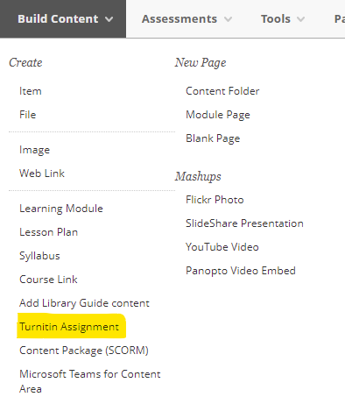
- A screen will load called Launch LTI Link, before the Turnitin creation page appears
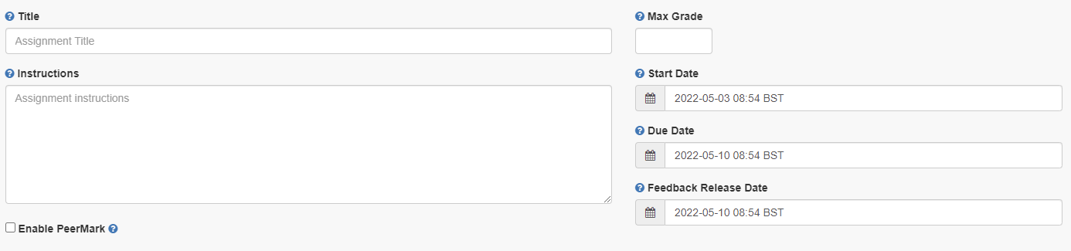
- Enter the assignment’s name in Title
- Enter Max Grade – normally this is 100
- Enter any instructions in Instructions
- Enter a Start Date and Time. This is when the assignment submission point becomes available for students to submit their assignments to.
- Enter a Due Date and Time. This is when students must submit their submission by.
- Enter a Feedback Release Date. This was called the Post Date before but is the time and date that feedback and marks are released to students. With anonymous marking, this is also the point at which you can ascertain the authors of the assignments.
- Click on Optional Settings to choose the correct settings for your Turnitin submission point.
- Submit papers to - standard paper repository
- Allow submission of any file type - do not select to ensure all assignments can be checked for originality
- Allow late submissions:
  - If deselected students will not be able to submit after the due date and how assignment extensions are processed should be considered.
  - If selected, students can submit assignments after the due date. Late submissions will be flagged as being submitted late.
- Enable anonymous marking – Yes should be used.
- Enable grammar checking - when enabled marks for grammar will be shown in GradeMark
- Attach a rubric - select a rubric here if using.
- Compare against – select all
- Generate Similarity Reports – controls the Similarity Reports as well as whether students can resubmit assessments up to the due date and time. If you select:
  - Immediately first report is final – students cannot resubmit assignments. Similarity reports are generated immediately for all submissions. Erroneous submissions must be deleted by instructors before resubmission may be made.
  - Immediately (can overwrite reports until due date) – students can resubmit assignments as many times as they want to until the assignments due date and time.
  - On due date – students can submit an assignment as many times as they want until the assignments due date and time. The Similarity report is generated on the due date and time.
- Exclude assignment template – a template of text can be uploaded or created to be automatically excluded from the Similarity Report (e.g. assignment question, brief, instructions).
- Save these settings for future use – select to save as default for future assignments.

- Click Submit and you will see the submission point in the area on Blackboard:

How do I use Rubrics?

What are rubrics?
Rubrics are marking or assessment criteria. Students will be able to view a rubric /form attached to an assignment submission point before they submit their assignment. Turnitin has four different types of rubrics that can be set up and enable you to define criteria to mark against
- Standard Rubric – each criteria are weighted using percentages and each scale has a mark allocated to it. The overall mark is calculated based on the percentage weightings
- Custom Rubric – criteria are not weighted
- Qualitative Rubric – no weighting or marks can be applied. The scales and criteria are used to provide guideline feedback
- Grading forms – can be used to provide free form feedback based on each criteria. You set the criteria and add comments for each student
For further information, see FAQ 705.

How do I create a rubric?
Rubrics can be created when an assignment submission point is set up, or after students have started to submit and you are ready to mark.

To create a rubric:
- Login to Blackboard and go to the module that contains the assignment
- If the assignment submission point has already been created:
  - Click on the submission point
  - From the Turnitin inbox, select the settings cog:
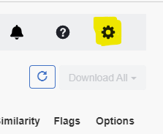
- Expand optional settings and select Attach a rubric
- The rubric manager dropdown will appear. Here you can choose from the dropdown list to select a rubric that you already have access to.
- If you are creating a rubric, select Launch Rubric Manager
- Select Create new Rubric
- At the bottom of the page select a rubric scoring option (see FAQ 705 for the different types of rubrics that are available to you.
- Add a rubric name at the top of the page
- Complete the Criteria / Scales depending on the rubric requirements
- Add additional criteria and scales using this symbol
- Click Save to apply the changes to the rubric

For further information, see FAQ 701.

How do I mark an assignment in Turnitin?
We recommend starting to mark after the due date to prevent student’s assignments from being overwritten.
- Go to the module that you are marking
- Go to the area where the submission point has been created (normally this is Assessment and Feedback)
- Click on the Turnitin submission point and the assignment inbox will open in a new window:
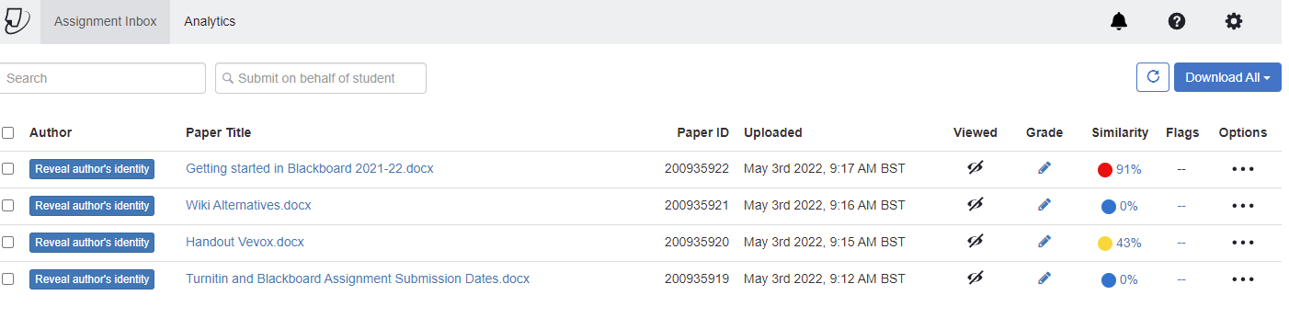
- To grade an assignment, select the pencil icon:
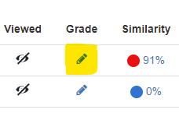
- The assignment will open in the feedback studio for you to mark and leave feedback.

Checking the similarity score
Turnitin has an inbuilt similarity report checker. It is a text matching function and not a plagiarism detection tool:
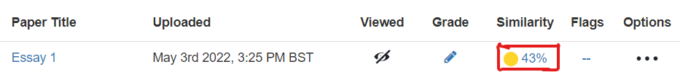
[Alt text: Image from the Turnitin inbox showing the Similarity Score highlighted.]
A Similarity Report shows textual matches or similarities between your assignment submitted to Turnitin and a range of online sources including Turnitin’s own bank of previously submitted work. Turnitin's online sources include: web pages, essay mills, online journals, articles and publications. The scan is generated once you have submitted your assignment to Turnitin.

The matching text displays as a percentage. To view the similarity report:
- Click on the Percentage, this opens the Document Viewer
- To view the sources, click on the number in the red box:

How do I interpret the Similarity Score?
Once you are in the feedback studio interface, you can expand the similarity score to show the Match Overview. This identifies the percentage of other sources that the assignment has used:
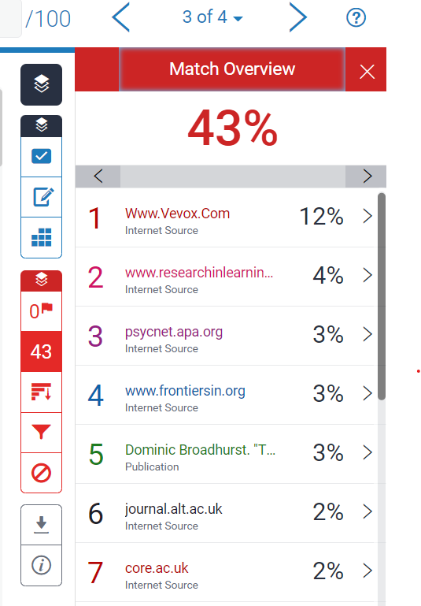
Clicking on a source will navigate to the part of the assignment where it is used.
The matching text will be highlighted and a pop up will appear to show the original source that the assignment has matched against.
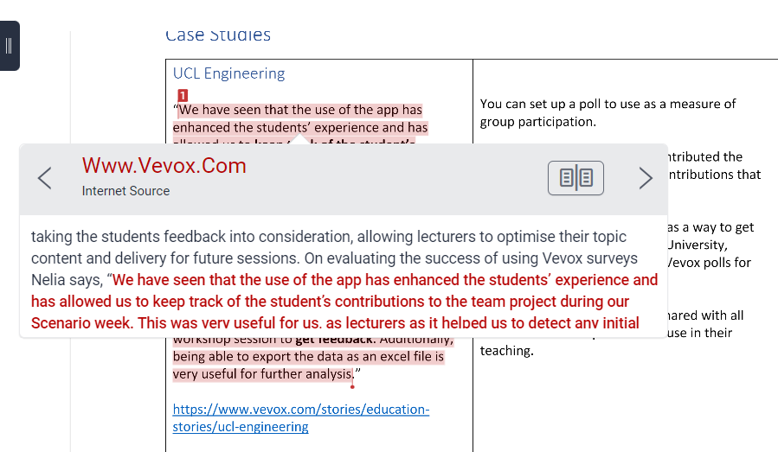

What are flags?
Flags pick up potential integrity issues such as:
- Replaced text characters which could be inserted to circumvent a similarity match.
- Hidden text such as quotation marks that could impact the percentage of quoted material and enable the passing off of such content as original.
Turnitin’s algorithms look at a document for any inconsistencies that would set it apart from a normal submission. A flag is not necessarily an indicator of a problem. However, we’d recommend you focus your attention there for further review.
If an assignment has a flag, then this will be marked in the feedback studio. Click on the flag for further information:
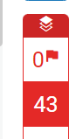

How do I give in-text feedback and comments on an assignment?

Feedback and comments can be given once an assignment has been opened. If you click on the assignment this icon appears:
- The 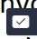symbol is QuickMarks – a tool that contains a bank of comments that can be inserted onto the text
- The symbol allows you to enter feedback and comments of your choosing
- The symbol allows you to enter feedback in line with the text on the assignment
If you are using Rubrics then you can choose to associate your comment with a criterion. When you are creating your comment select Assign Criterion.
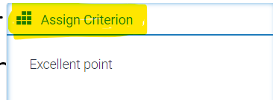
In the dropdown that appears select the Criterion you want to apply to your comment.

How do I mark using groups?
Turnitin groups can be used to divide assignments for marking purposes, for example between seminar groups. Please notes that groups should be formed before the submission point is created.
To put students into groups:
- Set up groups in Blackboard
- Populate the groups with students
- Go to the Turnitin submission point and click on the link to open the assignment inbox.
- Select the groups you want to mark by clicking the dropdown arrow for all students and selecting other groups.
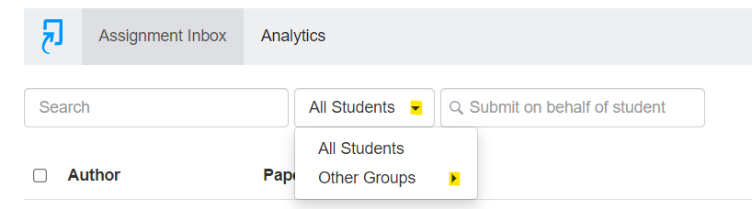
- The assignment inbox will then show the students’ assignments that belong to that group:
- For further information, please see FAQ534.

How do I use QuickMarks?
QuickMarks are a bank of comments that might be applicable on multiple occasions to students across different modules.
They can also provide explanations to help students further develop from your feedback.

How do I enter QuickMarks’ manager window?
There are two ways of entering QuickMark manager:
- Click in any place in a paper submitted to Turnitin and click on the QuickMark icon:
Click on the cog icon in the top right corner of the pop-up window:
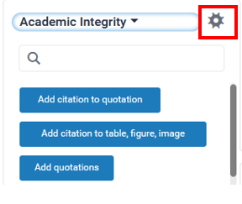
- Click on the QuickMark icon on the Turnitin tools’ menu on the left-hand side:

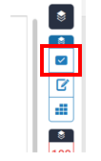
Then click on the cog icon in the top right corner:

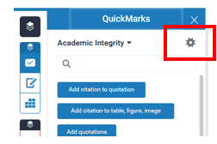

How do I add a Quick Mark?
You can either add your QuickMark to existing QuickMark set or create a new set.
- To choose the set from the list:
  - Click on the three horizontal lines icon on the left top corner:
  - Choose one of the Sets:
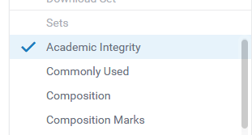
- To create a new QuickMark set:
Select Add to Set and Create New Set
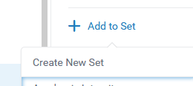
Type in the title and press Save.

How do I use a QuickMark?

- Click in any place in a paper submitted to Turnitin and click on the QuickMark icon:
Choose the appropriate set by clicking on the black drop-down arrow:
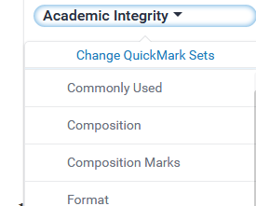
Click on the QuickMark you want to add.

How do I delete QuickMarks and QuickMark sets?

- Deleting QuickMark sets:
In the QuickMark manager window, click on the minus symbol next to the QuickMark set you want to delete:
- Deleting QuickMarks:
You cannot completely delete a QuickMark but archiving it will remove it from any sets and make it invisible. To archive a QuickMark:
- Click on the three horizontal lines icon on the left top corner
- Click on the QuickMark you want to archive and click Archive

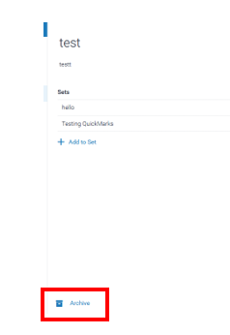

Where should I leave my feedback summary?
General comments and an overview of feedback for students should be left in the feedback summary:
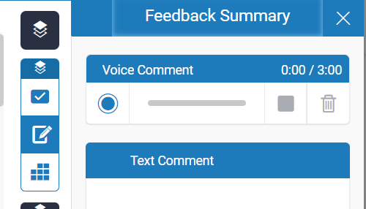
Enter your written feedback in the Text Comment box.
For audio feedback, click on the record button. You will be asked to give browser permission for the device to pick up your microphone. Select Allow.

Where should I enter the final mark?
When you have decided a mark to give an assignment:
- Double click on this symbol:
- Enter the number that you want to give the assignment
- Press Enter on your keyboard and click outside of the mark box (anywhere on the assignment)
- Close the assignment and the mark should populate in the entry on the Turnitin Assignment page: 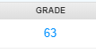
Tip: Do not toggle between assessments – instead, after you have marked the assignment, close it down and re-open the next assessment.

How do students submit to Turnitin?
- Log into Blackboard and go to the module for your assignment
- Go to the Turnitin submission point:
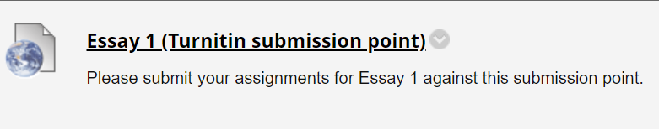

- Click on the submission point and a new window will open
- Select Upload Submission
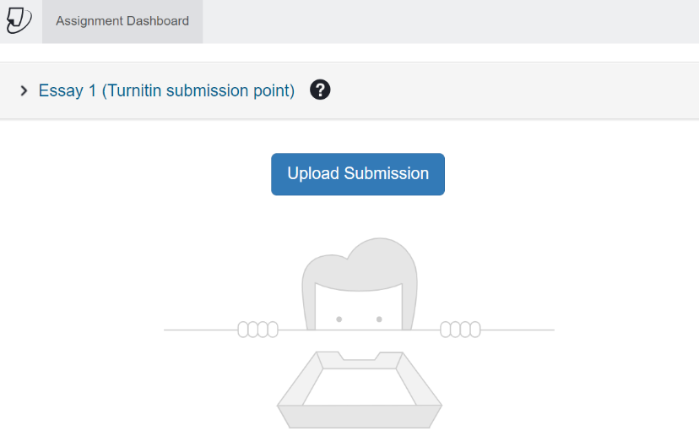
- The file upload window will open
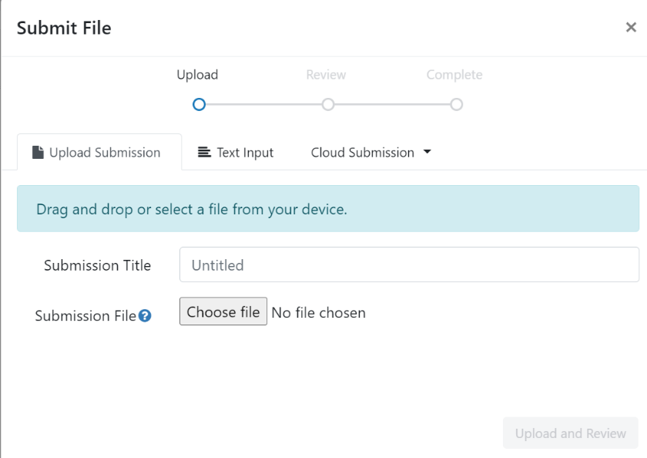

- You can drag and drop your submission file onto the submission point, or select Choose file to search your file store
- The Submission Title will automatically populate with your file name. You can amend this by deleting the text and renaming the file if you wish.
- Select Upload and Review
- Your file will upload and you will be able to preview the submission:
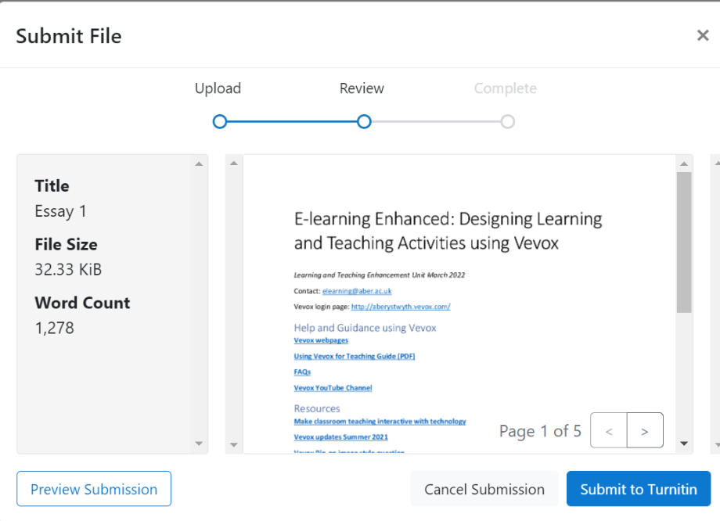
- If you are happy that it’s the correct file select Submit to Turnitin.
- You will see a message to say your submission is complete.
- You can also download your Digital Receipt:
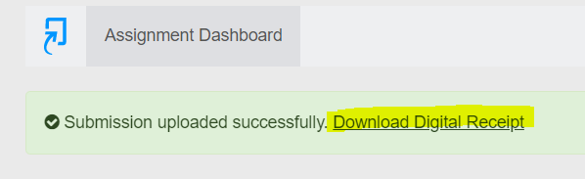
- For confirmation of your submission see our guidance on How do I check that my assignment submission has been successful?

Quick start guide to Blackboard Assignment

How do I create an assignment submission point using Blackboard Assignment?
- Go to module in Blackboard and click Assessment and Feedback on the left-hand menu.
- Select Assessments and Assignment
- In Name and Colour enter a meaningful title for the assignment
- You can add instructions in Instructions box which will be visible to students
- You can also choose to attach a file to the assignment by clicking Browse My Computer or Browse Course
- Enter the assignments Due Date and Time – select a due date during the working week and a time during the working day so that support can be provided if required
- Under Grading, enter Points Possible. This is usually 100.
- Select whether the assignment is an Individual Submission or a Group Submission
- Select the Number of Attempts:
- Single Attempt - students can only submit their assignment once and Instructors have to delete any erroneous assignment submissions
- Multiple Attempts - students can submit an assignment multiple times before the due date but you specify the maximum number of attempts
- Unlimited Attempts - students can submit an assignment an unlimited number of times
- To enable anonymous marking - expand Grading Options and tick Enable Anonymous Marking and select On Specific date or After all submissions are graded
- To delegate marking - tick Enable Delegated Marking and allocate groups to different markers
- In most cases, the Display mark as should be Score. If your assignment is marked out of a number other than 100, then you might want to change this to Percentage so that you can transfer the marks easily.
- Select Include in Grade Centre Marking calculations.
- De-select Show to students in My Marks – if this is checked then students will see you live marking even when marking anonymously and before the feedback release date
- De-select Show average and median statistics for this column to students in My Marks
- If you would like the assignment to appear for a set period of time, enter information into the Availability field
- When you have filled in the information required, press Submit

How do I mark assignments in Blackboard Assignment?
An entry is automatically added to the Grade Centre when an assignment is created. This is where you can view and download the assignments. When you click Grade Centre from the Control Panel, you will see several views, including:

- Needs Marking – shows only assignments that have been submitted but not yet marked
- Full Grade Centre – shows all Grade Centre columns for all students

When you are ready to mark:
- Go to Grade Centre
- Select Needs Grading
- Click on the User Attempt (the student’s name is hyperlinked)
- The assignment will then open. Along the top of the assignment you have the following options:
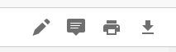
[alt text: in text marking tools available in Blackboard assignment.]
- is a pointer tool and allows you to annotate the assignment
- allows you to add comments to the document
- allows you to print the document
- allows you to download the document
To add a mark and general feedback to the learner:
- Click in the pink Attempt Box:
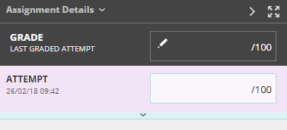
- The box will expand and there will be space for you to provide general feedback to the learner. Enter the mark next to the attempt
- You can save your feedback as draft or submit your feedback

How do students see their marks and feedback?
There are two places that students can access their grades and feedback for assignments – either the Original Submission Link or through My Grades.

Submission link
- Go to the original submission link and click on the title
- Here you will be able to view your mark (grade) and assignment feedback
- If your tutor has given your feedback through an attached file, click on the file name to download the attachment

MyGrades
- Go to the module, click on Tools and My Grades
- Click on the Assignment Title
- This will show you the same view through the document viewer that was described above

Component Marks Transfer Guide

Mapping the Grade Centre
Mapping the columns can be done at any time after your Grade Centre columns have been created. For many Blackboard tools the columns are created automatically (for example when you set up the Turnitin submission point). For other types of assessment, you might need to create your own columns.
If you are working off campus you will need to have VPN enabled to access MyAdmin.
- To map a module’s marks, go to the module in Blackboard
- Click on Course Tools > AStRA::Map Columns
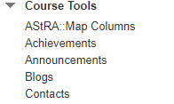
- You will then be taken directly into the Grade Transfer screen in myadmin.aber.ac.uk for that module:
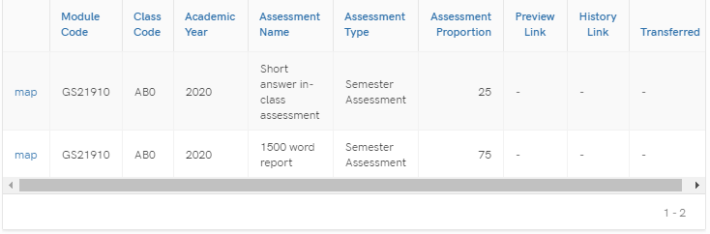

Mapping Columns to the Astra Column
The information displays from AStRA, so if there are any issues or discrepancies, the module record in AStRA needs to be amended. The Assessment Proportion (weighting) for each component will display.
Each component from the Astra module record will be arranged on separate lines.
To begin the transfer process, select:
- Map on the component that you wish to transfer
- A window will open for you to select the Blackboard Grade Centre Column and further details of the Assessment information will be displayed.
- Select the Grade Centre Column that you would like to map by clicking on the dropdown menu. Gradebook Columns will display in the same order that they appear in the Grade Centre. Any hidden columns will display at the bottom of the list and will have (hidden) after their names.
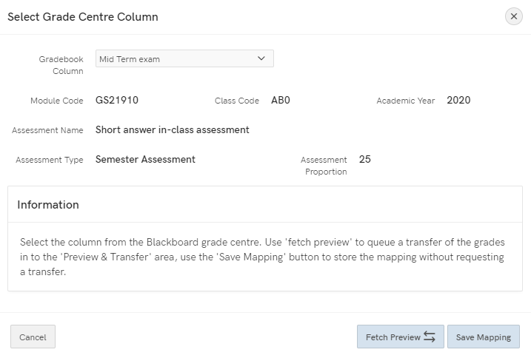
- Note that you can map the same Blackboard Grade Centre column to multiple modules in Astra. However, you can only map 1 Grade Centre Column against each component. Please see guidance on creating Grade Centre Columns further in this document to pull together multiple Grade Centre columns into one column to transfer.
- Fetch Preview to be selected if you want to queue the transfer of grades into the Preview & Transfer area
- Save mapping if you just want to set up the mapping process but transfer at a later date
After clicking Fetch Preview, the option will disappear:
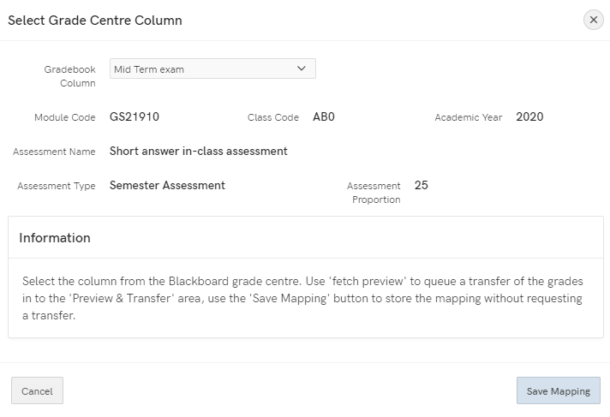
- After 5 minutes, the option to Preview & Transfer will appear

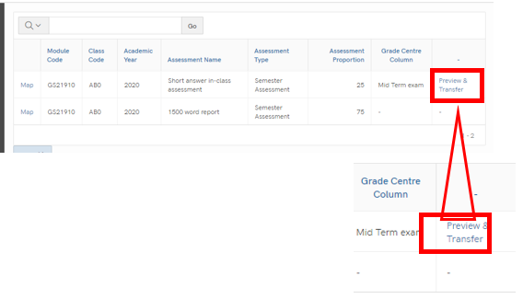
- You can amend the columns against which marks are mapped for any point if you save.
- When you are ready to transfer the marks, click Preview & Transfer. Once you select Preview & Transfer, you’ll be unable to amend the mappings
- In the window that opens, you’ll see the following information:
- The scores for the component will be in the far right hand column – double-check that these scores are correct.
- Anyone with a score of 0 are highlighted as per the below for you to double-check:
- In addition to this, check any marks over 100 or any anomalies
- Note that the marks will be transferred as they are – for example, if there are 120 marks then these will be transferred as they are
- If you are satisfied with the preview, scroll down to the bottom of the page and select Mark for Transfer
- You’ll get a pop up acknowledging that Marks staged for next Transfer
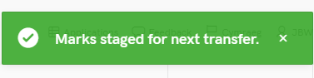
You can then check they have appeared correctly by logging into AStRA and viewing STF080.
To access the STF080 report:
Students > Student Modules > Exams > Assessment Marks per Module
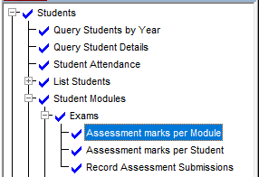

Marks can be altered in AStRA if required. The marks should appear in AStRA quarter past and quarter to every hour.
If you need to transfer additional marks, you can press the Preview & Transfer button again.

Merged Modules (Parent-Child Modules)
If you have parent-child modules, or want to do multiple modules at once:
- Go to myadmin.aber.ac.uk and log in
- Select Grades Transfer tool
- Search for the child module in My Admin
- Select the Column that you would like to map the marks to and follow the process as above
Managing Columns in the Grade Centre
A list of components on the AStRA mapping screen is fed from the Full Grade Centre. In some cases you may need make some changes to the Grade Centre before mapping.
Removing Old Columns
Sometimes Grade Centre columns for assignments from previous years may still appear in the Grade Centre and therefore on the AStRA mapping screen. Some of the old and new columns’ names may be the same or similar causing difficulties for the mapping process.
In this case, an additional option allowing to delete past assignments columns (ones which do not have a submission point anymore) from the Grade Centre should appear on the AStRA mapping page.
- Tick the ‘Delete these assignments’ box > click ‘Save’.
- Go to the Full Grade Centre click on the grey arrow next to the column you want to delete > click ‘Delete column’ (this option appears only for columns which do not have a submission point therefore you do not have to worry about deleting a current assignment column).
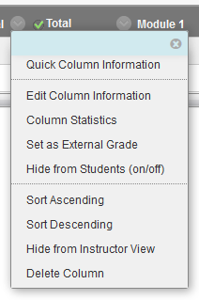

Component made up of more than one element
If a component consists of more than one element, for example, 20% of the overall mark consists of 4 short tests each having a separate column in the Grade Centre, you will need to create a Calculated Column in the Grade Centre.
- Go to the Grade Centre > Full Grade Centre > Create Calculated Column > Weighted Column
- Give the column a name and under Primary Display choose Percentage
- In the Select Columns > Select all columns for the same component and press the arrow.
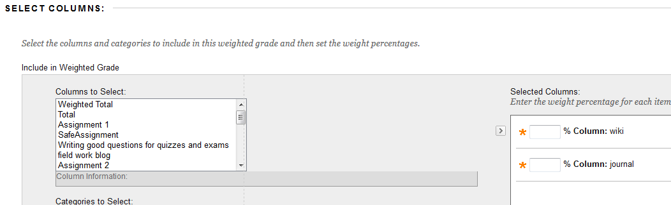
- Enter the weight percentage for each of the elements (it should add up to 100%).
- Under Options > Show this Column to Students > Tick No
- Click ‘Submit’

Seminar group submissions / Extensions
If students are divided into groups and have different submission points for the same assignment, or there is a submission point for extensions.
Go to Grade Centre > Full Grade Centre > Create Calculated Column > Total column
- Give the column a name and under Primary Display choose Percentage
- In the Select Columns > Select all columns for the same component and press the arrow.
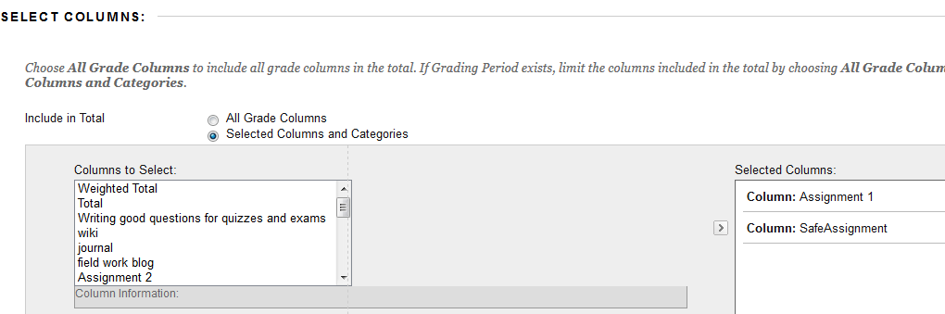
- Leave the Calculate as running total set to Yes (this is important, otherwise blank columns will be treated as a mark of 0 rather empty).
- Under Options > Show this Column to Students > Tick No
- Click Submit

Exam Marks
You can create an exams Grade Centre column and type the marks in the column.
- Go to the Full Grade Centre > Create Column
- Give the column a name and under Primary Display choose Percentage
- In the Points Possible box, enter 100
- Under Options > Show this Column to Students > Tick No
- Click ‘Submit’
Note: You should also hide the Total column from students so they won’t be able to calculate their exam mark:
Click on the little arrow next to the column you want to hide > Edit Column Information> Show this Column to Students > tick No.

