Academy Forum 5: Working with Students as Partners

Lauren Harvey & Jim Woolley, Learning and Teaching Enhancement Unit
UKPSF Mapping: A1, A2, A3, A4, A5, K2, K4, V1, V3

April 2022

Key resources
International Journal for Students as Partners
Healey HE Consultants: Students as partners and change agents
Engagement through partnership: students as partners in learning and teaching in higher education
Students as Partners in Higher Education Literature Review
LTEU Students as Partners project: What is a Well-Designed Blackboard module?
HEFCW and Welsh Government Learner Involvement and Student Partnership

Choices in designing students as partners
- How do I choose the students’ role in a SaP project? Take a look at Catherine Bovill’s article A Framework to Explore Roles within Student-Staff Partnerships in Higher Education. The article includes a matrix to outline the different roles that are available.
- How do I choose a SaP project?

Design questions:
•Is working in partnership appropriate?
•What is your partnership project designed to do? How do staff and students benefit from it?
•How will you engage students in the project?
•What training or support do you need to provide for the project?
•Is this going to be a one-off project or continuous?
•How will you evaluate its success?

Students as Co-creators of Curriculum
Lubicz-Nawrocka, T. M. (2018). Students as partners in learning and teaching: The benefits of co-creation of the curriculum. International Journal for Students As Partners, 2(1), 47–63. https://doi.org/10.15173/ijsap.v2i1.3207
Benefits:
- Shared responsibility, respect, and trust
- Learning from each other within a collaborative learning community
- Individual satisfaction and development

Students as Co-designers of Assessment
Millmore, A. (2021). Hand over the reins: A case study for student-staff partnership in designing module assessments. International Journal for Students As Partners, 5(1), 86–96. https://doi.org/10.15173/ijsap.v5i1.4382
This case study looks at a student-staff partnership project at the University of Reading in the School of Law. Positive outcomes:
- Students developed employability attributes
- Broke down power dynamic between student and staff
There were 4 stages to the project:
Stage 1: Participant sampling – asking for volunteers to assist in the project
Stage 2: Developing the collaborative relationship with student partners – with mind-mapping activities
Stage 3: Focus groups with three phases.
Stage 4: Assessment co-design
Activity 1: Consider different types of assessment.
Activity 2: Create an assessment breakdown for a new module focusing on type of assessment, weighting of the elements, timing of the assessments.
Activity 3: Map the employability attributes of the proposed assessment.

Students as Partners and power relationships
O’Shea, S. (2018). Equity and students as partners: The importance of inclusive relationships. International Journal for Students As Partners, 2(2), 16–20. https://doi.org/10.15173/ijsap.v2i2.3628
Working with students as partners involves the negotiation of a power relationship.

What technological tools are available to me for students as partners work?

Inform:
Canvas student opinion, ask them specific questions, or give them the opportunity to provide feedback:
- Blackboard Surveys - asynchronous
- Vevox polling – synchronous

Consult, Involve, Partner, Control
- Teams – set up a Teams site, teams meeting
- Make use of Planner for actions

Schemes to pay Students as Partners:
- Aber Works scheme
- Aber Forwards scheme

Benefits
- Beneficial and improves engagement
- Payment for student
- Insightful and new insights without working with students as partners
- Extra time to talk about study skills

Challenges
- Limited by PhD student status – responses to small scale decisions.
- Managing multiple student perspectives
- Fair distribution of labour amongst students
- Secure budgets – practicalities of bringing students in ahead of the curve
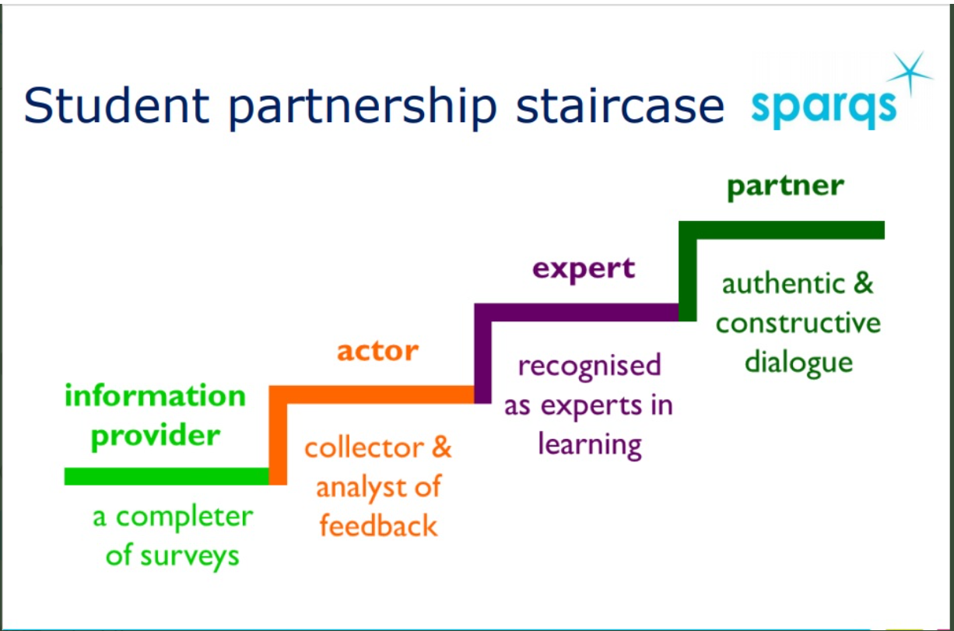

Additional resources within the context of the pandemic
The following resources are taken from a workshop run by Mick Healey and Ruth Healey for Aberystwyth University in 2021. The resources focus on staff-student relationships in the pandemic.

Students as Partners and the Pandemic

Cook-Sather, A. & Nandeeta, B. (Eds) (2020) Naming and navigating troubling transitions: Pedagogical partnership during the pandemic. Teaching and Learning Together in Higher Education Issue 30. https://repository.brynmawr.edu/tlthe/vol1/iss30/

Cruz, L., & Grodziak, E. (2021). SoTL under Stress: Rethinking Teaching and Learning Scholarship during a Global Pandemic. Teaching & Learning Inquiry, 9(1), 3-12. https://doi.org/10.20343/teachlearninqu.9.1.2

Gravett, K. (2020) Troubling transitions: re-thinking dominant narratives surrounding students’ educational transitions. SRHE News Blog. April 9, 2020. https://srheblog.com/2020/04/09/troubling-transitions-re-thinking-dominant-narratives-surrounding-students-educational-transitions/
Green, W. (2020) Partnerships in global learning – before and after the outbreak of COVID-19. Students as Partners in Global Learning Blog.

Hassan, O., Scanlon, D., McDonald, C., Algeo, N., Nic Corcráin, M., Jenkins, T., Kelly, S., and Whelan, S. (2020). Supporting Student Engagement and Partnership in Higher Education Decision-Making during the Pandemic: A reflection from the National Student Engagement Programme (NStEP). AISHE-J, 12(3), 1-9 http://ojs.aishe.org/index.php/aishe-j/article/download/545/825
Matias, P. (2020) Four sides of transition. Teaching and Learning Together in Higher Education Issue 30. https://repository.brynmawr.edu/tlthe/vol1/iss300/1
Matthews, K. E., Cook-Sather, A., Godbold, N., Healey, M., & Rafferty, C. (2020). Learner-teacher partnership in times of COVID-19: A community poll to share practices and perspectives. Brisbane: University of Queensland. For findings see: https://www.surveymonkey.com/stories/SM-RTB68869/. Reviewed by McCreadie, K in IJSaP 4(2). In press.
McCreadie, C. (2020). Learner-teacher partnership in times of COVID-19: Community poll review. International Journal for Students as Partners, 4(2), 155-157. https://doi.org/10.15173/ijsap.v4i2.4371

Ntem, A., Ngyuen, E., Rafferty, C., Kwan, C., & Benlahceneim, A. (2020) Students as Partners in crisis: The impact of COVID-19 on the transition to remote and virtual spaces. International Journal for Students as Partners, 4(2), 1-8. https://doi.org/10.15173/ijsap.v4i2.4432

Ouyang, F., Chang, Y., Scharber, C. et al. (2020) Examining the instructor-student collaborative partnership in an online learning community course. Instructional Science. https://doi.org/10.1007/s11251-020-09507-4
Riddell, Jessica, Scott Stoddard, & Georges-Phillipe Gadoury-Sansfacon (2020) Building capacities for student mentorship and collaboration in the time of COVID and beyond. https://www.jessicariddell.com/about
Weiler, K. & Williamson, A. (2020) Partnering to build responsive learning communities that support students in crisis. Teaching and Learning Together in Higher Education Issue 30. https://repository.brynmawr.edu/tlthe/vol1/iss30/3
Whelehan, Dale F. (2020). Students as Partners: A Model to Promote Student Engagement in Post-COVID-19 Teaching and Learning. AISHE-J, 12(3), 1-10. http://ojs.aishe.org/index.php/aishe-j/article/download/479/841
Vayada, Preeti, Matthews, Kelly E., & Llang, Yifei (2020) We are all in it together. HERDSA Connect 42(3), 15.

