Active Learning ​& Student Engagement
Developed by Mary Jacob, LTEU, Aberystwyth University, updated 31/8/2022
Email: thestaff@aber.ac.uk
Social media: Twitter, Weekly Resource Roundup, L&T Trello board

Description
Active learning can help students engage with learning tasks, promote deeper learning, and foster higher order thinking. The result can be better retention of learning.
Many lecturers wonder what we can do besides ‘deliver content’. This session builds on a chapter in a forthcoming book about active learning. Synthesising early definitions and current research on active learning, I’ve come to consider active learning to be any activity where students carry out an Active Cognitive Task (ACT). It is not the content itself but what students do with it that matters.
As suggested by the name, an ACT has three essential elements:
- Task – Student must carry out a task, not just absorb information or perform an operation by rote. It is not the content itself but what they do with it that matters.
- Cognitive – The task must involve thinking, a cognitive engagement with new ideas. Both the early definitions and recent research in cognitive science emphasise thinking. Students drive new information into long-term memory so they can use it in a meaningful way. This is the constructive aspect of learning, where students create mental schemas by reinforcing connections between ideas. Because this mental work can be hard, it is sometimes referred to as ‘effortful learning’ (Brown et al, 2014) or ‘desirable difficulty’ (Bjork, 1994). For ideas on how to get students to take this on board, see Deslauriers (2019)
- Active – The task must be active, not passive, such that students take responsibility and ownership of the learning process. This requires building mutual trust and giving students agency.
This session explores why and how we might want to make lectures more interactive. While there is already a lot of good practice in active learning at our university, especially in seminars and practicals, it can be challenging to use active learning in a lecturing context. There is no ‘one size fits all’ solution. Two common approaches are to break up lectures with short interactions or hold longer problem-solving activities that require students to prepare outside of class.
We will use the following models:
- Online engagement framework for HE
- Bloom’s taxonomy – higher orders of thinking
- ICAP: Interactive / Constructive / Active / Passive
- ABC learning design – six types of learning
After this session, you should be able to apply these models for active learning and student engagement to your own practice and design Active Cognitive Tasks (ACTs) to help your students learn.

Top tips
- Break up lecture with several short interactions
- Lecture then have students solve problems etc
- Start small and start early

Where to get more ideas
- Classroom assessment techniques (Angelo & Cross), e.g.:
  - Think-pair-share
  - Brainstorming
  - Muddiest point

Make it active - ICAP model
Chi, M. T. H. (2009). Active-Constructive-Interactive: A Conceptual Framework for Differentiating Learning Activities. Topics in Cognitive Science, 1, 1, 73-105.
The table below is drawn from Chi’s article and shows three types of active learning. The fourth component in her model is passive learning, which involves passively receiving information with no associated cognitive task.
 | Active | Constructive | Interactive
Characteristics | Do something, often physical | Produce output beyond given information, discovery learning | Dialogue with other students or teacher
Overt activities | Engaging activities:  underline, point, paraphrase, manipulate objects, select, repeat | Self-construction activities:  explain, elaborate, concept map, plan/predict outcomes | Instructional dialogue or joint dialogue:  revise errors from feedback, or build on partner’s contribution
Cognitive processes | Attending:  activate existing knowledge, store new information | Creating individually:  infer new knowledge, integrate new with existing knowledge, restructure own mental model | Creating jointly:  create while incorporating partner’s contributions

Make it cognitive - Bloom’s taxonomy higher orders of thinking
Bloom, B. S., Taxonomy of educational objectives: the classification of educational goals. New York: David McKay Co. [London]: Longman, 1956.
Anderson, L. W., Krathwohl, D. R., Airasian, P. W., Cruikshank, K. A., Mayer, R. E., Pintrich, P. R., Raths, J. D., ... Bloom, B. S. (2001). A taxonomy for learning, teaching, and assessing: A revision of Bloom's Taxonomy of educational objectives. New York: Addison-Wesley.
Shabatura, J. (2018). Using Bloom’s Taxonomy to Write Effective Learning Objectives. Teaching Innovation and Pedagogical Support, University of Arkansas. Image below by Jessica Shabatura.
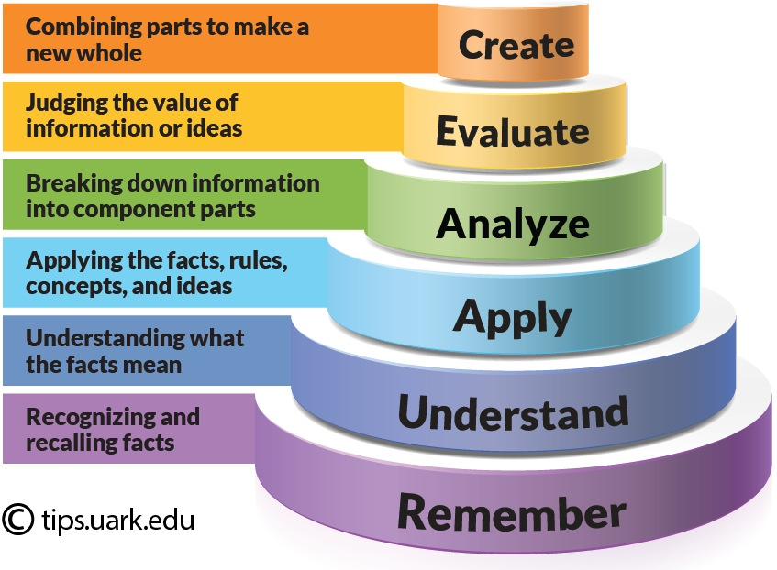
Each level in the taxonomy includes the levels below it. For example, in order to analyse something, you need to be able to remember and understand the facts, as well as apply the core concepts.
The top three levels are widely recognised as higher order thinking. The level of ‘apply’ is on the borderline. ‘Apply’ and serves as a useful benchmark for the minimum level we should aim for when teaching in higher education.

Make it a task - ABC learning design types of learning
Young, C. & Perović, N. (2016). Rapid and Creative Course Design: As Easy as ABC?, Social and Behavioral Sciences 228, Pages 390-395.
Based on Laurillard, D. (2012). Teaching as a design science: Building pedagogical patterns for learning and technology. New York, NY: Routledge.
Laurillard, D. Explanation of the six activity types (3-minute video)
ABC Learning Design at UCL: Blog, Download materials, Video
- Acquisition – absorb information transmitted by teaching staff, books, videos, etc
- Collaboration – work together with peers towards a goal
- Investigation – study or research independently, going beyond transmitted content
- Discussion – exchange ideas with peers or teaching staff
- Practice – develop a skill using feedback, may be smaller-scale tasks
- Production – create something, good for consolidation

Mapping ABC Learning Design, ICAP, and Bloom’s Taxonomy
The elements in these models often have a most natural fit with each other. There is no one ‘right’ answer, as correspondences often rely on the specific details of how an activity is implemented. Acquisition would be passive if no other type of learning is used with it.
ABC Learning Design | ICAP | Bloom’s taxonomy
Acquisition | Passive? | Remember
Collaboration | Interactive | depends on task
Investigation | Constructive | Evaluate
Discussion | Interactive | Understand
Practice | Active | Apply
Production | Constructive | Create

Online Engagement Framework for HE
Redmond, P., Heffernan, A., Abawi, L., Brown, A., & Henderson, R. (2018). An Online Engagement Framework for Higher Education. Online Learning, 22(1), 183–204.
Please read the article and write your ideas in the table in the Tasks section of this document. We will compile our ideas into a collaborative document during the session.
The table below is quoted from Redmond’s article. Please note that her indicators are very general and illustrative only. In our discussion, we are looking for something more specific. For example, social engagement can include establishing trust. What things can we do with our students in order to build that trust?
Online Engagement Element | Indicators (illustrative only)
Social engagement | - Building community  - Creating a sense of belonging  - Developing relationships  - Establishing trust
Cognitive engagement | - Thinking critically  - Activating metacognition  - Integrating ideas  - Justifying decisions  - Developing deep discipline understandings  - Distributing expertise
Behavioural engagement | - Developing academic skills  - Identifying opportunities and challenges  - Developing multidisciplinary skills  - Developing agency  - Upholding online learning norms  - Supporting and encouraging peers
Collaborative engagement | - Learning with peers  - Relating to faculty members  - Connecting to institutional opportunities  - Developing professional networks
Emotional engagement | - Managing expectations  - Articulating assumptions  - Recognising motivations  - Committing to learning

Session Tasks
During our live session, we will share ideas for applying these models in our own teaching.

How can we apply the active learning models to our own teaching?
Give a concrete example for each one to show what active learning looks like in both traditional and online teaching contexts.

ABC learning design
Activity type | Traditional teaching | Online teaching
Acquisition
Collaboration
Investigation
Discussion
Practice
Production

Bloom’s taxonomy
Higher order thinking | Traditional teaching | Online teaching
Create
Evaluate
Analyse
Apply

ICAP
Category | Traditional teaching | Online teaching
Interactive
Constructive
Active

How can we promote student engagement?
What specific, concrete actions can we take to encourage engagement? How can we promote engagement in both traditional and online teaching contexts?
Engagement type | Traditional teaching | Online teaching
Social
Cognitive
Behavioural
Collaborative
Emotional

Additional resources
Aspire reading list for PGCTHE – Scroll down to see the Active Learning section of the list
ABC Learning Design at UCL: Blog, Download materials, Video
Advance HE. (2019). Scotland Thematic Series, Winter 2018/19: Active Learning.
Angelo, T. A., & Cross, K. P. (1988). Classroom assessment techniques: A handbook for college teachers. National Center for Research to Improve Postsecondary Teaching and Learning.
Bjork, R. A. (1994). ‘Memory and metamemory considerations in the training of human beings,’ Metacognition: Knowing about knowing, edited by Janet Metcalfe and Arthur Shimamura, Cambridge, MA: MIT Press, pp. 185–205.
Bonwell, C. C., & Eison, J. A. (1991). Active learning: Creating excitement in the classroom. Washington, DC: School of Education and Human Development, George Washington University.
“Students must do more than just listen: They must read, write, discuss, or be engaged in solving problems. Most important, to be actively involved, students must engage in such higher-order thinking tasks as analysis, synthesis, and evaluation. Within this context, it is proposed that strategies promoting active learning be defined as instructional activities involving students in doing things and thinking about what they are doing.”
Brown, P. C., Roediger, H. L., and McDaniel, M. A. (2014). Make it stick: the science of successful learning, Cambridge, MA: The Belknap Press of Harvard University Press.
Chi, M. T. H. (2009). Active-Constructive-Interactive: A Conceptual Framework for Differentiating Learning Activities. Topics in Cognitive Science, 1(1), 73-105.
“Interactive activities are most likely to be better than constructive activities, which in turn might be better than active activities, which are better than being passive.”
Chickering, A. W., Gamson, Z. F., Poulsen, S. J., & Johnson Foundation. (1987). Seven principles for good practice in undergraduate education. Racine, WI: Johnson Foundation.
“3. Uses Active Learning Techniques: Learning is not a spectator sport. Students do not learn much just by sitting in classes listening to teachers, memorizing pre-packaged assignments, and spitting out answers. They must talk about what they are learning, write about it, relate it to past experiences, apply it to their daily lives. They must make what they learn part of themselves.”
Deslauriers, L., McCarty, L. S., Callaghan, K., Kestin, G., McCarty, L. S., and Miller, K. (2019). ‘Measuring actual learning versus feeling of learning in response to being actively engaged in the classroom,’ Proceedings of the National Academy of Sciences of the United States of America, 116(39), pp. 19251-19257
European University Association (EUA) (Belgium). (2019). Promoting Active Learning in Universities: Thematic Peer Group Report. Learning & Teaching Paper #5
Jacob, M. (forthcoming). ‘Active Cognitive Tasks: Synthesising frameworks for active learning online’, in Wendy Garnham and Isobel Gowers eds. Active Learning in Higher Education (Routledge).
Vanderbilt University Center for Teaching, Bloom’s Taxonomy of Educational Objectives
Vanderbilt University Center for Teaching, Classroom Assessment Techniques (CATs)
“Classroom Assessment Techniques (CATs) are generally simple, non-graded, anonymous, in-class activities designed to give you and your students useful feedback on the teaching-learning process as it is happening.”
Wiggins, B. L., Eddy, S. L., Grunspan, D. Z., & Crowe, A. J. (2017). The ICAP Active Learning Framework Predicts the Learning Gains Observed in Intensely Active Classroom Experiences. (AERA open.)
Wiggins, G. P., & McTighe, J. (2008). Understanding by design. Alexandria, VA: Association for Supervision and Curriculum Development. See their further resources.
- Teach for understanding and transfer
- Backward design:
  - What should students be able to do? (learning outcomes)
  - How can we measure their ability to do it? (assessment)
  - What learning activities will help them develop the desired skills? (activities)
Young, C. & Perović, N. (2016). Rapid and Creative Course Design: As Easy as ABC?, Social and Behavioral Sciences 228, pp. 390-395.

